Venture Name-
Batch No-
Team No-

Ignite Venture Assessment - Milestone 3
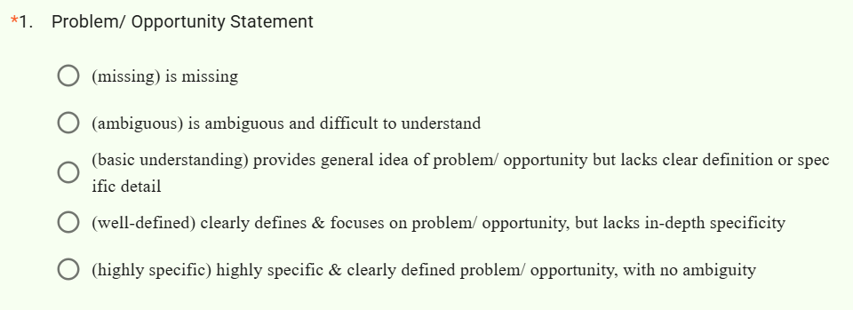
*
2.
What is the one thing that the students need to do to improve their output on Problem/ Opportunity Statement?
Answer:

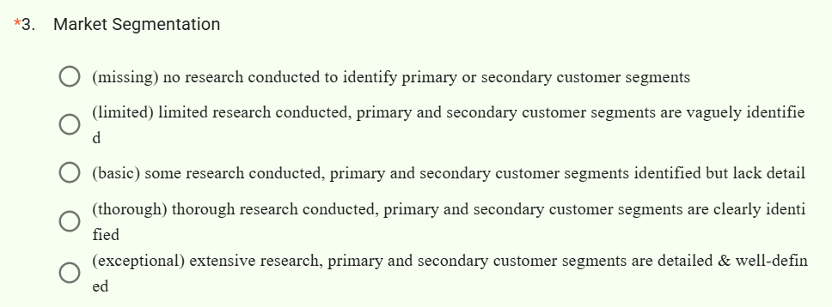
4.
What is the one thing that the students need to do to improve their output on Market Segmentation?

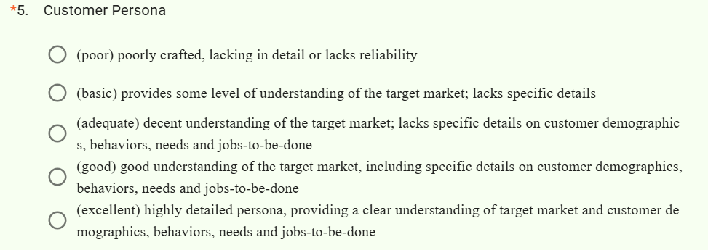
*
6.
What is the one thing that the students need to do to improve their output on Customer Persona?

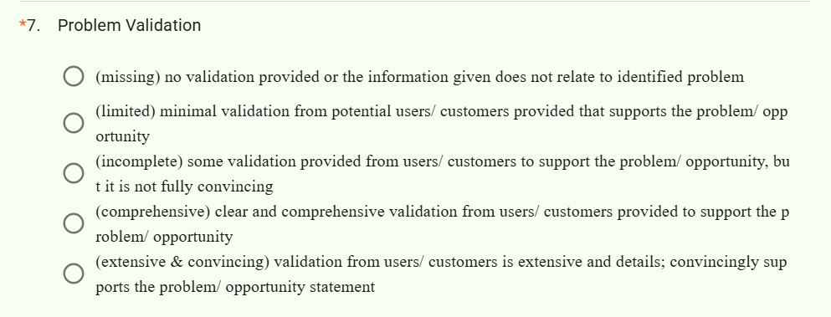

8.
What is the one thing that the students need to do to improve their output on Problem Validation?

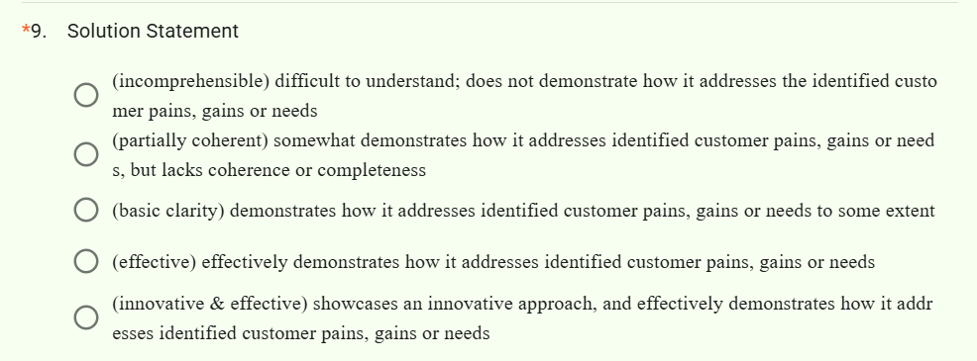
10.
What is the one thing that the students need to do to improve their output on Solution Statement?

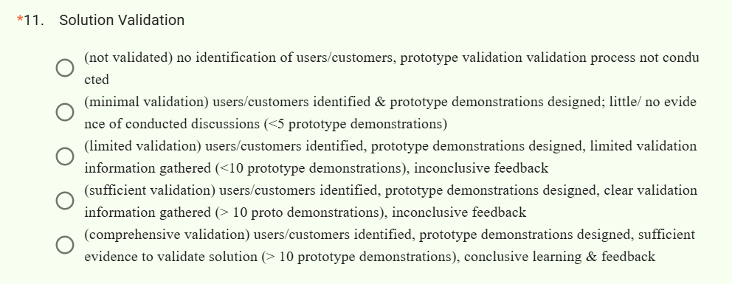
12.
What is the one thing that the students need to do to improve their output on Solution Validation?

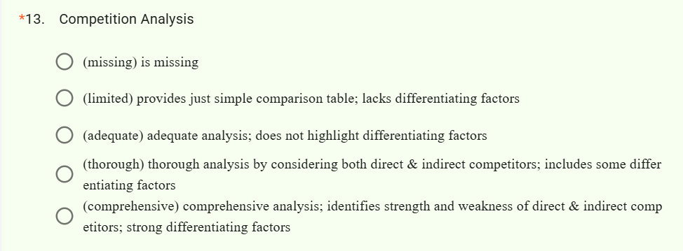
14.
What is the one thing that the students need to do to improve their output on Competition Analysis?

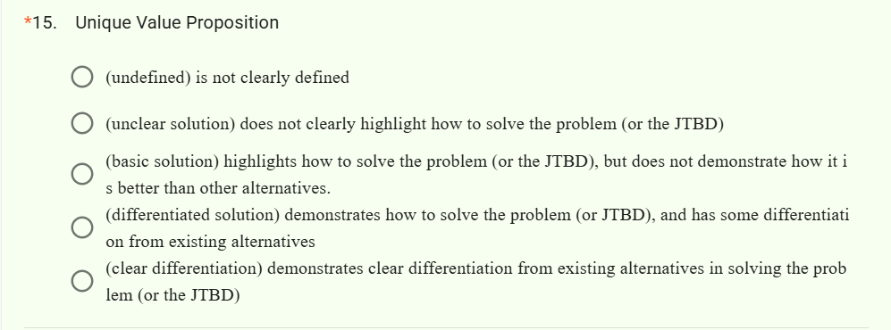
16.
What is the one thing that the students need to do to improve their output on Unique Value Proposition?

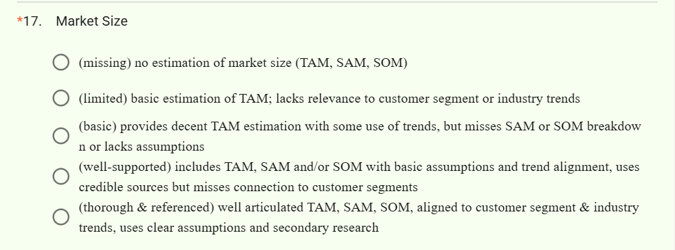
18.
What is the one thing that the students need to do to improve their output on Market Size?

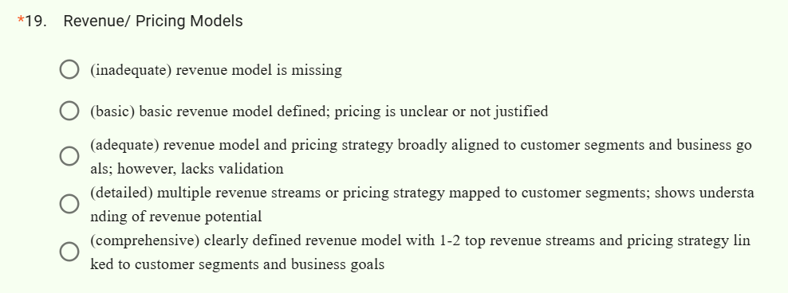
20.
What is the one thing that the students need to do to improve their output on Revenue/ Pricing Models?

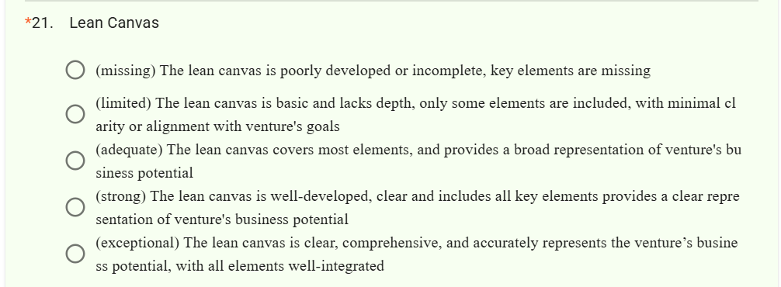
22.
What is the one thing that the students need to do to improve their output on Lean Canvas?

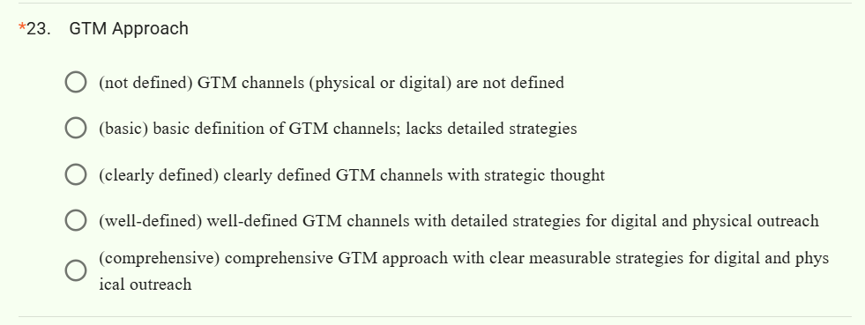
24.
What is the one thing that the students need to do to improve their output on GTM Approach?

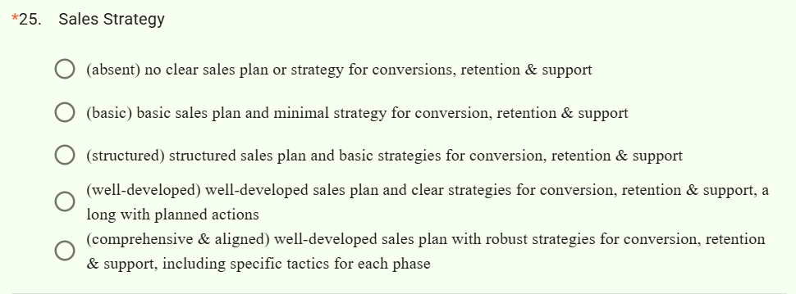
26.
What is the one thing that the students need to do to improve their output on Sales Strategy?

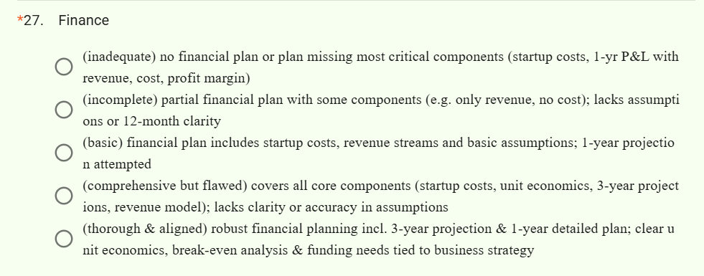
28.
What is the one thing that the students need to do to improve their output on Finance?

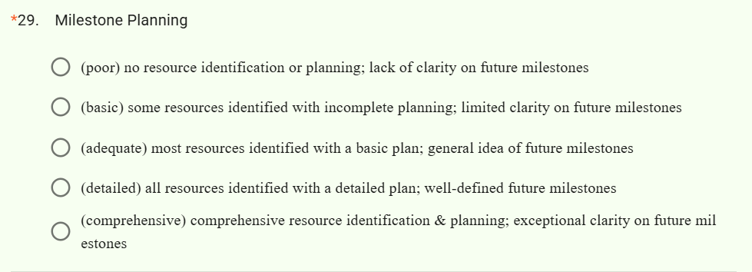
30.
What is the one thing that the students need to do to improve their output on Milestone Planning?

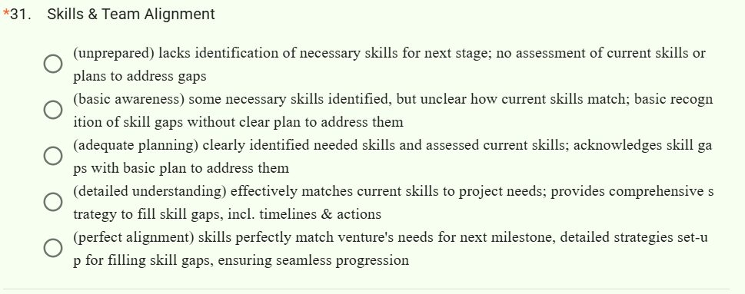
32.
What is the one thing that the students need to do to improve their output on Skills & Team Alignment?

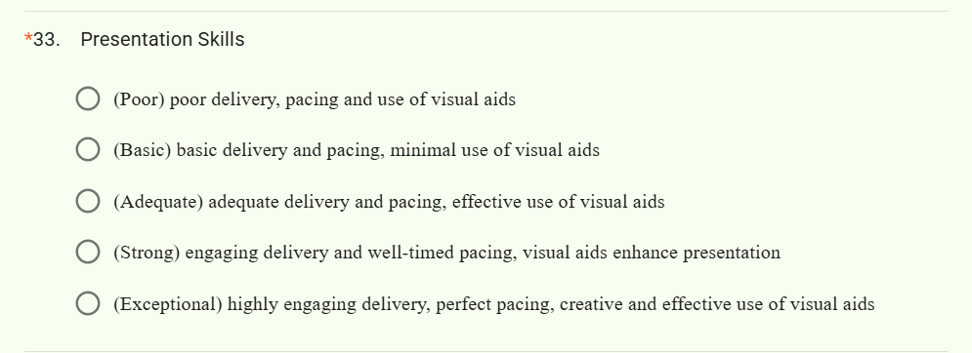
34. What is the one thing that the students need to do to improve their output on Presentation Skills?

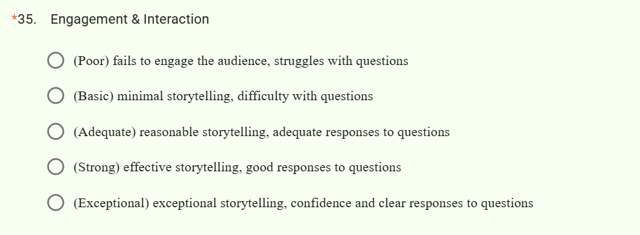
36.
What is the one thing that the students need to do to improve their output on Engagement & Interaction?


38.
Please share your reasons for the above

