Ignite Venture Assessment - Milestone 2
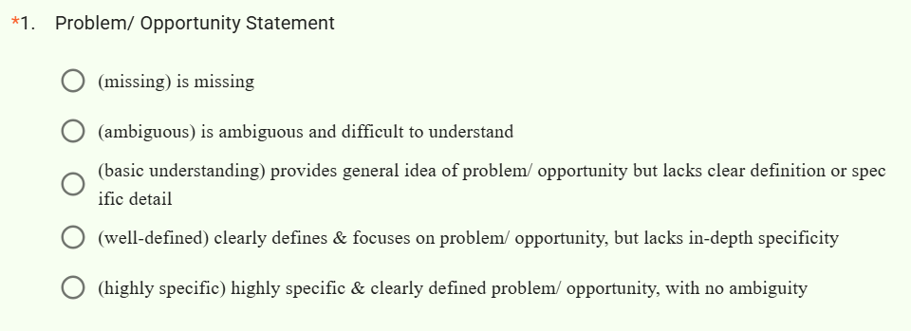
*
2.
What is the one thing that the students need to do to improve their output on Problem/ Opportunity Statement?
Answer:

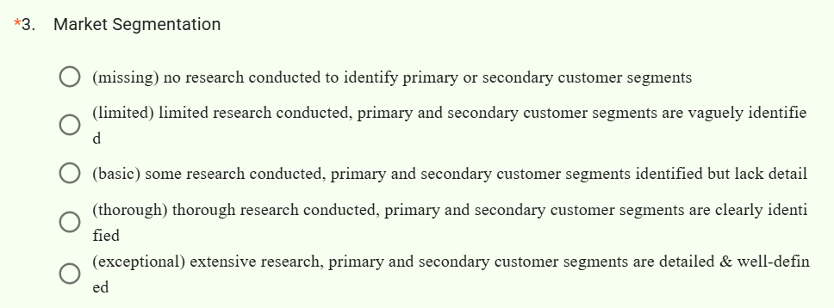
4.
What is the one thing that the students need to do to improve their output on Market Segmentation?

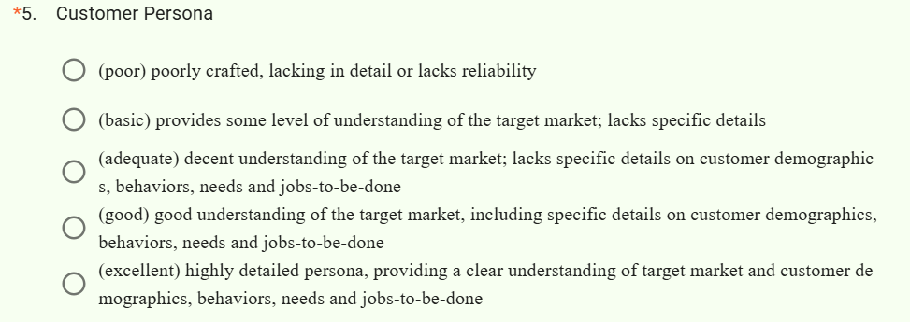
*
6.
What is the one thing that the students need to do to improve their output on Customer Persona?

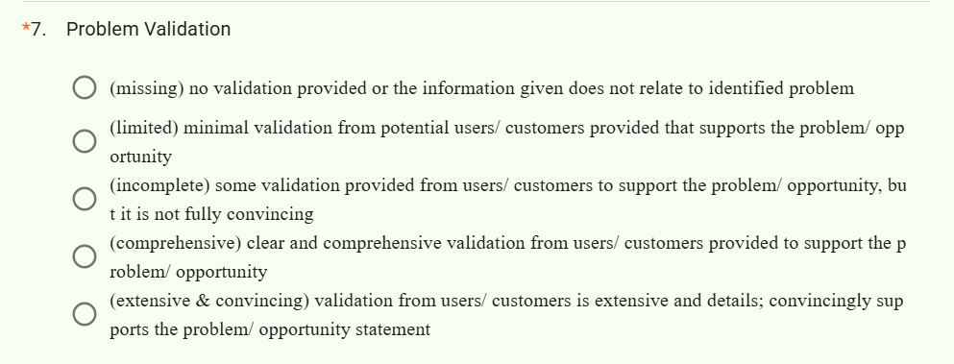

8.
What is the one thing that the students need to do to improve their output on Problem Validation?

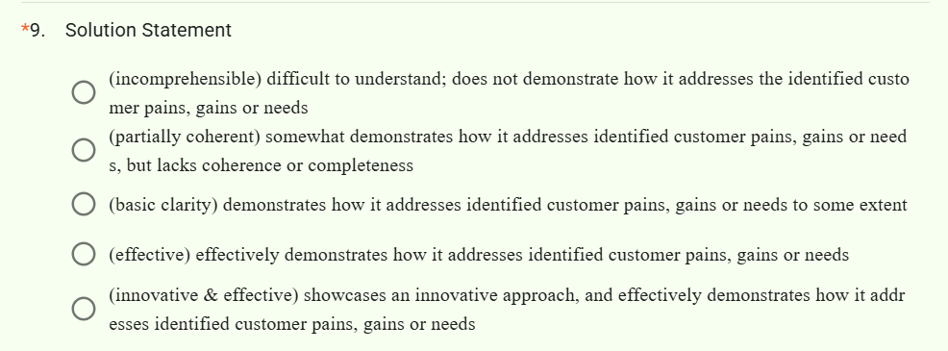
10.
What is the one thing that the students need to do to improve their output on Solution Statement?

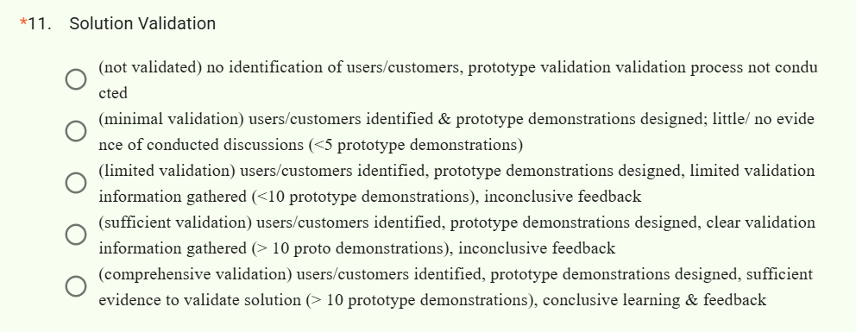
12.
What is the one thing that the students need to do to improve their output on Solution Validation?

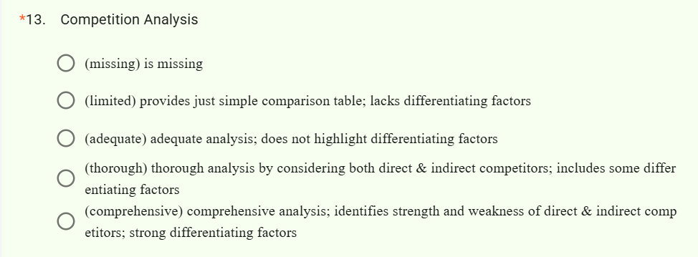
14.
What is the one thing that the students need to do to improve their output on Competition Analysis?

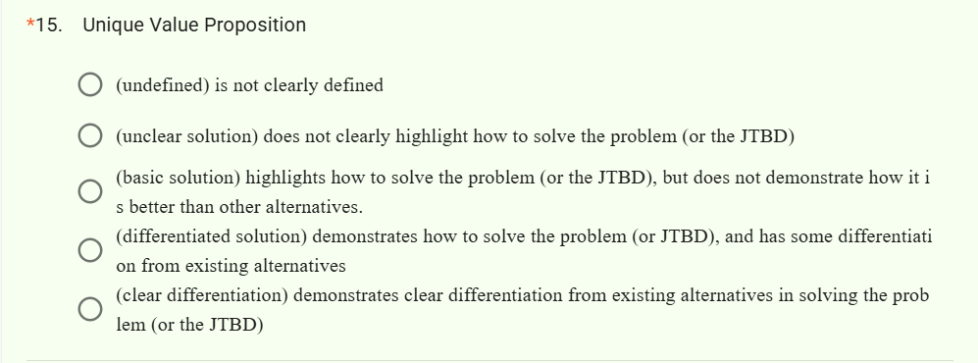
16.
What is the one thing that the students need to do to improve their output on Unique Value Proposition?

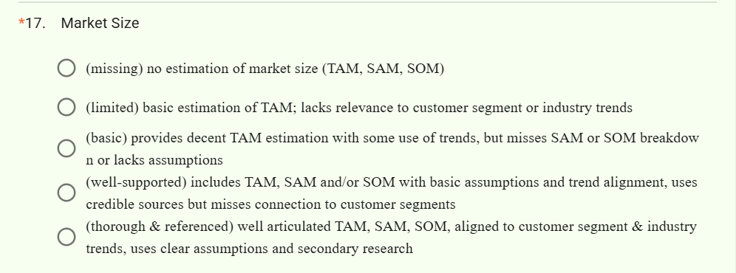
18.
What is the one thing that the students need to do to improve their output on Market Size?

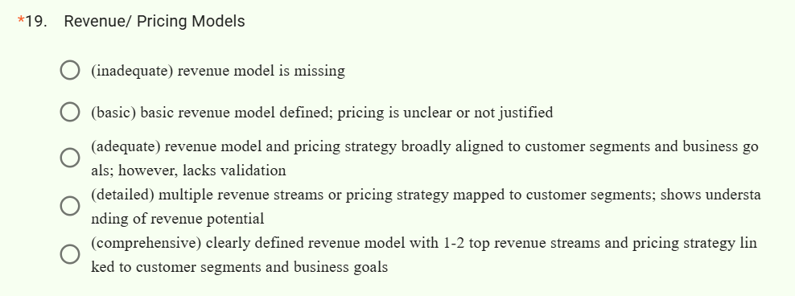
20.
What is the one thing that the students need to do to improve their output on Revenue/ Pricing Models?

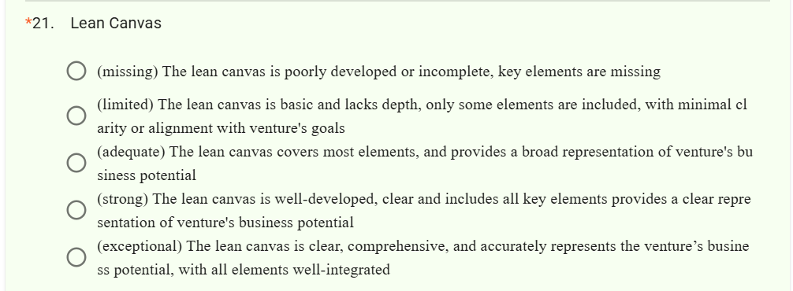
22.
What is the one thing that the students need to do to improve their output on Lean Canvas?

