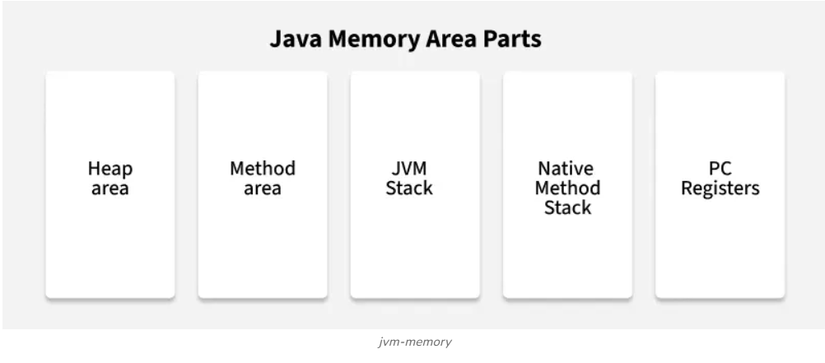

1. Heap Area
- Heap is a shared runtime data area where objects and arrays are stored. It is created when the JVM starts.
- JVM allows user to adjust the heap size. When the new keyword is used the object is allocated in the heap and its reference is stored in the stack.
- There exists one and only one heap for a running JVM process.
Scanner sc = new Scanner(System.in)
Here, the Scanner object is stored in the heap and the reference sc is stored in the stack
Note: Garbage collection in heap area is mandatory.

2. Method Area
- Method area is a logical part of the heap and it is created when the JVM starts.
- Method area is used to store class-level information such as class structures, Method bytecode, Static variables, Constant pool, Interfaces.
- Method area can be of fixed or dynamic size depending on the system's configuration.
- Static variables in Java are stored in the Method Area.
- Garbage collection of the method area is not guaranteed and depends on JVM implementation.

3. JVM Stacks
- A stack is created when a thread is created and the JVM stack is used to store method execution data, including local variables, method arguments and return addresses
- Each Thread has its own stack, ensuring thread safety.
- Stacks size can be either fixed or dynamic and it can be set when the stack is created.
- The memory for stack needs not to be contiguous.
- Once a method completes execution, its associated stack frame is removed automatically.

4. Native Method Stacks
- Native method stack is also known as C stacks.
- Native method stacks are not written in Java language
- This memory is allocated for each thread when it is created and can have either a fixed or dynamic size.
- Native method stacks handle the execution of native methods that interact with the Java code.

5. Program Counter (PC) Registers
Each JVM thread which carries out the task of a specific method has a program counter register associated with it. The non native method has a PC which stores the address of the available JVM instruction whereas in a native method, the value of program counter is undefined. PC register is capable of storing the return address or a native pointer on some specific platform.

Working of a Garbage Collector
The Garbage collector in Java automatically removes the unused objects that are no longer needed. It runs in the background to free up memory.
- Garbage collector finds objects that are no longer needed by the program.
- It removes those unused objects to free up the memory and making space for new objects.
- Java uses generational garbage collection so that new objects are collected more frequently in the young generation than older objects which survive longer in the old generation, this helps improve efficiency.
- You can request garbage collection using System.gc(), but the JVM ultimately decides when it should run.

