|  |  |  |  |  |  |
| --- | --- | --- | --- | --- | --- |
| **P.V.P Siddhartha Institute of Technology** | | | | | |
| **Department of Computer Science and Engineering** | | | | | |
| **Course: B. Tech** | **Year: IV** | **Semester: I** | **Sec:**  **1,2,3** | **Descriptive: II** | **A.Y:2024-25** |
| **Subject Code:**  **20CS4703C** | **Subject Name: User Interface Design** | | | | **Regulation: PVP20** |

**1A) Analyse the various qualities of screen design for visually pleasing composition and give suitable examples for each quality. 5M (CO3-L4)**

* **List of Qualities-1M**
* **Explanation and diagrams-4M**

They provide visually pleasing composition with the following qualities of Screen Elements

* Balance
* Symmetry
* Regularity
* Predictability
* Sequentially
* Economy
* Unity
* Proportion
* Simplicity
* Groupings

**BALANCE:**

Create Screen Balance by providing an equal weight of screen elements, left to right & top to bottom.

* Balance is stabilization or equilibrium, a midway centre of suspension. The opposite of balance is instability; the design elements seemingly ready to topple over.

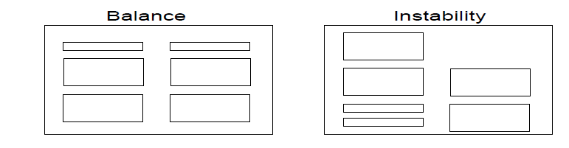**SYMMETRY:**

* Create symmetry by replicating elements left & right of the screen centre line. It is axial duplication. A unit on one side of the centre line is exactly replicated on the other side. This exact replication creates formal balance, but the difference is that balance can be achieved without symmetry. Symmetry’s opposite is asymmetry. Our eye tends to perceive something as more compressed or compact when it is symmetric. Asymmetric arrays are perceived as larger.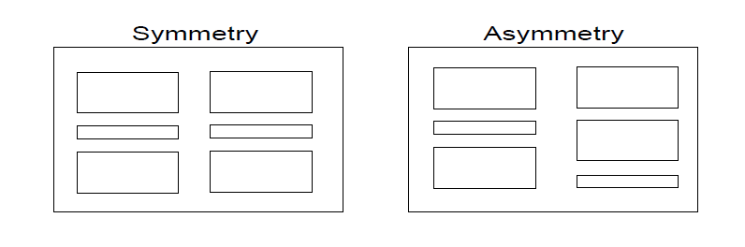

**REGULARITY:**

* Create regularity by establishing standard & consistently spaced horizontal and vertical alignment positions. Also, use similar element sizes, shapes, colours & spacing.It is uniformity of elements based on some principle or plan. Regularity in screen design is achieved by establishing standard & consistently spaced column & row starting points for screen elements.
* The opposite of regularity, irregularity, exists when no such plan or principle is apparent. A critical element on a screen will stand out better, however, if it is not regularized.

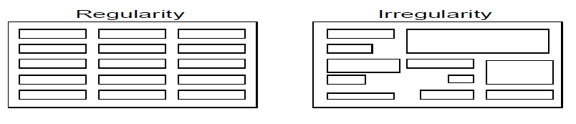

**PREDICTABILITY:**

* Create predictability by being consistent and following conventional orders or arrangements.It suggests a highly conventional order or plan. Viewing part of a screen enables one to predict how the rest of the screen will look.
* The opposite of predictability – spontaneity suggests no plan and thus an inability to predict the structure of the remainder of a screen or the structure of other screens. In screen design predictability is also enhanced through design consistency.

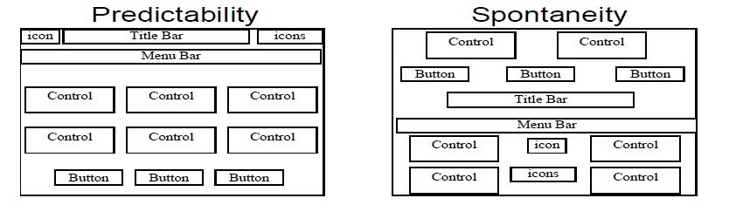

**SEQUENTIALITY:**

* Provide sequentially by arranging elements to guide the eye through the screen in an obvious, logical, rhythmic & efficient manner.The eyes tend to be attracted to:
  + A brighter element before one less bright.
  + Isolated elements before elements in a group.
  + An unusual shape before a usual one / Big objects before little objects. The opposite of sequentially is randomness, whereby an arrangement and flow cannot be detected.

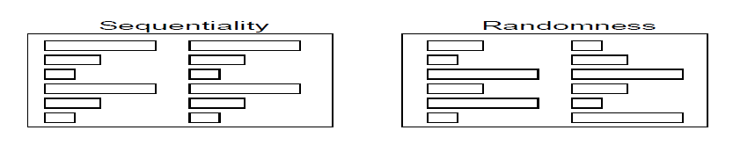

**ECONOMY:**

* Provide economy by using a few styles, display techniques & colours as possible.Economy is the frugal and judicious use of display elements to get the message across as simply as possible.
* The opposite is intricacy, the use of many elements just because they exist. The effect of intricacy is ornamentation which often detracts from clarity.

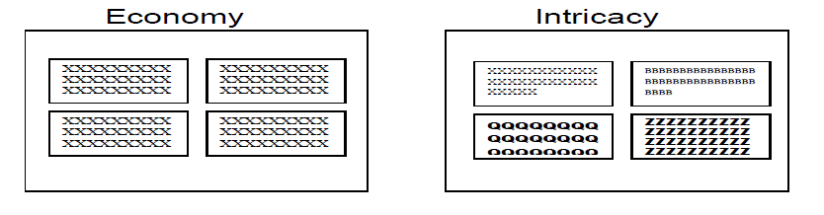

**UNITY:**

* Create unity by using similar sizes, shapes or colours for related information. Also, by leaving less space between elements of a screen than the space left in the margins.
* It is coherence, a totality of elements that is visually all one piece. With unity, the elements seem to belong together, to dovetail so completely that they are seeing as one thing. The opposite of unity is fragmentation, each piece retaining its own character.

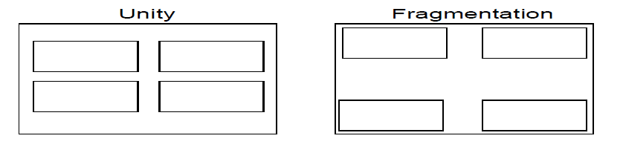

**PROPORTION:**

* Create windows & groupings of data & text with aesthetically pleasing proportions.
* Square (1:1): The simplest of proportions, it has an attention-getting quality and suggests stability and permanence. When rotated it becomes a dynamic diamond, expressing movement and tension.
* Square root of two (1:1.414): A divisible rectangle yielding two pleasing proportional shapes. When divided equally in two along its length, the two smaller shapes that result are also both square roots of two rectangles.
* Golden Rectangle (1:1.618): This “divine division of a line” results when a line is divided such that the smaller part is to the greater part as the greater part is to the whole. The golden rectangle also has another unique property.
* Square Root of three (1:1.732): Used less frequently than the other proportions, its narrowness gives it a distinctive shape.

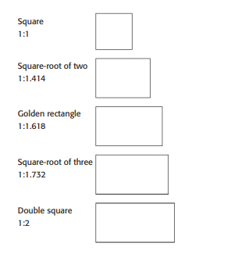

**SIMPLICITY (COMPLEXITY):**

* Optimize the number of elements on the screen, within limits of clarity.
* Minimize the alignment points, especially horizontal or columnar.

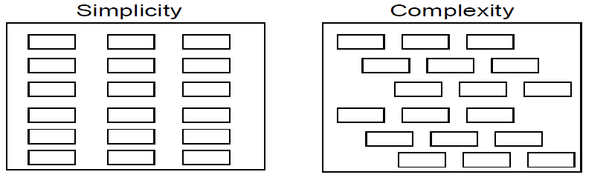

**GROUPINGS:**

* Provide functional groupings.
* Create spatial groupings.
* Provide meaningful titles for each grouping.
* Incorporate line borders.
* Create lines consistent in height & length.
* Use rules & borders sparingly.

**2A) Identify the characteristics and capabilities of the following device-based controls. 3M (CO3-L3) B) Light pen C) Touch screen**

* **Each one carries ONE mark**

**A) Joystick:** A touch-sensitive surface separate from the screen

**• Advantages**

– Direct relationship between hand and pointer movement in terms of direction and speed

– Does not obscure vision of screen

– Does not require additional desk space (if mounted on keyboard)

• **Disadvantage**

– Movement indirect, in plane different from screen

– Requires hand to be removed from keyboard keys

– Requires different hand movements

– May be difficult to control

– May be fatiguing to use over extended time

– May be slow and inaccurate

**B) Light pen**

• **Description**

– A special surface on a screen sensitive to the touch of a special stylus or pen

• **Advantage**

– Direct relationship between hand and pointer movement in terms of direction, distance, and speed – Movement is direct, in the same plane as screen

– Requires minimal additional desk space

– Stands up well in high-use environments

– More accurate than finger touching

**Disadvantage**

– Hand may obscure part of screen

– Requires picking it to use

– Requires moving the hand far from the keyboard to use

– Very fatiguing to use for extended period of time

**C) Touch screen**

**Touch Screen:** It allows direct control touches on the screen using a finger

**• Advantages**

– Direct relationship between hand and pointer movement in terms of direction and speed

– Movement is direct, in the same plane as screen

– Requires no additional desk space

• **Disadvantage**

–Finger may obscure part of screen

– Finger may be too large for accuracy with small objects

–Requires moving the hand far from the keyboard to use

– Very fatiguing to use for extended period of time

– May Damage the screen

**2B) Explain the uses of colours? 2M (CO3-L2)**

* **Any four or five Uses**
* Use colour to assist in formatting
* Relating elements into grouping
* Breaking apart separate groupings of information
* Highlighting or calling attention to important information
* Use colour as visual code to identify
* Screen captions and data
* Information from different sources
* Status of information
* Use colour to
* Realistically portray natural objects
* Increase screen appeal

**3A) Compare and Contrast Direct and Indirect control Pointing devices? 3M (CO2-L3)**

* **Direct and Indirect control Pointing devices -1M and examples-1M**

**Direct-control pointing devices**

• **Lightpen**

–enabled users to point to a spot on a screen and to perform a select, position, or other task

–it allows direct control by pointing to a spot on the display

–incorporates a button for the user to press when the cursor is resting on the desired spot on the screen

–lightpen has three disadvantages: users' hands obscured part of the screen, users had to remove their hands from the keyboard, and users had to pick up the lightpen

**• Touch screen**

* allows direct control touches on the screen using a finger
* early designs were rightly criticized for causing fatigue, hand obscuring-the-screen, hand- off-keyboard, imprecise pointing, and the eventual smudging of the display
* lift-off strategy enables users to point at a single pixel
* the users touch the surface
* then see a cursor that they can drag around on the display
* when the users are satisfied with the position, they lift their fingers off the display to activate
* can produce varied displays to suit the task
* are fabricated integrally with display surfaces

**Indirect pointing devices**

* + **Mouse** – the hand rests in a comfortable position, buttons on the mouse are easily pressed, even long motions can be rapid, and positioning can be precise
  + **trackball** – usually implemented as a rotating ball 1 to 6 inches in diameter that moves a cursor
  + **joystick** --for tracking purposes • graphics tablet – a touch-sensitive surface separate from the screen • touchpad – built-in near the keyboard offers the convenience and precision of a touchscreen while keeping the user's hand off the display surface

**3B) Explain Speech Generation? 2M (CO2-L2)**

Speech generation is a successful technology with widespread application in consumer products and on telephones.

When algorithms are used to generate the sound(synthesis), the intonation may sound robot-like and distracting. The quality of the sound can be improved when phonemes, words and phrases from digitized human speech can be smoothly integrated into meaningful sentences.

Text-to-speech utilities like the built-in Microsoft Windows Narrator can be used to read passages of text in web browsers and word processors.

* the messages are simple and short,
* deal with events in time,
* require an immediate response
* when user’s visual channels are overloaded
* They must be free to move around

When the environment is too brightly lit, too poorly lit, subject to severe vibration, or otherwise unsuitable for visual displays.