|  |  |  |  |  |  |
| --- | --- | --- | --- | --- | --- |
| **P.V.P Siddhartha Institute of Technology** | | | | | |
| **Department of Computer Science and Engineering** | | | | | |
| **Course: B.Tech** | **Year: IV** | **Semester: I** | **Sec:**  **1,2,3** | **Descriptive: I** | **A.Y:2024-25** |
| **Subject Code:**  **20CS4703C** | **Subject Name: User Interface Design** | | | | **Regulation: PVP20** |

**1A) Explain the general principles of user interface design? 3M (CO1-L2)**

* **Listing-1M**
* **Explanation-4M**

**General Principles:**

The design goals in creating a user interface are described below.

They are fundamental to the design and implementation of all effective interfaces, GUI and Web. These principles are general characteristics of the interface, and they apply to all aspects.

The compilation is presented alphabetically, and the ordering is not intended to imply degree of importance.

**Aesthetically Pleasing**:

* Provide visual appeal by following these presentation and graphic design principles:
* Provide meaningful contrast between screen elements.
* Create groupings.
* Align screen elements and groups.
* Provide three-dimensional representation.
* Use colour and graphics effectively and simply.

**Clarity:**

* The interface should be visually, conceptually, and linguistically clear, including Visual elements Functions
* Metaphors
* Words and Text

**Compatibility:**

* Provide compatibility with the following:
* The user
* The task and job
* The Product
* Adopt the User’s Perspective

**Configurability**

* Permit easy personalization, configuration, and reconfiguration of settings.
* Enhances a sense of control
* Encourages an active role in understanding

**Comprehensibility:**

* A system should be easily learned and understood:
* A user should know the following: What to look at What to do When to do it Where to do it Why to do it How to do it
* The flow of actions, responses, visual presentations, and information should be in a sensible order that is easy to recollect and place in context.

**Consistency:**

* A system should look, act, and operate the same throughout.
* Similar components should: Have a similar look.
* Have similar uses.
* Operate similarly.
* The same action should always yield the same result
* The function of elements should not change.
* The position of standard elements should not change.

**Control**:

* The user must control the interaction.
* Actions should result from explicit user requests.
* Actions should be performed quickly.
* Actions should be capable of interruption or termination.
* The user should never be interrupted for errors
* The context maintained must be from the perspective of the user.
* The means to achieve goals should be flexible and compatible with the user's skills, experiences, habits, and preferences

**Directness:**

* Provide direct ways to accomplish tasks.
* Available alternatives should be visible.
* The effect of actions on objects should be visible

**Flexibility:**

* A system must be sensitive to the differing needs of its users, enabling a level and type of performance based upon: Each user's knowledge and skills.
* Each user's experience.
* Each user's personal preference.
* Each user's habits.
* The conditions at that moment

**Efficiency:**

* Minimize eye and hand movements, and other control actions.
* Transitions between various system controls should flow easily and freely.
* Navigation paths should be as short as possible.
* Eye movement through a screen should be obvious and sequential.
* Anticipate the user's wants and needs whenever possible.

**Familiarity:**

* Employ familiar concepts and use a language that is familiar to the user.
* Keep the interface natural, mimicking the user's behavior patterns.
* Use real-world metaphors.

**Forgiveness**:

* Tolerate and forgive common and unavoidable human errors.
* Prevent errors from occurring whenever possible.
* Protect against possible catastrophic errors.
* When an error does occur, provide constructive messages.

**Predictability:**

* The user should be able to anticipate the natural progression of each task. Provide distinct and recognizable screen elements.
* Provide clues to the result of an action to be performed.
* All expectations should be fulfilled uniformly and completely.

**Recovery:**

A system should permit: Commands or actions to be abolished or reversed. Immediate return to a certain point if difficulties arise. Ensure that users never lose their work as a result of: An error on their part. Hardware, software, or communication problems

**Responsiveness**:

* The system must rapidly respond to the user's requests.
* Provide immediate acknowledgment for all user actions:
* Visual.
* Textual Auditory.

**Transparency**:

* Permit the user to focus on the task or job, without concern for the mechanics of the interface.
* Workings and reminders of workings inside the computer should be invisible to the user.

**Simplicity:**

* Provide as simple an interface as possible. Five ways to provide simplicity:
* Use progressive disclosure, hiding things until they are needed Present common and necessary functions first prominently feature important functions Hide more sophisticated and less frequently used functions.
* Provide defaults.

**1B) Illustrate the History of Screen design? 2M (CO1-L2)**

* **Explanation with Diagrams-2M**

While developers have been designing screens since a cathode ray tube display was first attached to a computer, more widespread interest in the application of good design principles to screens did not begin to emerge until the early 1970s, when IBM introduced its 3270 cathode ray tube text-based terminal.

A 1970s screen often resembled the one pictured in. It usually consisted of many fields (more than are illustrated here) with very cryptic and often unintelligible captions.

It was visually cluttered, and often possessed a command field that challenged the user to remember what had to be keyed into it.

Ambiguous messages often required referral to a manual to interpret. Effectively using this kind of screen required a great deal of practice and patience.

Most early screens were mono-chromatic, typically presenting green text on black backgrounds.

User memory was supported by providing clear and meaningful field captions and by listing commands on the screen, and enabling them to be applied through function keys. Messages also became clearer.

These screens were not entirely clutter-free, however. Instructions and reminders to the user had to be inscribed on the screen in the form of prompts or completion aids.

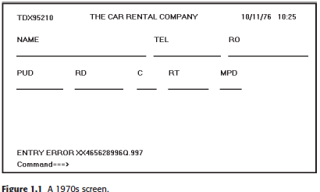

In the 1980s, 1970s-type screens were still being designed, and many still reside in systems today.

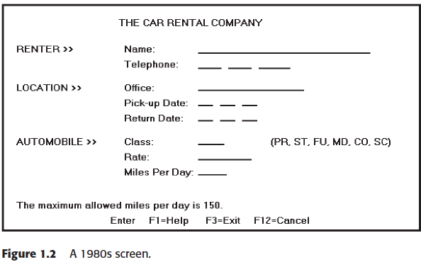

Multiple properties of elements were also provided, including many different font sizes and styles, line thicknesses, and colors. The entry field was supplemented by a multitude of other kinds of controls, including list boxes, drop-down combination boxes, spin boxes, and so forth. These new controls were much more effective in supporting a person’s memory, now simply allowing for selection from a list instead of requiring a remembered key entry.

Completion aids disappeared from screens, replaced by one of the new listing controls. Screens could also be simplified, the much more powerful computers being able to quickly present a new screen. In the 1990s, our knowledge concerning what makes effective screen design continued

to expand

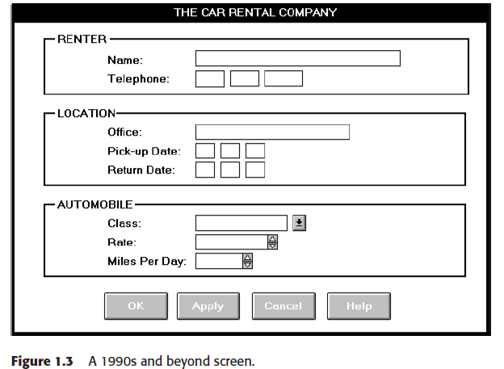

**2) Identify the important Human Characteristics which have influence on interface and screen design 5M (CO4-L3)**

* **Listing-1M**
* **Explanation-4M**

**Importance of human characteristics**

Importance in design is

* perception,
* memory,
* visual acuity,
* foveal and peripheral vision,
* sensory storage,
* information processing,
* learning, skill, and
* Individual differences.

**Perception**

* Proximity
* Similarity
* Matching patterns
* Succinctness
* Closure
* Unity
* Continuity
* Balance
* Expectancies
* Context

**Memory:**

Memory is not the most stable of human attributes, as anyone who has forgotten why they walked into a room, or forgotten a very important birthday, can attest.

* Short-term, or working, memory.
* Long-term memory
* Mighty memory
* Sensory Storage

**Mental Models**:

* As a result of our experiences and culture, we develop mental models of things and people we interact with.
* A mental model is simply an internal representation of a person's current understanding of something. Usually a person cannot describe this mental mode and most often is unaware it even exists. Mental models are gradually developed in order to understand something, explain things, make decisions, do something, or interact with another person.
* Mental models also enable a person to predict the actions necessary to do things if the action has been forgotten or has not yet been encountered.

**Movement Control** :

Once data has been perceived and an appropriate action decided upon, a response must be made; in many cases the response is a movement. In computer systems, movements include such activities as pressing keyboard keys, moving the screen pointer by pushing a mouse or rotating a trackball, or clicking a mouse button

The implications in screen design are: – Provide large objects for important functions. – Take advantage of the "pinning" actions of the sides, top, bottom, and corners of the screen.

**Learning:**

Learning, as has been said, is the process of encoding in long-term memory information that is contained in short-term memory. It is a complex process requiring some effort on our part. Our ability to learn is important-it clearly differentiates people from machines. Given enough time people can improve the performance in almost any task. Too often, however, designers use our learning ability as an excuse to justify complex design. A design developed to minimize human learning time can greatly accelerate human performance. People prefer to stick with what they know, and they prefer to jump in and get started. Unproductive time spent learning is something frequently avoided.

**Skill:**

* The goal of human performance is to perform skillfully. To do so requires linking in-puts and responses into a sequence of action. The essence of skill is performance of actions or movements in the correct time sequence with adequate precision. It is characterized by consistency and economy of effort. Economy of effort is achieved by establishing a work pace that represents optimum efficiency.
* It is accomplished by in-creasing mastery of the system through such things as progressive learning of short-cuts, increased speed, and easier access to information or data. Skills are hierarchical in nature, and many basic skills may be integrated to form increasingly complex ones. Lower-order skills tend to become routine and may drop out of consciousness.
* System and screen design must permit development of increasingly skillful performance.

**Individual Differences**:

In reality, there is no average user. A complicating but very advantageous human characteristic is that we all differ-in looks, feelings, motor abilities, intellectual abilities, learning abilities and speed, and so on. In a keyboard data entry task.

For example, the best typists will probably be twice as fast as the poorest and make 10 times fewer errors.

**3A) Identify the role of screen navigation and flow in screen design? 3M (CO3-L3)**

* **Role of Screen Navigation with assist in navigation through screems-3M**
* Provide an ordering of screen information and elements that:
* Is rhythmic guiding a person’s eye through display encourages natural movement sequences.
* Minimizes pointer and eye movement distances.
* Locate the most important and most frequently used elements or controls at top left. Maintain top to bottom, left to right flow.

Assist in navigation through a screen by

* Aligning elements
* Grouping elements
* Use of line borders

Through focus and emphasis, sequentially, direct attention to items that are

1. Critical

2. Important

3. Secondary

4. Peripheral

Tab through window in logical order of displayed information.

* locate command button at the end of the tabbing order sequence, when groups of related information must be broken and displayed on separate screens, provide breaks at logical or natural points in the information flow.
* In establishing eye movement through a screen, also consider that the eye trends to move sequentially, for example – From dark areas to light areas from big objects to little objects from unusual shapes to common shapes.
* From highly saturated colours to unsaturated colours. These techniques can be initially used to focus a person’s attention to one area of the screen and then direct it elsewhere.
* Maintain top to bottom, left to right through the screen. This top to bottom orientation is recommended for information entry for the following reasons – Eye movements between items will be shorter. Control movements between items will be shorter.
* Groupings are more obvious perceptually. When one’s eyes move away from the screen and then back, it returns to about same place it left, even if it is seeking next item in sequence.
* Most product style guides recommend a left to right orientation. Our earliest display screens reflected this left to right entry orientation.
* Top to bottom orientation is also recommended for presenting displays of read only information that must be scanned.

**3B) Classify the Ordering of screen data and content in Design? 2M (CO3-L4)**

**Ordering of screen data and content in Design-2M**

**Ordering of screen data and content**

* Divide information into units that are logical, meaningful and sensible.
* Organize by interrelationships between data or information.
* Provide an ordering of screen units of elements depending on priority.
* Possible ordering schemes include
* Conventional
* Sequence of use
* Frequency of use
* Function
* Importance
* General to specific
* Form groups that cover all possibilities.
* Ensure that information is visible.
* Ensure that only information relative to task is presented on screen.
* Organizational scheme is to minimize number of information variables

**Upper -Left Starting Point**

Provide an obvious starting point in the screen’s upper left corner. Eyeball fixation studies indicate that in looking at displays of information, usually one’s eyes move first to the upper-left centre of the display, and then quickly move through the display in a clockwise direction.

Streveler and Wasserman (1984) found that visual targets located in the upper-left quadrant of a screen were found fastest and those located in the lower-right quadrant took longest to find. Provide an obvious starting point in the upper-left corner of the screen.

This is near the location where visual scanning begins and will permit a left-to-right, top-to-bottom reading of information or text as is common in Western cultures.