PRASAD V. POTLURI SIDDHARTHA INSTITUTE OF TECHNOLOGY,
KANURU, VIJAYAWADA
DEPARTMENT OF COMPUTER SCIENCE & ENGINEERING
INNOVATIVE TEACHING METHODOLOGY
Academic Year: 2024-25
Teaching Methodology - JAM (Just a Minute)
Class: II B.TECH
Semester: I-Semester
Section: S1
Name of the Course: Universal Human Values
Name of the Faculty: A.Divya
---------------------------------------------------------------------------------------------------------------
Number of Students Involved: 72
List of the Topics:
1) Students sharing about oneself
2) How to explore the differences of Needs of Self and Body

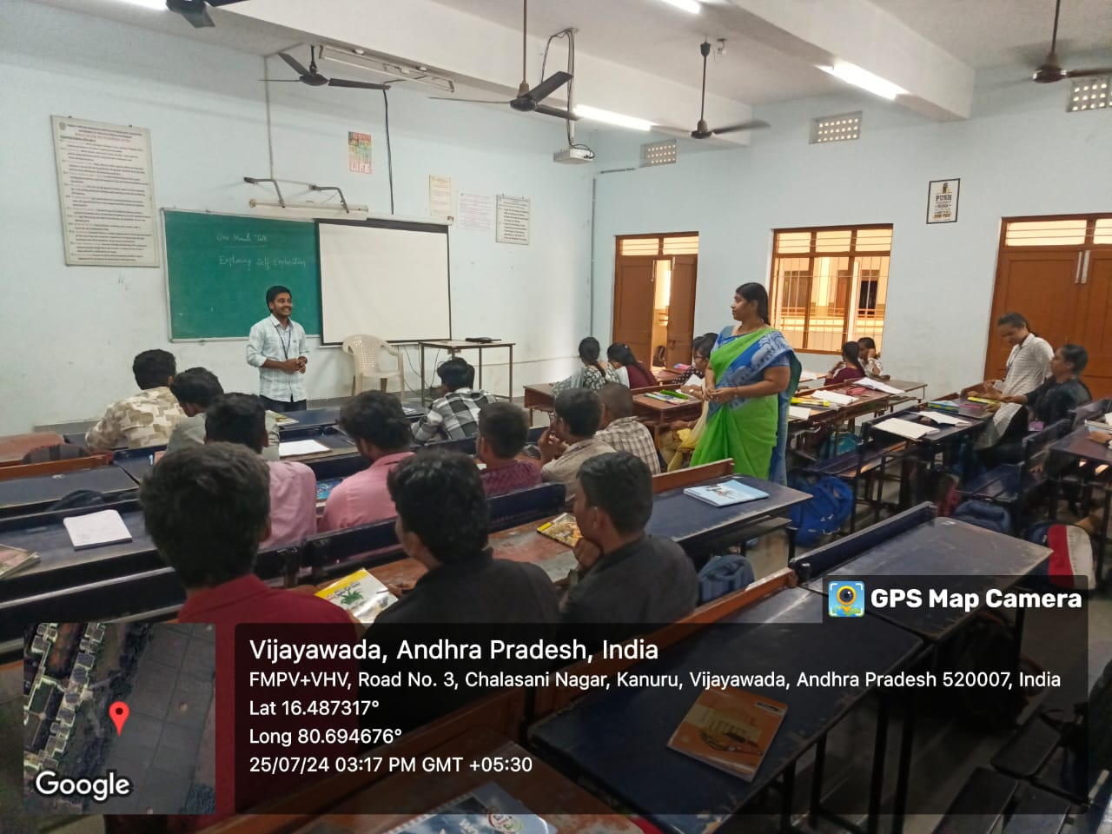
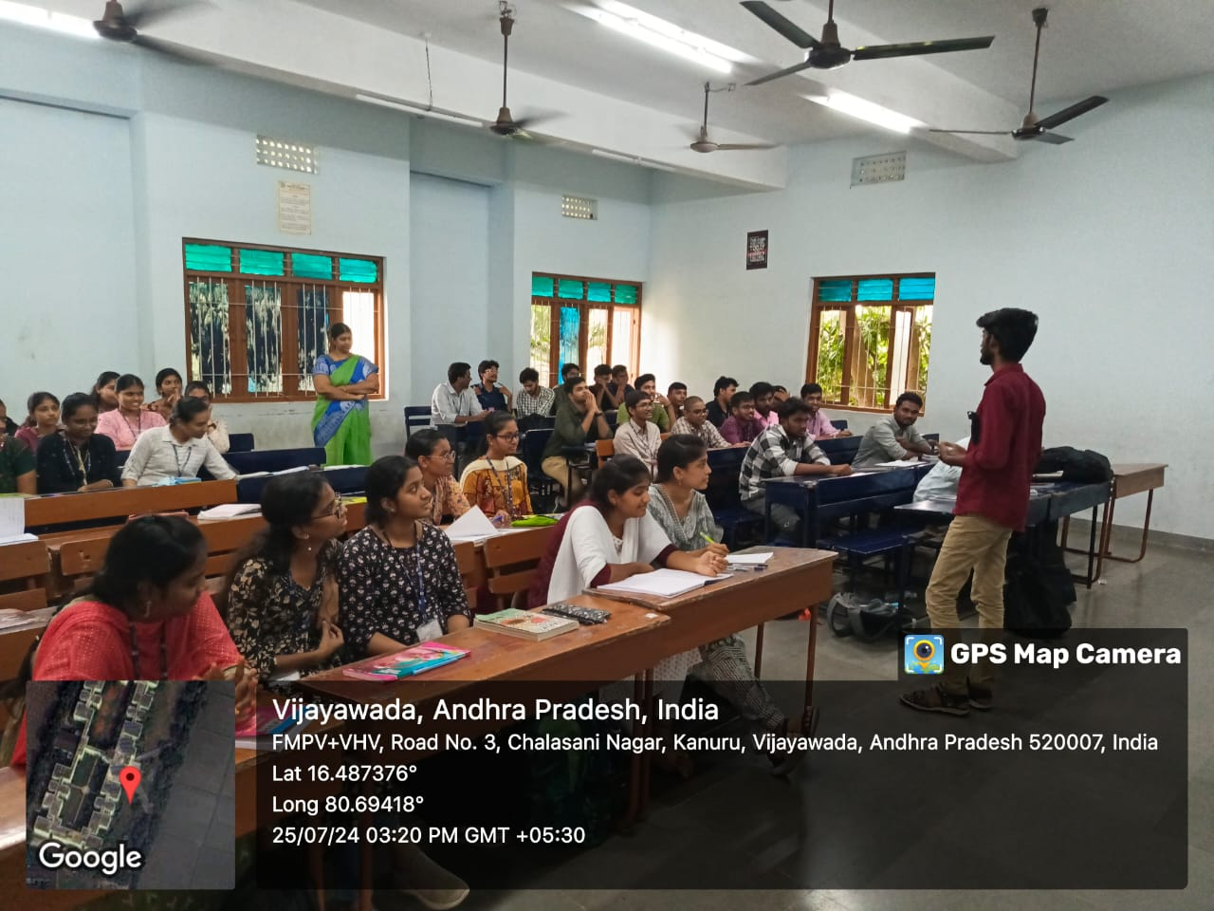
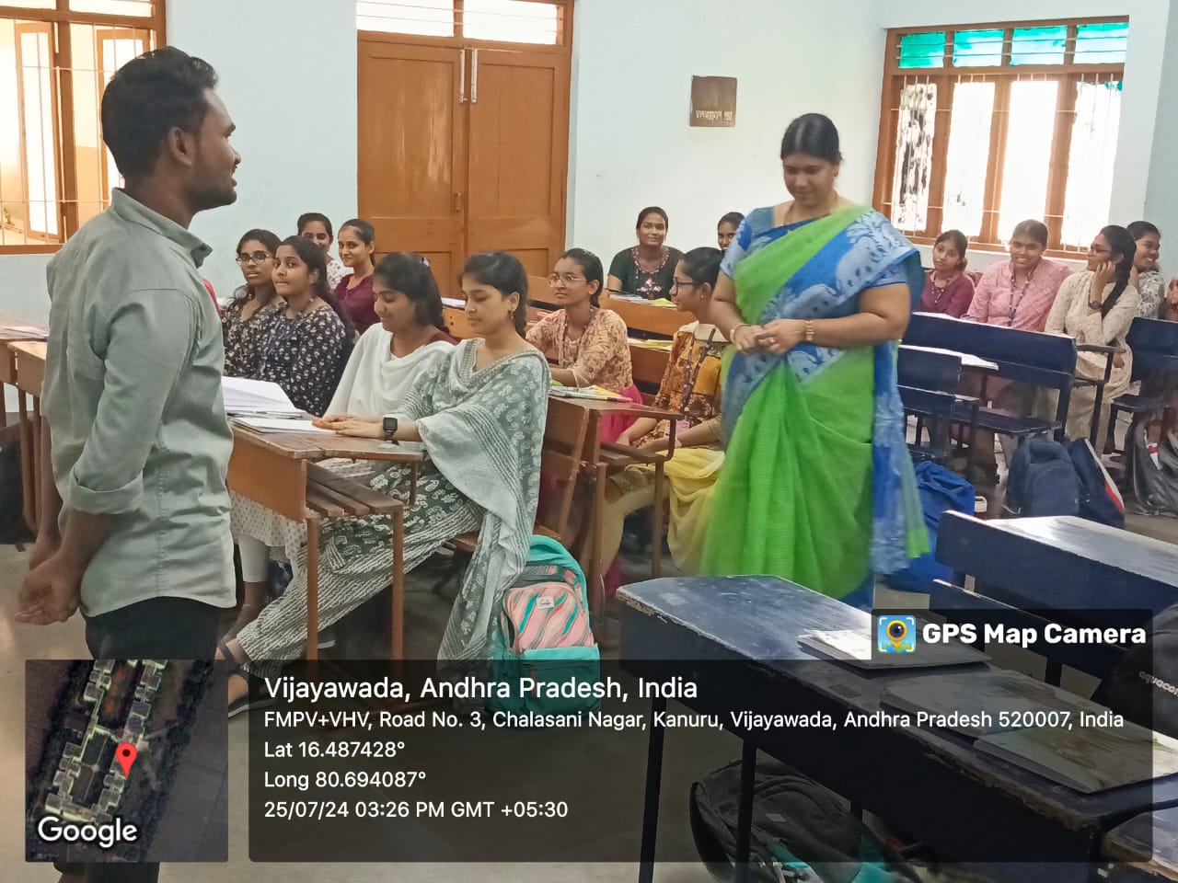
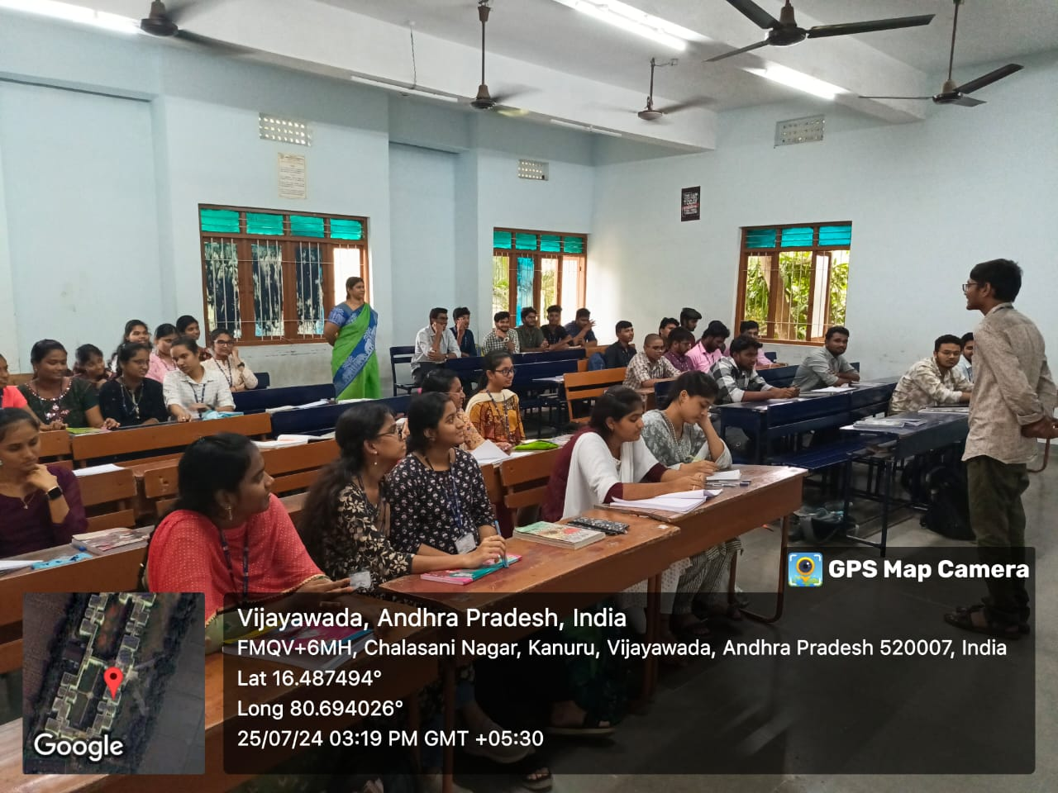

Signature of the Faculty

PRASAD V. POTLURI SIDDHARTHA INSTITUTE OF TECHNOLOGY,
KANURU, VIJAYAWADA
DEPARTMENT OF COMPUTER SCIENCE & ENGINEERING
INNOVATIVE TEACHING METHODOLOGY
Academic Year: 2024-25
Teaching Methodology – Group Discussion
Class: II B.TECH
Semester: I-Semester
Section: S1
Name of the Course: Universal Human Values
Name of the Faculty: A.Divya
---------------------------------------------------------------------------------------------------------------
Number of Students Involved: 72
List of the Topics:
1) Exploring Human Consciousness
2) Exploring Natural Acceptance
3) Exploring Harmony of self with the body

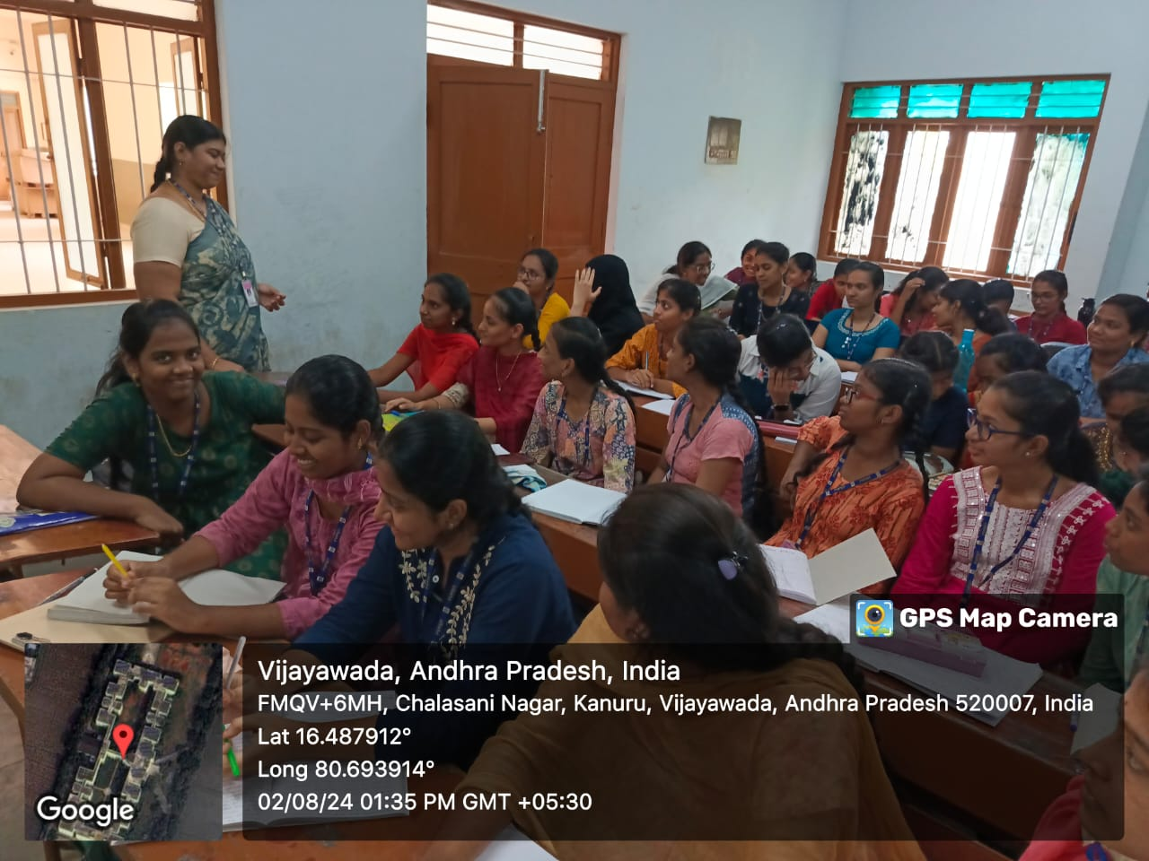

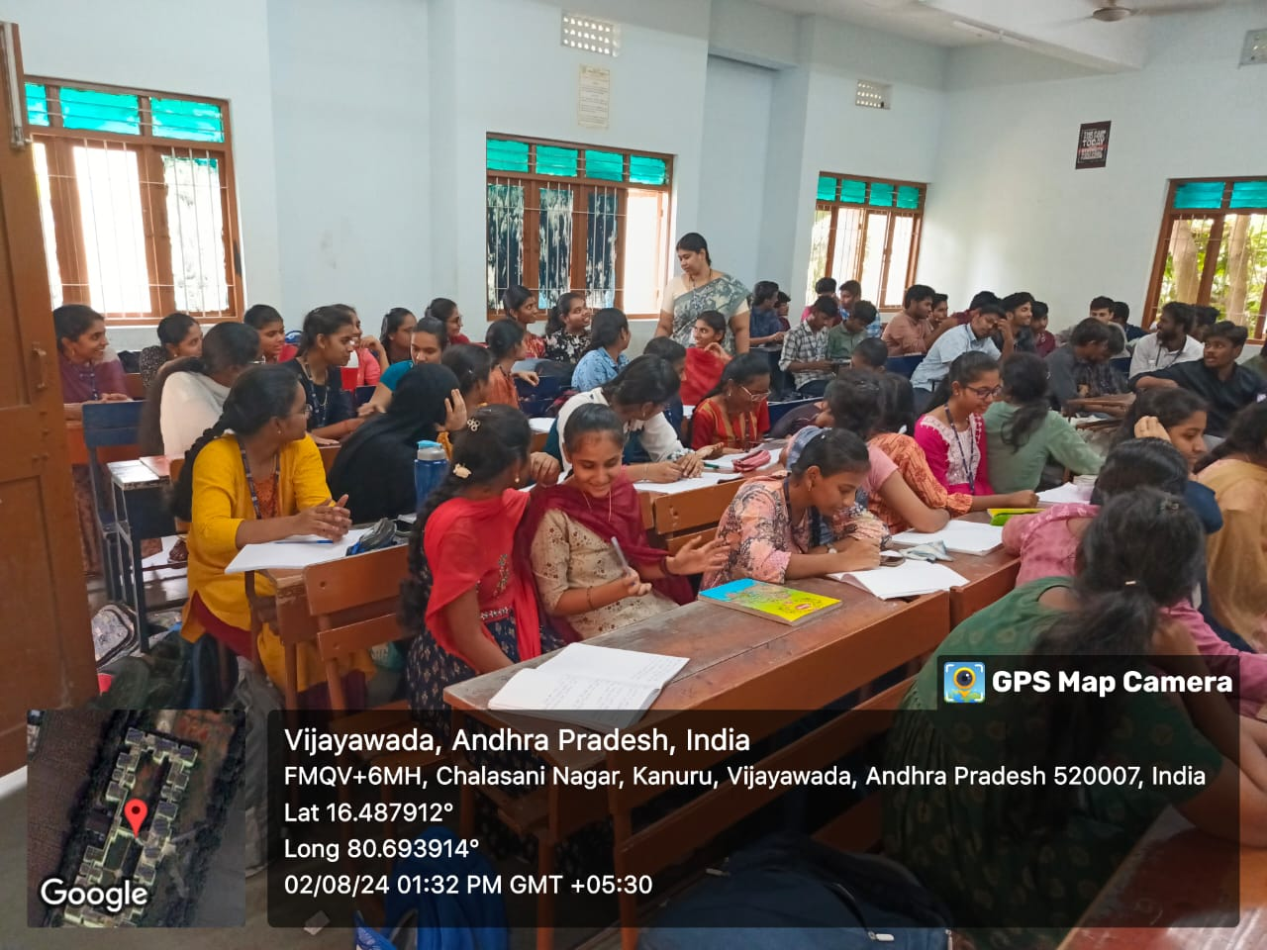

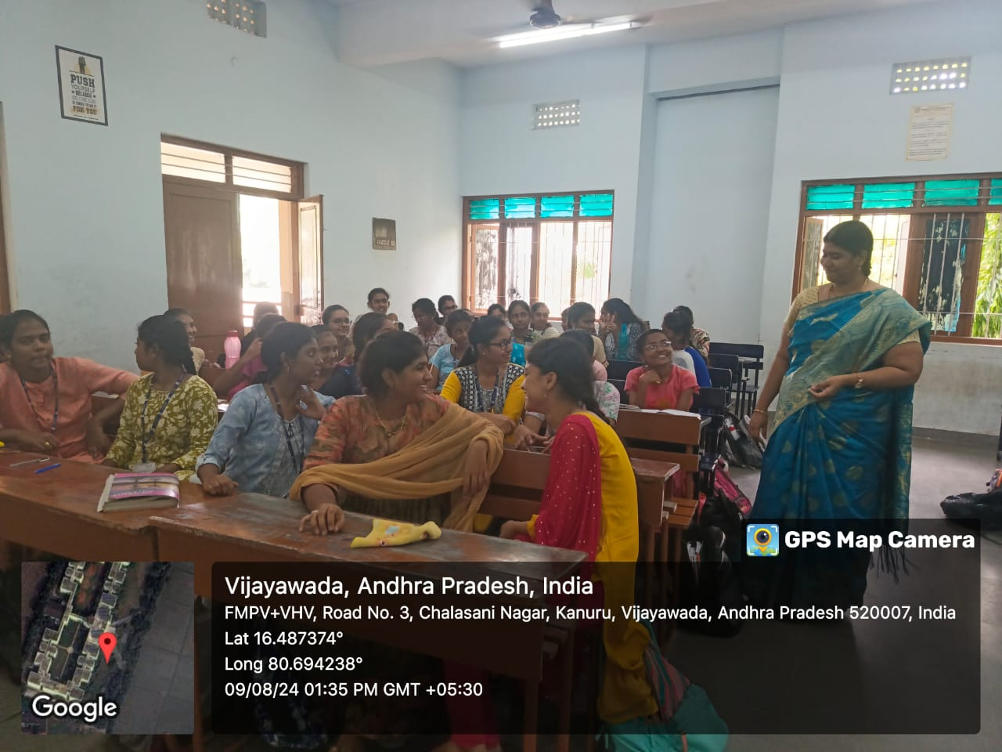
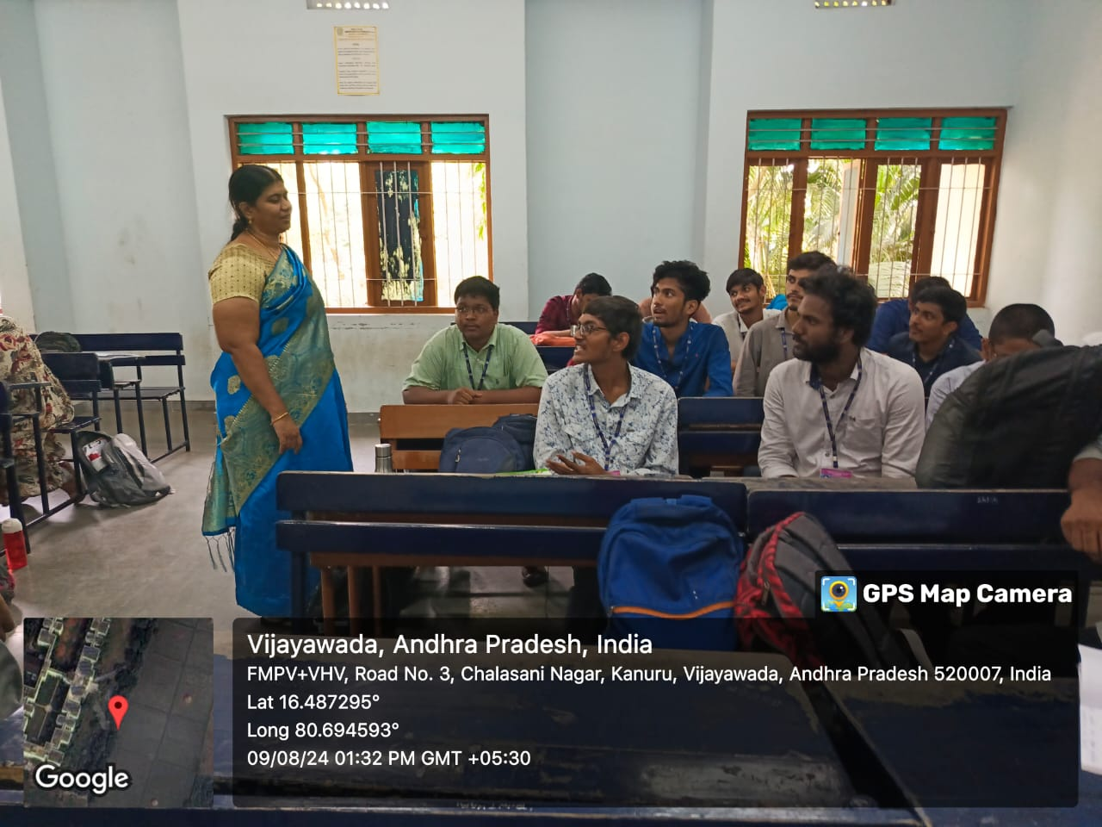

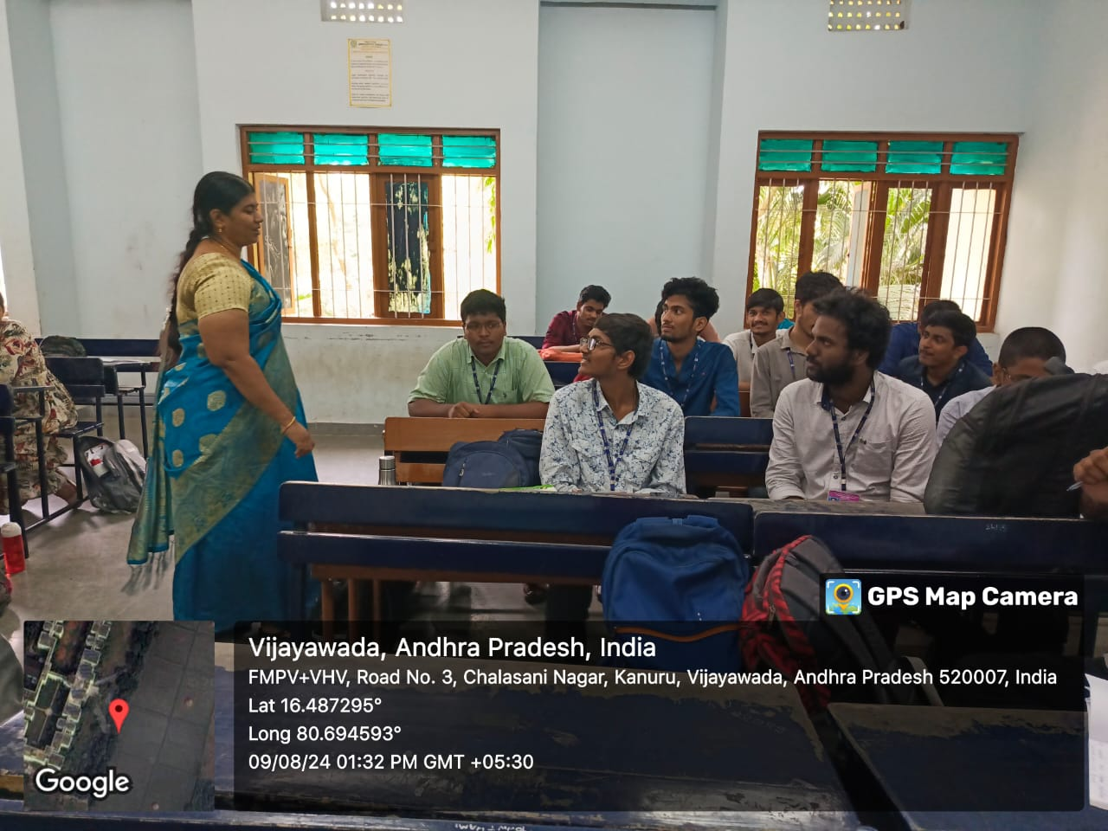

Signature of the Faculty

PRASAD V. POTLURI SIDDHARTHA INSTITUTE OF TECHNOLOGY,
KANURU, VIJAYAWADA
DEPARTMENT OF COMPUTER SCIENCE & ENGINEERING
INNOVATIVE TEACHING METHODOLOGY
Academic Year: 2024-25
Teaching Methodology – Flip Class
Class: II B.TECH
Semester: I-Semester
Section: S1
Name of the Course: Universal Human Values
Name of the Faculty: A.Divya
---------------------------------------------------------------------------------------------------------------
Number of Students Involved: 72
List of the Topics:
1) Exploring Sources of Imagination in the self.
2) Exploring the feeling of Trust.
3) Exploring the Respect –as the Right Evaluation

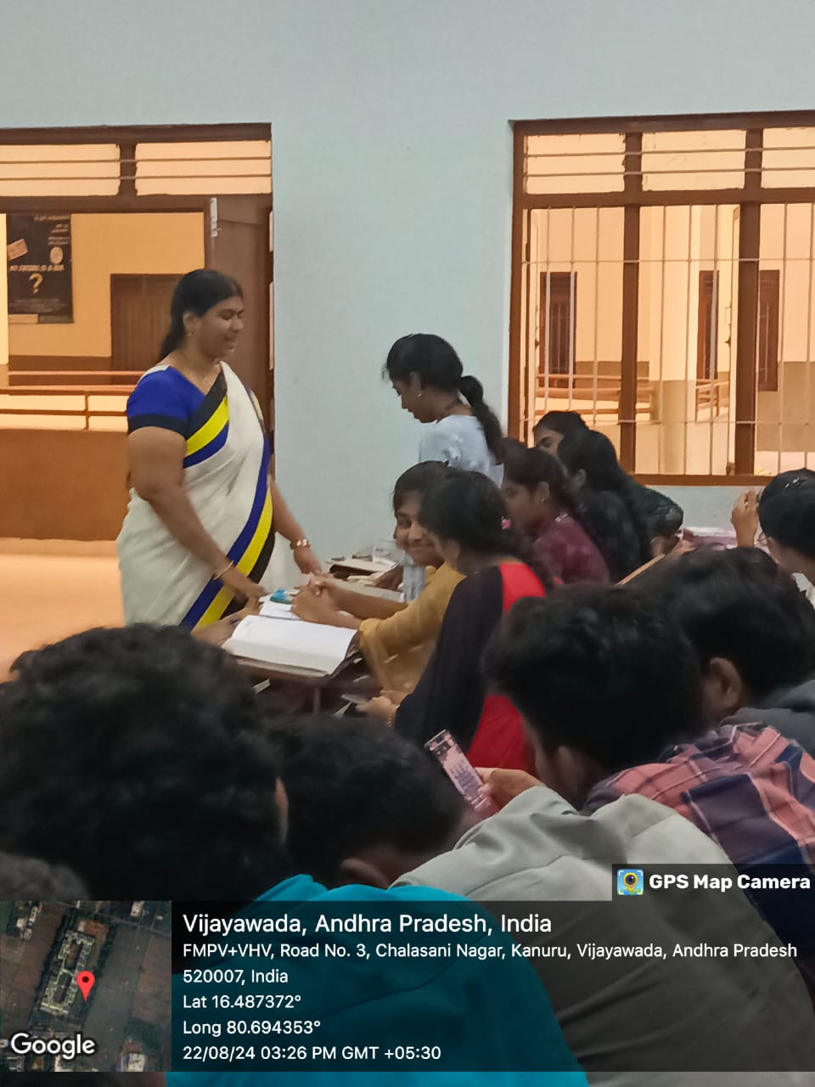
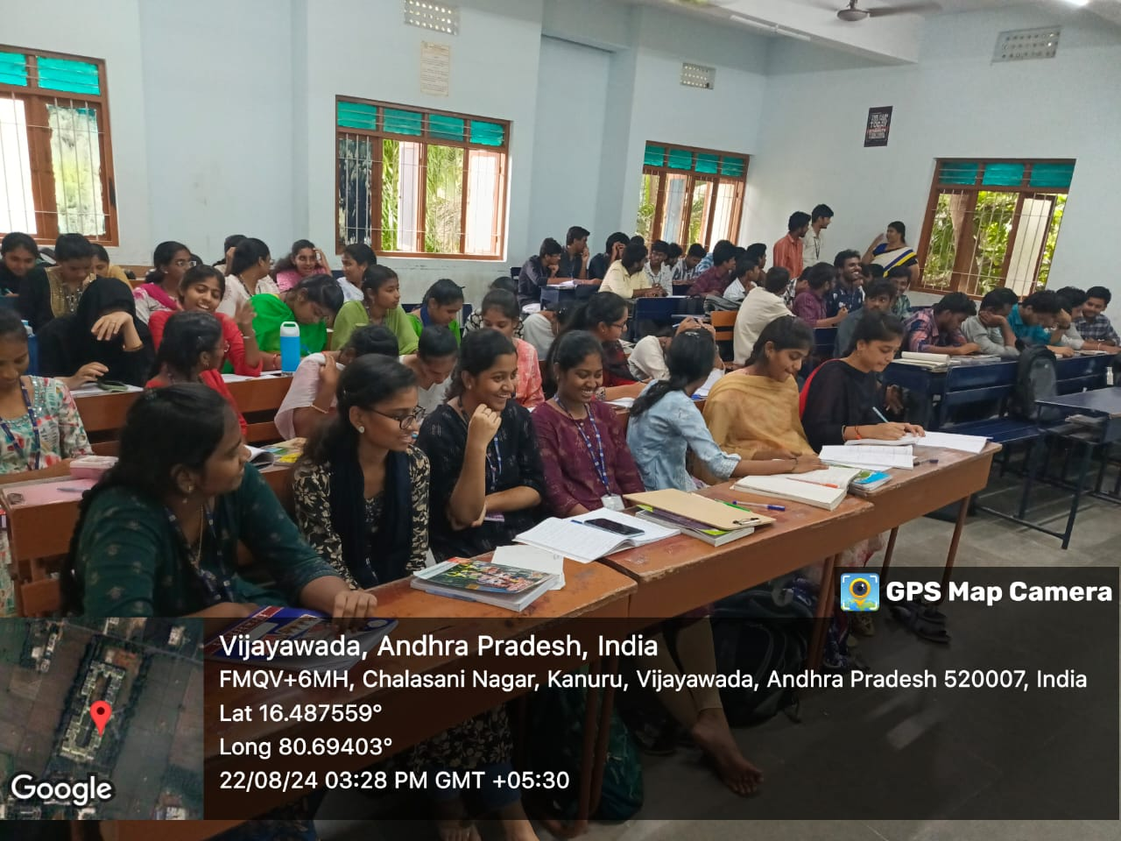
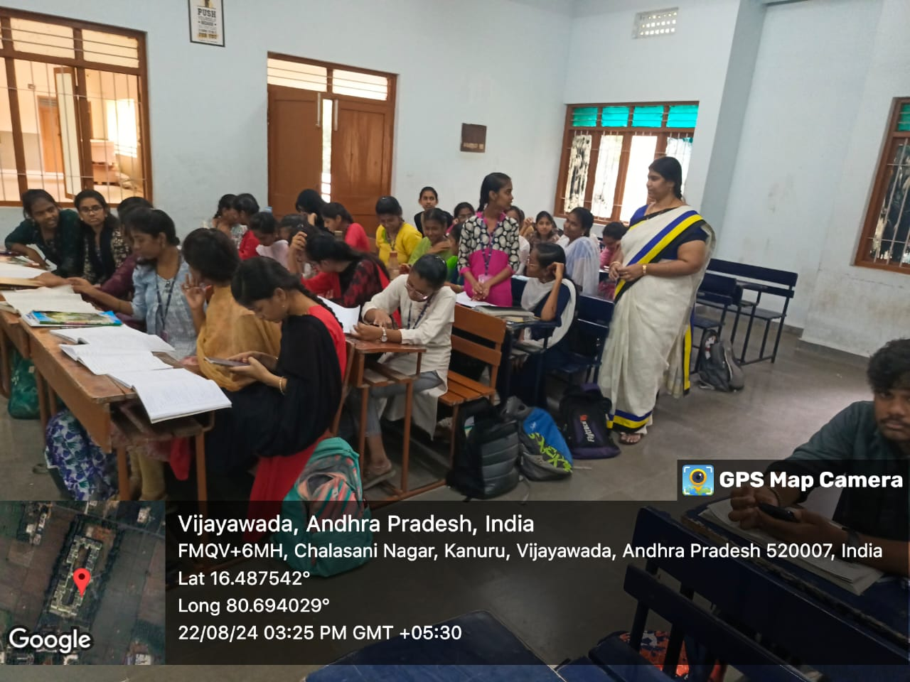
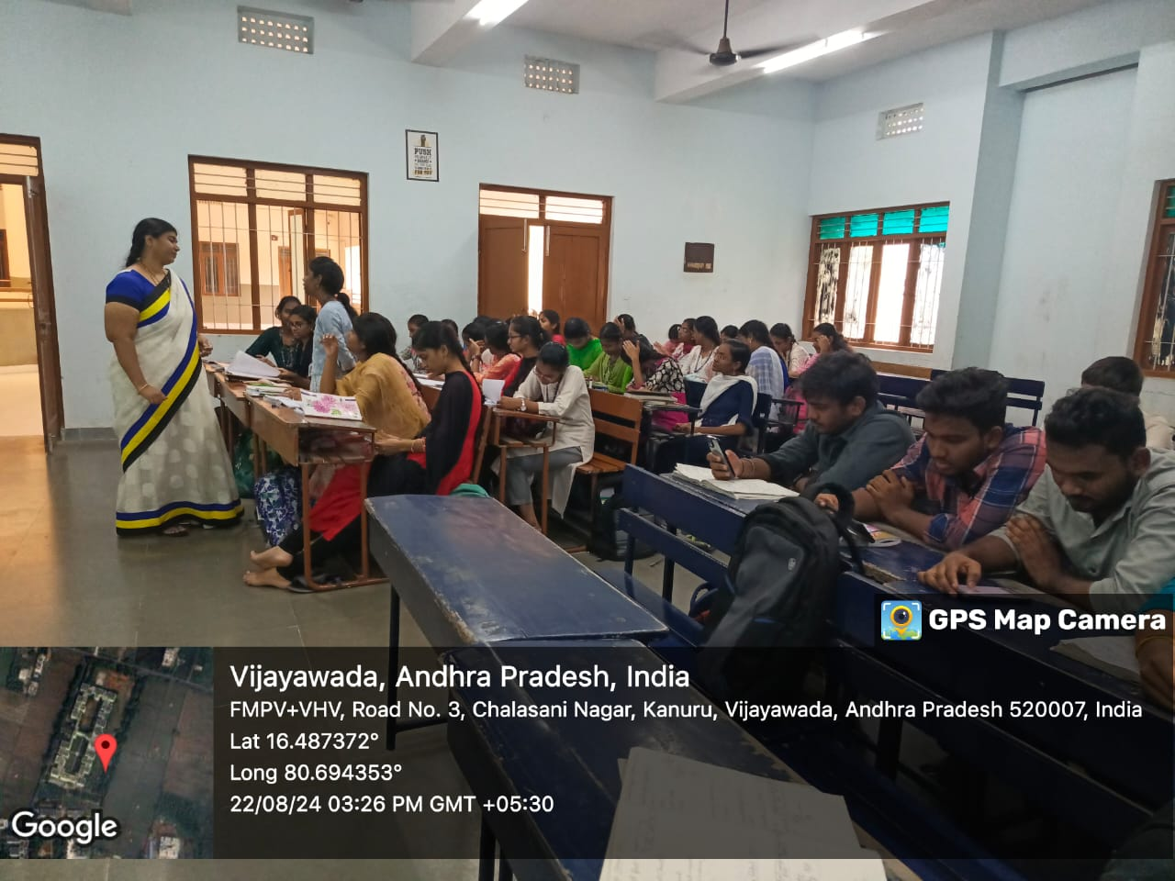

Signature of the Faculty

