What is a Regular Expression?

A Regular Expression (RegEx) is a sequence of characters that defines a search pattern. It is used for matching, searching, and manipulating strings based on specific patterns in text. In Python, regular expressions are implemented using the `re` module.

Regular expressions are powerful tools for string operations such as:
- Searching for substrings
- Finding and replacing text
- Validating formats (e.g., email addresses, phone numbers)
- Extracting information from text

Basics of Regular Expressions in Python
1. Importing the `re` Module
The `re` module in Python provides functions to work with regular expressions.

import re

2. Basic Regular Expression Functions
- `re.search()` : Searches for the first occurrence of the pattern.
- `re.match()` : Checks for a match only at the beginning of the string.
- `re.findall()` : Finds all matches of the pattern in the string.
- `re.sub()` : Replaces all matches of the pattern with another string.

Example usage:
import re

# Searching for a pattern in a string
pattern = r'\d+'
r'\d+': The r means it is a raw string, and \d+ is treated as a literal pattern, where \d matches any digit, and + means one or more digits.
string= "The year is 2023."
result = re.search(pattern, string)
print(result.group()) # Output: 2023

3. Basic Regular Expression Patterns
3.1 Metacharacters :
Special characters that define patterns.

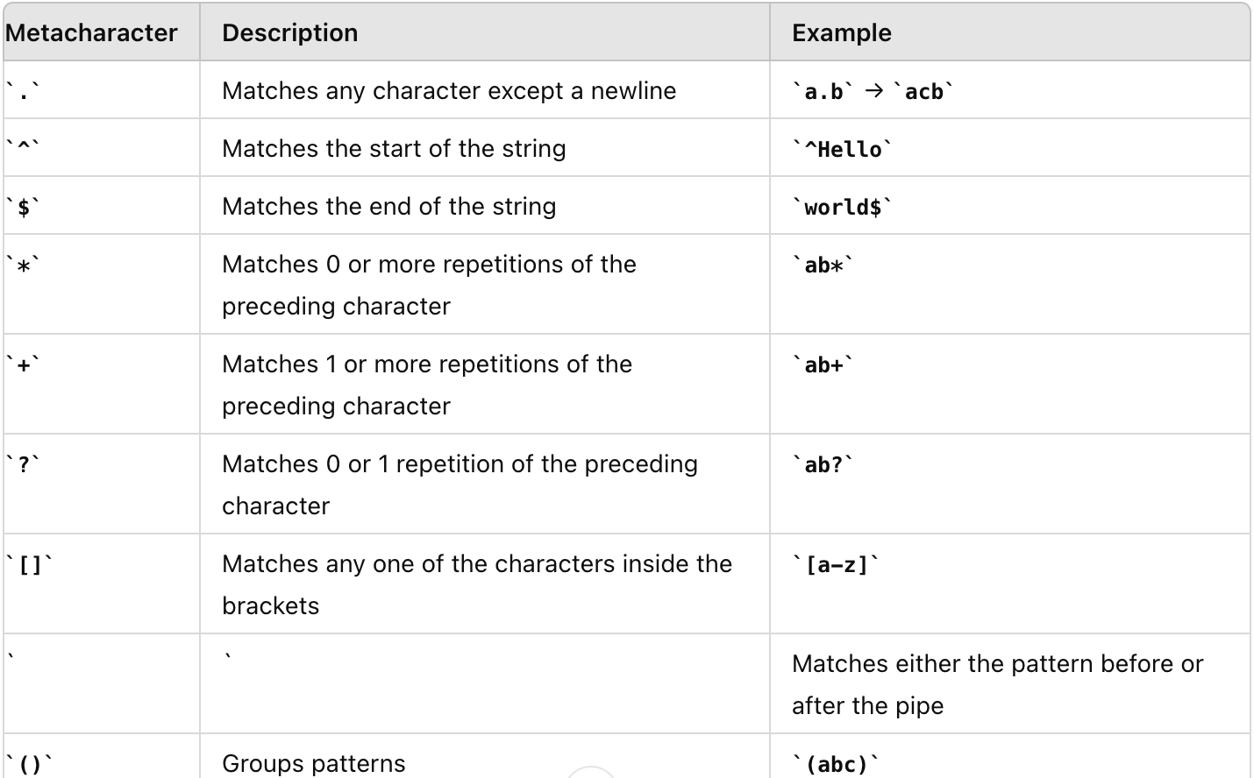

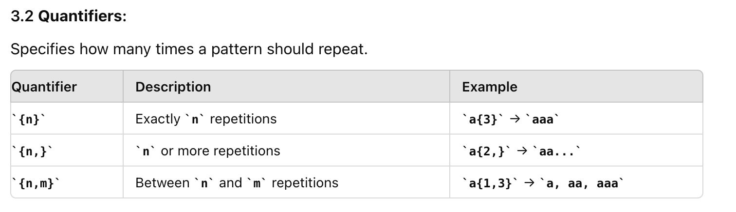

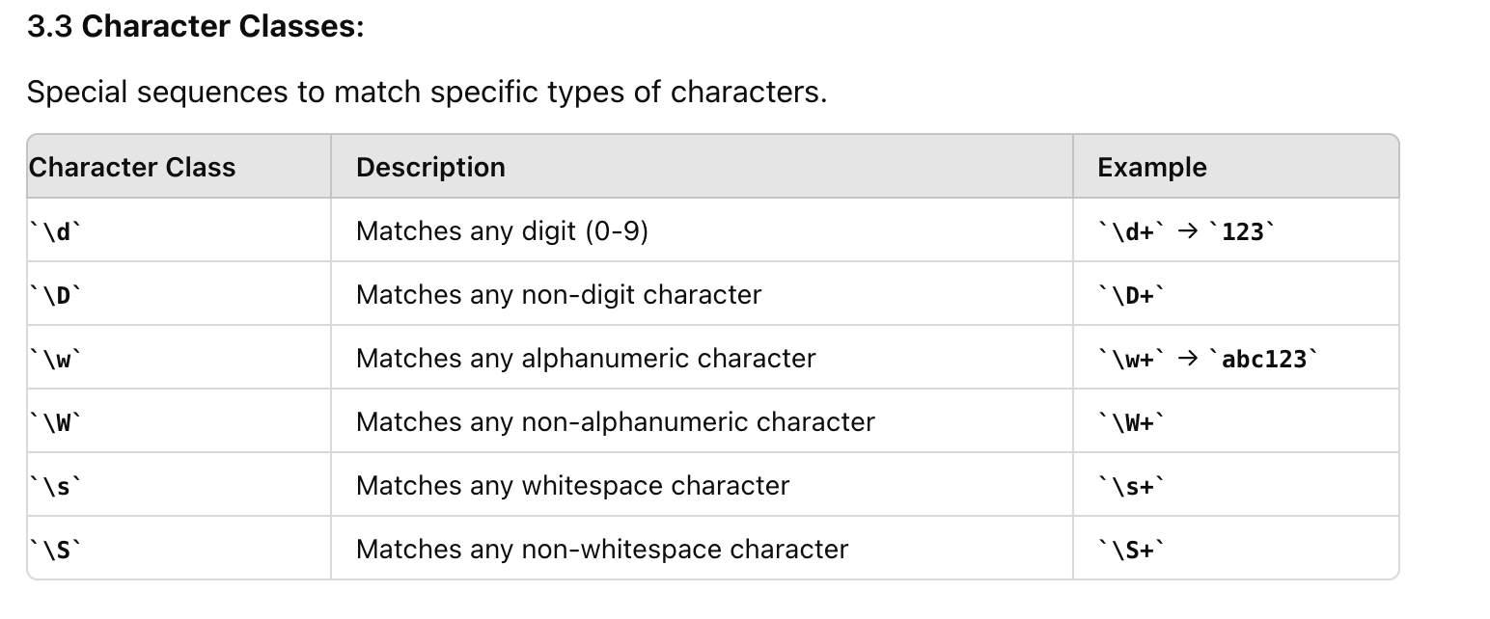

4. Examples of Regular Expressions

1. Matching a Phone Number (Format: `123-456-7890`) :
phone_pattern = r'\d{3}-\d{3}-\d{4}'
text = "Contact us at 123-456-7890."
result = re.search(phone_pattern, text)
print(result.group()) # Output: 123-456-7890

2. Extracting Email Addresses :

email_pattern = r'[a-zA-Z0-9._%+-]+@[a-zA-Z0-9.-]+\.[a-zA-Z]{2,}'
text = "Send an email to example@example.com."
emails = re.findall(email_pattern, text)
print(emails) # Output: ['example@example.com']

3. Replacing Text :
text = "The sky is blue."
result = re.sub(r'blue', 'clear', text)
print(result) # Output: The sky is clear.

4. Escaping Special Characters
If you need to match special characters like `.` or `?`, you should escape them using a backslash (`\`).

text = "Price is 12.99 USD."
result = re.search(r'\d+\.\d+', text)
print(result.group()) # Output: 12.99

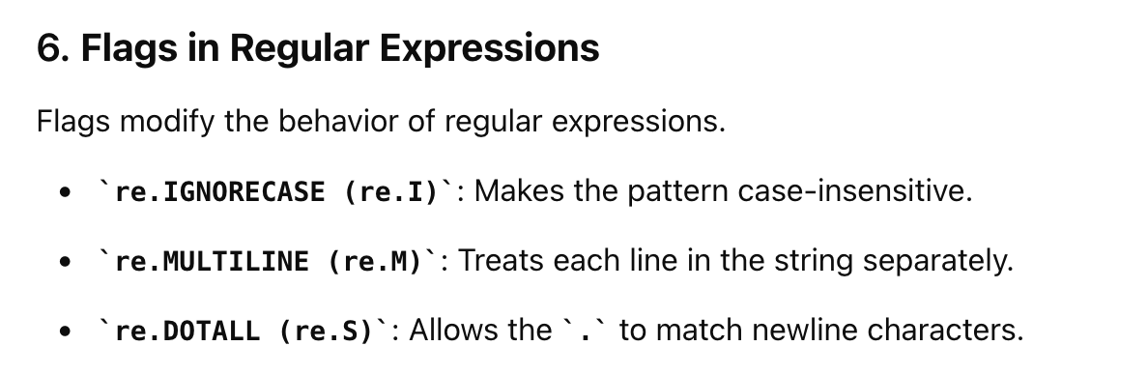

text = "Hello World\nHELLO WORLD"
pattern = r'hello'
result = re.findall(pattern, text, re.IGNORECASE)
print(result) # Output: ['Hello', 'HELLO']

