Function Definition and Invocation in Python
Functions in Python are blocks of reusable code that perform a specific task. They help to organize code, avoid repetition, and make the code more modular and easier to understand.
1. Defining Functions
To define a function in Python, you use the def keyword, followed by the function name, parentheses (), and a colon :. Inside the parentheses, you can specify parameters (inputs to the function). The body of the function is indented and contains the statements that define what the function does.
Syntax: 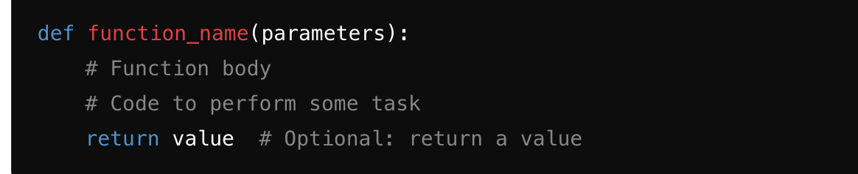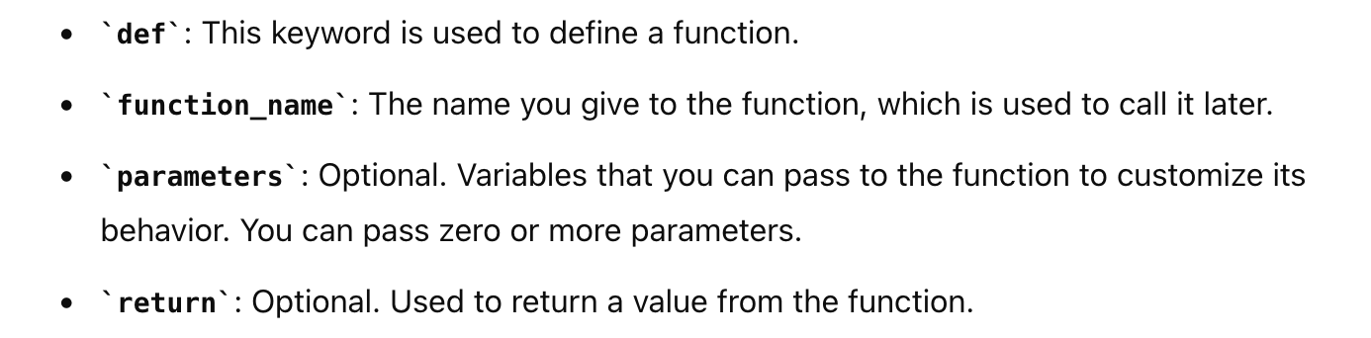
Example:
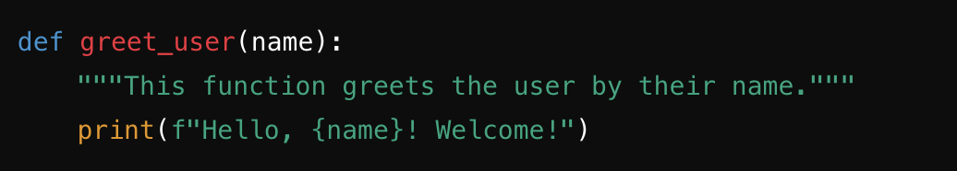
2. Function Invocation (Calling a Function)
Once a function is defined, you can call it by using its name followed by parentheses. If the function expects parameters, you need to pass the arguments inside the parentheses.
Syntax: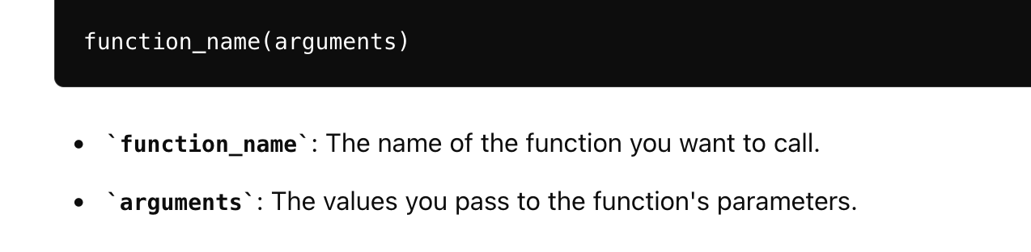

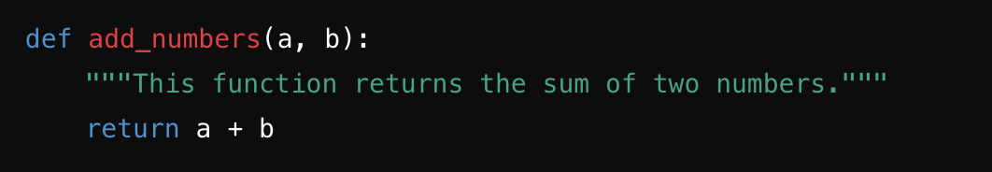
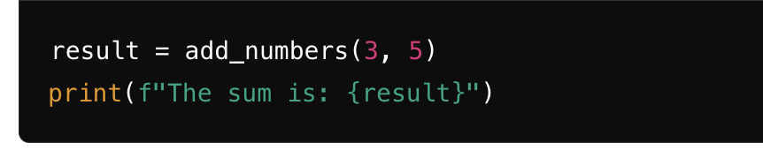Function Parameters and Arguments in Python

Understanding function parameters and arguments is crucial for writing flexible and reusable functions in Python. Here's a detailed explanation of different types of parameters and arguments:

1. Positional Arguments

Positional arguments are the most common way to pass arguments to a function. The arguments are passed in the same order as the function parameters are defined.

Example:

def subtract(a, b):

return a - b

# Function call with positional arguments
result = subtract(10, 4)
print(result) # Output: 6

2. Keyword Arguments

Keyword arguments allow you to pass arguments to a function by explicitly naming each parameter, regardless of their order. This makes your code more readable and allows you to specify only certain arguments while relying on default values for others.

Example:

def describe_person(name, age, city):
"""Prints a description of a person."""
print(f"{name} is {age} years old and lives in {city}.")

# Function call with keyword arguments
describe_person(age=30, city="New York", name="Alice")

# 3. Default Arguments
Default arguments allow a function to have optional parameters. You provide default values for parameters, so if an argument is not passed, the default value is used.

Example:
def greet(name, greeting="Hello"):
print(f"{greeting}, {name}!")

# Function call with both arguments
greet("Alice", "Hi")

# Function call with only the required argument
greet("Bob")

4. Variable-Length Arguments

Variable-length arguments allow you to pass a varying number of arguments to a function. This is useful when you do not know beforehand how many arguments you need to pass.

## a. Non-Keyword Variable-Length Arguments (`*args`)

The `*args` syntax allows a function to accept any number of positional arguments. Inside the function, `args` is a tuple containing all the extra arguments passed.

Example:

def sum_numbers(*args):
"""Returns the sum of all the numbers provided as arguments."""
return sum(args)

# Function call with varying number of arguments
print(sum_numbers(1, 2, 3)) # Output: 6
print(sum_numbers(4, 5, 6, 7, 8)) # Output: 30
print(sum_numbers()) # Output: 0

Explanation:

- `sum_numbers(1, 2, 3)` : The function takes three arguments, which are stored in the tuple `args` as `(1, 2, 3)`. The function returns the sum, which is `6`.
- `sum_numbers(4, 5, 6, 7, 8)` : Here, five arguments are passed and stored in `args` as `(4, 5, 6, 7, 8)`. The function returns `30`.
- `sum_numbers()` : No arguments are passed, so `args` is an empty tuple `()`, and the function returns `0`.

Lambda Functions (Anonymous Functions) in Python

Lambda functions, also known as anonymous functions, are small, unnamed functions defined with the `lambda` keyword in Python. They are typically used for simple, one-time operations where a full function definition would be excessive.

1. Syntax and Usage of Lambda Functions

A lambda function in Python has the following syntax:

lambda arguments: expression

- **`lambda`**: This keyword is used to define a lambda function.
- **`arguments`**: These are the input parameters, similar to those in a regular function. A lambda function can have any number of arguments, including zero.
- **`expression`**: This is a single expression that the lambda function evaluates and returns.

# Defining a lambda function to add two numbers
add = lambda x, y: x + y

# Using the lambda function
result = add(5, 3)
print(result) # Output: 8
2. Lambda Function with No Arguments

2. Lambda function to return a constant
constant = lambda: 42 # Using the lambda function
print(constant()) # Output: 42
3. Lambda Function with One Argument
# Lambda function to square a number
square = lambda x: x ** 2
# Using the lambda function
print(square(4)) # Output: 16

4. Lambda Function with Conditional Logic
# Lambda function to check if a number is even
is_even = lambda x: x % 2 == 0 # Using the lambda function
print(is_even(4)) # Output: True
print(is_even(5)) # Output: False
5. Using Lambda with map() Function
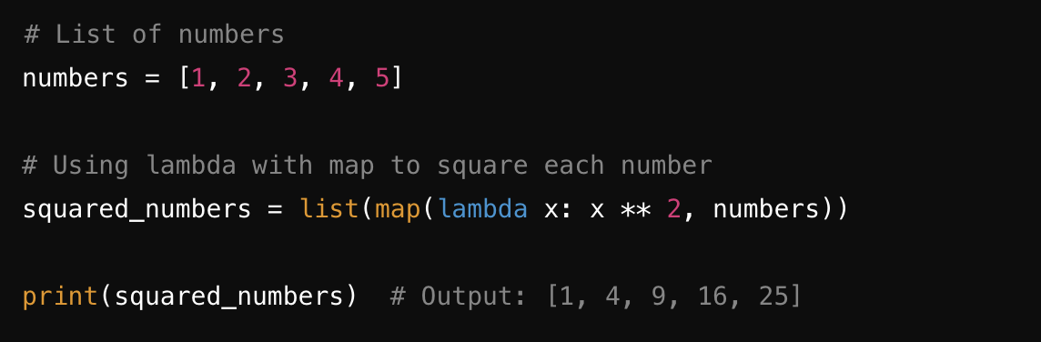
2. Use Cases for Lambda Functions

Lambda functions are particularly useful in scenarios where a small function is required temporarily and defining a full function with `def` would be too cumbersome. Some common use cases include:

- Using with `map()`: Applying a function to all items in an iterable.
- Using with `filter()`: Filtering items in an iterable based on a condition.
- Using with `reduce()`: Performing a cumulative operation on an iterable.
- Sorting and Key Functions: Specifying a key function for sorting or retrieving elements.

Example 1: Using Lambda with map()

The `map()` function applies a given function to all items in an iterable (like a list) and returns an iterator with the results.

# List of numbers
numbers = [1, 2, 3, 4, 5]
squared_numbers = list(map(lambda x: x ** 2, numbers))
print(squared_numbers) # Output: [1, 4, 9, 16, 25]

Example 2: Using Lambda with `filter()`

The `filter()` function filters elements in an iterable based on a condition defined by a function, returning only those elements for which the function returns `True`.

# List of numbers
numbers = [1, 2, 3, 4, 5, 6, 7, 8, 9]
# Using lambda with filter to get odd numbers
odd_numbers = list(filter(lambda x: x % 2 != 0, numbers))
print(odd_numbers) # Output: [1, 3, 5, 7, 9]

Example 3: Using Lambda with `reduce()`

The `reduce()` function, from the `functools` module, applies a rolling computation to sequential pairs of values in an iterable. It's useful for cumulative operations like summing or multiplying all elements.

from functools import reduce

# List of numbers
numbers = [1, 2, 3, 4, 5]
# Using lambda with reduce to compute the product of all numbers
product = reduce(lambda x, y: x * y, numbers)
print(product) # Output: 120

