P.V.P Siddhartha Institute of Technology
Department of Computer Science and Engineering
Course: B.Tech |  | Year: II | Semester: II | Descriptive: II | A.Y:2024-25
Subject Code: 23CS3402 |  | Subject Name: Database Management Systems |  |  | Regulation:PVP23
Duration:1 hr 30 min |  | Maximum Marks:30 Marks |  |  | Date: 01-05-25 |  |  | Session: F.N
Answer ONE Question from each section. Each Question carries 10 Marks. 3×10M=30M
Q. No | Question |  |  |  |  | Marks | CO |  | Level
1 a) | Apply relational algebra operations inspired by set theory, such as UNION, INTERSECT, and DIFFERENCE. |  |  |  |  | 5 | CO2 |  | L3
1 b) | Make use of INNER JOIN, LEFT JOIN, RIGHT JOIN and FULL OUTER JOIN with an example in relational algebra . |  |  |  |  | 5 | CO2 |  | L3
 | OR
2 a) | - Create Products table with the following columns:  - ProductID (Primary Key, Integer)  - ProductName (String, Not Null)  - Price (Decimal, greater than 0 using a check constraint)  - CategoryID (Foreign Key Referencing Categories(CategoryID)).  Explain the constraints you used. |  |  |  |  | 5 | CO2 |  | L3
2 b) | Apply a query to find the average, maximum, and minimum scores for each subject. |  |  |  |  | 5 | CO2 |  | L3
  Student_id | Subject_name | Score
  1 | Math | 85
  2 | Science | 90
  3 | Math | 78
  4 | Science | 88
  5 | Math | 92
3 a) | Consider the universal relation R = {A, B, C, D, E, F, G, H, I, J} and the set of functional dependencies  F = {{A, B}→{C}, {A}→{D, E}, {B}→{F}, {F}→{G, H}, {D}→{I, J}}. What is the key for R? Decompose R into 2NF and then 3NF relations. |  |  |  |  | 5 | CO3 |  | L3
3 b) | Apply 2NF and remove partial dependencies from the following Relation  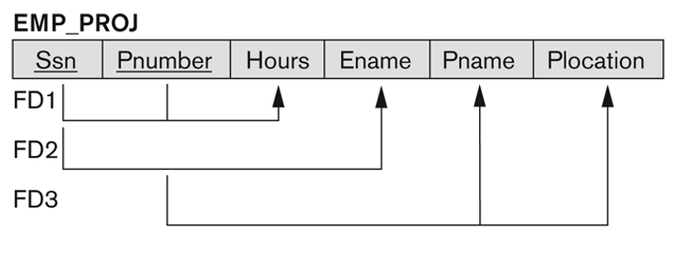 |  |  |  |  | 5 | CO3 |  | L3
 | OR
4 a) | Consider the Universal Relation A(P, Q,R,S,T) and the set of functional dependencies.  P→QR,RS→T,Q→S,T→P  i). List the candidate keys  ii). Is it in the 2 NF?  iii).Is it in 3NF? |  |  |  |  | 5 | CO3 |  | L3
4 b) | Identify the challenges and benefits associated with implementing normalization. |  |  |  |  | 5 | CO3 |  | L3
5 a) | Describe the properties of Transactions. |  |  |  |  | 5 | CO1 |  | L2
5 b) | Discuss the criteria for characterizing schedules based on their recoverability and serializability properties. |  |  |  |  | 5 | CO1 |  | L2
 | OR
6 a) | Explain the principles of the Two-Phase Locking (2PL) protocol. Discuss the types of locks used in 2PL and their role in preventing conflicts among concurrent transactions. |  |  |  |  | 5 | CO1 |  | L2
6 b) | Explain the shadow paging technique for recovery. Discuss the steps involved in implementing shadow paging and its advantages in terms of simplicity and efficiency. |  |  |  |  | 5 | CO1 |  | L2

Course Coordinator

Module Coordinator Program Coordinator

