P.V.P SIDDHARTHA INSTITUTE OF TECHNOLOGY (AUTONOMOUS)
BRANCH : Computer Science and Engineering |  |  | REGULATION : PVP23
Course: B.Tech | SUBJECT : Database Management Systems
SubjectCode: 23CS3402 |  | Year and Semester: II Year / II Sem |  | Section: I/II/III
Academic Year:2024-25 (Semester-II)
ASSIGNMENT-I

Q.NO | SET -1 | CO | LEVEL
1 | Demonstrate the three schema architecture for database systems with a neat diagram. | CO1 | L2
2 | Construct ER diagram for Library Management System. Identify entities, roles, weak entity sets if any. | CO4 | L4
3 | Explain the weak entity with an example. | CO1 | L2

Q.NO | SET - 2 | CO | LEVEL
1 | Discuss about different types of Database users. | CO1 | L2
2 | A university registrar’s office maintains data about the following  entities:  (a) COURSES- including number, title, credits, syllabus, and prerequisites;  (b) COURSE OFFERINGS- including course number, year, semester, section number, instructor(s), timings, and classroom;  (c) STUDENTS- including student-id, name, and program;  (d) INSTRUCTORS - including identification number, name,  department, and title.  Further, the enrolment of students in courses and grades awarded to students in each course they are enrolled for must be appropriately modelled.  Construct an E-R diagram for the registrar’s office. Determine the mapping constraints for the given scenario. | CO4 | L4
3 | Compare Binary Vs Ternary relationships. | CO1 | L2

Q.NO | SET - 3 | CO | LEVEL
1 | Explain the differences between Database and File System. | CO1 | L2
2 | Draw an ERD containing the Order and Customer entity types connected by a 1-M relationship from Customer to Order. Choose an appropriate relationship name using your common knowledge of interactions between customers and orders. Define minimum cardinalities so that an order is optional for a customer and a customer is mandatory for an order. For the Customer entity type, add attributes CustNo (primary key), CustFirstName, CustLastName, CustStreet, CustCity, CustState, CustZip, and CustBal (balance). For the Order entity type, add attributes for the OrdNo (primary key), OrdDate, OrdName, OrdStreet,OrdCity, OrdState, and OrdZip. | CO4 | L4
3 | Explain how entities in an ER model are transformed into relational tables. Provide an example. | CO1 | L2

Q.NO | SET - 4 | CO | LEVEL
1 | Compare centralized and client-server architectures in the context of Database Management Systems. | CO1 | L2
2 | Draw an ER Diagram for the University database. | CO4 | L4
3 | Differentiate between participation constraints (total and partial) and cardinality constraints. | CO1 | L2

Q.NO | SET - 5 | CO | LEVEL
1 | Explain the following concepts  i) Data Independence ii) Database Schema | CO1 | L2
2 | Consider the ER diagram shown in Figure 7.21 for part of a BANK database. Each bank can have multiple branches, and each branch can have multiple accounts and loans.  a. List the strong (non weak) entity types in the ER diagram.  b. Is there a weak entity type? If so, give its name, partial key, and identifying relationship.  c. What constraints do the partial key and the identifying relationship of the weak entity type specify in this diagram?  d. List the names of all relationship types, and specify the (min, max) constraint on each participation of an entity type in a relationship type.  Justify your choices.  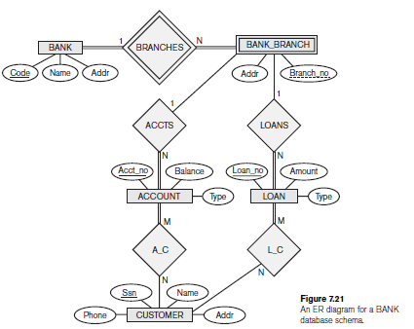 | CO4 | L4
3 | Explain the weak entity with an example. | CO1 | L2

Q.NO | SET - 6 | CO | LEVEL
1 | Compare centralized and client-server architectures in the context of Database Management Systems. | CO1 | L2
2 | Draw an ERD containing the Order and Customer entity types connected by a 1-M relationship from Customer to Order. Choose an appropriate relationship name using your common knowledge of interactions between customers and orders. Define minimum cardinalities so that an order is optional for a customer and a customer is mandatory for an order. For the Customer entity type, add attributes CustNo (primary key), CustFirstName, CustLastName, CustStreet, CustCity, CustState, CustZip, and CustBal (balance). For the Order entity type, add attributes for the OrdNo (primary key), OrdDate, OrdName, OrdStreet,OrdCity, OrdState, and OrdZip. | CO4 | L4
3 | Explain the Process of transforming entity types, relationship types, and attributes into tables, keys and constraints | CO1 | L2

Q.NO | SET - 7 | CO | LEVEL
1 | Explain various categories of Data Models. | CO1 | L2
2 | Construct ER diagram for Library Management System. Identify entities, roles, weak entity sets if any. | CO4 | L4
3 | Compare Binary Vs Ternary relationships. | CO1 | L2

Q.NO | SET - 8 | CO | LEVEL
1 | Demonstrate the three schema architecture for database systems with a neat diagram. | CO1 | L2
2 | A university registrar’s office maintains data about the following  entities:  (a) COURSES- including number, title, credits, syllabus, and prerequisites;  (b) COURSE OFFERINGS- including course number, year, semester, section number, instructor(s), timings, and classroom;  (c) STUDENTS- including student-id, name, and program;  (d) INSTRUCTORS - including identification number, name,  department, and title.  Further, the enrolment of students in courses and grades awarded to students in each course they are enrolled for must be appropriately modelled.  Construct an E-R diagram for the registrar’s office. Determine the mapping constraints for the given scenario. | CO4 | L4
3 | Discuss the following terms:  i) Relationship instance ii) Composite attribute  iii) Multivalued attribute iv) Derived attribute. | CO1 | L2

Q.NO | SET - 9 | CO | LEVEL
1 | Outline various Database applications. | CO1 | L2
2 | Consider the ER schema for the MOVIES database,  Assume that MOVIES is a populated database. ACTOR is used as a generic term and includes actresses. Given the constraints shown in the ER schema, respond to the following statements with True, False, or Maybe. Assign a response of Maybe to statements that, while not explicitly shown to be True, cannot be proven False based on the schema as shown. Justify each answer.  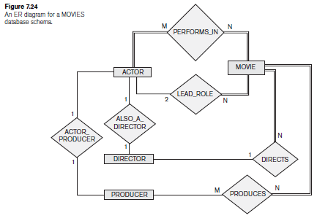  a. There are no actors in this database that have been in no movies.  b. There are some actors who have acted in more than ten movies.  c. Some actors have done a lead role in multiple movies.  d. A movie can have only a maximum of two lead actors.  e. Every director has been an actor in some movie.  f. No producer has ever been an actor.  g. A producer cannot be an actor in some other movie.  h. There are movies with more than a dozen actors.  i. Some producers have been a director as well.  j. Most movies have one director and one producer.  k. Some movies have one director but several producers.  l. There are some actors who have done a lead role, directed a movie, and  produced some movie.  m. No movie has a director who also acted in that movie. | CO4 | L4
3 | Explain the Process of transforming entity types, relationship types, and attributes into tables, keys and constraints | CO1 | L2

Q.NO | SET - 10 | CO | LEVEL
1 | Illustrate the client-server architectures for DBMS | CO1 | L2
2 | Draw an ER Diagram for the University database. | CO4 | L4
3 | Describe and differentiate between entity types and entity sets in the context of the Entity-Relationship Model.Discuss the role of attributes and keys in defining the characteristics and uniqueness of entities within a database. | CO1 | L2

Set No | Roll Numbers
1 | 1,11,21,31,41,51,61,LE-5.
2 | 2,12,22,32,42,52,62,LE-6.
3 | 3,13,23,33,43,53,63
4 | 4,14,24,34,44,54,64
5 | 5,15,25,35,45,55,65
6 | 6,16,26,36,46,56,66
7 | 7,17,27,37,47,57,LE-1
8 | 8,18,28,38,48,58,LE-2
9 | 9,19,29,39,49,59,LE-3
10 | 10,20,30,40,50,60, LE-4

