|  |  |  |  |  |
| --- | --- | --- | --- | --- |
| **P.V.P SIDDHARTHA INSTITUTE OF TECHNOLOGY (AUTONOMOUS)** | | | | |
| **BRANCH : Computer Science and Engineering** | | | **REGULATION : PVP23** | |
| **Course: B.Tech** | **SUBJECT : Database Management Systems** | | | |
| **SubjectCode: 23CS3402** | | **Year and Semester: II Year / II Sem** | | **Section: I/II/III** |
| **Academic Year:2024-25 (Semester-II)** | | | | |
| **ASSIGNMENT-II** | | | | |

1. **Problem Statement CO2 L3**

Given a library management system with tables for publishers, library branches, books, book authors, book copies, and book lending.

Write a SQL query to retrieve details about books, including the book ID, title, publisher name, publication year, author name, number of copies, branch name, and branch address.

**Table Details:**

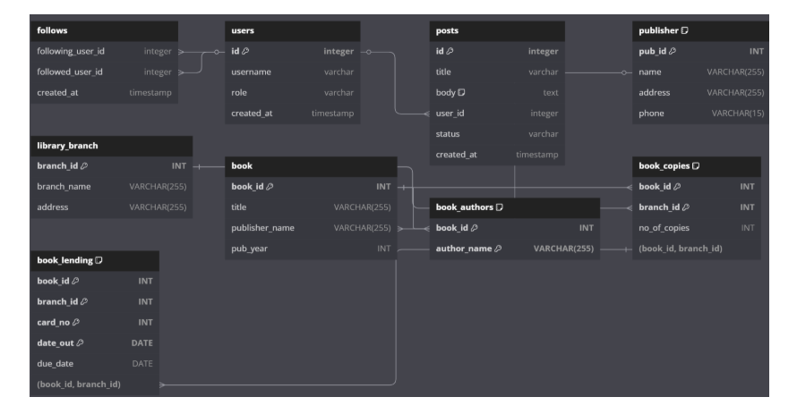

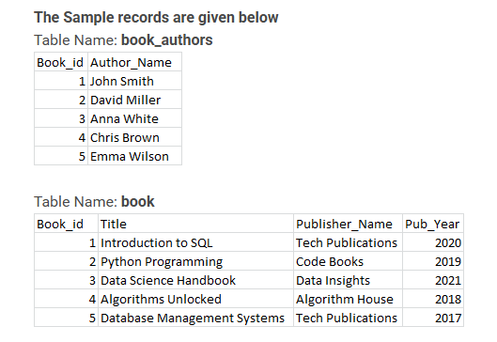

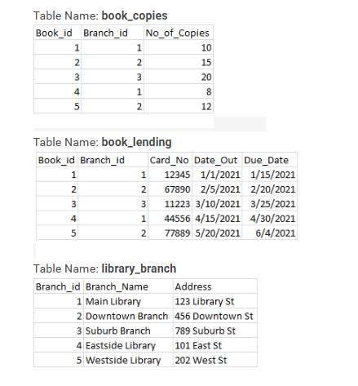

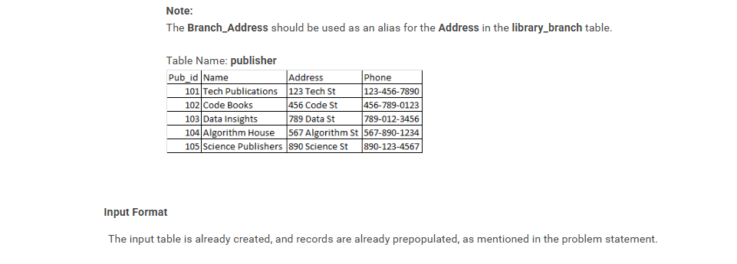

1. **Problem Statement CO2 L3**

Given a library management system with tables for publishers, library branches, books, book authors, book copies, and book lending.

Write a query to extract information about library borrowers who have borrowed at least one book between January 1, 2021, and April 30, 2021.

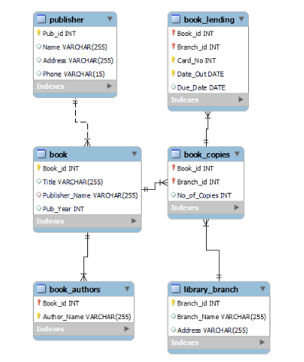

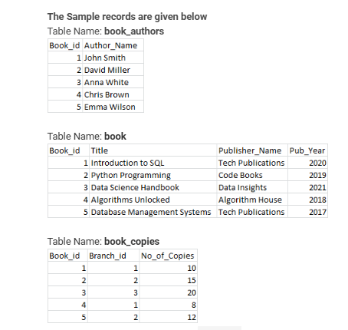

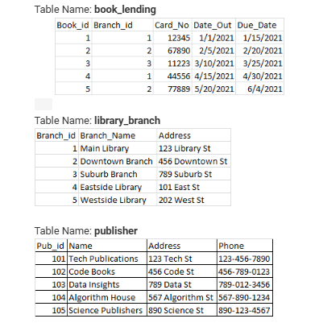

1. **Problem Statement CO2 L3**

Given a database for a library, the problem is to partition the book table based on the year of publication and assign a row number to each book within its publication year. **(Same as Above Tables)**

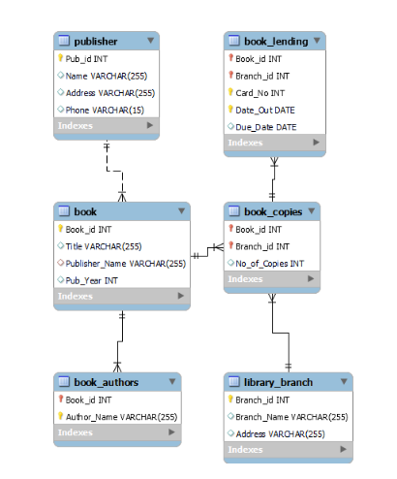

1. **Problem Statement CO4 L4**

Given a library database, create a view that displays details about all books and the number of available copies currently in the library. The view should include information such as book ID, title, publisher name, publication year, author name, branch ID, and the number of copies available. **(Same as Above Tables).**

1. **Problem Statement CO2 L3**

The HR department wants to identify employees who possess specific technical skills for an upcoming project. Specifically, they are looking for employees who have expertise in both Java and SQL.

You need to write a SQL query to retrieve the names and salaries of employees who meet the following criteria:

The employee must have both 'Java' and 'SQL' listed as skills.

The query should return only those employees who have both skills and no other employees.

**Table details are given below**

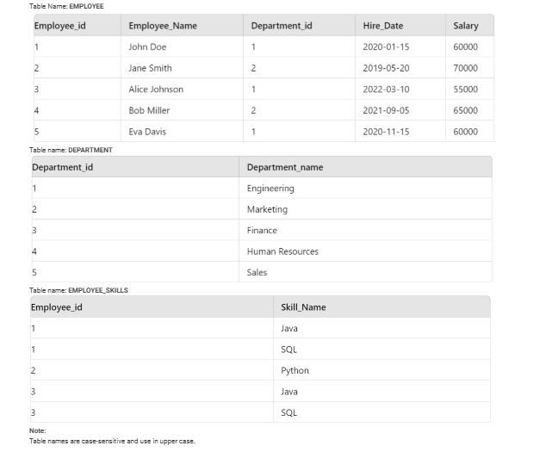

1. **Problem Statement CO2 L3**

In a company, the HR department is interested in understanding the management structure. Each employee in the company reports to a manager, and they want to identify unique managers based on the current employee records. Write a query to retrieve the distinct names of managers from the EMPLOYEE table.

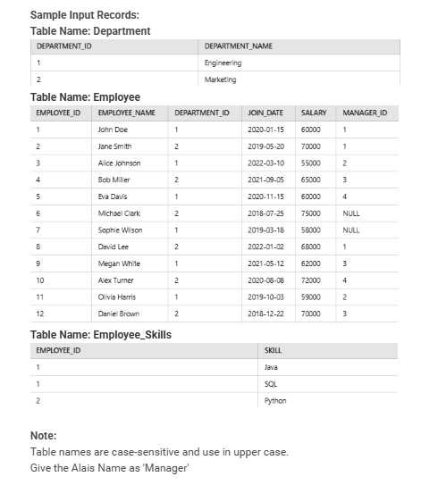

1. **Problem Statement CO4 L4**

You are tasked with managing a sales database that includes information about SALESMAN, CUSTOMER, and ORDERS.

Your goal is to create queries to list all salesman and indicate whether they have or don't have customers in their respective cities using the UNION operation.

The following table has already been created, and the records are inserted into the table.

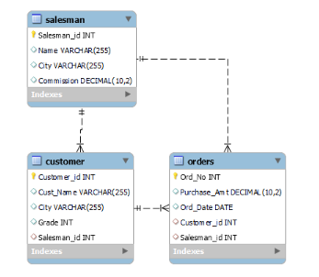

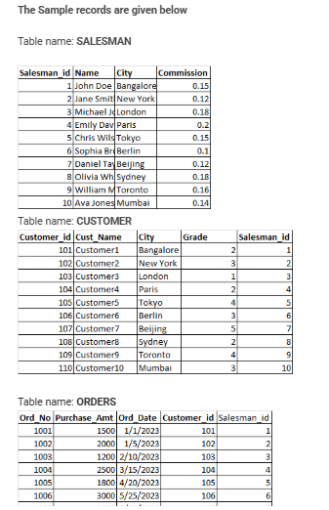

1. **Problem Statement CO4 L4**

Given a database with three tables: SALESMAN, CUSTOMER, and ORDERS. Your task is to create a view, named MaxOrderSalesmanView, that identifies the salesman who has the customer with the highest order amount on each day. The view should display the order date, salesman ID, salesman name, and the maximum order amount for each day.

The following table has already been created, and the records are prepopulated into the table**.(Same as Above Table).**

1. **Problem Statement CO2 L3**

Given a database for a movie production company. The database includes information about actors, directors, movies, movie cast, and ratings.

Write a query to retrieve a list of actors who have participated in movies either before the year 2005 or after the year 2015. The data is stored in a prepopulated database with tables for actors, directors, movies, movie casts, and ratings.

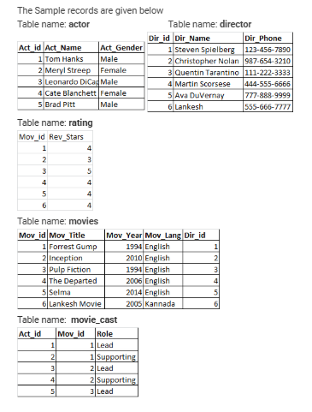

1. **Problem Statement CO2 L3**

The HR department wants to identify the highest-paid employee in each department to recognize top performers. Write a query to retrieve the details of the highest-paid employee in each department.

Table details are given below:

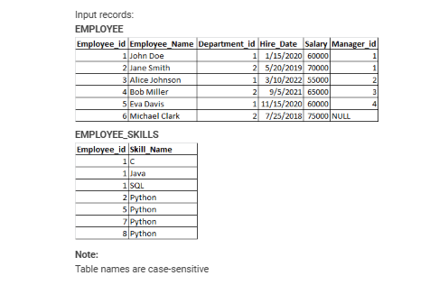

**Course Coordinator**

**Module Coordinator Program Coordinator**