P.V.P Siddhartha Institute of Technology
Department of Computer Science and Engineering
Course: B.Tech |  |  | Year: II | Semester: II | Descriptive: II | A.Y:2023-24
Subject Code: 20CS3402 |  |  | Subject Name: Advanced Data Structures |  |  | Regulation:PVP20
Duration:1 hr 30 min |  |  | Maximum Marks:15 Marks |  |  | Date:25-4-24 |  | Session: F.N
Answer all the Questions. Each Question carries 5Marks 3×5M=15M
Q.No |  |  |  |  |  |  | Marks | CO | Level
1. | a) | Apply insertion operation on B- Tree of order 3 for the given elements 6, 7, 9, 22, 13, 31, 35, 28, 24, 5, 34, 8, 25, 10, 11, 12, 14, 39, |  |  |  |  | 4 | CO3 | L3
 | b) | Explain pattern matching and give its applications |  |  |  |  | 1 | CO2 | L2
2. | a) | Apply all pairs shortest path algorithm on the given graph  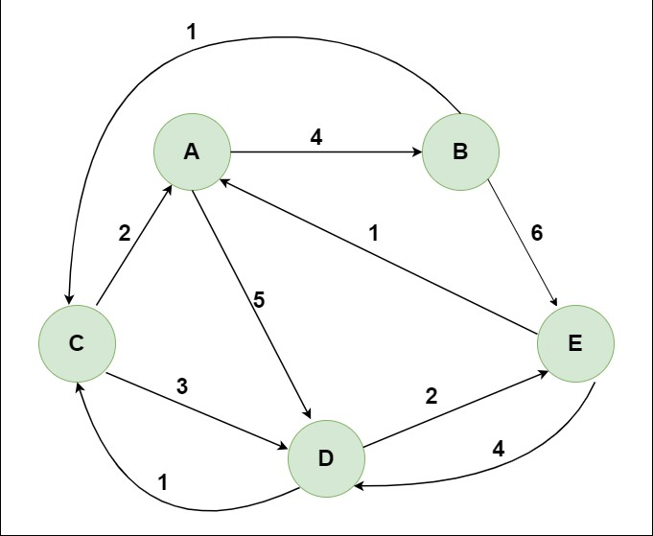 |  |  |  |  | 4 | CO3 | L3
 | b) | Which algorithm will be suitable on the graph below to find shortest path from a single source to all other vertices |  |  |  |  | 1 | CO1 | L2
3. | a) | Organize the ordering of vertices produced by topological sort when it is run on the below graph |  |  |  |  | 1.5 | CO4 | L4
 | b) | Analyze the KMP algorithm that will effectively search for a given text – abcabcabdabc for a given pattern- abcabdabc |  |  |  |  | 1.5 | CO4 | L4
 | c) | Explain in detail how to find the 11 in the below data structure using smart find algorithm |  |  |  |  | 2 | CO2 | L2

