**Deletion from a B-tree**

Deleting an element on a B-tree consists of three main events: **searching the node where the key to be deleted exists**, deleting the key and balancing the tree if required. While deleting a tree, a condition called **underflow** may occur. Underflow occurs when a node contains less than the minimum number of keys it should hold. The terms to be understood before studying deletion operation are:

1. **Inorder Predecessor**

The largest key on the left child of a node is called its inorder predecessor. 2. **Inorder Successor**

The smallest key on the right child of a node is called its inorder successor. **Deletion Operation**

Before going through the steps below, one must know these facts about a B tree of degree **m**.

1. A node can have a maximum of m children. (i.e. 3)

2. A node can contain a maximum of m - 1 keys. (i.e. 2)

3. A node should have a minimum of ⌈m/2⌉ children. (i.e. 2)

4. A node (except root node) should contain a minimum of ⌈m/2⌉ - 1 keys. (i.e. 1) There are three main cases for deletion operation in a B tree.

**Case I**

The key to be deleted lies in the leaf. There are two cases for it.

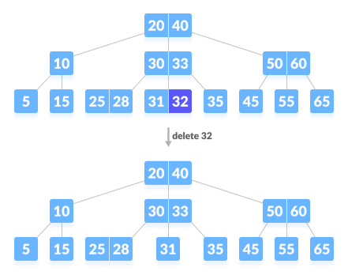

1. The deletion of the key does not violate the property of the minimum number of keys a node should hold.

In the tree below, deleting 32 does not violate the above properties.Deleting a leaf key (32) from B-tree

2. The deletion of the key violates the property of the minimum number of keys a node should hold. In this case, we borrow a key from its immediate neighboring sibling node in the order of left to right.

First, visit the immediate left sibling. If the left sibling node has more than a minimum number of keys, then borrow a key from this node.

Else, check to borrow from the immediate right sibling node.

In the tree below, deleting 31 results in the above condition. Let us borrow a key from

the left sibling node.

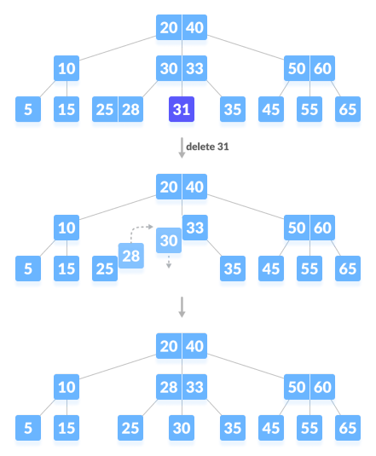Deleting a leaf key (31)If both the immediate sibling nodes already have a minimum

number of keys, then merge the node with either the left sibling node or the right sibling node. **This merging is done through the parent node.**

Deleting 30 results in the above case.

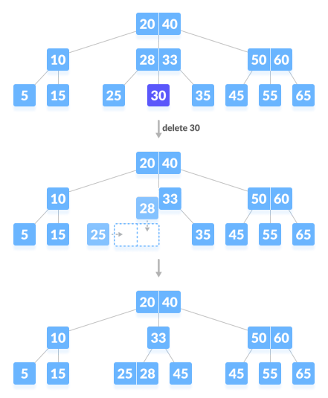Delete a leaf key (30)

**Case II**

If the key to be deleted lies in the internal node, the following cases occur.

1. The internal node, which is deleted, is replaced by an inorder predecessor if the left

child has more than the minimum number of keys.

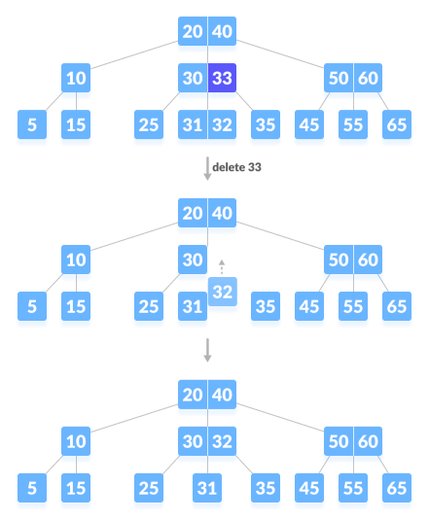Deleting an internal node (33)

2. The internal node, which is deleted, is replaced by an inorder successor if the right child has more than the minimum number of keys.

3. If either child has exactly a minimum number of keys then, merge the left and the right children.

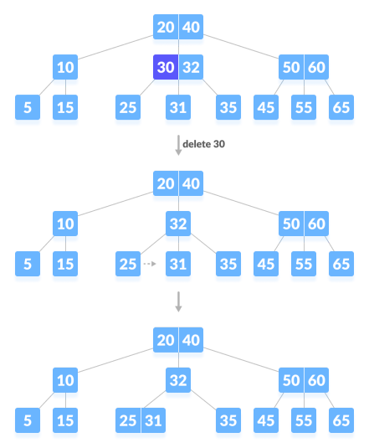Deleting an internal node (30)After merging if the parent node has less than the minimum number of keys then, look for the siblings as in Case I. **Case III**

In this case, the height of the tree shrinks. If the target key lies in an internal node, and the deletion of the key leads to a fewer number of keys in the node (i.e. less than the minimum required), then look for the inorder predecessor and the inorder successor. If both the children contain a minimum number of keys then, borrowing cannot take place. This leads to Case II(3) i.e. merging the children.

Again, look for the sibling to borrow a key. But, if the sibling also has only a minimum number of keys then, merge the node with the sibling along with the parent. Arrange the children accordingly (increasing order).

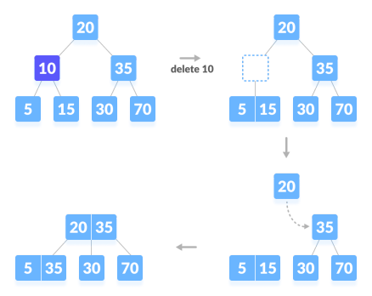Deleting an internal node (10)

**Deletion Complexity**

Best case Time complexity: Θ(log n)

Average case Space complexity: Θ(n)

Worst case Space complexity: Θ(n)

Deletion in B-Tree

For deletion in b tree we wish to remove from a leaf. There are three possible case for deletion in b tree.

Let k be the key to be deleted, x the node containing the key. Then the cases are:

Case-I

If the key is already in a leaf node, and removing it doesn’t cause that leaf node to have too few keys, then simply remove the key to be deleted. key k is in node x and x is a leaf, simply delete k from x.

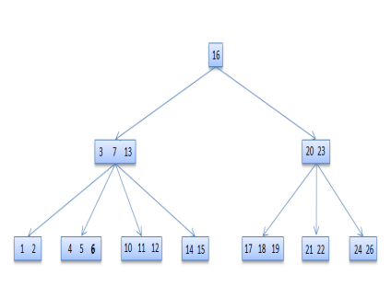**6 deleted**

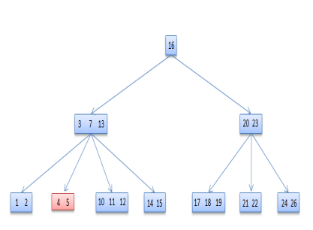

Case-II

If key k is in node x and x is an internal node, there are three cases to consider:

*Case-II-a*

If the child y that precedes k in node x has at least t keys (more than the minimum), then find the predecessor key k' in the subtree rooted at y. Recursively delete k' and replace k with k' in x

*Case-II-b*

Symmetrically, if the child z that follows k in node x has at least t keys, find the successor k' and delete and replace as before. Note that finding k' and deleting it can be performed in a single downward pass.

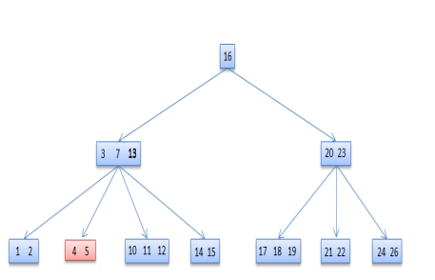

**13 deleted**

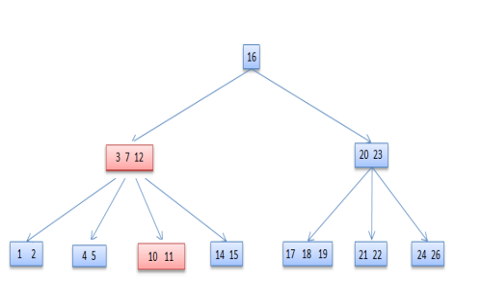

*Case-II-c*

Otherwise, if both y and z have only t−1 (minimum number) keys, merge k and all of z into y, so that both k and the pointer to z are removed from x. y now contains 2t − 1 keys, and subsequently k is deleted.

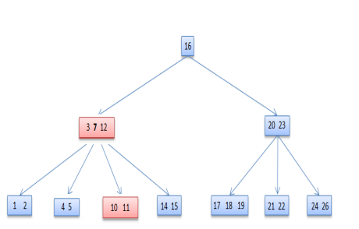**7 deleted**

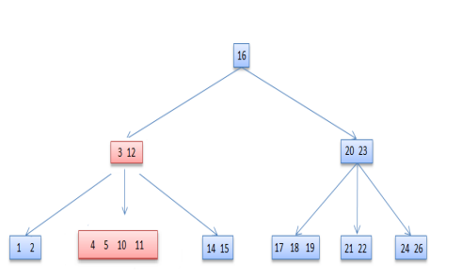

Case-III

If key k is not present in an internal node x, determine the root of the appropriate subtree that must contain k. If the root has only t − 1 keys, execute either of the following two cases to ensure that we descend to a node containing at least t keys. Finally, recurse to the appropriate child of x.

**Case-III-a**

If the root has only t−1 keys but has a sibling with t keys, give the root an extra key by moving a key from x to the root, moving a key from the roots immediate left or right sibling up into x, and moving the appropriate child from the sibling to x.

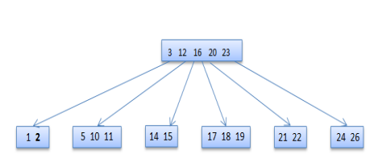**2 deleted**

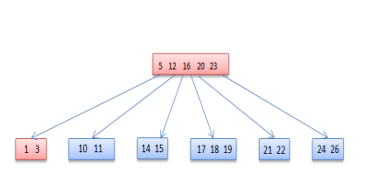**Case-III-b**

If the root and all of its siblings have t−1 keys, merge the root with one sibling. This involves moving a key down from x into the new merged node to become the median key for that node.

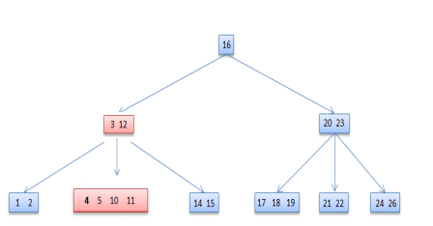**4 deleted**

****# Deleting a key on a B-tree in Python

# Btree node

class BTreeNode:

def __init__(self, leaf=False):

self.leaf = leaf

self.keys = []

self.child = []

class BTree:

def __init__(self, t):

self.root = BTreeNode(True)

self.t = t

# Insert a key

def insert(self, k):

root = self.root

if len(root.keys) == (2 * self.t) - 1: temp = BTreeNode()

self.root = temp

temp.child.insert(0, root)

self.split_child(temp, 0)

self.insert_non_full(temp, k) else:

self.insert_non_full(root, k) # Insert non full

def insert_non_full(self, x, k):

i = len(x.keys) - 1

if x.leaf:

x.keys.append((None, None)) while i >= 0 and k[0] < x.keys[i][0]: x.keys[i + 1] = x.keys[i] i -= 1

x.keys[i + 1] = k

else:

while i >= 0 and k[0] < x.keys[i][0]: i -= 1

i += 1

if len(x.child[i].keys) == (2 * self.t) - 1: self.split_child(x, i) if k[0] > x.keys[i][0]:

i += 1

self.insert_non_full(x.child[i], k)

# Split the child

def split_child(self, x, i):

t = self.t

y = x.child[i]

z = BTreeNode(y.leaf)

x.child.insert(i + 1, z)

x.keys.insert(i, y.keys[t - 1]) z.keys = y.keys[t: (2 * t) - 1] y.keys = y.keys[0: t - 1]

if not y.leaf:

z.child = y.child[t: 2 * t] y.child = y.child[0: t - 1]

# Delete a node

def delete(self, x, k):

t = self.t

i = 0

while i < len(x.keys) and k[0] > x.keys[i][0]: i += 1

if x.leaf:

if i < len(x.keys) and x.keys[i][0] == k[0]: x.keys.pop(i)

return

return

if i < len(x.keys) and x.keys[i][0] == k[0]: return self.delete_internal_node(x, k, i) elif len(x.child[i].keys) >= t: self.delete(x.child[i], k) else:

if i != 0 and i + 2 < len(x.child): if len(x.child[i - 1].keys) >= t: self.delete_sibling(x, i, i - 1) elif len(x.child[i + 1].keys) >= t: self.delete_sibling(x, i, i + 1) else:

self.delete_merge(x, i, i + 1) elif i == 0:

if len(x.child[i + 1].keys) >= t: self.delete_sibling(x, i, i + 1) else:

self.delete_merge(x, i, i + 1) elif i + 1 == len(x.child): if len(x.child[i - 1].keys) >= t:

self.delete_sibling(x, i, i - 1) else:

self.delete_merge(x, i, i - 1) self.delete(x.child[i], k)

# Delete internal node

def delete_internal_node(self, x, k, i):

t = self.t

if x.leaf:

if x.keys[i][0] == k[0]:

x.keys.pop(i)

return

return

if len(x.child[i].keys) >= t:

x.keys[i] = self.delete_predecessor(x.child[i]) return

elif len(x.child[i + 1].keys) >= t: x.keys[i] = self.delete_successor(x.child[i + 1]) return

else:

self.delete_merge(x, i, i + 1)

self.delete_internal_node(x.child[i], k, self.t - 1)

# Delete the predecessor

def delete_predecessor(self, x):

if x.leaf:

return x.pop()

n = len(x.keys) - 1

if len(x.child[n].keys) >= self.t: self.delete_sibling(x, n + 1, n) else:

self.delete_merge(x, n, n + 1) self.delete_predecessor(x.child[n])

# Delete the successor

def delete_successor(self, x):

if x.leaf:

return x.keys.pop(0)

if len(x.child[1].keys) >= self.t: self.delete_sibling(x, 0, 1)

else:

self.delete_merge(x, 0, 1)

self.delete_successor(x.child[0])

# Delete resolution

def delete_merge(self, x, i, j):

cnode = x.child[i]

if j > i:

rsnode = x.child[j]

cnode.keys.append(x.keys[i])

for k in range(len(rsnode.keys)): cnode.keys.append(rsnode.keys[k]) if len(rsnode.child) > 0:

cnode.child.append(rsnode.child[k]) if len(rsnode.child) > 0:

cnode.child.append(rsnode.child.pop()) new = cnode

x.keys.pop(i)

x.child.pop(j)

else:

lsnode = x.child[j]

lsnode.keys.append(x.keys[j])

for i in range(len(cnode.keys)):

lsnode.keys.append(cnode.keys[i]) if len(lsnode.child) > 0: lsnode.child.append(cnode.child[i]) if len(lsnode.child) > 0:

lsnode.child.append(cnode.child.pop()) new = lsnode

x.keys.pop(j)

x.child.pop(i)

if x == self.root and len(x.keys) == 0: self.root = new

# Delete the sibling

def delete_sibling(self, x, i, j):

cnode = x.child[i]

if i < j:

rsnode = x.child[j]

cnode.keys.append(x.keys[i])

x.keys[i] = rsnode.keys[0]

if len(rsnode.child) > 0:

cnode.child.append(rsnode.child[0]) rsnode.child.pop(0)

rsnode.keys.pop(0)

else:

lsnode = x.child[j]

cnode.keys.insert(0, x.keys[i - 1])

x.keys[i - 1] = lsnode.keys.pop() if len(lsnode.child) > 0:

cnode.child.insert(0, lsnode.child.pop())

# Print the tree

def print_tree(self, x, l=0):

print("Level ", l, " ", len(x.keys), end=":") for i in x.keys:

print(i, end=" ")

print()

l += 1

if len(x.child) > 0:

for i in x.child:

self.print_tree(i, l)

B = BTree(3)

for i in range(10):

B.insert((i, 2 * i))

B.print_tree(B.root)

B.delete(B.root, (8,))

print("\n")

B.print_tree(B.root)