**Floyd Warshall Algorithm**

The**Floyd-Warshall algorithm**, named after its creators**Robert Floyd and Stephen Warshall**, is a fundamental algorithm in computer science and graph theory. It is used to find the shortest paths between all pairs of nodes in a weighted graph. This algorithm is highly efficient and can handle graphs with both **positive** and n**egative edge weights**, making it a versatile tool for solving a wide range of network and connectivity problems.

**Floyd Warshall Algorithm:**

*The****Floyd Warshall Algorithm****is an all pair shortest path algorithm unlike*[*Dijkstra*](https://www.geeksforgeeks.org/dijkstras-shortest-path-algorithm-greedy-algo-7/)*and*[*Bellman Ford*](https://www.geeksforgeeks.org/bellman-ford-algorithm-dp-23/)*which are single source shortest path algorithms. This algorithm works for both the****directed****and****undirected weighted****graphs. But, it does not work for the graphs with negative cycles (where the sum of the edges in a cycle is negative). It follows*[*Dynamic Programming*](https://www.geeksforgeeks.org/introduction-to-dynamic-programming-data-structures-and-algorithm-tutorials/)*approach to check every possible path going via every possible node in order to calculate shortest distance between every pair of nodes.*

**Idea Behind Floyd Warshall Algortihm:**

*Suppose we have a graph****G[][]****with****V****vertices from****1****to****N****. Now we have to evaluate a****shortestPathMatrix[][]****where s****hortestPathMatrix[i][j]****represents the shortest path between vertices****i****and****j****.*

*Obviously the shortest path between****i****to****j****will have some****k****number of intermediate nodes. The idea behind floyd warshall algorithm is to treat each and every vertex from****1****to****N****as an intermediate node one by one.*

*The following figure shows the above optimal substructure property in floyd warshall algorithm:*

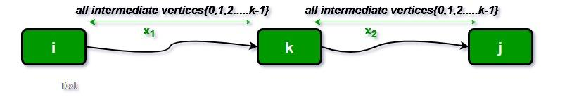

**Floyd Warshall Algorithm Algorithm:**

* Initialize the solution matrix same as the input graph matrix as a first step.
* Then update the solution matrix by considering all vertices as an intermediate vertex.
* The idea is to pick all vertices one by one and updates all shortest paths which include the picked vertex as an intermediate vertex in the shortest path.
* When we pick vertex number **k** as an intermediate vertex, we already have considered vertices **{0, 1, 2, .. k-1}**as intermediate vertices.
* For every pair**(i, j)** of the source and destination vertices respectively, there are two possible cases.
  + **k** is not an intermediate vertex in shortest path from**i**to**j**. We keep the value of**dist[i][j]**as it is.
  + **k** is an intermediate vertex in shortest path from **i** to**j**. We update the value of**dist[i][j]**as **dist[i][k] + dist[k][j],** if **dist[i][j] > dist[i][k] + dist[k][j]**

**Pseudo-Code of Floyd Warshall Algorithm :**

*For k = 0 to n – 1  
For i = 0 to n – 1  
For j = 0 to n – 1  
Distance[i, j] = min(Distance[i, j], Distance[i, k] + Distance[k, j])*

*where i = source Node, j = Destination Node, k = Intermediate Node*

**Illustration of Floyd Warshall Algorithm :**

*Suppose we have a graph as shown in the image:*

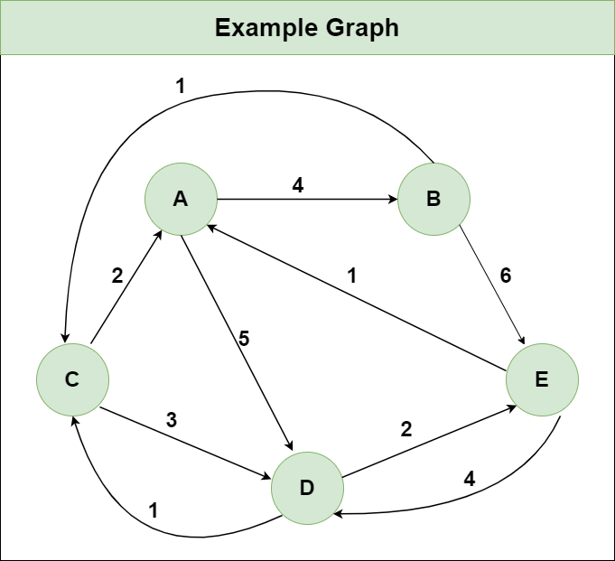

***Step 1:****Initialize the Distance[][] matrix using the input graph such that Distance[i][j]= weight of edge from****i****to****j****, also Distance[i][j] = Infinity if there is no edge from****i****to****j.***

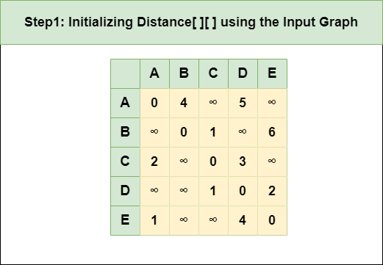

***Step 2****: Treat node****A****as an intermediate node and calculate the Distance[][] for every {i,j} node pair using the formula:*

*= Distance[i][j] = minimum (Distance[i][j], (Distance from i to****A****) + (Distance from****A****to j ))  
= Distance[i][j] = minimum (Distance[i][j], Distance[i][****A****] + Distance[****A****][j])*

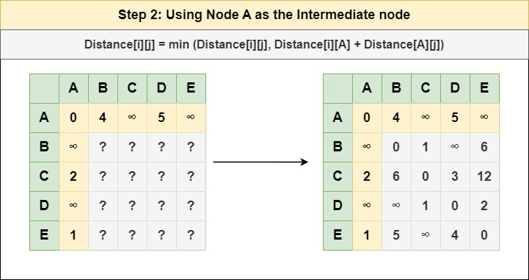

***Step 3****: Treat node****B****as an intermediate node and calculate the Distance[][] for every {i,j} node pair using the formula:*

*= Distance[i][j] = minimum (Distance[i][j], (Distance from i to****B****) + (Distance from****B****to j ))  
= Distance[i][j] = minimum (Distance[i][j], Distance[i][****B****] + Distance[****B****][j])*

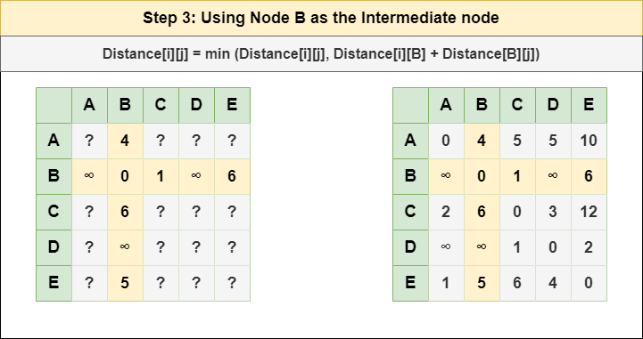

***Step 4****: Treat node****C****as an intermediate node and calculate the Distance[][] for every {i,j} node pair using the formula:*

*= Distance[i][j] = minimum (Distance[i][j], (Distance from i to****C****) + (Distance from****C****to j ))  
= Distance[i][j] = minimum (Distance[i][j], Distance[i][****C****] + Distance[****C****][j])*

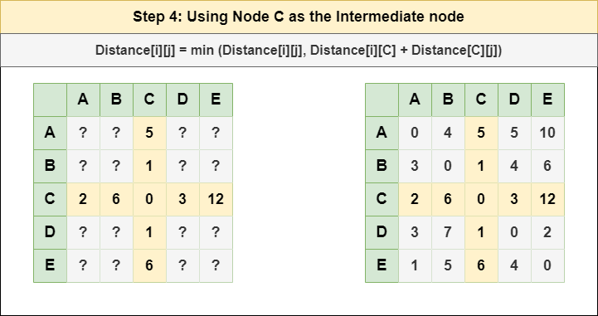

***Step 5****: Treat node****D****as an intermediate node and calculate the Distance[][] for every {i,j} node pair using the formula:*

*= Distance[i][j] = minimum (Distance[i][j], (Distance from i to****D****) + (Distance from****D****to j ))  
= Distance[i][j] = minimum (Distance[i][j], Distance[i][****D****] + Distance[****D****][j])*

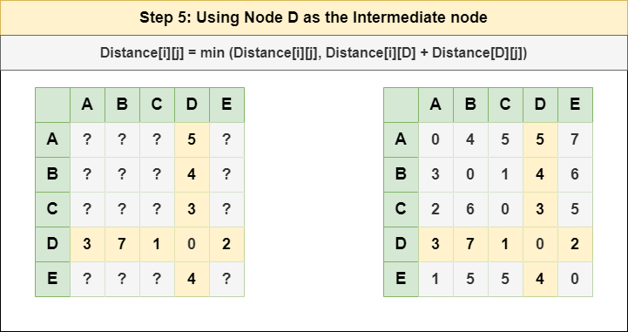

***Step 6****: Treat node****E****as an intermediate node and calculate the Distance[][] for every {i,j} node pair using the formula:*

*= Distance[i][j] = minimum (Distance[i][j], (Distance from i to****E****) + (Distance from****E****to j ))  
= Distance[i][j] = minimum (Distance[i][j], Distance[i][****E****] + Distance[****E****][j])*

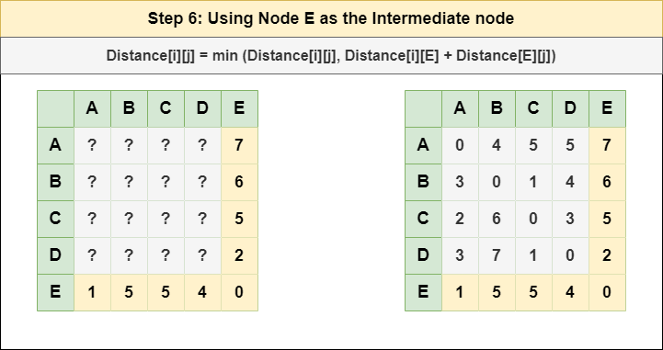

***Step 7****: Since all the nodes have been treated as an intermediate node, we can now return the updated Distance[][] matrix as our answer matrix.*

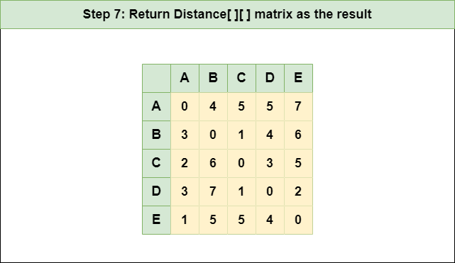

| // C++ Program for Floyd Warshall Algorithm  #include <bits/stdc++.h>  using namespace std;   // Number of vertices in the graph  #define V 4   /* Define Infinite as a large enough  value.This value will be used for  vertices not connected to each other */  #define INF 99999   // A function to print the solution matrix  void printSolution(int dist[][V]);   // Solves the all-pairs shortest path  // problem using Floyd Warshall algorithm  void floydWarshall(int dist[][V])  {       int i, j, k;      /* Add all vertices one by one to      the set of intermediate vertices.      ---> Before start of an iteration,      we have shortest distances between all      pairs of vertices such that the      shortest distances consider only the      vertices in set {0, 1, 2, .. k-1} as      intermediate vertices.      ----> After the end of an iteration,      vertex no. k is added to the set of      intermediate vertices and the set becomes {0, 1, 2, ..      k} */      for (k = 0; k < V; k++) {          // Pick all vertices as source one by one          for (i = 0; i < V; i++) {              // Pick all vertices as destination for the              // above picked source              for (j = 0; j < V; j++) {                  // If vertex k is on the shortest path from                  // i to j, then update the value of                  // dist[i][j]                  if (dist[i][j] > (dist[i][k] + dist[k][j])                      && (dist[k][j] != INF                          && dist[i][k] != INF))                      dist[i][j] = dist[i][k] + dist[k][j];              }          }      }       // Print the shortest distance matrix      printSolution(dist);  }   /* A utility function to print solution */  void printSolution(int dist[][V])  {      cout << "The following matrix shows the shortest "              "distances"              " between every pair of vertices \n";      for (int i = 0; i < V; i++) {          for (int j = 0; j < V; j++) {              if (dist[i][j] == INF)                  cout << "INF"                       << " ";              else                  cout << dist[i][j] << "   ";          }          cout << endl;      }  }   // Driver's code  int main()  {      /* Let us create the following weighted graph              10      (0)------->(3)          |     /|\      5 |     |          |     | 1      \|/     |      (1)------->(2)              3     */      int graph[V][V] = { { 0, 5, INF, 10 },                          { INF, 0, 3, INF },                          { INF, INF, 0, 1 },                          { INF, INF, INF, 0 } };       // Function call      floydWarshall(graph);      return 0;  } |
| --- |

**output**

The following matrix shows the shortest distances between every pair of vertices

0 5 8 9

INF 0 3 4

INF INF 0 1

INF INF INF 0