**UNIT-3 PROGRAMMING TEST**

**STACKS AND QUEUES**

PROBLEM-1

[Minimum indexes | Practice Problems (hackerearth.com)](https://www.hackerearth.com/practice/data-structures/stacks/basics-of-stacks/practice-problems/algorithm/yassers-conditions-6cc26a09/)

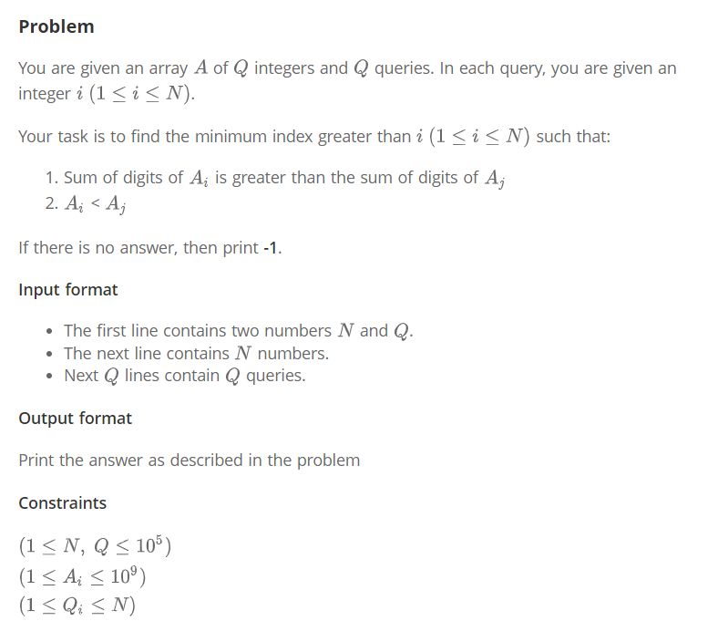

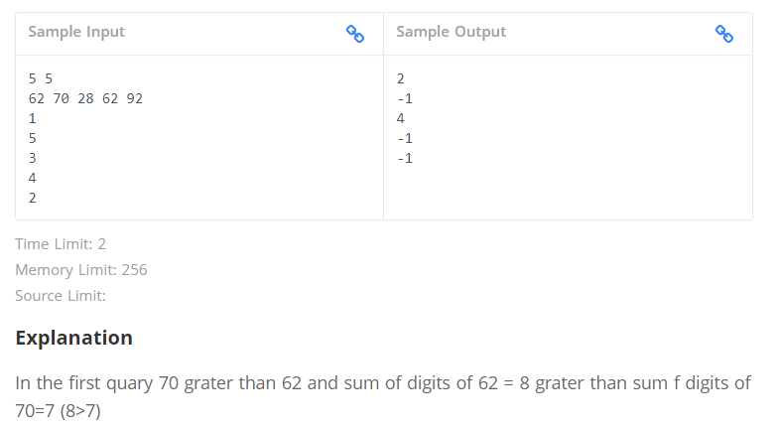

PROBLEM-2

[Stack and Queue <Nissan> | Practice Problems (hackerearth.com)](https://www.hackerearth.com/practice/data-structures/stacks/basics-of-stacks/practice-problems/algorithm/staque-1-e790a29f/)

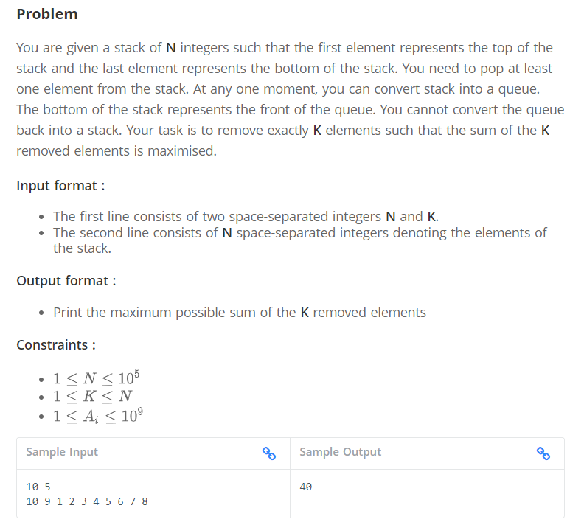

PROBLEM-3

[Jumpy Humpy | Practice Problems (hackerearth.com)](https://www.hackerearth.com/practice/data-structures/stacks/basics-of-stacks/practice-problems/algorithm/jumpy-humpy-5e0231d6/)

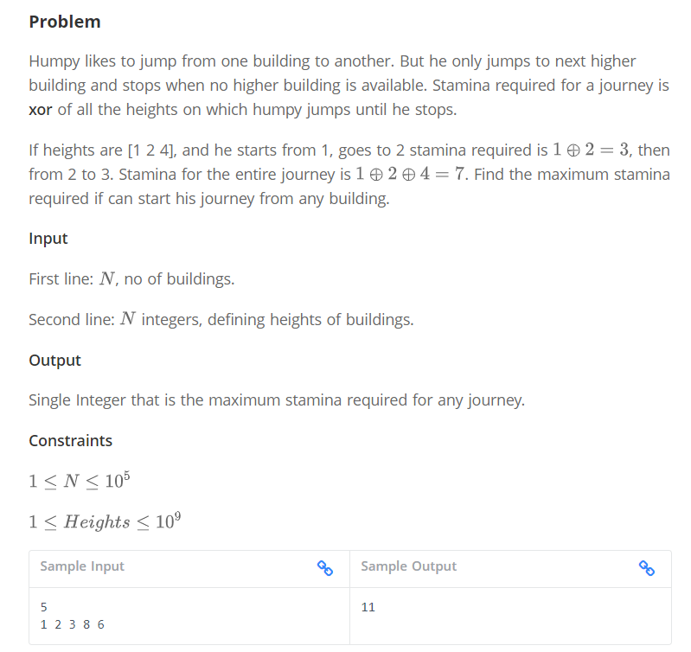

**Explanation**

If he starts from building 1, the stamina required is 1 ^ 2 ^ 3 ^ 8 = 8

From the building 2, the stamina required is 2 ^ 3 ^ 8 = 9

From the building 3, the stamina required is 3 ^ 8 = 11

Similarly, from 8 and 6, stamina required are 8 and 6 respectively.

The maximum stamina required for the journey is from building 3 is 11.

So the answer is 11.

PROBLEM-4

[A Game of Numbers | Practice Problems (hackerearth.com)](https://www.hackerearth.com/practice/data-structures/stacks/basics-of-stacks/practice-problems/algorithm/a-game-of-numbers-1-5d3a8cb3/)

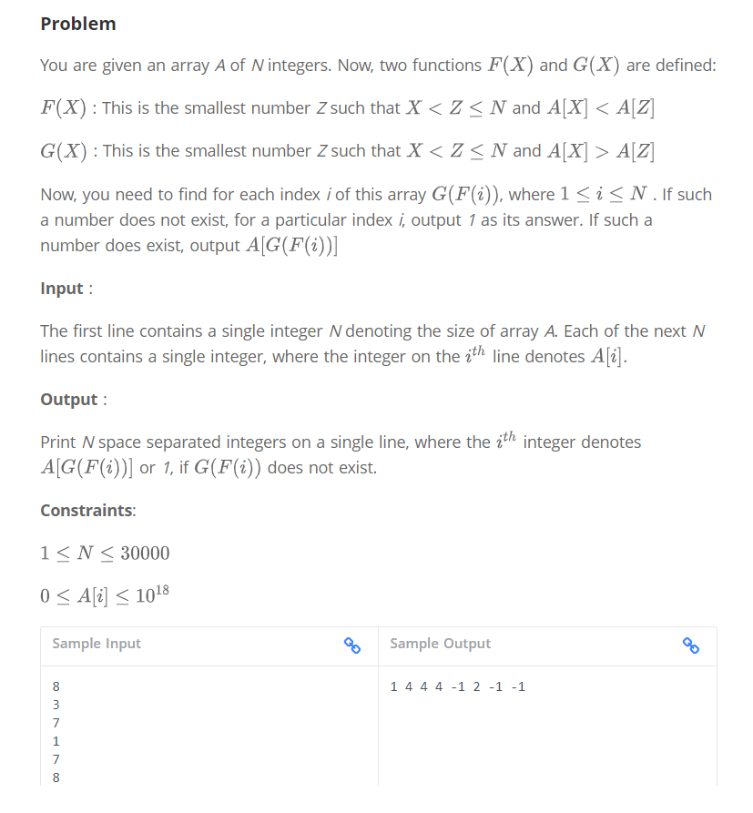

PROBLEM-5

[Holiday decorations | Practice Problems (hackerearth.com)](https://www.hackerearth.com/practice/data-structures/queues/basics-of-queues/practice-problems/algorithm/holiday-decorations-b53daa12/)

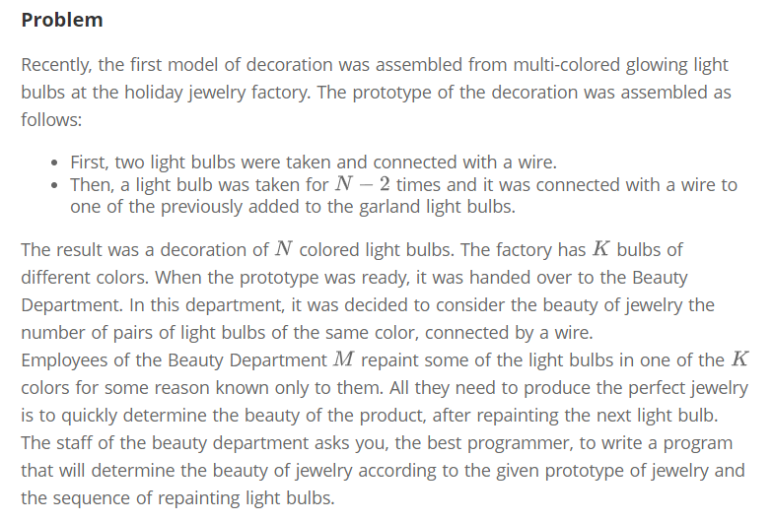

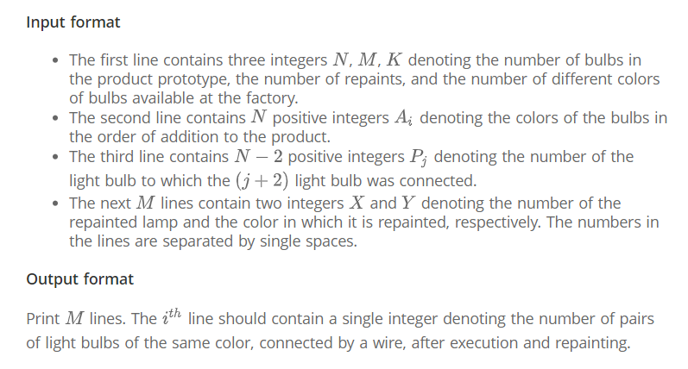

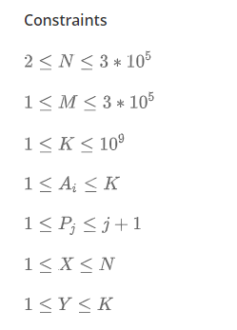

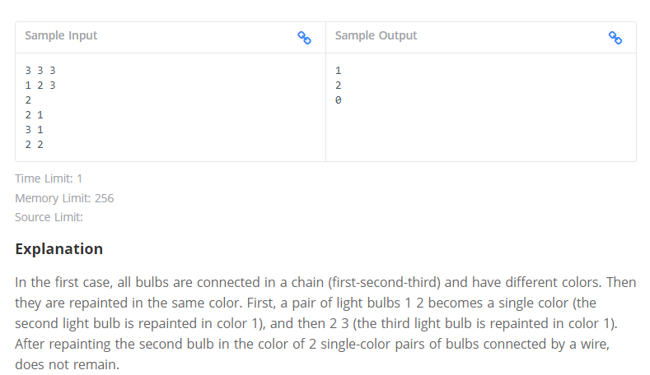

PROBLEM-6

[Disk tower | Practice Problems (hackerearth.com)](https://www.hackerearth.com/practice/data-structures/queues/basics-of-queues/practice-problems/algorithm/disk-tower-b7cc7a50/)

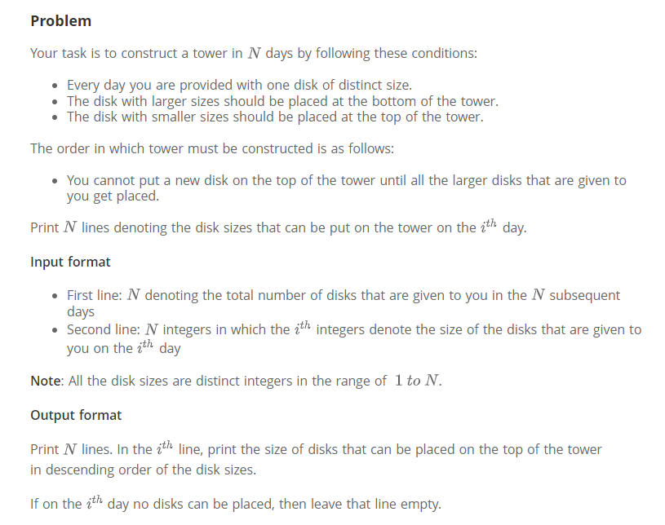

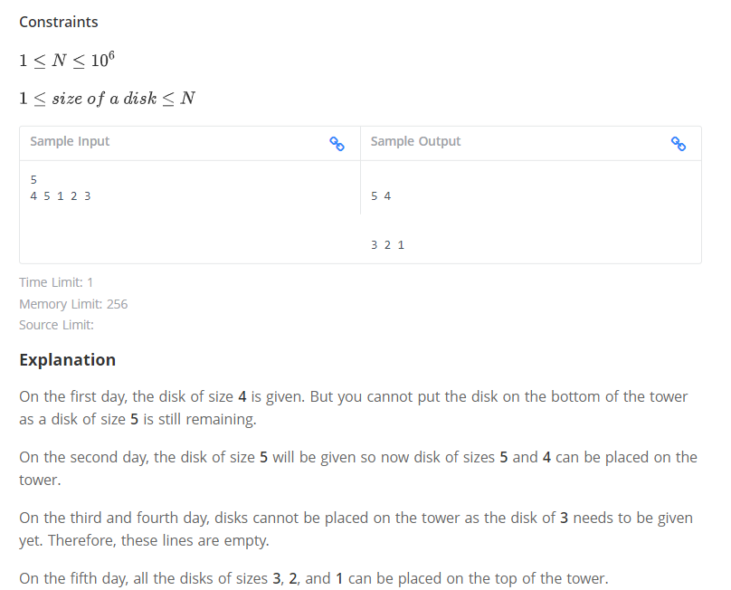

PROBLEM-7

[Empty arrays | Practice Problems (hackerearth.com)](https://www.hackerearth.com/practice/data-structures/queues/basics-of-queues/practice-problems/algorithm/empty-array-31ed638c/)

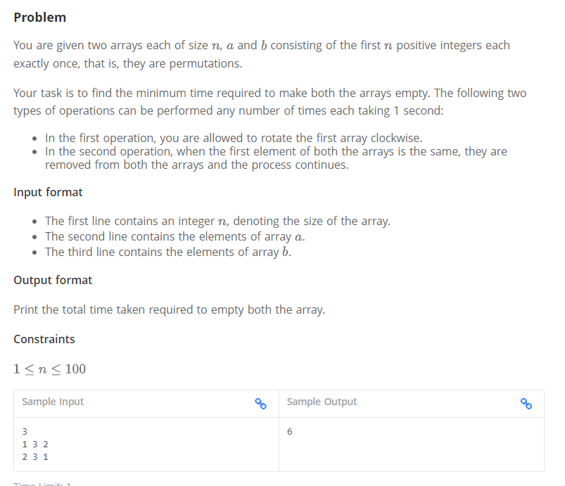

**Explanation**

Perform operation 1 to make a = 3, 2, 1

Perform operation 1 to make a = 2, 1, 3

Now perform operation 2 to make a = 1, 3 and b = 3, 1

Perform operation 1 to make a = 3, 1

Now perform operation 2 to make a = 1 and b =  1

Now perform operation 2 to make a = {} and b =  {}

PROBLEM-8

[Number Recovery | Practice Problems (hackerearth.com)](https://www.hackerearth.com/practice/data-structures/queues/basics-of-queues/practice-problems/algorithm/number-recovery-0b988eb2/)

