Date:

EXPERIMENT-12

Aim:

Develop a program to find minimum cost spanning tree of a graph.

Description:
Spanning Tree:

Given an undirected and connected graph G=(V,E), a spanning tree of the graph G is a tree that spans G (that is, it includes every vertex of G ) and is a subgraph of G (every edge in the tree belongs to G )

Minimum Spanning Tree:

The cost of the spanning tree is the sum of the weights of all the edges in the tree. There can be many spanning trees. Minimum spanning tree is the spanning tree where the cost is minimum among all the spanning trees. There also can be many minimum spanning trees.

Minimum spanning tree has direct application in the design of networks. It is used in algorithms approximating the travelling salesman problem, multi-terminal minimum cut problem and minimum-cost weighted perfect matching.

Other practical applications are:
- Cluster Analysis
- Handwriting recognition
- Image segmentation

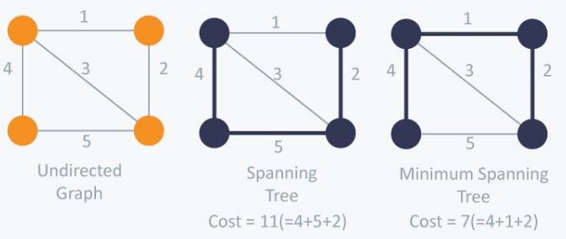

There are two famous algorithms for finding the Minimum Spanning Tree:

Kruskal’s Algorithm:

The Algorithm builds the spanning tree by adding edges one by one into a growing spanning tree. Kruskal's algorithm follows greedy approach as in each iteration it finds an edge which has least weight and add it to the growing spanning tree.

Algorithm Steps:

- Sort the graph edges with respect to their weights.
- Start adding edges to the MST from the edge with the smallest weight until the edge of the largest weight.
- Only add edges which doesn't form a cycle , edges which connect only disconnected components.

Prim’s Algorithm:

The Algorithm also use Greedy approach to find the minimum spanning tree. In Prim’s Algorithm we grow the spanning tree from a starting position. Unlike an edge in Kruskal's, we add vertex to the growing spanning tree in Prim's.

Algorithm Steps:

- Maintain two disjoint sets of vertices. One containing vertices that are in the growing spanning tree and other that are not in the growing spanning tree.
- Select the cheapest vertex that is connected to the growing spanning tree and is not in the growing spanning tree and add it into the growing spanning tree. This can be done using Priority Queues. Insert the vertices, that are connected to growing spanning tree, into the Priority Queue.
- Check for cycles. To do that, mark the nodes which have been already selected and insert only those nodes in the Priority Queue that are not marked.

Program & Output for Test Cases given below:

Test Cases for Minimum Cost Spanning Tree:

Activity | Executed /  Not Executed
Display the MST of a graph using any one of above algorithm

Result:
Thus the program to find minimum cost spanning tree of a graph is completed.

Questions:

- Define spanning tree?
- List the applications of spanning trees?

