P.V.P Siddhartha Institute of Technology
Department of Computer Science and Engineering
Course: B. Tech | Year: II | Semester: I | CLASS : II CSE S1 | A.Y:2023-24
Subject Code: 20ES1305 | Subject Name: DATA STRUCTURES |  |  | Regulation:PVP20
INNOVATIVE TEACHING METHODOLOGY

S.No | ACTIVITY/WORK | CO | LEVEL | PO
1. | QUIZ: Students are given question in the platform quizizz.com to answer the questions. Questions are also taken from previous GATE papers.  Unit No – Quiz No No of Questions  Unit-1 Quiz-1 19  Unit-1 Quiz-2 16  Unit-1 Quiz-3 14  Unit-1 Quiz-4 18  Unit-2 Quiz-1 10  Unit-2 Quiz-2 13  Unit-2 Quiz-3 10  Unit-3 Quiz-1 16  Unit-3 Quiz-2 12  Unit-4 Quiz-1 20  Unit-4 Quiz-2 20  Unit-5 Quiz-1 15 | CO1 | L2 | PO1, PO5,  PO12
 | 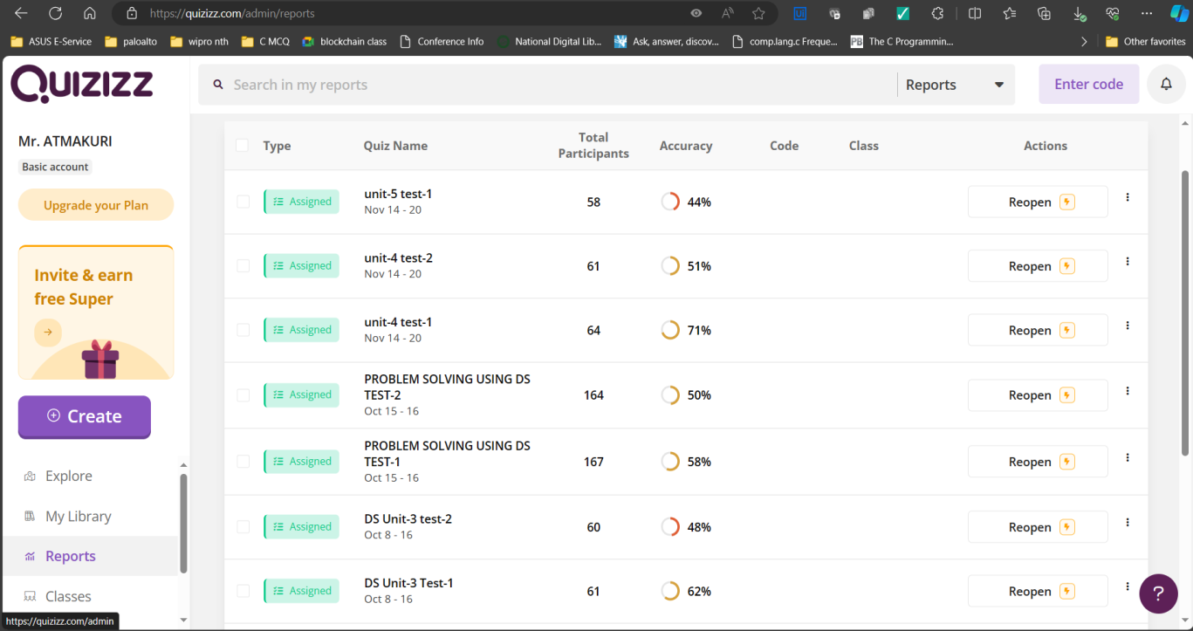
2. | SLIP TEST: Students are given questions to self access their knowledge.  In Unit-1, 3 Sets of Paper are designed to cover all the topics.  In Unit-2, 4 Sets of Paper are designed to cover all the topics. | CO1,CO2,CO3 | L2,L3 | PO1,  PO10,  PO12,  PSO1
3. | Programming Test: Students are given problem statements to solve which access the application of the concepts learned.  Unit-1, Problems on Sorting. Total 8 Problems.  Unit-2, Problems on Linked List. Total 4 Problems.  Unit-3, Problems on Stacks and Queues. Total 8 Problems. | CO2,CO3,  CO4 | L2,L3,  L4 | PO1,  PO2,  PO5,  PO9,  PO10,  PO12,  PSO1
4. | Additional Experiments as Team Work: 18 enthusiastic, visionary students are given a set of programs that cover the concepts of all units which are of easy, medium, hard level.  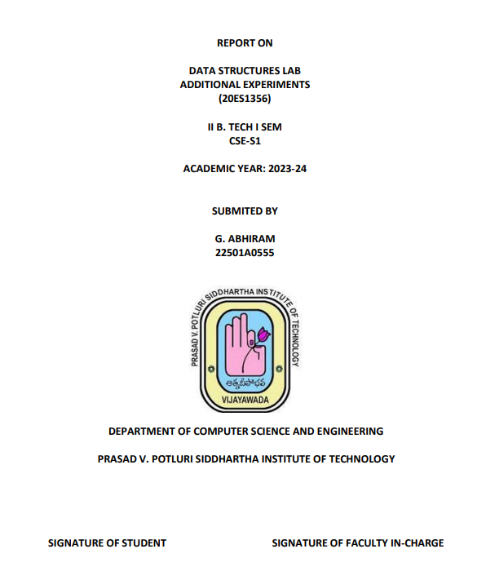 | CO2,CO3,  CO4 | L2,L3,  L4 | PO1,  PO2,  PO5,  PO8,  PO9,  PO10,  PO12,  PSO1
5. | Video Presentation: Students are given choice to select a problem statement or topic in Data Structures and explain it. They are given instructions to record and submit it. 61 students have submitted the task. This will help students to improve their overall development in terms of technical and soft skills. | CO1,  CO2,CO3,  CO4 | L2,L3,  L4 | PO1,  PO2,  PO5,  PO8,  PO9,  PO10,  PO12,  PSO1
 | 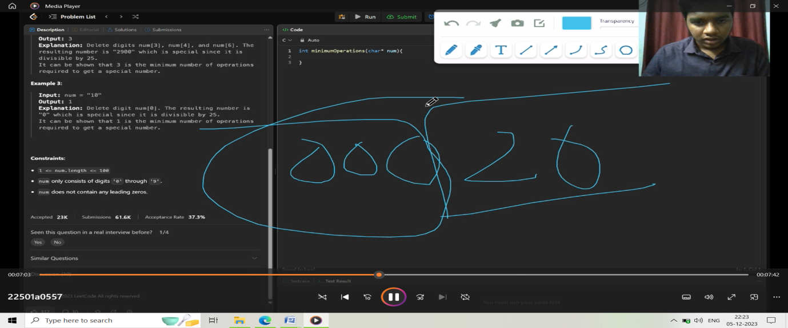
6. | Coding Contests: Students are encouraged to practice problems and participate in various coding contests in different coding platforms. 64 students have participated regularly in the contests and few achieved badges and are having a good score.  Platforms: Codechef, Leetcode, Hackerrank, GeeksforGeeks  Students are encouraged to update their achievements in LinkedIn and projects in Github. | CO1,  CO2,CO3,  CO4 | L2,L3,  L4 | PO1,  PO2,  PO5,  PO8,  PO9,  PO10,  PO12,  PSO1
 | 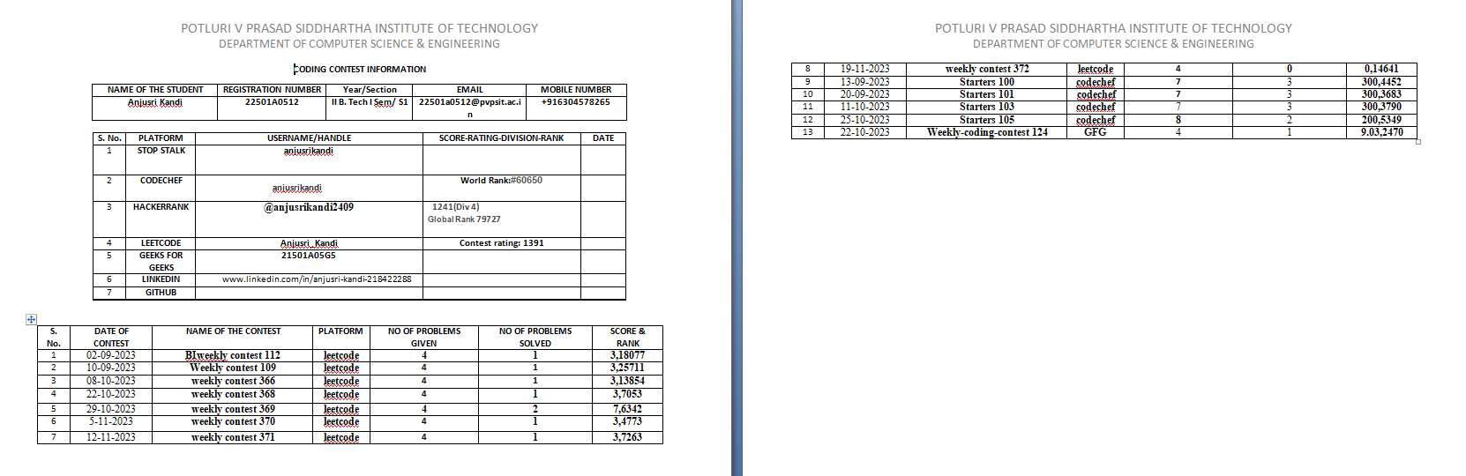
7. | FLIP CLASS: Students are encouraged to deliver the concepts in the class using blackboard and presentations.  Topics: Sorting, Linked List, Queues, Binary Search Trees, Graphs | CO1 | L2 | PO1,  PO9,  PO10
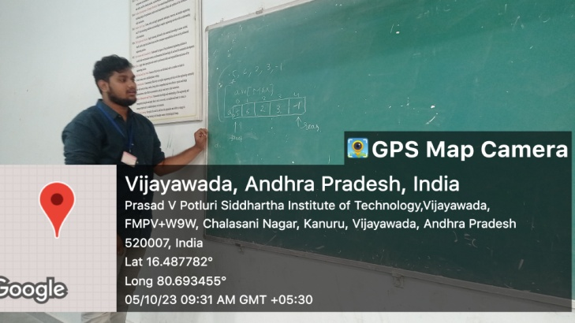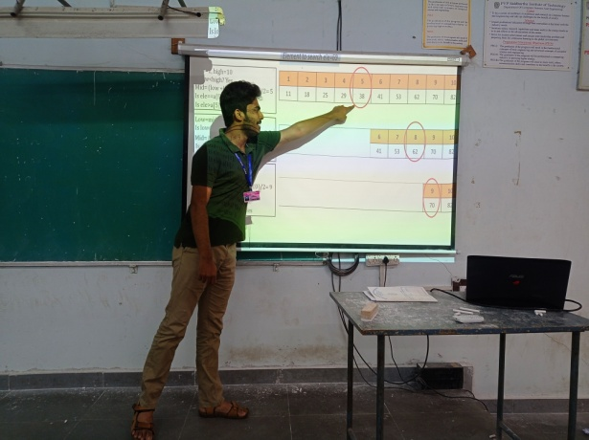

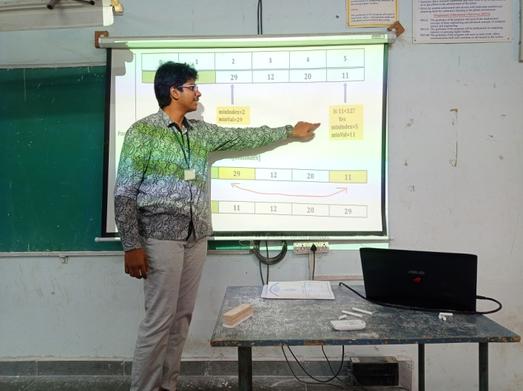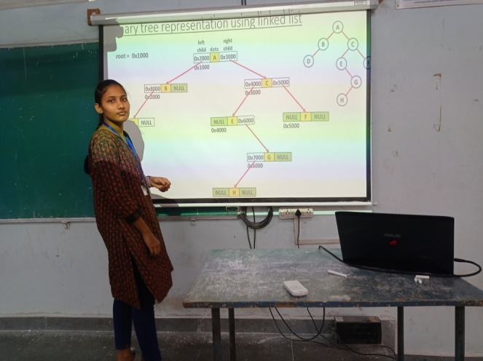
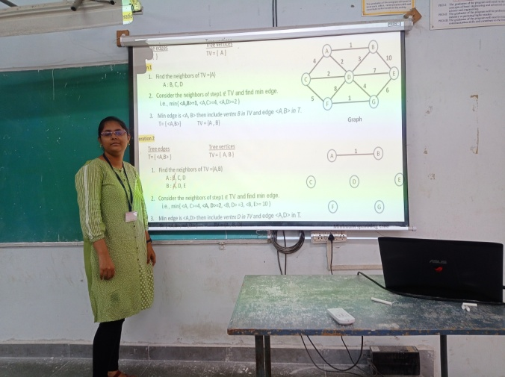

8. | ROLE PLAY: A team of students have participated to demonstrate the working of a Singular Linked List. | CO1 | L2 | PO1,  PO9,  PO10
 | 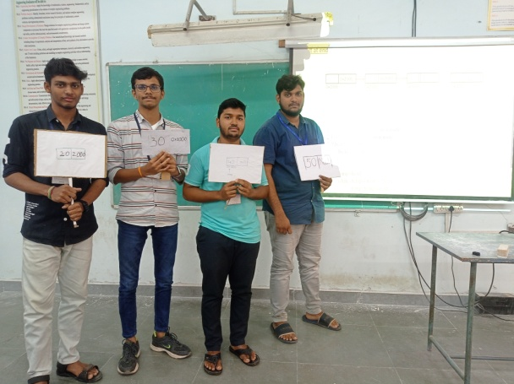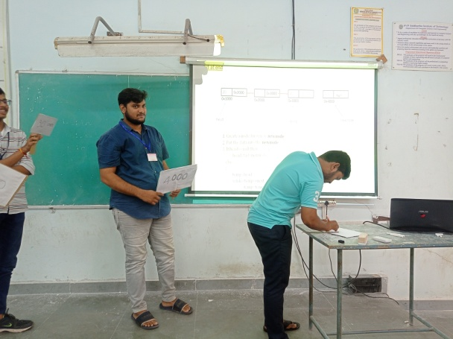
9. | Industry-Institute Interaction: Training to students by BYTS India Pvt. Ltd on Stacks, Queues, and Trees using Linked Lists in the month of October. | CO1,  CO2,CO3,  CO4 | L2,L3,  L4 | PO1,  PO2,  PO5,  PO8,  PO9,  PO10,  PO12,  PSO1
 | 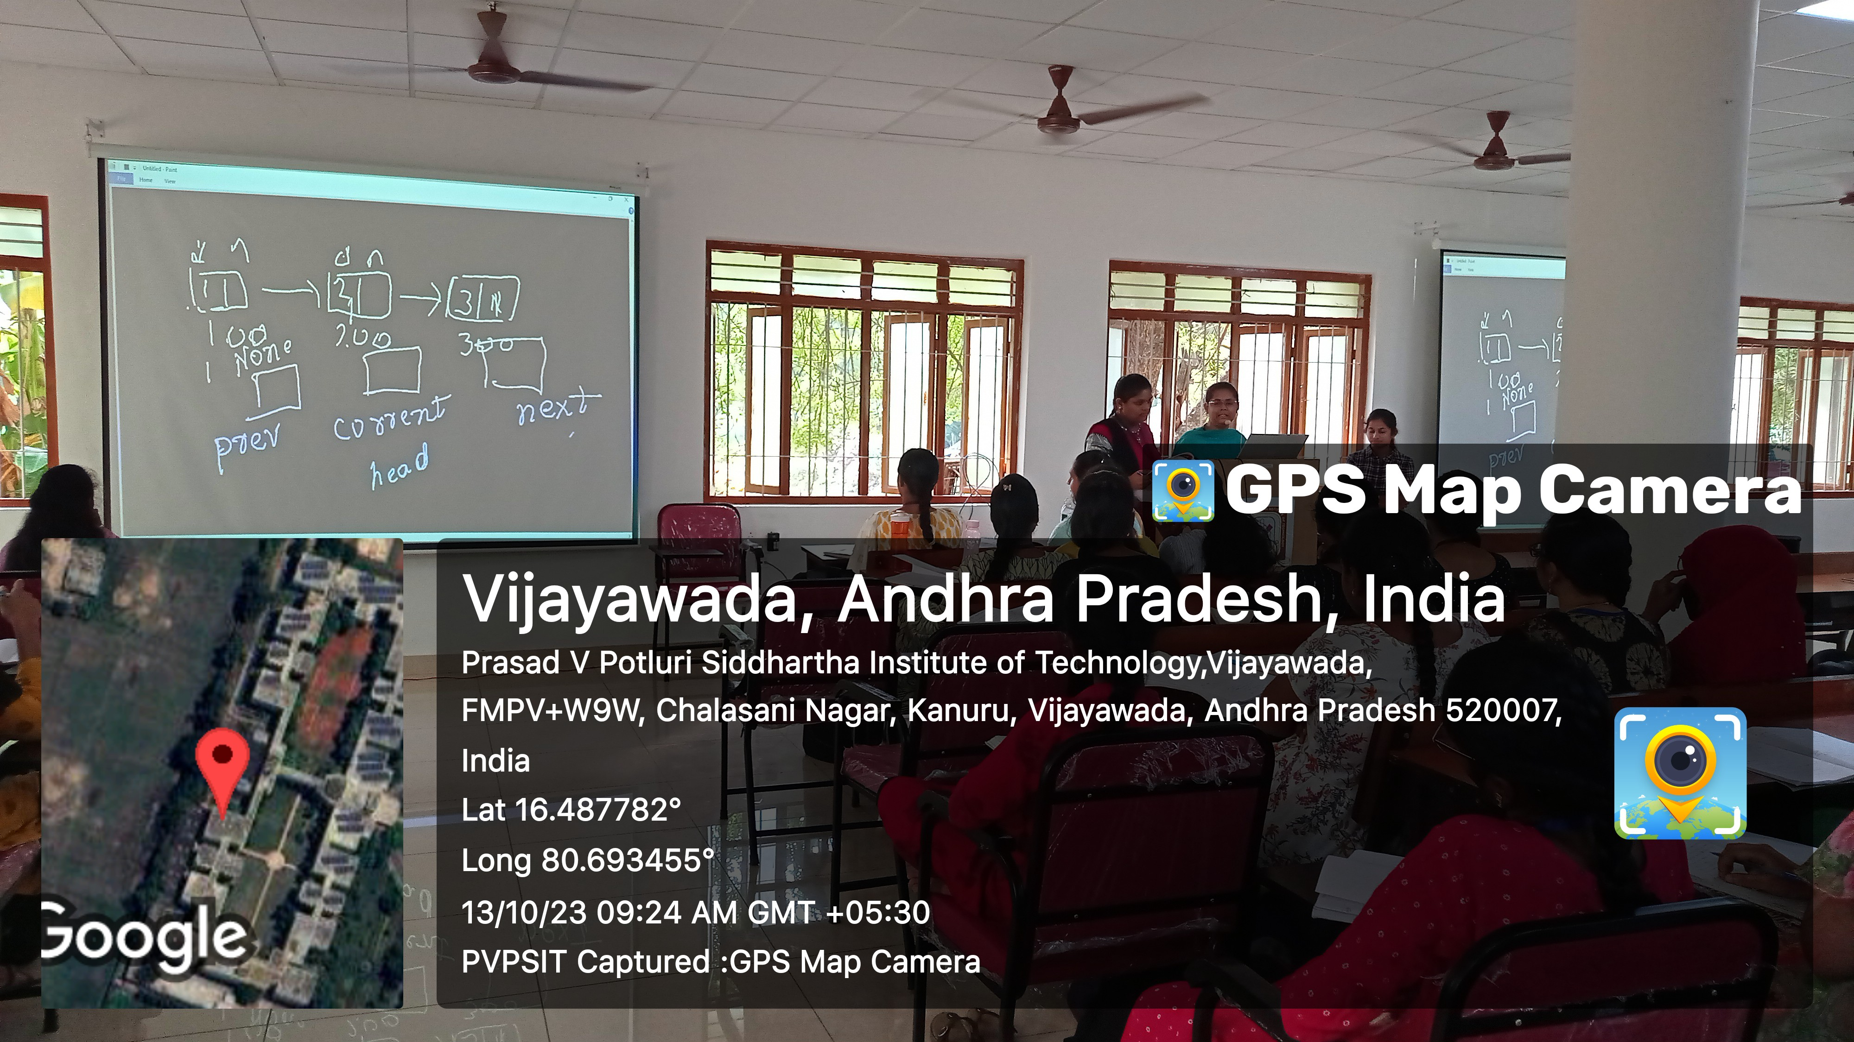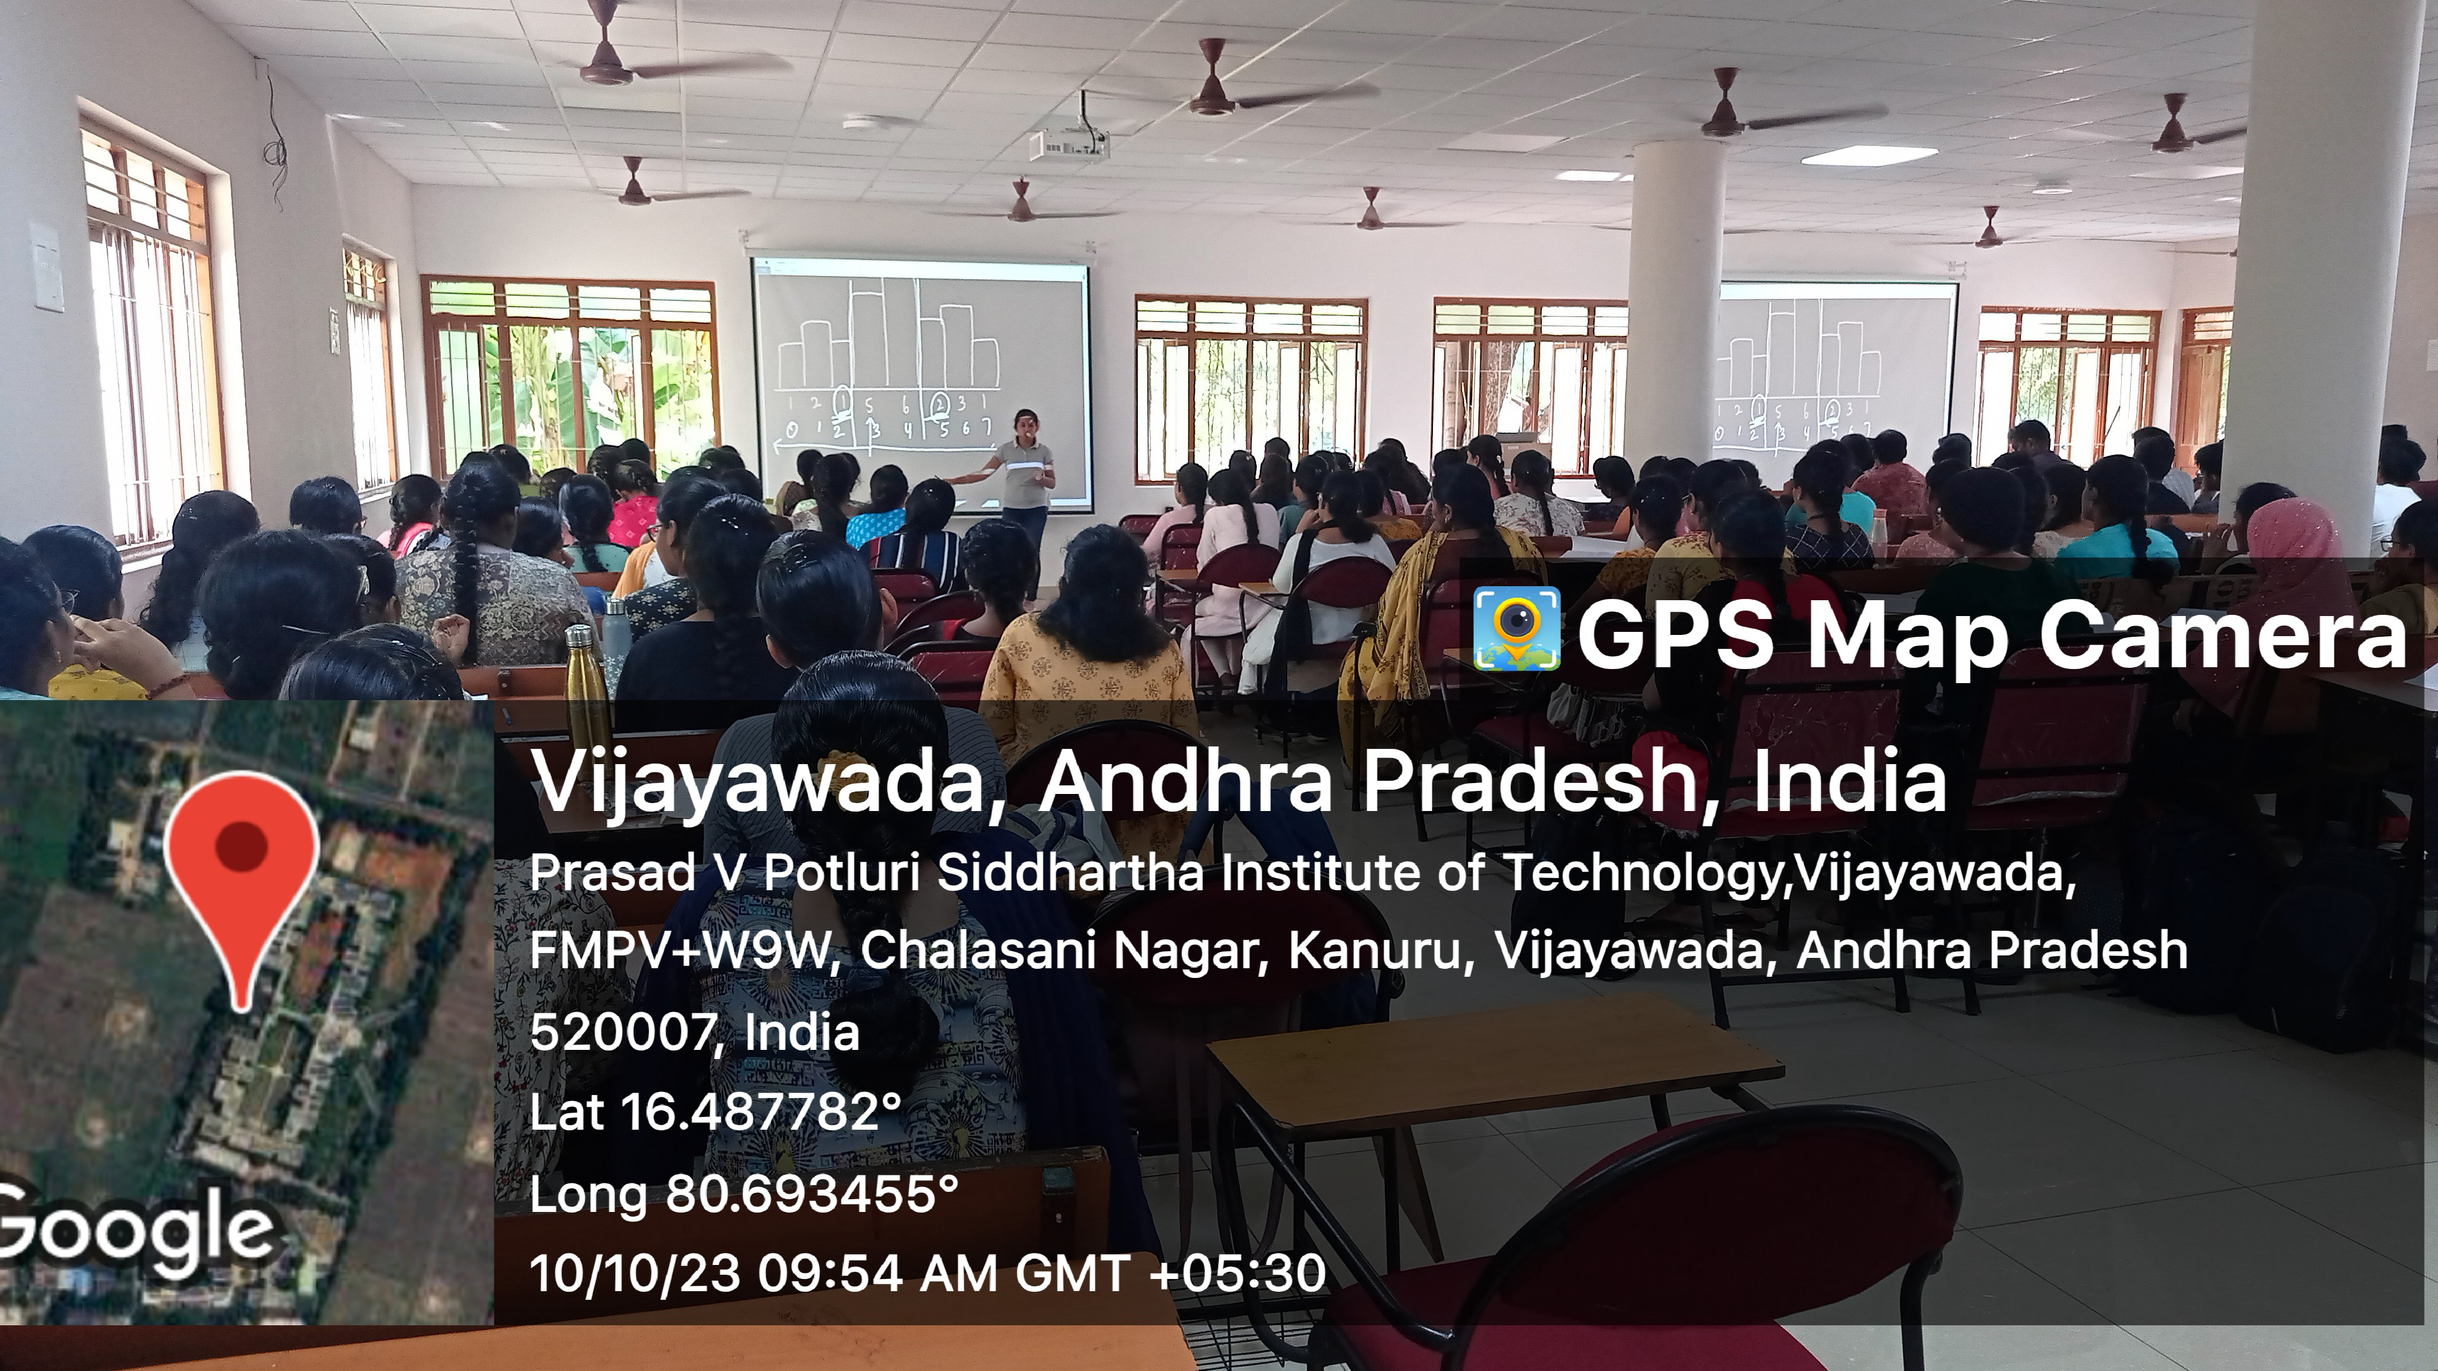

SIGNATURE OF COURSE COORDINATOR
(Mr. Prashant Atmakuri)

