Deadlock: Application in Satellites

Deadlock in Operating Systems occurs when processes are stuck waiting for resources held by each other, and in satellite systems this can cause mission-critical failures such as halted communication, navigation, or data processing. Preventing deadlock in satellites is vital because recovery options are limited once deployed in space.

Deadlock Concept in Operating Systems
- Definition: Deadlock is a state where two or more processes cannot proceed because each is waiting for a resource held by another.
- Necessary Conditions (Coffman conditions):
  - Mutual Exclusion – Resources cannot be shared simultaneously.
  - Hold and Wait – Processes hold resources while waiting for others.
  - No Preemption – Resources cannot be forcibly taken away.
  - Circular Wait – A closed chain of processes exists, each waiting for a resource held by the next.
- Example: Process P1 holds Resource R1 and requests R2, while Process P2 holds R2 and requests R1. Neither can proceed, causing deadlock. GeeksForGeeks

Deadlock Handling Techniques
- Prevention: Break one of the four conditions (e.g., avoid circular wait by ordering resource requests).
- Avoidance: Use algorithms like Banker’s Algorithm to ensure safe resource allocation.
- Detection & Recovery: Monitor resource allocation graphs and terminate/restart processes if deadlock occurs. JETIR

Application in Satellites
Satellites are highly resource-constrained systems where deadlock can be catastrophic. Examples include:
- Communication Systems
  - Multiple subsystems (antenna control, signal processing, telemetry) may compete for shared communication channels.
  - Deadlock could freeze data transmission, cutting off contact with ground stations.
- Onboard Computers
  - Satellites run real-time operating systems (RTOS) to manage tasks like navigation, thermal control, and payload operations.
  - Deadlock in task scheduling could halt critical functions such as orbit correction or solar panel alignment.
- Resource Management
  - Limited hardware (CPU cycles, memory, sensors) must be shared among many processes.
  - Deadlock could prevent execution of high-priority tasks like collision avoidance or power management.
- Autonomous Operations
  - Modern satellites often operate autonomously for long periods.
  - Deadlock prevention is crucial since manual intervention is impossible once in orbit.

Strategies Used in Satellite Systems
- Static Resource Allocation: Predefine resource usage to avoid circular waits.
- Priority Scheduling: Assign higher priority to mission-critical tasks (e.g., attitude control).
- Watchdog Timers: Detect stalled processes and reset them to recover from potential deadlocks.
- Redundancy: Duplicate critical subsystems to ensure continued operation if one process fails. mohitmishra786.github.io

Key Takeaway
Deadlock is a fundamental OS problem, but in satellites it becomes a mission-critical risk. Preventive strategies like static allocation, priority scheduling, and watchdog monitoring are essential because once a satellite is in orbit, deadlock recovery is extremely limited.
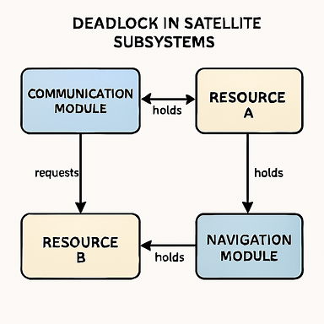
In this example:
- The Communication Module holds one resource (say, the antenna) but requests another (processor).
- The Navigation Module holds the processor but requests the antenna.
- This creates a circular wait, locking both modules in deadlock.
This kind of situation highlights why satellites rely on static resource allocation, priority scheduling, and watchdog timers to prevent such deadlocks — because once in orbit, manual intervention isn’t possible.

🔧 Breakdown of Strategies by Subsystem
Subsystem | Strategy Applied | Purpose
Communication Module | Static Resource Allocation | Predefines resource usage to avoid circular waits
Thermal Control | Watchdog Timers | Detects stalled processes and resets them to prevent system freeze
Navigation Module | Priority Scheduling | Ensures critical tasks (e.g., orbit correction) are executed first
Payload Operations | Redundancy | Duplicates key systems to maintain function if one process deadlocks
These strategies are essential because satellites operate autonomously in space, where manual recovery is impossible. By embedding these techniques into the onboard OS and control logic, engineers ensure continuous, reliable operation even under resource contention.

