**P.V.P Siddhartha Institute of Technology(Autonomous)**

**Department of Computer Science and Engineering**

**MACHINE LEARNING IV CSE SEM-II**

**MID-I Answers Academic Year : 2024-25**

1. **Construct a decision tree for the following example and Classify whether the person gets the Job offer or Not. (CO1-L2) (5M)**

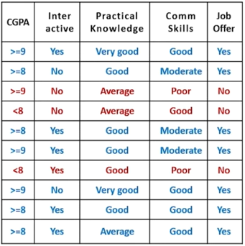

### Ans: Step 1: Dataset Overview

We have the following **attributes**:

* **CGPA**: (>=9, >=8, <8)
* **Interactive**: (Yes, No)
* **Practical Knowledge**: (Very good, Good, Average)
* **Communication Skills**: (Good, Moderate, Poor)
* **Job Offer** (Target): (Yes, No)

We have **10 instances** total.

**Step 2: Count Total Positives and Negatives**

* **Job Offer = Yes** → 7 records
* **Job Offer = No** → 3 records

**Step 3: Calculate Entropy of the Entire Dataset (S)**

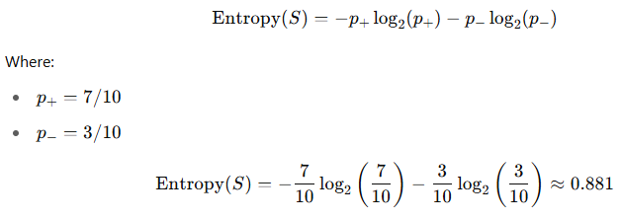

### Step 4: Choose Best Attribute Using Information Gain

We compute Information Gain for each attribute and choose the one with **highest gain**.

### Example Calculation: Attribute = CGPA

**CGPA Values:**

* >=9: 3 (Yes), 0 (No) → Entropy = 0
* >=8: 3 (Yes), 0 (No) → Entropy = 0
* <8: 1 (Yes), 3 (No) → Entropy:

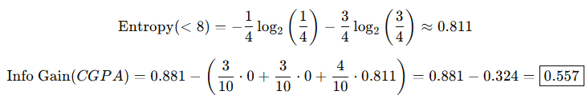

### Try Next Attribute: Interactive

* Yes: 5 Yes, 1 No → Entropy ≈ 0.650
* No: 2 Yes, 2 No → Entropy = 1.0

Clearly, CGPA gives better gain.

### Step 5: Root Node = CGPA

We use **CGPA** as the root node.

### Build Branches from CGPA

#### Branch 1: CGPA = >=9 → All Yes → ****Leaf Node: Yes****

#### Branch 2: CGPA = >=8 → All Yes → ****Leaf Node: Yes****

#### Branch 3: CGPA = <8 → 1 Yes, 3 No

Subset:

* (Interactive: No, Practical: Average, Comm: Good) → No
* (Interactive: Yes, Practical: Good, Comm: Poor) → No
* (Interactive: No, Practical: Average, Comm: Good) → No
* (Interactive: Yes, Practical: Average, Comm: Good) → Yes

Let’s calculate gain on this subset.

### Subset: Attribute = Interactive (on CGPA < 8)

* Yes: 1 Yes, 1 No → Entropy = 1
* No: 0 Yes, 2 No → Entropy = 0



Let’s use **Interactive** for CGPA < 8 split.

### Continue Tree: Branch CGPA < 8 → Split on Interactive

#### Branch 3.1: Interactive = No → Both No → Leaf: No

#### Branch 3.2: Interactive = Yes → 1 Yes, 1 No

Now split this on **Comm Skills or Practical Knowledge**.

Try **Comm Skills**:

* Poor → No
* Good → Yes → Perfect split

**2a) Identify the differences between Biological Neuron and Artificial Neuron.(CO-2)(L3) 2M**

**Ans:** 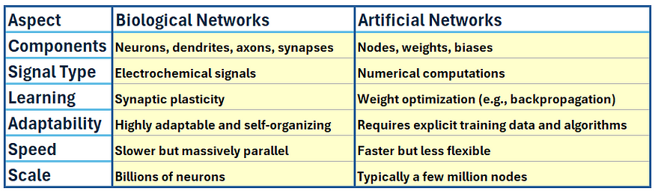

**2b)** Solve a given problem using back-propagation algorithm and perform the updated weight of W**35**.(Use sigmoid activation function =1/1+e-x)(**CO-2)(L3)(3M)**

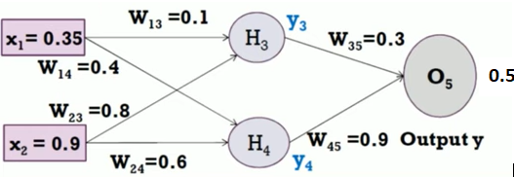

**Ans:** We are given a neural network and asked to perform **backpropagation** to update weight **W35W_{35}W35​** using the **sigmoid activation function**:

### ****Given Values:****

* **Inputs:**
  + x1=0.35x_1 = 0.35x1​=0.35
  + x2=0.9x_2 = 0.9x2​=0.9
* **Weights:**
  + W13=0.1W_{13} = 0.1W13​=0.1, W23=0.8W_{23} = 0.8W23​=0.8
  + W14=0.4W_{14} = 0.4W14​=0.4, W24=0.6W_{24} = 0.6W24​=0.6
  + W35=0.3W_{35} = 0.3W35​=0.3 ⬅️ (to be updated)
  + W45=0.9W_{45} = 0.9W45​=0.9
* **Target Output t=0.5t = 0.5t=0.5**
* **Activation Function (Sigmoid):**

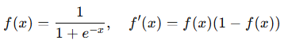

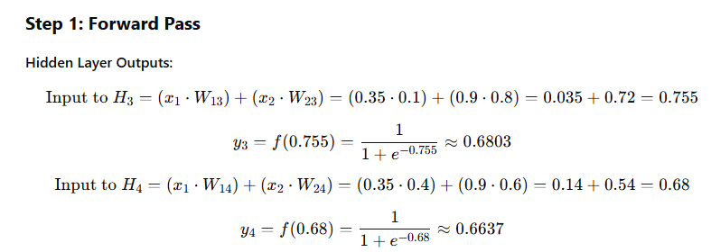

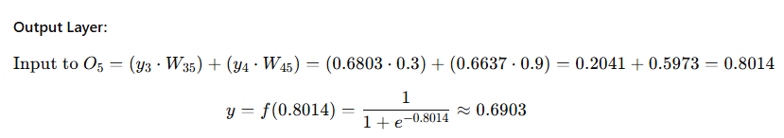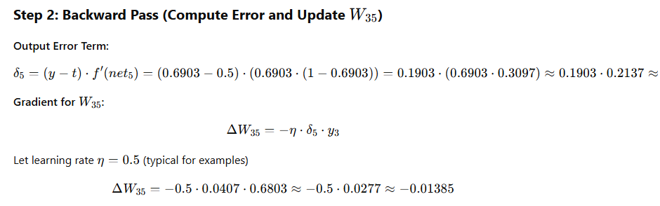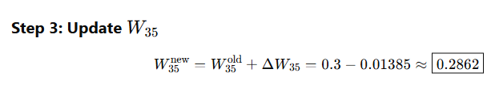

**3)** Apply Naïve Bayes Algorithm and predict if an accident will happen or Not?

{**Weather Condition -Rain, Road Condition =Good, Traffic Condition = Normal, Engine Problem= No, Accident=?} (CO2-L3)(5M)**

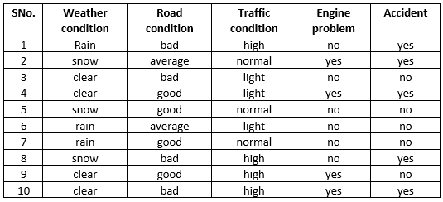

### Ans: ****Step 1: Dataset Summary****

We need to calculate the **prior** and **likelihood** for each class.

#### Target: Accident = {yes, no}

### ****Step 2: Count Totals****

#### Total Records: 10

* **Accident = yes** → 5 instances (Rows: 1, 2, 8, 9, 10)
* **Accident = no** → 5 instances (Rows: 3, 4, 5, 6, 7)

**Step 3: Calculate Prior Probabilities**

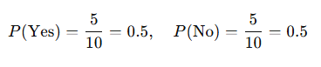

### Step 4: Likelihoods for Given Conditions

### 

### Step 5: Apply Naïve Bayes Formula

### 

### Step 6: Normalize Probabilities (Optional for Classification)

### 

### Final Prediction:



Based on the Naïve Bayes algorithm, **no accident is predicted** for the given conditions.