# Case Study – Hospital Management System

Whenever a new patient is either admitted or comes for outdoor check-up, a unique patient id is generated after storing the name, address and date of birth of the patient. For further visits, the patient uses his unique id. There are several departments in the Hospital. A department characterized by a unique id, name, floor number and total workers. The doctors have a unique employee id, and their name, address, contact number, qualifications are stored with this id. Similarly other workers like nurses, ward boys, ambulance drivers also have a unique employee id. Also, each worker is characterized by name, address and type. Doctors and workers can be associated with multiple departments with different schedules. Whenever patient is admitted in the hospital various details are recorded. The patient id, name and address are stored, the department number and name in which the patient is admitted along with the bed number and room number is also stored. Also, for every patient, a senior doctor and junior doctor are appointed. The details of the doctors, like name, id, contact number is recorded. The prescribed medicines are also stored for a patient. In case of outdoor checkups, the patient id is stored, along with the department number, the employee id of the doctor, the prescription and the date of checkup. For emergency duty every night, the employee_id of doctor and the nurse is stored along with the date.

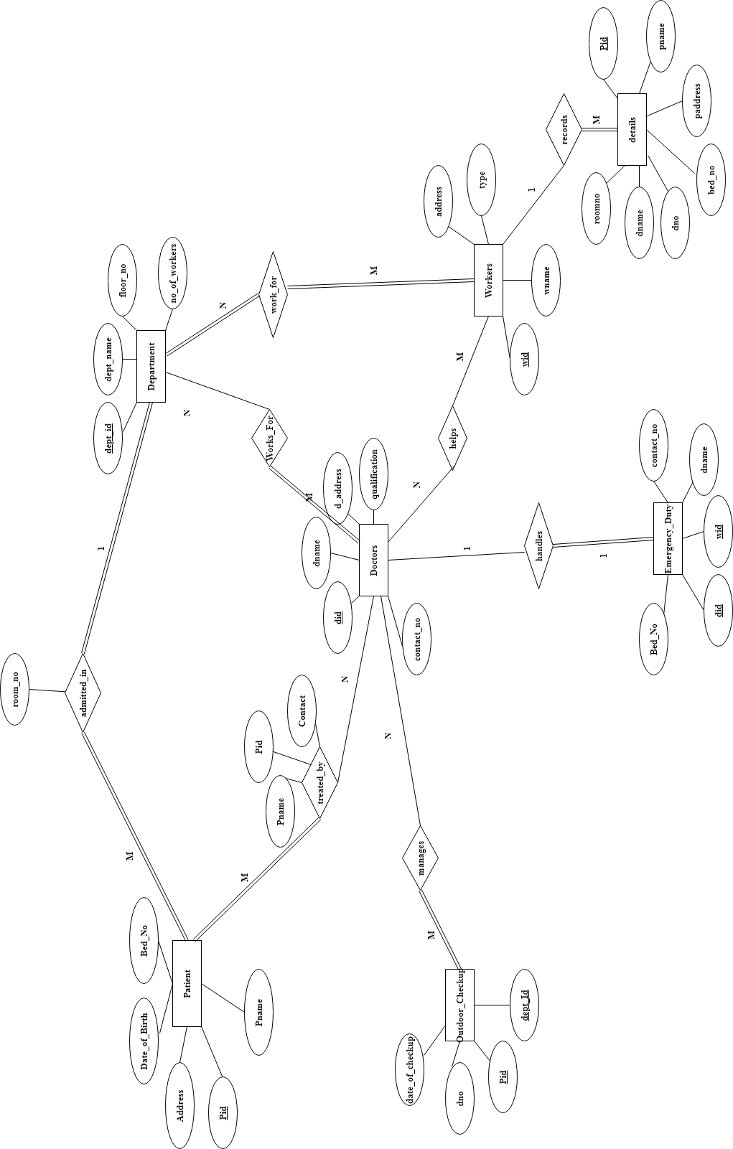

**ER Diagram**

# Relational Schema

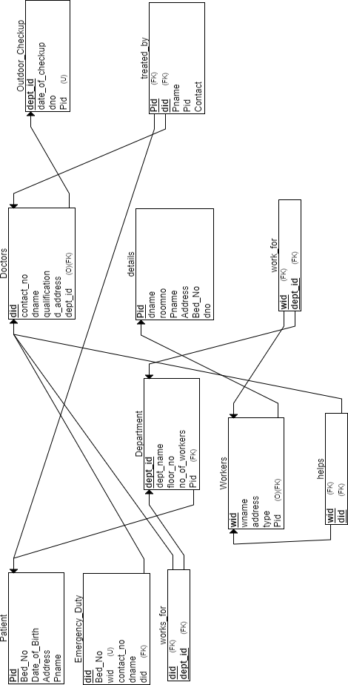

**SQL Queries**

drop database hospital; create database hospital; use hospital;

create table Patient(Bed_No int, Date_of_Birth varchar(20), Address varchar(20), Pname varchar(20), Pid int, primary key(Pid));

desc Patient;

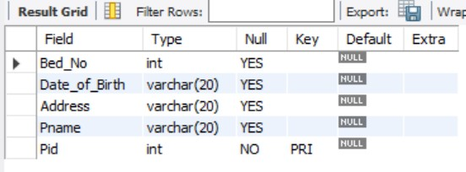

create table Department(dept_name varchar(20), floor_no int, dept_id int, no_of_workers int, Pid int, primary key(dept_id), FOREIGN KEY (Pid) REFERENCES Patient(Pid) );

desc Department;

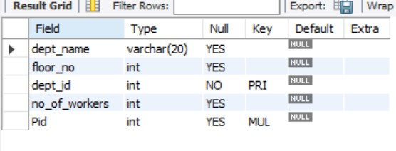

CREATE TABLE Outdoor_Checkup(date_of_checkup varchar(20),dno int, dept_id int, Pid int, PRIMARY KEY (dept_id), UNIQUE (Pid) );

desc Outdoor_Checkup;

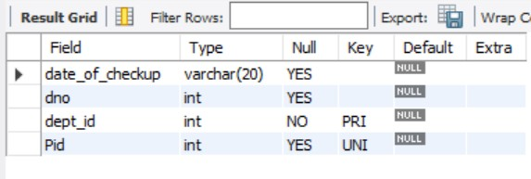

CREATE TABLE details (dname varchar(20), roomno int, Pid int,

Pname varchar(20), Address varchar(20), Bed_No int, dno int, PRIMARY KEY (Pid)); desc details;

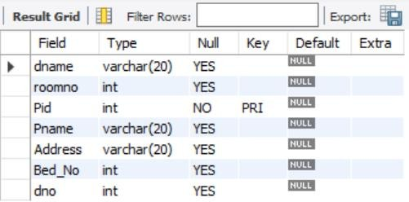

CREATE TABLE Doctors(did int, contact_no int, dname varchar(20),

qualification varchar(40), d_address varchar(20), dept_id int, PRIMARY KEY (did), FOREIGN KEY (dept_id) REFERENCES Outdoor_Checkup(dept_id));

desc Doctors;

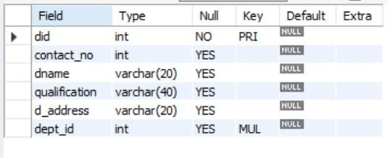

CREATE TABLE Emergency_Duty(Bed_No int, wid int, contact_no int, dname varchar(20),

did int, PRIMARY KEY (did), FOREIGN KEY (did) REFERENCES Doctors(did), UNIQUE (wid) );

desc Emergency_Duty;

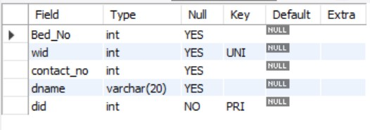

CREATE TABLE Workers(wname varchar(20),wid int,address varchar(20), type varchar(20), Pid int, PRIMARY KEY (wid), FOREIGN KEY (Pid) REFERENCES details(Pid));

desc Workers;

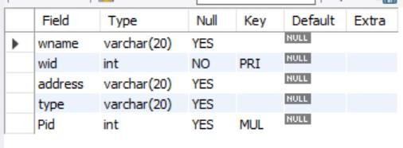

CREATE TABLE treated_by(Pname varchar(20), Pid int, Contact int, did int, PRIMARY KEY (Pid, did), FOREIGN KEY (Pid) REFERENCES Patient(Pid),

FOREIGN KEY (did) REFERENCES Doctors(did));

desc treated_by;

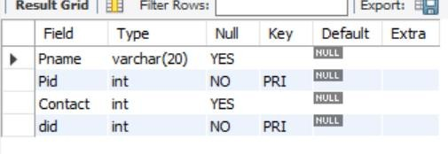

CREATE TABLE works_for(did int,dept_id int,PRIMARY KEY (did, dept_id),

FOREIGN KEY (did) REFERENCES Doctors(did),FOREIGN KEY (dept_id) REFERENCES

Department(dept_id)); desc works_for;

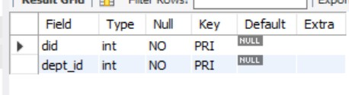

CREATE TABLE helps(wid int,did int,PRIMARY KEY (wid, did),

FOREIGN KEY (wid) REFERENCES Workers(wid), FOREIGN KEY (did) REFERENCES

Doctors(did)); desc helps;

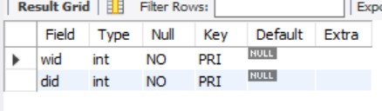

CREATE TABLE work_for(wid int,dept_id int,PRIMARY KEY (wid, dept_id),

FOREIGN KEY (wid) REFERENCES Workers(wid),FOREIGN KEY (dept_id) REFERENCES Department(dept_id));

desc work_for;

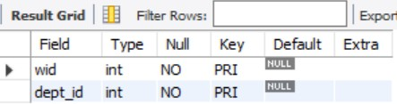

set foreign_key_checks=0;

insert into patient values(1,'21-01-2001','Vijayawada','Mohan',1001); insert into patient values(2,'05-07-1978','Vijayawada','Farooq',1002); insert into patient values(3,'08-12-1989','Guntur','Ramesh',1003);

insert into patient values(4,'04-10-1992','Vishakapatnam','Ravi Kiran',1004); select * from patient;

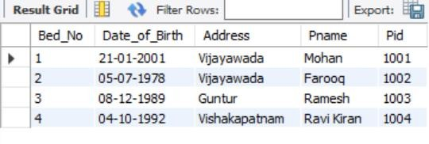

insert into department values('General Medicine',1,2001,50,1001); insert into department values('General Medicine',1,2004,50,1004); insert into department values('Surgery',2,2002,90,1002);

insert into department values('Psychiatry',3,2003,72,1003); select * from department;

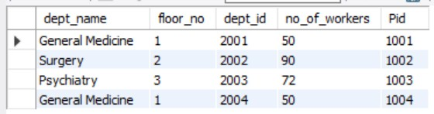

insert into Outdoor_Checkup values('01-01-2022',3,2001,1003); insert into Outdoor_Checkup values('25-12-2021',5,2004,1004); insert into Outdoor_Checkup values('25-12-2021',2,2002,1002); select * from Outdoor_Checkup;

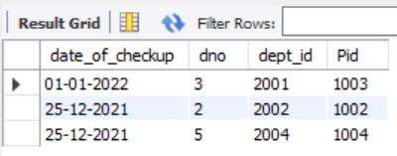

insert into details values('Nithin',501,1001,'Mohan','Vijayawada',3,4);

insert into details values('Siddique',512,1004,'Ravi Kiran','Vishakapatnam',3,1); insert into details values('Radha',210,1002,'Farooq','Vijayawada',2,5);

insert into details values('Michael',106,1002,'Farooq','Vijayawada',5,2); insert into details values('Reshma',309,1003,'Ramesh','Guntur',1,3); select * from details;

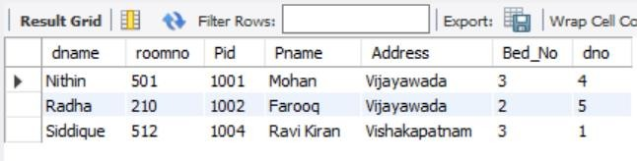

insert into doctors values(1,912345678,'Siddique','Head Chief on Medicine','Hyderabad',2001);

insert into doctors values(2,923546781,'Michael','Surgical attending physician','Chennai',2002);

insert into doctors values(3,987654312,'Reshma','MD Resident','Vijayawada',2003); insert into doctors values(4,896543721,'Nithin','MD Resident','Nellore',2001);

insert into doctors values(5,951234678,'Radha','Attending Psychiatrist','Banglore',2002); select * from doctors;

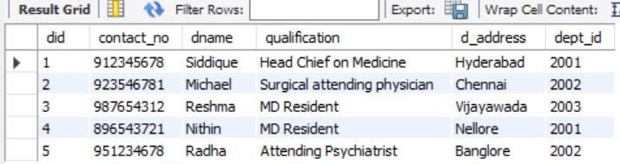

insert into Emergency_Duty values(1,3001,896543721,'Nithin',4); insert into Emergency_Duty values(2,3002,987654312,'Reshma',3); select * from Emergency_Duty;

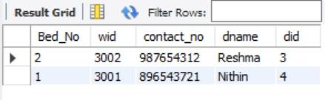

insert into workers values('Venkat',3001,'Vijayawada','Cleaner',1002); insert into workers values('Harika',3002,'Vijayawada','Nurse',1001); insert into workers values('Kumar',3003,'Guntur','Support',1004); select * from workers;

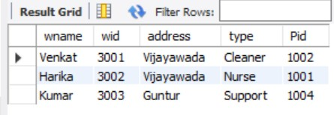

insert into treated_by values('Mohan',1001,896543721,4); insert into treated_by values('Farooq',1002,923546781,2); insert into treated_by values('Ramesh',1003,987654312,3); insert into treated_by values('Ravi Kiran',1004,912345678,1); select * from treated_by;

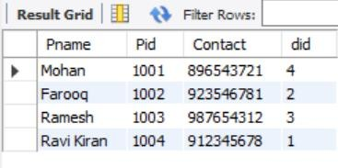

insert into works_for values(1,2001); insert into works_for values(2,2002); insert into works_for values(3,2003); insert into works_for values(4,2001); insert into works_for values(5,2002); select * from works_for;

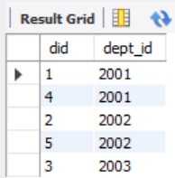

insert into helps values(3001,2); insert into helps values(3002,4); insert into helps values(3003,1); select * from helps;

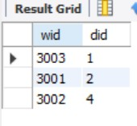

# Simple Queries

update Department set floor_no=2 where pid=1004; select * from Department;

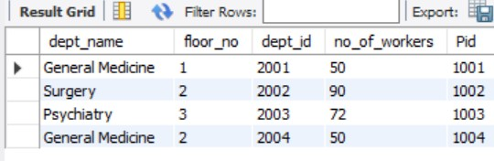

delete from patient where pid = 1004; select * from patient;

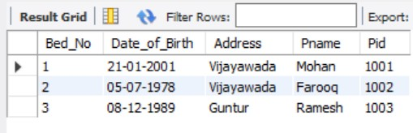

select dept_id,pname from doctors,details where doctors.did=details.dno;

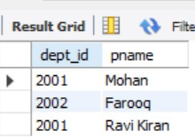

select dname from doctors where did between 2 and 4;

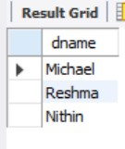

select dname, Pname from details order by roomno;

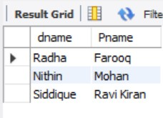

select wname from workers group by address;

