# CASE STUDY 2

Company Database

# DESCRIPTION:

A database is to be designed for a medium sized Company dealing with industrial applications of computers. The Company delivers various products to its customers ranging from a single application program through to complete installation of hardware with customized software. The Company employs various experts, consultants and supporting staff. All personnel are employed on long‐ term basis, i.e. there is no short‐term or temporary staff. Although the Company is somehow structured for administrative purposes (that is, it is divided into departments headed by department managers) all projects are carried out in an inter‐disciplinary way. For each project a project team is selected, grouping employees from different departments, and a Project Manager (also an employee of the Company) is appointed who is entirely and exclusively responsible for the control of the project, quite independently of the Company's hierarchy.

The following is a brief statement of some facts and policies adopted by the Company.

* Each employee works in some department.
* An employee may possess a number of skills
* Every manager (including the MD) is an employee
* A department may participate in none/one/many projects.
* At least one department participates in a project.
* An employee may be engaged in none/one/many projects
* Project teams consist of at least one member.

ER – DIAGRAM:

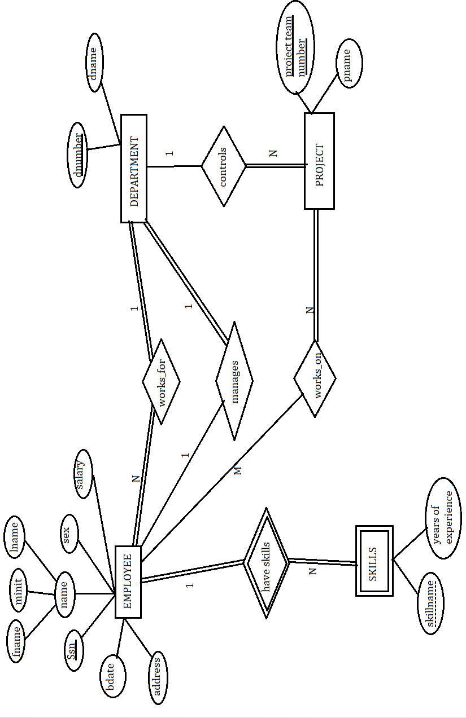

# RELATIONAL DATABASE SCHEMA:

EMPLOYEE

|  |  |  |  |  |  |  |  |  |  |
| --- | --- | --- | --- | --- | --- | --- | --- | --- | --- |
| Fname | Minit | Lname | Ssn | Bdate | Address | Sex | Salary | Dno | Pteamno |

DEPARTMENT

|  |  |  |
| --- | --- | --- |
| Dname | Dnumer | Mgrssn |

PROJECT

|  |  |  |
| --- | --- | --- |
| Pname | Pteamno | Dno |

SKILLS

|  |  |  |
| --- | --- | --- |
| Essn | Sname | YearsOfExp |

EMPLOYEE – Primary key (Ssn) , Foreign Key (Dno, Pteamno) DEPARTMENT – Primary key (Dnumber), Foreign key (Mgrssn) PROJECT – Primary key (Pteamno), Foreign key (Dno)

SKILLS - Primary key (Essn, Sname)

**MYSQL DATA BASE FOR THE CASE STUDY** :

create database company; use company;

create table Employee( Fname varchar(10), Minit char, Lname varchar(10),

Ssn varchar(9) primary key, Bdate date, Address varchar(50), Sex char, Salary float, Dno int, Pteamno int );

INSERT INTO Employee VALUES("John", "B", "Smith", "123456789", "1965-01- 09", "731 Fondren, Houstan, TX", "M", 30000, 1, 2);

INSERT INTO Employee VALUES("Franklin", "T", "Wong", "333445555", "1955- 12-08", "638 Voss, Houston, TX", "M", 40000, 2, 3);

INSERT INTO Employee VALUES("Alicia", "T", "Zelaya", "999887777", "1968-01- 19", "3321 Castle, Spring, TX", "F", 25000, 3, 1);

INSERT INTO Employee VALUES("Jennifer", "S", "Wallace", "987654321", "1941- 06-20", "291 Berry, Bellaire, TX", "F", 43000, 1, 2);

INSERT INTO Employee VALUES("Ramesh", "K", "Narayan", "666884444", "1962- 09-15", "975 Fire Oak, Humble, TX", "M", 38000, 2, 3);

create table Department( Dname varchar(20), Dnumber int primary key, Mgrssn varchar(10));

INSERT INTO Department VALUES("Research", 1, "123456789");

INSERT INTO Department VALUES("Administration", 2, "333445555");

INSERT INTO Department VALUES("Headquarters", 3, "999887777");

create table Project( Pname varchar(10), Pteamno int primary key, Dno int); insert into Project values("ProjectX", 3, 2);

insert into Project values("ProjectY", 1, 3);

insert into Project values("ProjectZ", 2, 1);

create table Skills( Essn varchar(9), Sname varchar(20), YearsOfExp int, primary key(essn, sname));

insert into Skills values("123456789", "Linux", 5);

insert into Skills values("123456789", "Technical Support", 4); insert into Skills values("333445555", "AI and ML", 3);

insert into Skills values("333445555", "Linux", 2); insert into Skills values("999887777", "Oracle", 4); insert into Skills values("987654321", "Python", 6); insert into Skills values("666884444", "Oracle", 3);

alter table Employee add foreign key (Dno) references Department (Dnumber); alter table Employee add foreign key (Pteamno) references Project (Pteamno); alter table Department add foreign key (Mgrssn) references Employee (Ssn); alter table Project add foreign key (Dno) references Department (Dnumber); alter table Skills add foreign key (Essn) references Employee (Ssn);

select * from Employee;

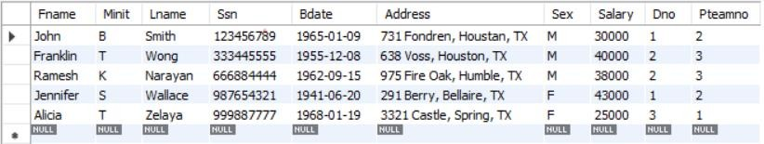

select * from Department;

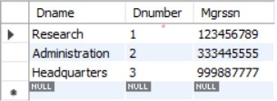

select * from Project;

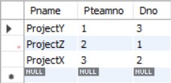

select * from Skills;

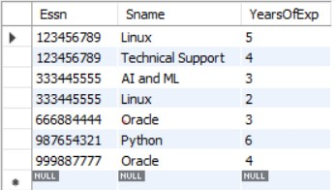

# BASIC QUERIES :

Q1. Retrieve the birthdate and address of the employee whose name is "John B. Smith"

select bdate, address from Employee where Fname = "John" and Minit = "B" and Lname = "Smith";

OUTPUT:



Q2. List the employees working in department 1 select * from Employee where dno = 1; OUTPUT:

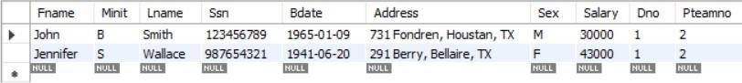

Q3. find all the employees who have more than one skill. select essn from Skills group by essn having count(*) >= 2; OUTPUT:

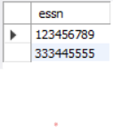

Q4. find all employee working in "Research" department.

select fname from Employee, Department where dno = dnumber and dname = "Research";

OUTPUT:

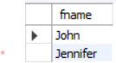

Q5. List the names and salaries of employees earning a salary of 35000 or more. select fname from employee where salary >= 35000;

OUTPUT:

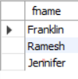

Q6. Retrieve the names of managers of each department

select fname from employee, department where dno = dnumber and mgrssn = ssn; OUTPUT:

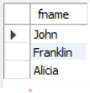

Q7. Retrieve the names of employees who work in project team 3.

select fname from employee, project where employee.pteamno = project.pteamno and project.pteamno = 3;

OUTPUT:

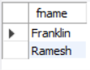

Q8. Count the number of employees working in each project;

select count(*), p.pteamno from employee as e, project as p where e.pteamno = p.pteamno group by p.pteamno;

OUTPUT:

