P.V.P SIDDHARTHA INSTITUTE OF TECHNOLOGY
BRANCH : Computer Science & Engineering | REGULATION : PVP20
Course: B.Tech | SUBJECT : Operating Systems
Subject Code: 20CS3401 | Year and Semester: II-II
QUESTION BANK
UNIT - 1
Q. NO. | QUESTION | CO | LEVEL | MARKS
1 | A) Illustrate the abstract view of computer system.  B) “Operating System is a resource manager”- Justify the statement with suitable functionality of OS. | CO1 | L2 | 14
2 | A) Compare thread and process.  B) Discuss Multithreading Models with a neat diagram. | CO1 | L2 | 14
3 | A) Explain the Dual-Mode operation of an operating system.  B) What are the three main purposes of an operating system? | CO1 | L2 | 14
4 | Describe the Computer-System Architecture. | CO1 | L2 | 14
5 | Describe Operating System Services with a neat sketch. | CO1 | L2 | 14
6 | What is a System Call? Explain different types of System calls. | CO1 | L2 | 14
7 | What is an Operating system? Briefly explain Operating-System Functions. | CO1 | L2 | 14

UNIT - 2
Q. NO. | QUESTION | CO | LEVEL | MARKS
1 | A) With a neat diagram, explain the process state diagram.  B) Explain about various fields of Process Control Block. | CO1 | L2 | 14
2 | A) Explain in detail the sequence of actions taken by the Operating System to context switch between processes.  B) Differences between preemptive scheduling and non-preemptive Scheduling. | CO1 | L2 | 14
3 | Explain various multithreading models. | CO1 | L2 | 14
4 | Explain inter-process communication. | CO1 | L2 | 14
5 | A) Explain the criteria for evaluating the CPU scheduling algorithms? Why do we need it?  B) Describe the differences among short-term, medium-term, and long-term scheduling’s. | CO1 | L2 | 14
6 | Consider Four jobs to be executed on a single processor system arrive at time 0 in the order A, B, C, D. Their burst CPU time requirements are 4, 1, 8, 1 time units respectively.  Apply FCFS and SJF CPU scheduling algorithms to calculate average waiting time, average turnaround time. | CO2 | L3 | 14
7 | Demonstrate First-Come First-Served and Round Robin CPU Scheduling algorithms with suitable example. | CO1 | L2 | 14
8 | Demonstrate Shortest-Job-First and Priority CPU Scheduling algorithms with suitable example. | CO1 | L2 | 14
9 | 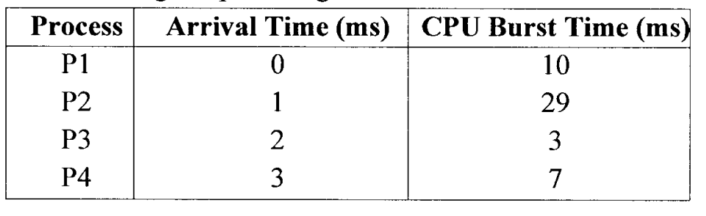  The following snapshot is given  Draw the Gantt chart and apply FCFS, SJF and RR CPU Scheduling algorithms to calculate the turnaround time and waiting time. | CO2 | L3 | 14
10 | Consider the following set of processes, with the length of the CPU burst given in milliseconds:  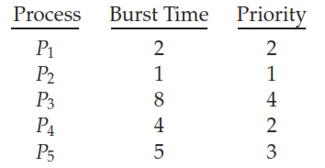  The processes are assumed to have arrived in the order P1, P2, P3, P4, and P5 at time 0.  a. Draw four Gantt charts that illustrate the execution of these processes and apply the following scheduling algorithms: FCFS, SJF, non-preemptive priority (a larger priority number implies a higher priority), and RR (quantum = 2).  b. What is the turnaround time of each process for each of the scheduling algorithms in the above.  c. What is the waiting time of each process for each of these scheduling algorithms?  d. Which of the algorithms results in the minimum average waiting time (over all processes)? | CO2 | L3 | 14
11 | Consider the following set of processes, with the length of the CPU burst time given in milliseconds:  Process Burst Time  P1 5  P2 3  P3 1  P4 2  P5 7  The processes are assumed to have arrived in the order P1, P2, P3, P4, and P5 all at time 0.  Draw Gantt charts and apply SJF, and RR (quantum = 2) CPU scheduling to calculate waiting time and turnaround time of each process. | CO2 | L3 | 14

UNIT - 3
Q. NO. | QUESTION | CO | LEVEL | MARKS
1 | What is a Critical Section problem? Explain in detail the conditions that a solution to the critical section problem must satisfy. | CO1 | L2 | 14
2 | Discuss Mutual-exclusion implementation with Test And Set instruction. | CO1 | L2 | 14
3 | What is a Semaphore? Explain various operations defined on it. | CO1 | L2 | 14
4 | Apply semaphores to provide synchronization for Readers-Writers Problem. | CO3 | L3 | 14
5 | Apply semaphores to provide synchronization for Dining Philosophers problem. | CO3 | L3 | 14
6 | Apply semaphores to provide synchronization for Producer Consumer problem. | CO3 | L3 | 14
7 | Apply Monitors to provide synchronization for Dining Philosophers problem. | CO3 | L3 | 14
8 | A) Explain deadlock avoidance process using Resource-Allocation-Graph.  B) How to Recover From Deadlock situations? Discuss in detail. | CO1 | L2 | 14
9 | Explain in detail about deadlock detection Techniques. | CO1 | L2 | 14
10 | Use Banker’s algorithm briefly explains the deadlock avoidance with a suitable example. | CO1 | L3 | 14
11 | Consider a system with five processes P0 through P4 and three resource types A, B, and C. Resource type A has ten instances, resource type B has five instances, and resource type C has seven instances. Suppose, at time T0, the following snapshot of the system has been taken:  Allocation Max Available  A B C A B C A B C  P0 0 1 0 7 5 3 3 3 2  P1 2 0 0 3 2 2  P2 3 0 2 9 0 2  P3 2 1 1 2 2 2  P4 0 0 2 4 3 3  Apply safety algorithm to find out whether the system is in safe state or not? | CO3 | L3 | 14
12 | Consider the following snapshot of a system:  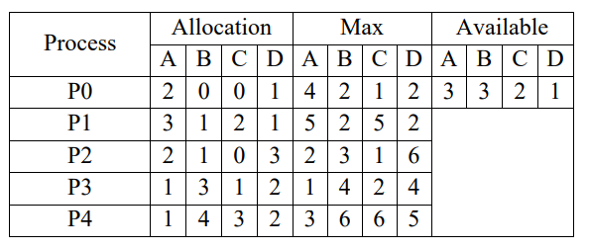  Answer the following questions using the banker’s  Algorithm  i) Apply Banker’s Algorithm and find whether the above system is safe or not. And also identify the safe sequence that meets the safety requirement.  ii) If a request from process P3 arrives for (0, 1, 0, 1), can the request be granted immediately? | CO3 | L3 | 14

UNIT - 4
Q. NO. | QUESTION | CO | LEVEL | MARKS
1 | A) Discuss about the Swapping of process.  B) Explain the difference between internal and external fragmentation. | CO1 | L2 | 14
2 | Apply ﬁrst-ﬁt, best-ﬁt, and worst-ﬁt algorithms to place processes of size 115 KB, 500 KB, 358 KB, 200 KB, and 375 KB (in order) for the given six memory partitions of 300 KB, 600 KB, 350 KB, 200 KB, 750 KB, and 125 KB (in order). | CO2 | L3 | 14
3 | Describe the Segmentation memory management scheme with hardware support. | CO1 | L2 | 14
4 | Explain Page memory management scheme with neat diagram. | CO1 | L2 | 14
5 | Explain the hierarchical and hashed techniques for structuring the page tables. | CO1 | L2 | 14
6 | Explain the hierarchical and inverted techniques for structuring the page tables. | CO1 | L2 | 14
7 | Under what circumstances do page faults occur? Describe the actions taken by the operating system when a page fault occurs. | CO1 | L2 | 14
8 | Apply FIFO and LRU page replacement algorithms to calculate number of page faults would occur by consider the following page reference string with five page frames: 1, 2, 3, 4, 2, 1, 5, 6, 2, 1, 2, 3, 7, 6, 3, 2, 1, 2, 3, 6. | CO2 | L3 | 14
9 | Apply LRU and Optimal page replacement algorithms to calculate number of page faults would occur by consider the following page reference string with six page frames: 1, 2, 3, 4, 2, 1, 5, 6, 2, 1, 2, 3, 7, 6, 3, 2, 1, 2, 3, 6. | CO2 | L3 | 14
10 | Apply FIFO and LRU page replacement algorithms to calculate number of page faults would occur by consider the following page reference string with three page frames: 7, 2, 3, 1, 2, 5, 3, 4, 6, 7, 7, 1, 0, 5, 4, 6, 2, 3, 0 , 1. | CO2 | L3 | 14
11 | Apply LRU and Optimal page replacement algorithms to calculate number of page faults would occur by consider the following page reference string with four page frames : 1, 2, 3, 4, 5, 3, 4, 1, 6, 7, 8, 7, 8, 9, 7, 8, 9, 5, 4, 5, 4, 2. | CO2 | L3 | 14
12 | What is the cause of thrashing? How does the system detect thrashing? Once it detects thrashing, what can the system do to eliminate this problem? | CO1 | L2 | 14

UNIT - 5
Q. NO. | QUESTION | CO | LEVEL | MARKS
1 | Describe the different directory structures. | CO1 | L2 | 14
2 | Describe the contiguous, linked, and indexed methods of allocating disk space. | CO1 | L2 | 14
3 | Discuss the advantages and disadvantages of different directory structure. | CO1 | L2 | 14
4 | Discuss the advantages and disadvantages of disk space allocation methods. | CO1 | L2 | 14
5 | Write short notes on  i. File Access Methods ii. File Operations | CO1 | L2 | 14
6 | Write short notes on  i. File Attributes ii. File System | CO1 | L2 | 14
7 | Analyze the performance of the three techniques of allocating disk blocks (contiguous, linked, and indexed), for what criteria should be used in deciding which strategy is best utilized for a particular ﬁle. | CO4 | L4 | 14
8 | Summarize FCFS, SSTF and SCAN Disk Scheduling algorithms with example. | CO2 | L2 | 14
9 | Summarize SCAN and LOOK Disk Scheduling algorithms with example. | CO2 | L2 | 14
10 | Apply LOOK, C-SCAN and C-LOOK disk-scheduling algorithms to calculate total distance (in cylinders) that the disk arm moves to satisfy all the pending requests. The queue of pending requests, in FIFO order, is: 86, 147, 91, 177, 94, 150, 102, 175, and 130. Let as assume that a disk drive has 200 cylinders, numbered 0 to 199. The drive is currently serving a request at cylinder 143, and the previous request was at cylinder 125. | CO2 | L3 | 14
11 | Apply FCFS, SSTF and SCAN disk-scheduling algorithms to calculate total distance (in cylinders) that the disk arm moves to satisfy all the pending requests. The queue of pending requests, in  FIFO order is: 2,069, 1,212, 2,296, 2,800, 544, 1,618, 356, 1,523, 4,965, and 368. Let as assume that a disk drive has 5,000 cylinders, numbered 0 to 4,999. The drive is currently serving a request at cylinder 2,150, and the previous request was at cylinder 1,805. | CO2 | L3 | 14

