**PRASAD V. POTLURI SIDDHARTHA INSTITUTE OF TECHNOLOGY,**

**KANURU, VIJAYAWADA**

**DEPARTMENT OF COMPUTER SCIENCE & ENGINEERING**

**INNOVATIVE TEACHING METHODOLOGY**

**Academic Year: 2024-25**

**Teaching Methodology - Flip Class**

**Class:** IV B.TECH

**Semester: I**-Semester

**Section:** S1

**Name of the Course:** User Interface Design

**Name of the Faculty:** A.Divya

---------------------------------------------------------------------------------------------------------------

**Name of the Topic:** Human Interaction Speeds

**Number of Students Involved: 72**

**Questions:**

1) What are Human interaction speeds?

2) What is RSVP?

3) What are the Advantages and Disadvantages of Human interaction speeds?

4) Discuss Reading speeds?

5) Explain Speaking Interaction speeds?

6) What are the types of Typing skills?

7) What are the 4 stages of HCI?

8) What is Prose Text?

9) What is Keying?

10) What are the methods for gaining and understanding the users?

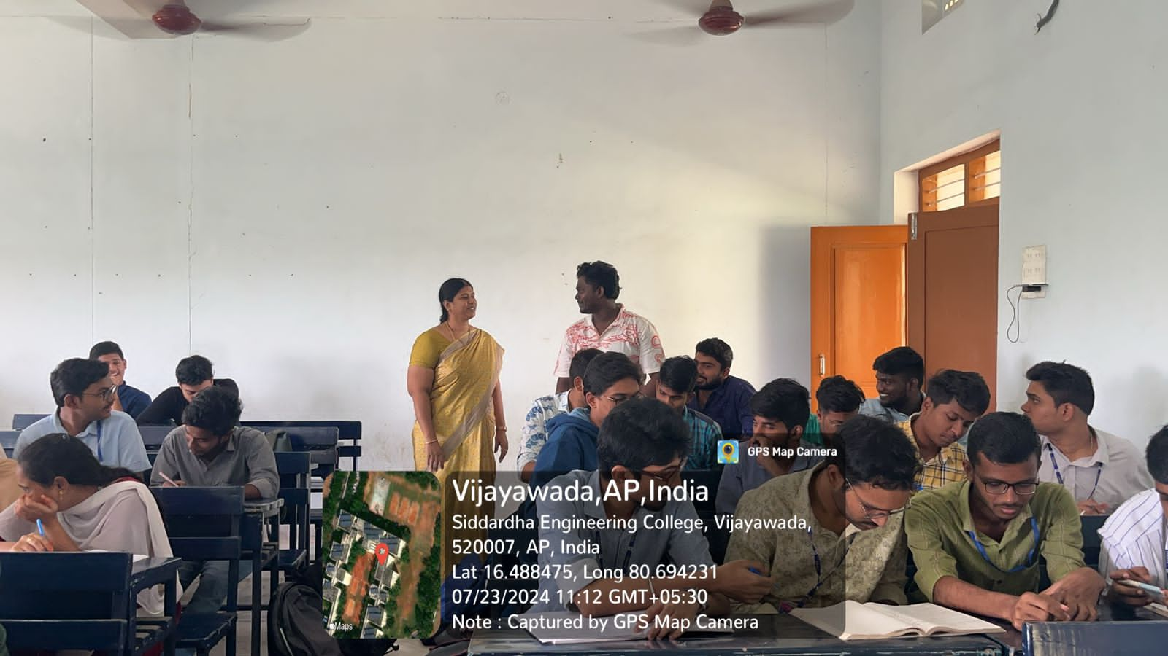

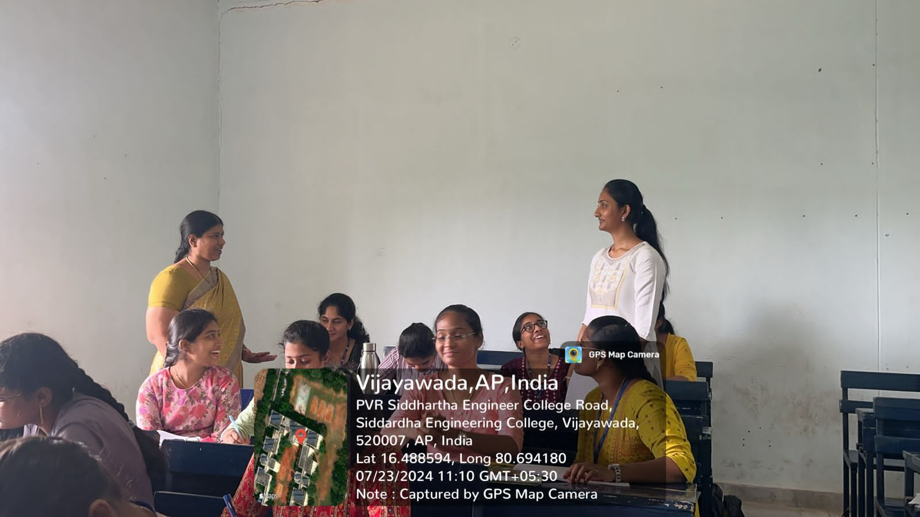

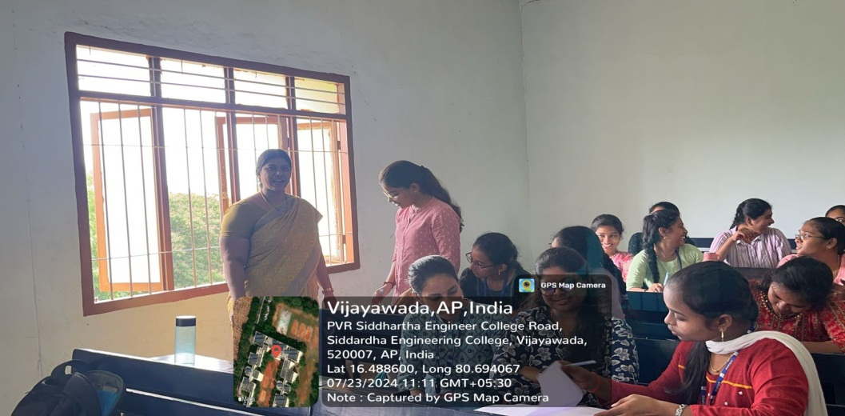

**Signature of the Faculty**