**PRASAD V. POTLURI SIDDHARTHA INSTITUTE OF TECHNOLOGY,**

**KANURU, VIJAYAWADA**

**DEPARTMENT OF COMPUTER SCIENCE & ENGINEERING**

**INNOVATIVE TEACHING METHODOLOGY**

**Academic Year: 2024 - 25**

**Teaching Methodology - SEMINAR (Individual Presentation)**

**Class :** III B.TECH

**Semester:** II - Semester

**Section:** S3

**Name of the Course:** MERN Stack Development

**Name of the Faculty:** Dr. K. Jyothsna Devi

---------------------------------------------------------------------------------------------------------------

**Name of the Topic: University front end web site designing using HTML and CSS**

**Number of Students Involved: 70**

**Student Name &Regd Number:**

|  |  |  |  |  |  |
| --- | --- | --- | --- | --- | --- |
| **S.No** | **Register No.** | **Name of the Student** | **S.No** | **Register No.** | **Name of the Student** |
| 1 | 22501A05D3 | PADAKALA ANAND KUMAR | 36 | 22501A05H0 | SOMALA THANU SRI |
| 2 | 22501A05D4 | PAIDIMUKKULA LAVANYA | 37 | 22501A05H1 | SOMULA VENKATA SYAM PRASAD REDDY |
| 3 | 22501A05D5 | PARASA KAMAL SIDDARDHA | 38 | 22501A05H2 | SREELAKSHMI SUDEEKSHA MEDARAMETLA |
| 4 | 22501A05D6 | PARIMISETTI SAI ADVAITH | 39 | 22501A05H3 | SREERAM SARATH CHANDRA |
| 5 | 22501A05D7 | PARVATANENI AMULYA | 40 | 22501A05H4 | SYED LATHEEF AHMMAD |
| 6 | 22501A05D8 | PARVATHANENI PHANI KRISHNA | 41 | 22501A05H5 | SYED MUHAMMAD AFZAL |
| 7 | 22501A05D9 | PATHIVADA HARSHAVARDHAN | 42 | 22501A05H6 | TADEPALLI NAGA SRI SAMANVITHA |
| 8 | 22501A05E0 | PAVAN KUMAR CHENNUPATI | 43 | 22501A05H7 | TATI GAYATHRI |
| 9 | 22501A05E2 | PEDAPATI MAHESH BABU | 44 | 22501A05H8 | TATIPARTHI MEGHANA |

|  |  |  |  |  |  |
| --- | --- | --- | --- | --- | --- |
| 10 | 22501A05E3 | PEDAPUDI MEGHANA | 45 | 22501A05H9 | TATIPARTHI TEJ MAHENDRA REDDY |
| 11 | 22501A05E4 | PEDDIBHOTLA SREE SATYA HARSHA | 46 | 22501A05I0 | THIRANDI RAMYA |
| 12 | 22501A05E5 | PERUMALLA HARSHITHA | 47 | 22501A05I1 | THIYYAGURA HEMA HARSHITHA |
| 13 | 22501A05E6 | PILLUTLA CHAITANYA | 48 | 22501A05I2 | THUMMALACHARLA THANUJA |
| 14 | 22501A05E7 | PODILI NAVEEN KUMAR | 49 | 22501A05I3 | TIPPIREDDY YOGITHA |
| 15 | 22501A05E8 | POLIMETLA NIKHIL | 50 | 22501A05I4 | TUMMURU VIMALA REDDY |
| **16** | 22501A05E9 | POTHINENI THRINATH | 51 | 22501A05I5 | TUNGALA REVANTH |
| 17 | 22501A05F0 | POTLURI NIKITHA | 52 | 22501A05I6 | UPPALAPATI HARSHITA |
| 18 | 22501A05F1 | PRODDUTURU SUNANDA | 53 | 22501A05I7 | VALLABHANENI DHANUSH |
| 19 | 22501A05F2 | PUVVADA MITHIL | 54 | 22501A05I8 | VALLABHANENI SUMANTH |
| 20 | 22501A05F3 | RAYALA BABY AKSHITHA | 55 | 22501A05I9 | VALLURU DIVYA CHARITHA |
| 21 | 22501A05F4 | RAYAPUDI SAI ROSHINI | 56 | 22501A05J0 | VANAMATLA ANITHA |
| 22 | 22501A05F5 | RENDUCHINTALA SRIHARI SAI PRANEETH | 57 | 22501A05J1 | VARANASI VIJAYA SAI VIGNESH |
| 23 | 22501A05F6 | RUKSANA SHAIK | 58 | 22501A05J2 | VEERANKI PHANI SIRISHA |
| 24 | 22501A05F7 | SAMBHANA SURYA HARSHA | 59 | 22501A05J3 | VEMULAPALLI GNANESWARI |
| 25 | 22501A05F8 | SANAPALA YASWANTH SAI NARASIMHA | 60 | 22501A05J4 | VIKRUTI SRIJA |
| 26 | 22501A05F9 | SASANAM MOHIT | 61 | 22501A05J5 | VUYYURU KEERTHI REDDY |
| 27 | 22501A05G0 | SAYILA SANTHI DEEPIKA | 62 | 22501A05J6 | YALAKALA ABIGNA |
| 28 | 22501A05G1 | SHAIK FAKRUDDIN | 63 | 22501A05J7 | YANAGANTI ANUSHA |
| 30 | 22501A05G2 | SHAIK IRFAN HARIS | 64 | 22501A05J8 | YARLAGADDA ESWAR ADITYA |
| 31 | 22501A05G4 | SHAIK SAHIRA | 65 | 23505A0513 | SUDABATHULA SIVA TULASI TEJASWI |
| 32 | 22501A05G5 | SHAIK SAMEENA | 66 | 23505A0514 | TIRUNAGARI SAI RITISH |
| 33 | 22501A05G6 | SHAIK SEEMA JABEEN | 68 | 23505A0515 | VALLURU MALLIKA |
| 34 | 22501A05G7 | SIDDHARTHA SAI VENKAT Y | 69 | 23505A0516 | VASANA VENKATA GANESH |
| 35 | 22501A05G8 | SIDDULA SUSHRUTH | 70 | 23505A0517 | VEERANKI REVANTH |

**Topics:**

1. PVPSIT College website
2. Inter college website
3. 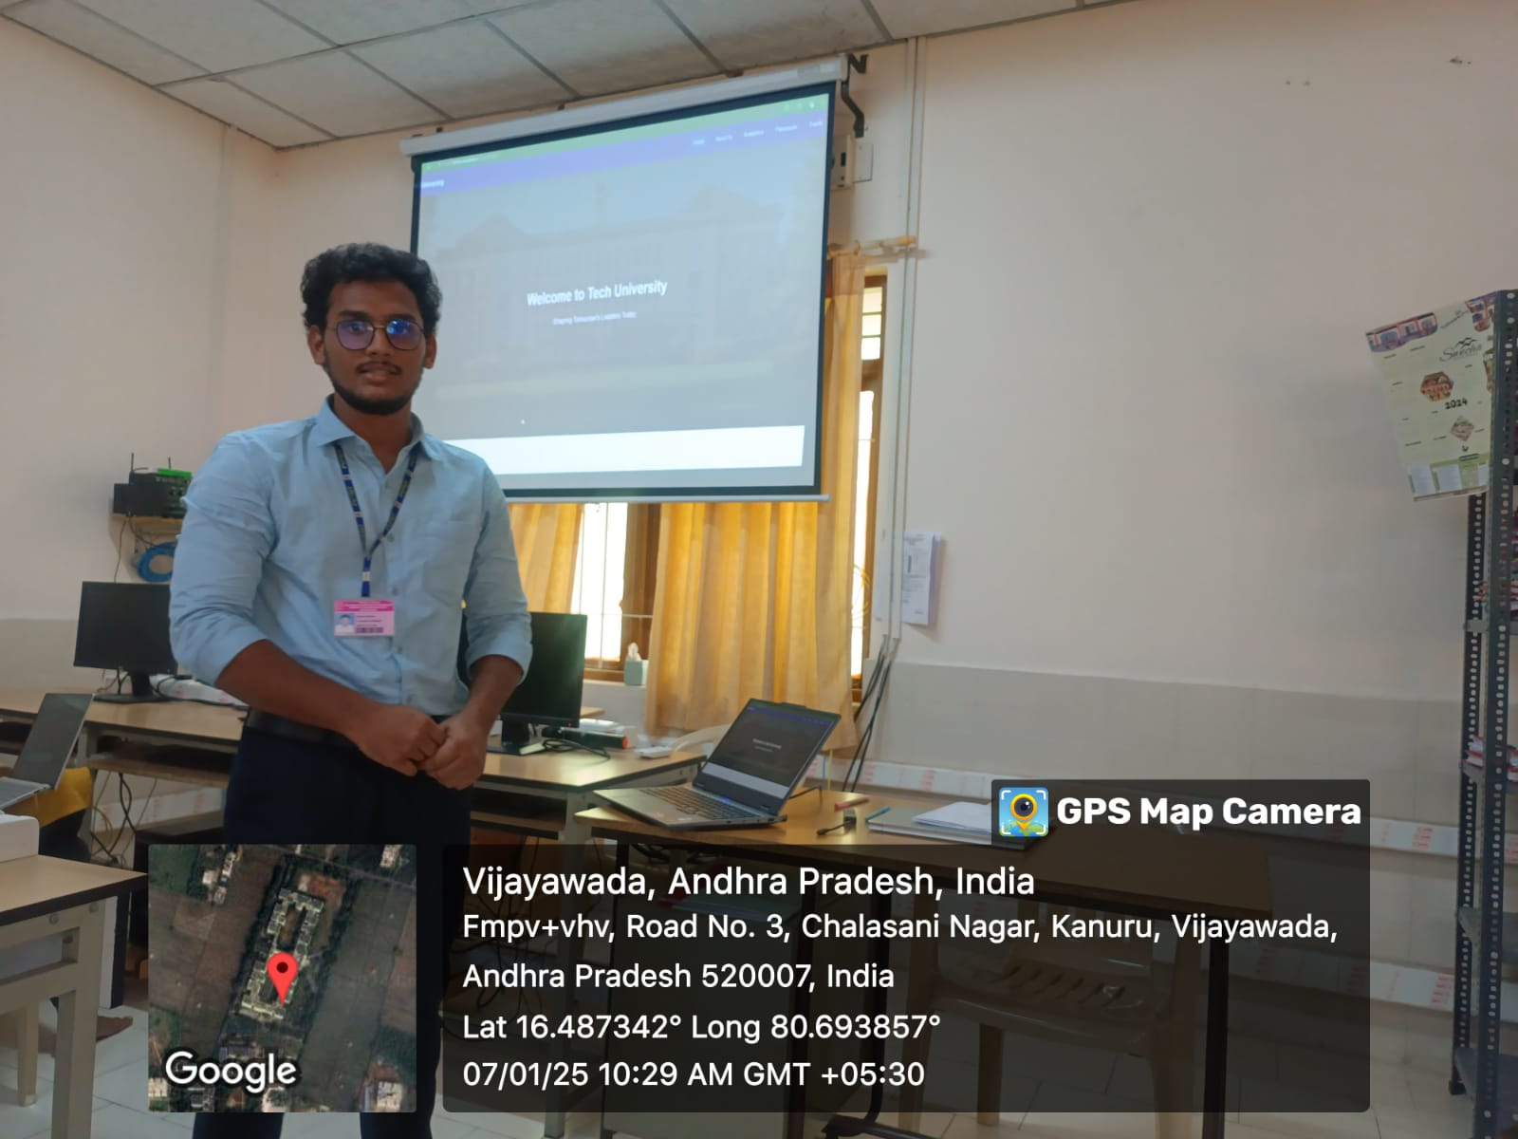University website

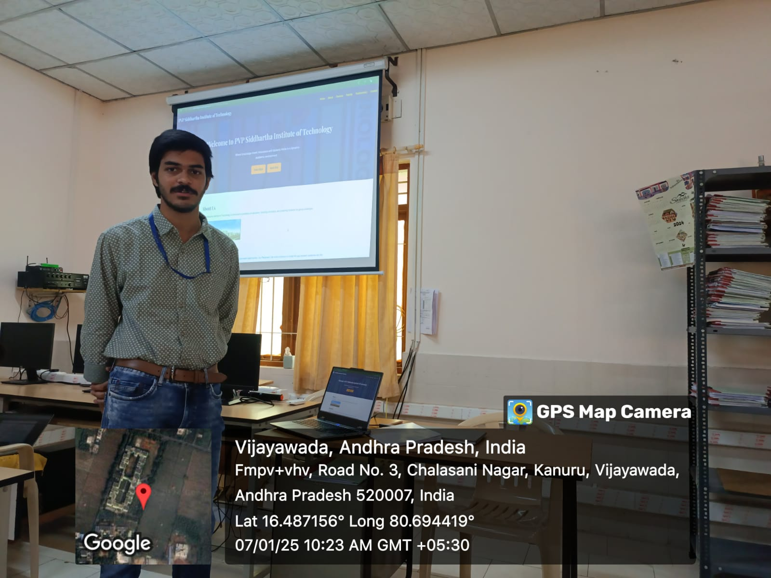

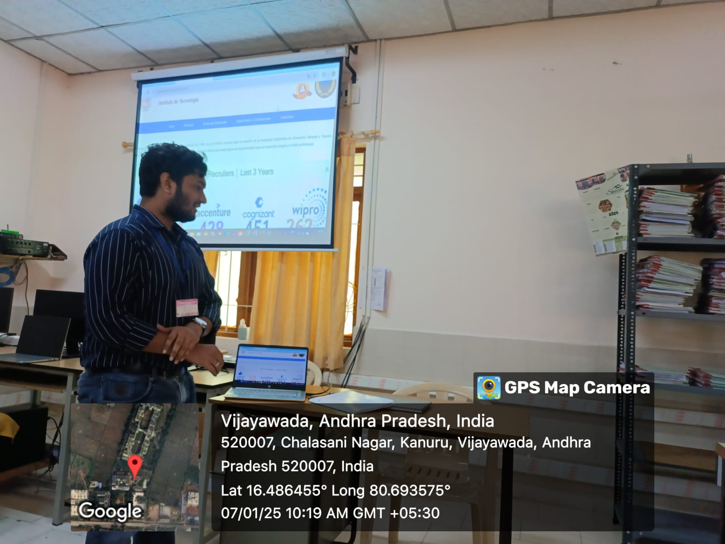

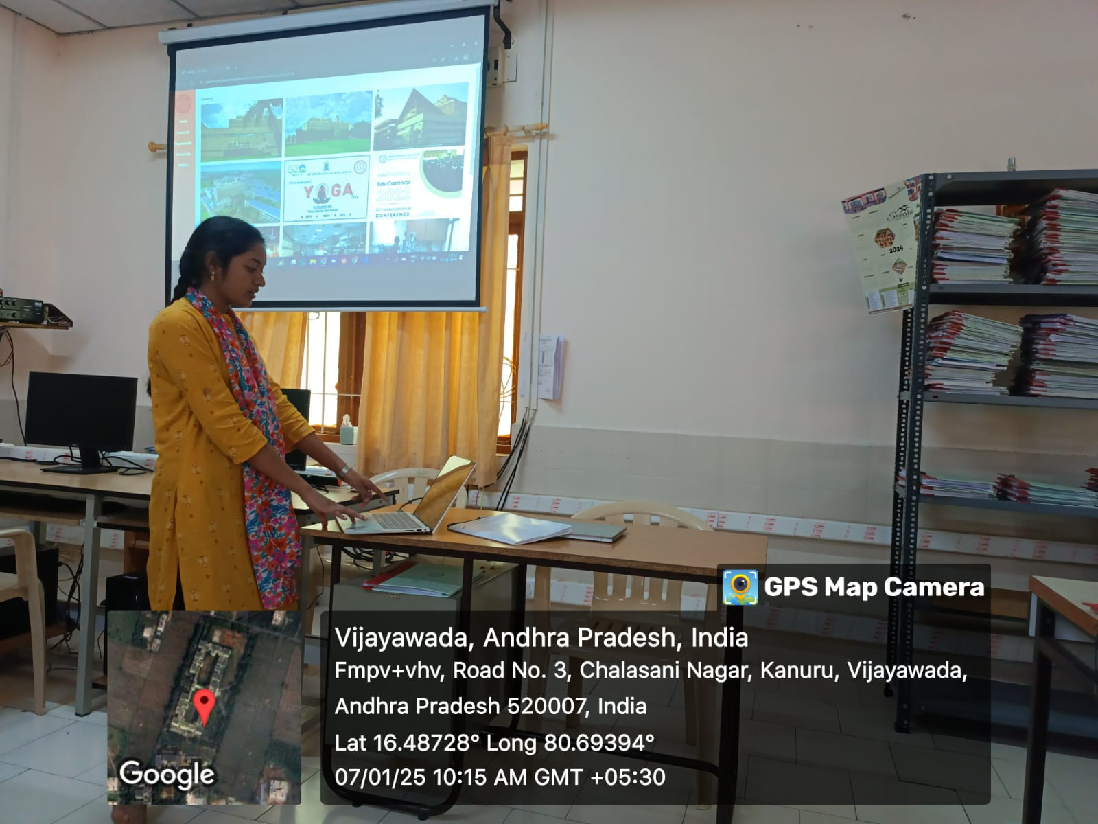

**Signature of the Faculty**