**PRASAD V. POTLURI SIDDHARTHA INSTITUTE OF TECHNOLOGY,**

**KANURU, VIJAYAWADA**

**DEPARTMENT OF COMPUTER SCIENCE & ENGINEERING**

**INNOVATIVE TEACHING METHODOLOGY**

**Academic Year: 2024 - 25**

**Teaching Methodology – Video Activity (Presentation)**

**Class :** III B.TECH

**Semester:** II - Semester

**Section:** S3

**Name of the Course: MERN Stack Development**

**Name of the Faculty:** Dr. K. Jyothsna Devi

---------------------------------------------------------------------------------------------------------------

**Name of the Topic: Third party State management libraries in React:** Redux, Flux,

**Number of Students Involved : 70**

**Student Name &Regd Number:**

|  |  |  |  |  |  |
| --- | --- | --- | --- | --- | --- |
| **S.No** | **Register No.** | **Name of the Student** | **S.No** | **Register No.** | **Name of the Student** |
| 1 | 22501A05D3 | PADAKALA ANAND KUMAR | 36 | 22501A05H0 | SOMALA THANU SRI |
| 2 | 22501A05D4 | PAIDIMUKKULA LAVANYA | 37 | 22501A05H1 | SOMULA VENKATA SYAM PRASAD REDDY |
| 3 | 22501A05D5 | PARASA KAMAL SIDDARDHA | 38 | 22501A05H2 | SREELAKSHMI SUDEEKSHA MEDARAMETLA |
| 4 | 22501A05D6 | PARIMISETTI SAI ADVAITH | 39 | 22501A05H3 | SREERAM SARATH CHANDRA |
| 5 | 22501A05D7 | PARVATANENI AMULYA | 40 | 22501A05H4 | SYED LATHEEF AHMMAD |
| 6 | 22501A05D8 | PARVATHANENI PHANI KRISHNA | 41 | 22501A05H5 | SYED MUHAMMAD AFZAL |
| 7 | 22501A05D9 | PATHIVADA HARSHAVARDHAN | 42 | 22501A05H6 | TADEPALLI NAGA SRI SAMANVITHA |
| 8 | 22501A05E0 | PAVAN KUMAR CHENNUPATI | 43 | 22501A05H7 | TATI GAYATHRI |
| 9 | 22501A05E2 | PEDAPATI MAHESH BABU | 44 | 22501A05H8 | TATIPARTHI MEGHANA |

|  |  |  |  |  |  |
| --- | --- | --- | --- | --- | --- |
| 10 | 22501A05E3 | PEDAPUDI MEGHANA | 45 | 22501A05H9 | TATIPARTHI TEJ MAHENDRA REDDY |
| 11 | 22501A05E4 | PEDDIBHOTLA SREE SATYA HARSHA | 46 | 22501A05I0 | THIRANDI RAMYA |
| 12 | 22501A05E5 | PERUMALLA HARSHITHA | 47 | 22501A05I1 | THIYYAGURA HEMA HARSHITHA |
| 13 | 22501A05E6 | PILLUTLA CHAITANYA | 48 | 22501A05I2 | THUMMALACHARLA THANUJA |
| 14 | 22501A05E7 | PODILI NAVEEN KUMAR | 49 | 22501A05I3 | TIPPIREDDY YOGITHA |
| 15 | 22501A05E8 | POLIMETLA NIKHIL | 50 | 22501A05I4 | TUMMURU VIMALA REDDY |
| **16** | 22501A05E9 | POTHINENI THRINATH | 51 | 22501A05I5 | TUNGALA REVANTH |
| 17 | 22501A05F0 | POTLURI NIKITHA | 52 | 22501A05I6 | UPPALAPATI HARSHITA |
| 18 | 22501A05F1 | PRODDUTURU SUNANDA | 53 | 22501A05I7 | VALLABHANENI DHANUSH |
| 19 | 22501A05F2 | PUVVADA MITHIL | 54 | 22501A05I8 | VALLABHANENI SUMANTH |
| 20 | 22501A05F3 | RAYALA BABY AKSHITHA | 55 | 22501A05I9 | VALLURU DIVYA CHARITHA |
| 21 | 22501A05F4 | RAYAPUDI SAI ROSHINI | 56 | 22501A05J0 | VANAMATLA ANITHA |
| 22 | 22501A05F5 | RENDUCHINTALA SRIHARI SAI PRANEETH | 57 | 22501A05J1 | VARANASI VIJAYA SAI VIGNESH |
| 23 | 22501A05F6 | RUKSANA SHAIK | 58 | 22501A05J2 | VEERANKI PHANI SIRISHA |
| 24 | 22501A05F7 | SAMBHANA SURYA HARSHA | 59 | 22501A05J3 | VEMULAPALLI GNANESWARI |
| 25 | 22501A05F8 | SANAPALA YASWANTH SAI NARASIMHA | 60 | 22501A05J4 | VIKRUTI SRIJA |
| 26 | 22501A05F9 | SASANAM MOHIT | 61 | 22501A05J5 | VUYYURU KEERTHI REDDY |
| 27 | 22501A05G0 | SAYILA SANTHI DEEPIKA | 62 | 22501A05J6 | YALAKALA ABIGNA |
| 28 | 22501A05G1 | SHAIK FAKRUDDIN | 63 | 22501A05J7 | YANAGANTI ANUSHA |
| 30 | 22501A05G2 | SHAIK IRFAN HARIS | 64 | 22501A05J8 | YARLAGADDA ESWAR ADITYA |
| 31 | 22501A05G4 | SHAIK SAHIRA | 65 | 23505A0513 | SUDABATHULA SIVA TULASI TEJASWI |
| 32 | 22501A05G5 | SHAIK SAMEENA | 66 | 23505A0514 | TIRUNAGARI SAI RITISH |
| 33 | 22501A05G6 | SHAIK SEEMA JABEEN | 68 | 23505A0515 | VALLURU MALLIKA |
| 34 | 22501A05G7 | SIDDHARTHA SAI VENKAT Y | 69 | 23505A0516 | VASANA VENKATA GANESH |
| 35 | 22501A05G8 | SIDDULA SUSHRUTH | 70 | 23505A0517 | VEERANKI REVANTH |

**Topics:**

1) Discuss the importance of State Management in React

2) Explain the Third Party State management tools

3) Explain the Redux implemenattaion

5) Explain the Flux implementation

6) Explore the case studies on Redux and Flux

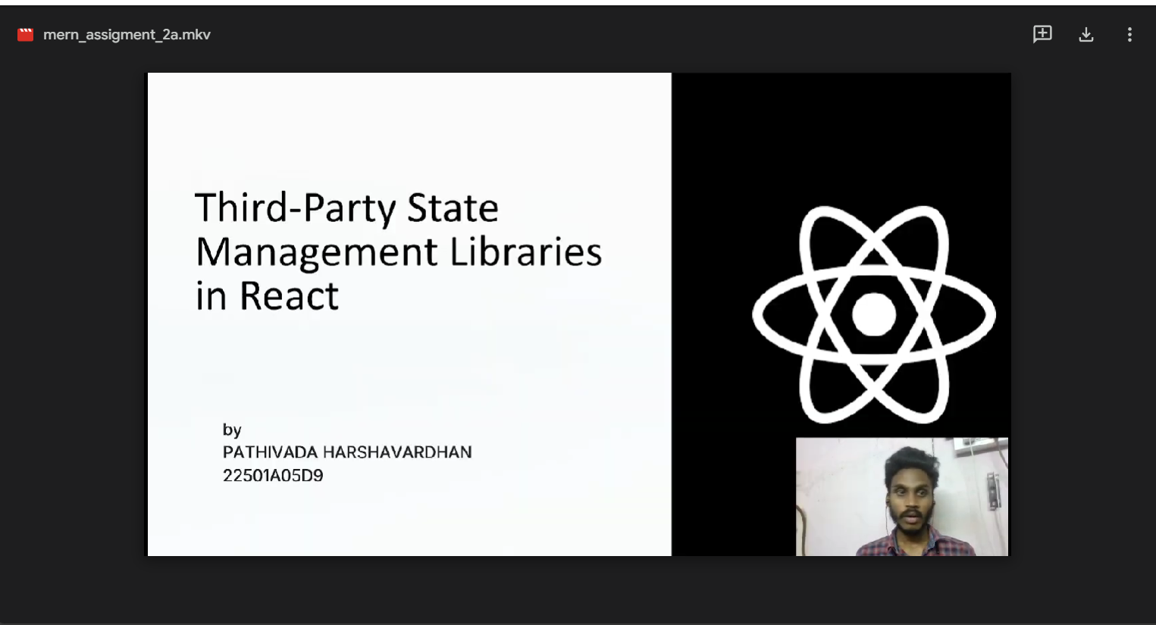

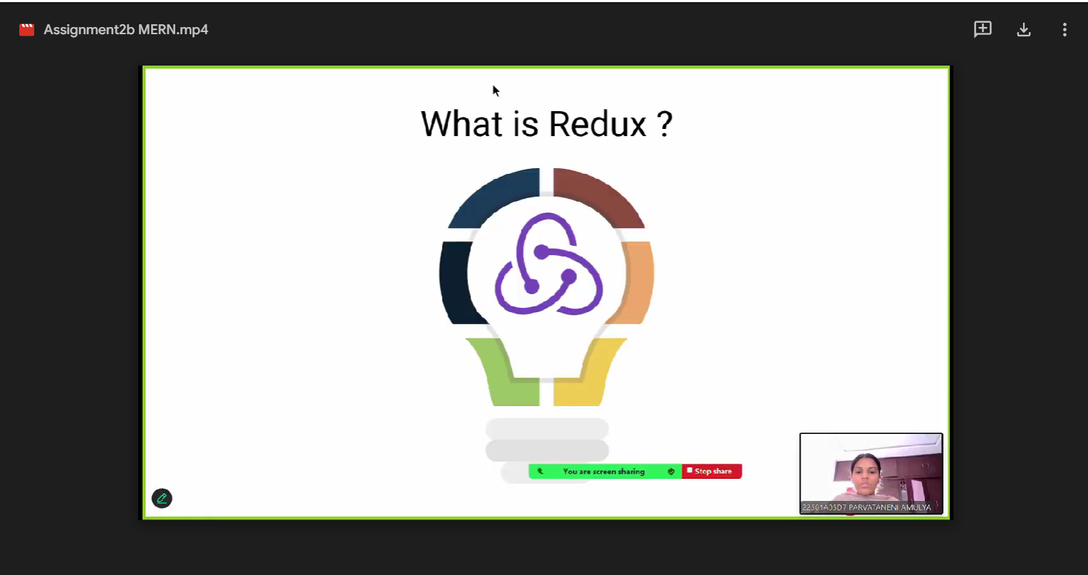

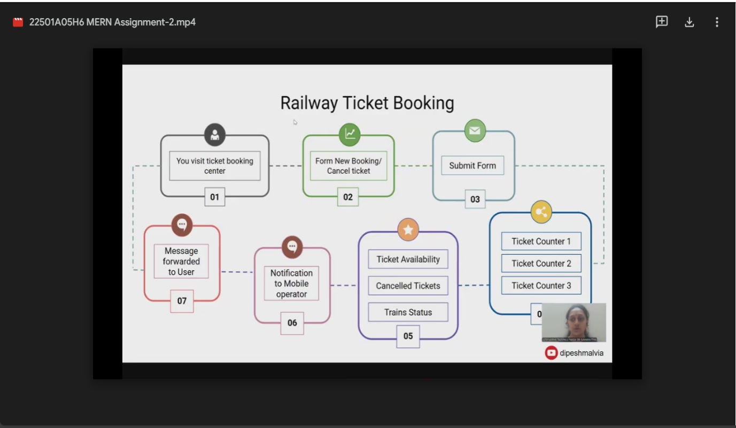

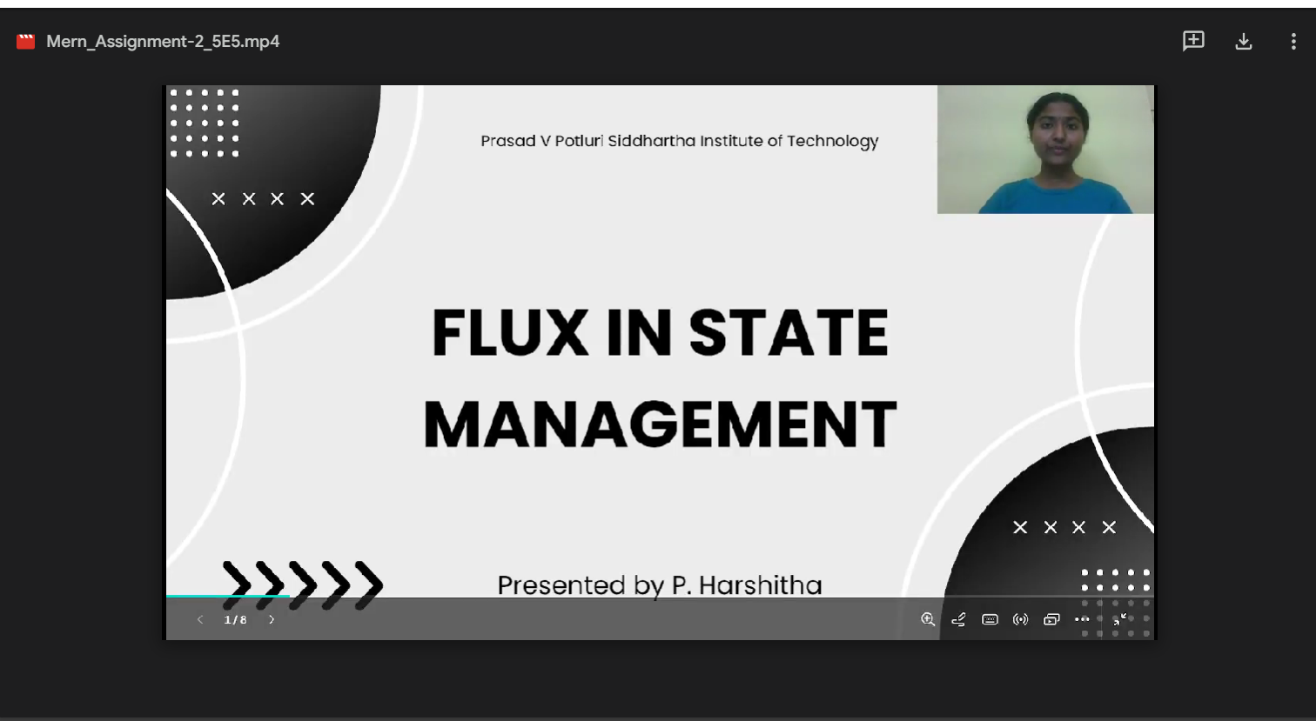

**Signature of the Faculty**