**PRASAD V. POTLURI SIDDHARTHA INSTITUTE OF TECHNOLOGY,**

**KANURU, VIJAYAWADA**

**DEPARTMENT OF COMPUTER SCIENCE & ENGINEERING**

**INNOVATIVE TEACHING METHODOLOGY**

**Academic Year: 2023 - 24**

**Teaching Methodology – Project based learning (Group Activity)**

**Class :** II B.TECH

**Semester:** II - Semester

**Section:** S3

**Name of the Course:** Advanced Data Structures

**Name of the Faculty:** Dr. K. Jyothsna Devi

---------------------------------------------------------------------------------------------------------------

**Name of the Topic:** Hashing, Priority Queue, 2-3 Trees, AVL Tress, Shortest path algorithms, Disjoint sets, String matching

**Number of Students Involved: 70**

**Group Members involved and the Title of the Projects:**

|  |  |  |  |
| --- | --- | --- | --- |
| **Group No.** | **Student Name** | **Reg. No** | **Title of the Project** |
| Team -1 | P. Amulya  T.N.S. Samanvitha | 22501A05D7  22501A05H6 | File compression (heap) |
| Team -2 | Yarlagadda Eswar Aditya  Shaik Fakruddin  Syed Muhammad Afzal  Varanasi Vijaya Sai Vignesh | 22501A05J8  22501A05G1  22501A05H5  22501A05J1 | Contact searching application (hash table, BST) |
| Team -3 | V. Phani Sirisha  P. Harshitha  Y. Anusha  V. Sumanth | 22501A05J2  22501A05E5  22501A05J7  22501A05I8 | Emergency Alert Triggering system (hash. Priority queue) |

|  |  |  |  |
| --- | --- | --- | --- |
| Team -4 | T. Vimala  P. Nikitha  Pavan Kumar .Ch  T. Tej Mahendra | 22501A05I4  22501A05F0  22501A05E0  22501A05H9 | Task management (Priority queue) |
| Team -5 | R. B. Akshitha  R. Sai Roshini  T. Gayathri  V. Anitha  V. Srija | 22501A05F3  22501A05F4  22501A05H7  22501A05J0  22501A05J4 | Spell checker (Hash) |
| Team -6 | T.Ramya  T.Thanuja  U Harshitha  V.Divya Charitha | 22501A05I0  22501A05I2  22501A05I6  22501A05I9 | Password hash (Hash) Universal hashing |
| Team -7 | P.Anand  P. Lavanya  P.Siddhartha  V.Gnaneshwari | 22501A05D3  22501A05D4  22501A05D5  22501A05J3 | Flight root planner (Shortest path algorithms) |
| Team -8 | S. Tejaswi  T. Sai Ritish  V. Venkata Ganesh  V. Revanth  V. Nitish Kumar | 23505A0513  23505A0514  23505A0516  23505A0517  23505A0518 | Dynamic on line reservation (heap) |

|  |  |  |  |
| --- | --- | --- | --- |
| Team -9 | T. Revanth  P.Sai Advaith  P. Mithil  M. Sudeeksha  T. Yogitha. | 22501A05I5  22501A05D6  22501A05F2  22501A05H2  22501A05I3 | Railway Booking system ( heap) |
| Team -10 | V.Dhanush  S.Sushruth.  P.Chaitanya.  P.Naveen kumar  Sk. Irfan Haris | 22501A05I7  22501A05G8  22501A05E6  22501A05E7  22501A05G2 | File management (hash) |
| Team -11 | Sk.Seema  Sk.Sahira  T.Meghana  P.Meghana | 22501A05G6  22501A05G4  22501A05H8  22501A05E3 | Metro route planner, (All pairs shortest path) |
| Team -12 | S.Yaswanth  S.Surya Harsha  S.Sarath Chandra full stack  P.Nikhil fullstack  P.Thrinath full stack | 22501A05F8  22501A05F7  22501A05H3  22501A05E8  22501A05E9 | Hospital emergency management (linked list, priority queue) |
| Team -13 | S.Syam.  P.Sree satya Harsha  S.Uday Bhaskar  P.Harsha Vardhan  P.Mahesh. | 22501a05H1  22501A05E4  22501a05G9 5  22501a05D9 5  22501a05E2 | Restaurant reservation system (Priority queue, hash) |

|  |  |  |  |
| --- | --- | --- | --- |
| Team -14 | Y. Siddhartha  Syed Latheef  R.sri Hari  S. Mohit  P. Phani Krishana | 22501A05G7  22501A05H4  22501A05F5  22501A05F9  22501A05D8 | Emergency contact Management system (hash) |
| Team -15 | Sk.Ruksana  T.Hema Harshitha  V.Keerthi Reddy  S.Thanu Sri  S.Santhi Deepika | 22501A05F6  22501A05I1  22501A05J5  22501A05H0  22501A05G0 | Elevator scheduling (priority) |
| Team -16 | P. Sunanda  Shaik Sameena  V. Mallika | 22501A05F1  22501A05G5  23505A0515 | Student Grade checker (hash) |

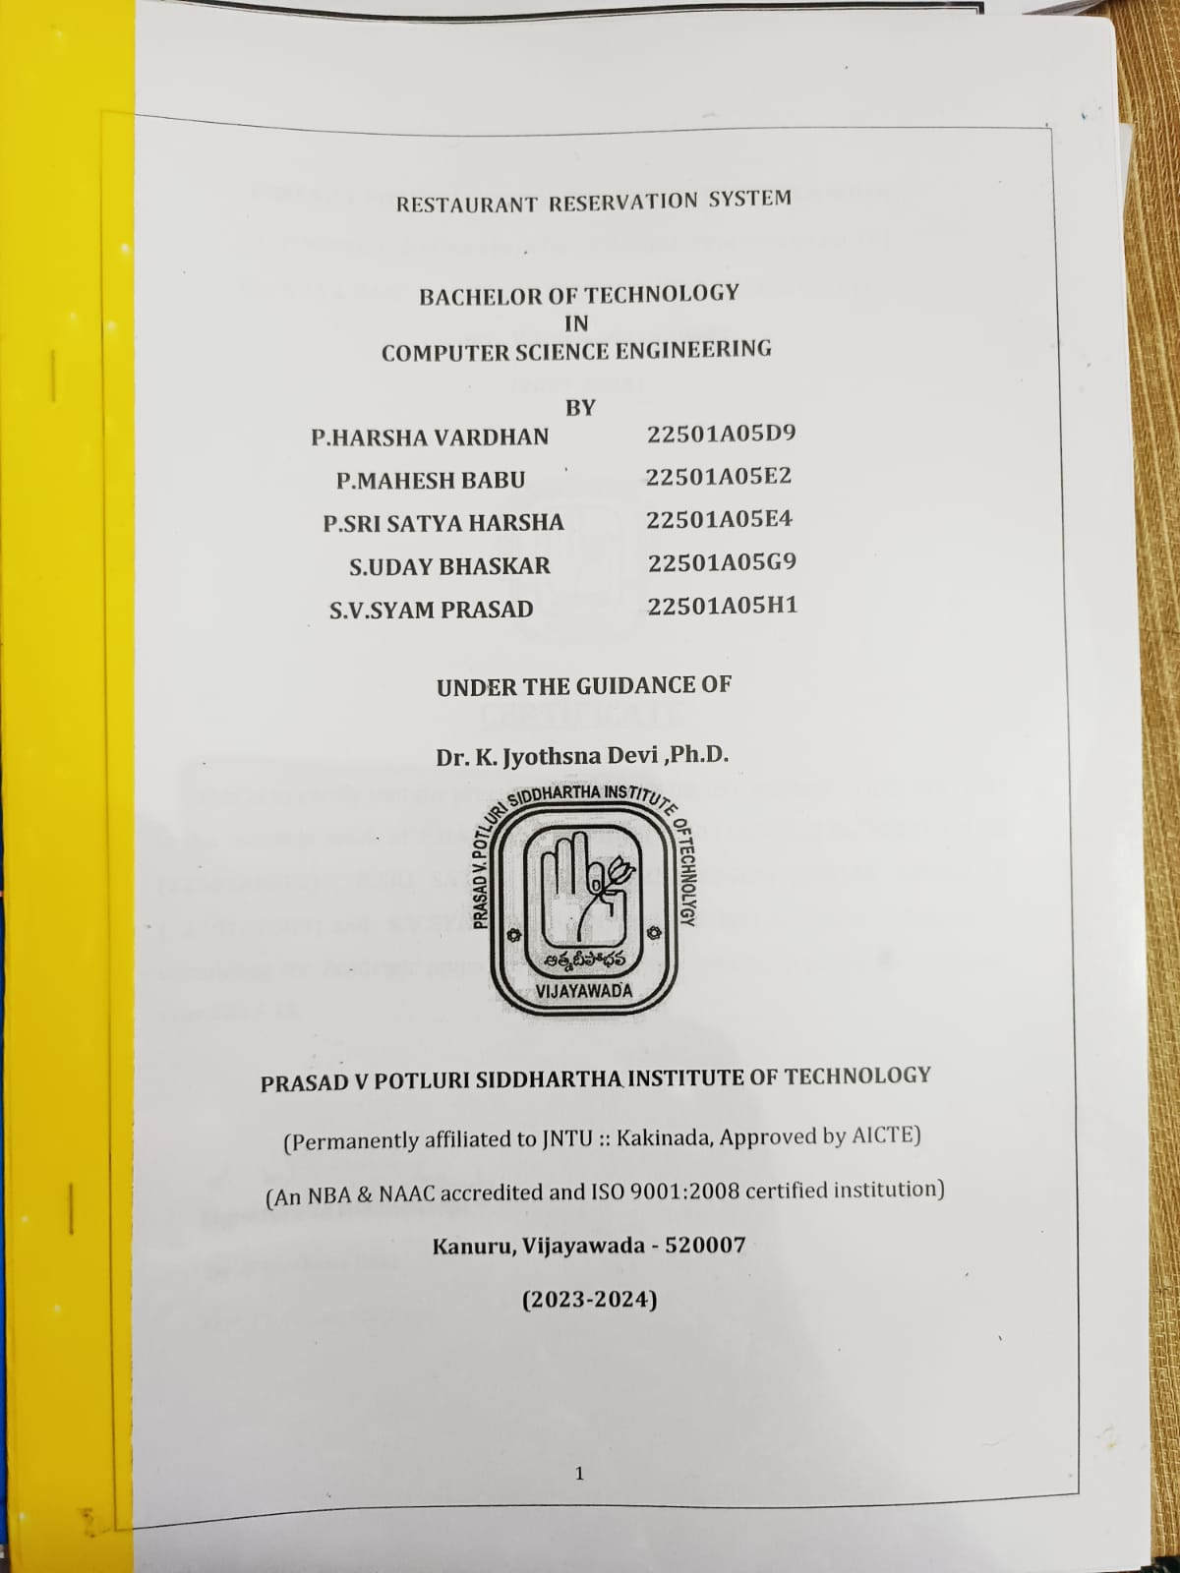

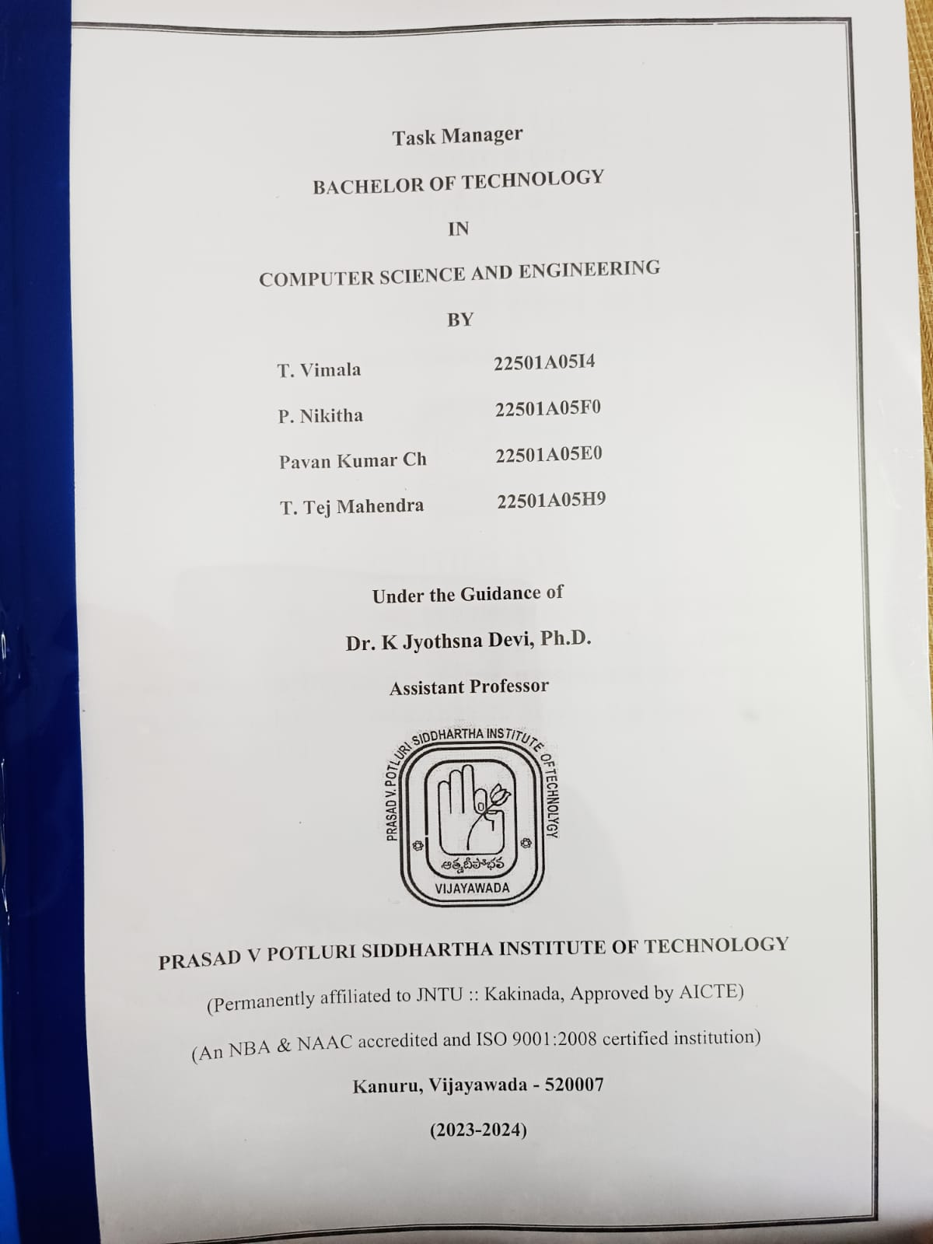

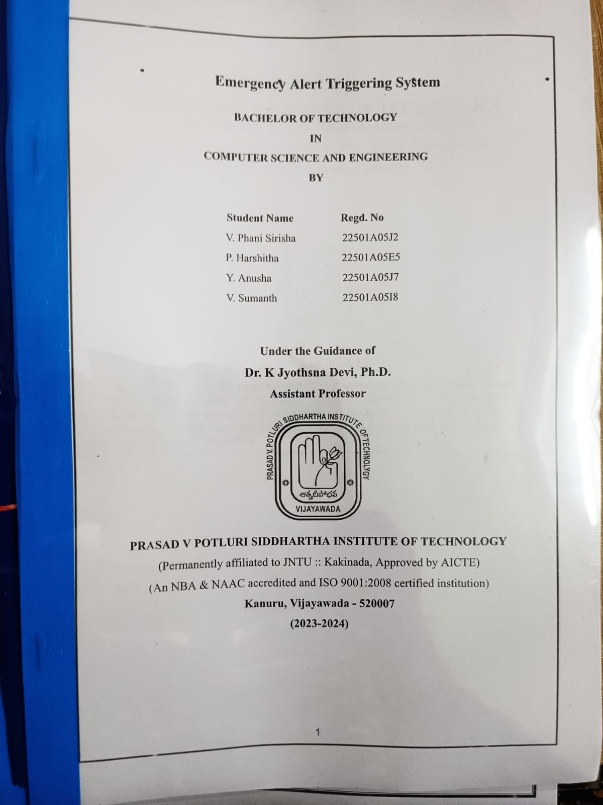

**Signature of the Faculty**