**PRASAD V. POTLURI SIDDHARTHA INSTITUTE OF TECHNOLOGY,**

**KANURU, VIJAYAWADA**

**DEPARTMENT OF COMPUTER SCIENCE & ENGINEERING**

**INNOVATIVE TEACHING METHODOLOGY**

**Academic Year: 2024-25**

**Teaching Methodology – GROUP DISCUSSION**

**Class:** II B. TECH

**Semester: II**-Semester

**Section:** S1

**Name of the Course: Software Engineering**

**Name of the Faculty:** A. Divya

------------------------------------------------------------------------------------------------------

**Name of the Topic:** Software Maintenance and process models and Estimation Cost

**Number of Students Involved: 72**

**Questions:**

1) What is Software Maintenance?

2) What is the Process Model?

3) What are the Factors Influencing Maintenance Costs?

4) What are the Cost Estimation models in Software Engineering?

5) What are the five basic parameters of the software cost model?

6) How to Estimate Effort in a software project?

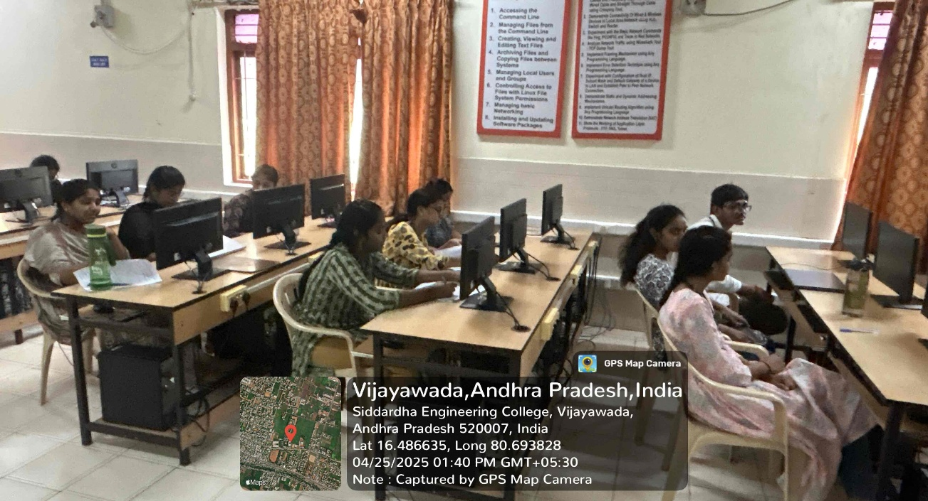

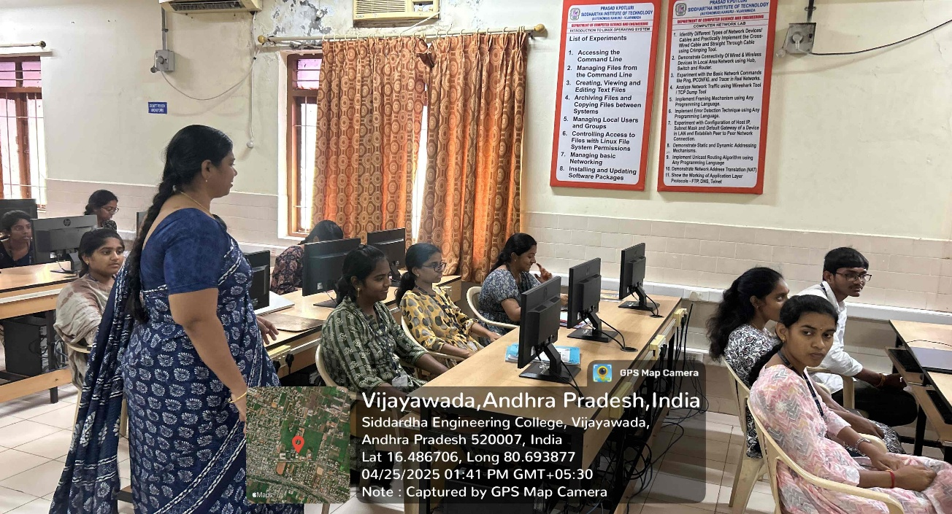

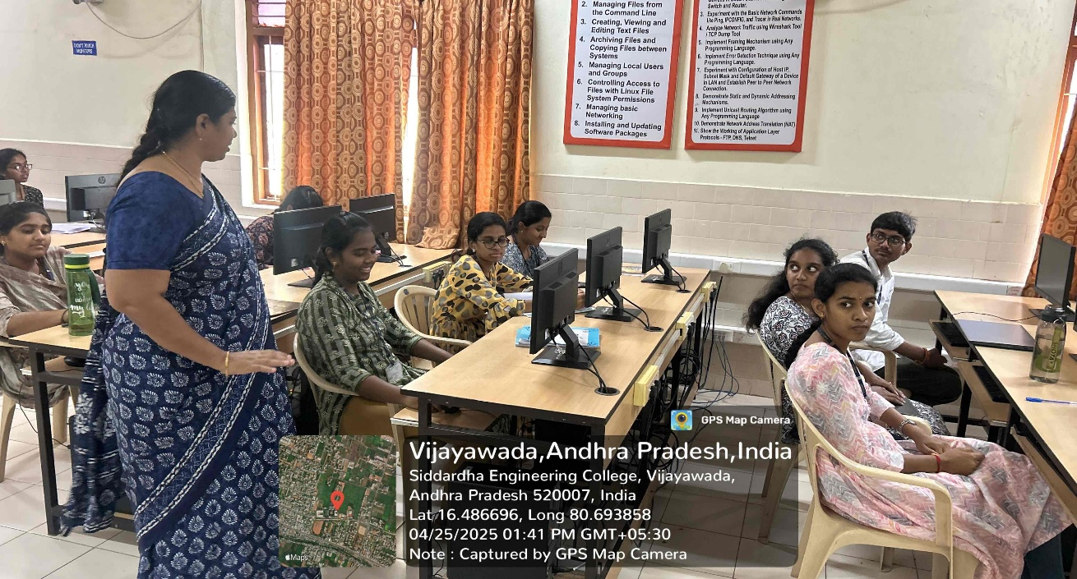

**Signature of the Faculty**