**PRASAD V. POTLURI SIDDHARTHA INSTITUTE OF TECHNOLOGY,**

**KANURU, VIJAYAWADA**

**DEPARTMENT OF COMPUTER SCIENCE & ENGINEERING**

**INNOVATIVE TEACHING METHODOLOGY**

**Academic Year: 2023 - 24**

**Teaching Methodology - SEMINAR (Individual Presentation)**

**Class :** II B.TECH

**Semester:** II - Semester

**Section:** S3

**Name of the Course:** Advanced Data Structures

**Name of the Faculty:** Dr. K. Jyothsna Devi

---------------------------------------------------------------------------------------------------------------

**Name of the Topic:** Universal hashing, Extendible hashing

**Number of Students Involved: 02**

**Student Name &Regd Number: 1) P. Anand Kumar (22501A05D3)**

**2) P. Chaitanya (22501A05E6)**

**Topics:**

1) Discuss the importance of hashing,

2) Explain universal hashing and extendible hashing

3) Explain the pictorial Representation of universal hashing and extendible hashing

4) Universal hashing and extendible hashing procedure. Give Each Step Explain with an example

5) Explain the Advantages and Disadvantages of Universal hashing and extendible hashing.

6) Explain the applications of Universal hashing and extendible hashing.

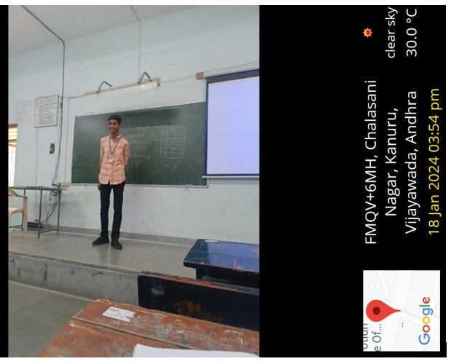

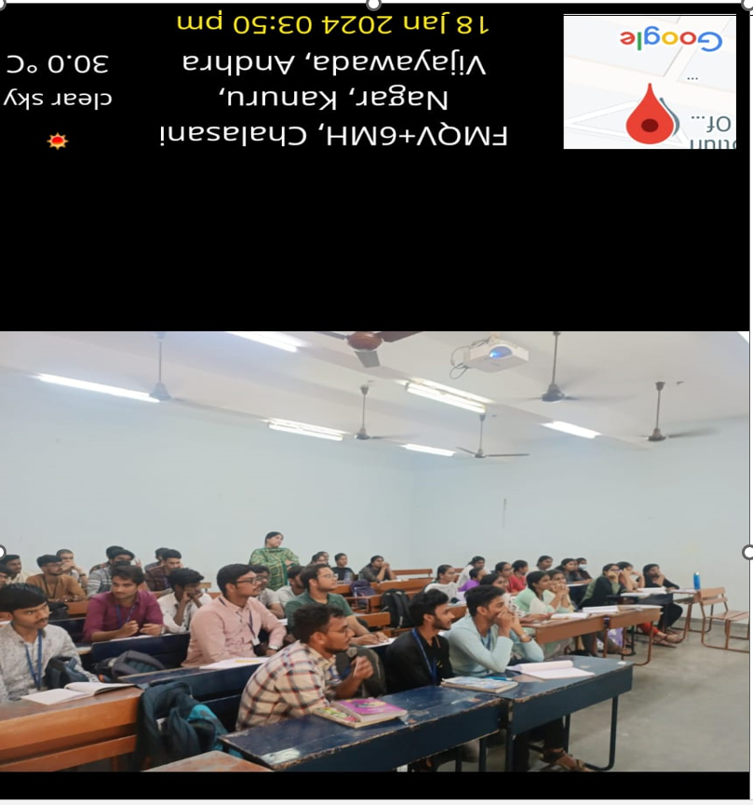

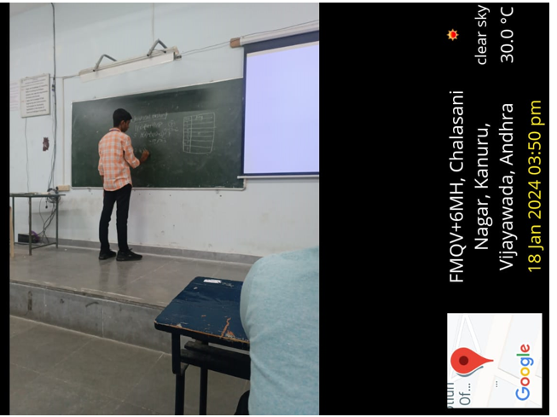

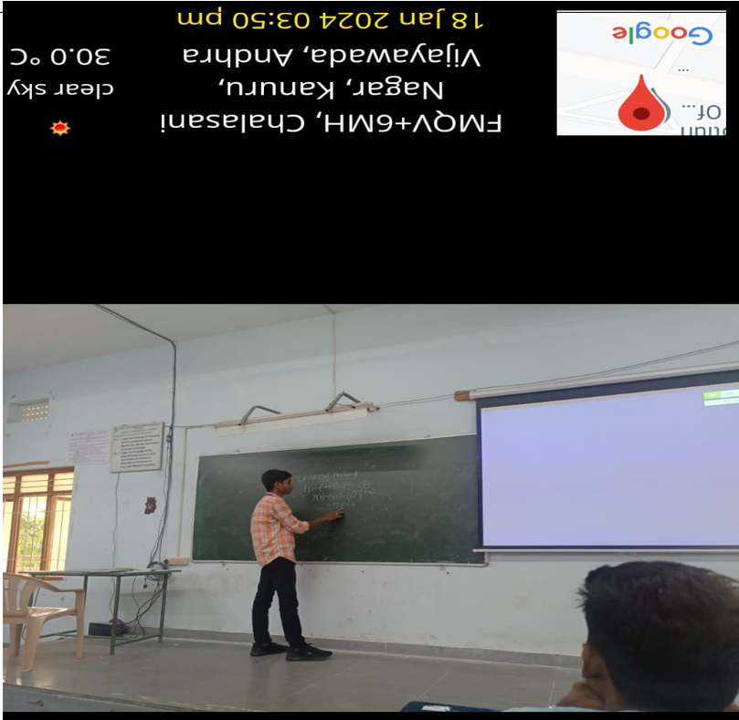

**Signature of the Faculty**