P.V.P Siddhartha Institute of Technology
Department of Computer Science and Engineering
Course: B.Tech |  | Year: II | Semester: I | Descriptive: II | A.Y:2024-25
Subject Code:23CS3301 |  | Subject Name: Advanced Data Structures and Algorithm Analysis |  |  | Regulation:PVP23
Duration:1 hr 30 min |  | Maximum Marks:30Marks |  |  | Date:28/11/24 |  | Session: F.N
Answer one from each Either-Or type of Questions.
Each Question carries 10 Marks
3×10M=30M
Q.No |  |  |  |  |  | Marks |  | CO | Level
1. | a) Discuss how Quick sort algorithm works to sort an array and trace the following dataset. 25, 91, 46, 35, 11, 82, 14, 55  Illustrate the best and average case complexity of Quick sort algorithm. |  |  |  |  | 5 |  | CO1 | L2
 | b) Identify an optimal solution using greedy method to the following instance of job sequencing with deadlines and profit problem  M=7, [P1:P7]=(3,5,20,18,1,6,30), [D1:D7]=(1,3,4,3,2,1,2) |  |  |  |  | 5 |  | CO2 | L3
(OR)
2. | a) Demonstrate an algorithm for sorting elements using simple merge. Apply the same for sorting list of elements given below:  67, 90, 12, 56, 23, 34, 45 |  |  |  |  | 5 |  | CO1 | L2
 | b) Construct minimum cost spanning tree using Prim’s algorithm for the given graph initiating from node 1. |  |  |  |  | 5 |  | CO2 | L3
3. | a) Illustrate Bellman-Ford algorithm to find the shortest path from a Single Source to all other vertices in a graph on the below graph. |  |  |  |  | 5 |  | CO1 | L2
 | b)Solve the following instance of 0/1 knapsack problem using dynamic programming n=3, m=4, profits (p1,p2,p3) = (3,7,12) weights (w1,w2,w3) = (3,5,7) and provide an optimal solution. |  |  |  |  | 5 |  | CO2 | L3
(OR)
4. | - Demonstrate all pair’s shortest path algorithm on the given below graph  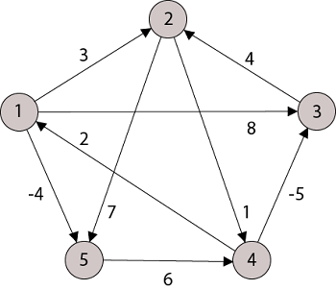 |  |  |  |  | 5 |  | CO1 | L2
 | b)Identify two sequences X = <A, B, C, B, D, A, B> and  Y = <B, D, C, A, B, A>. Develop the LCS of X and Y using Dynamic Programming |  |  |  |  | 5 |  | CO2 | L3
5. | a) Interview different complexity classes? Explain each with an example. |  |  |  |  | 2 |  | CO2 | L3
 | b)Elaborate how backtracking technique can be used to solve the n-queens problem. Construct an optimal solution for n=4 Queens. |  |  |  |  | 8 |  | CO4 | L3
(OR)
6. | a) Identify the advantages and disadvantages of backtracking compared branch and bound approach. |  |  |  |  | 2 |  | CO2 | L3
 | b) Adapt the Least Cost Branch Bound approach to solve instance of travelling sales person problem using the below graph.  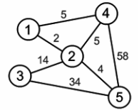 |  |  |  |  | 8 |  | CO4 | L3

