P.V.P Siddhartha Institute of Technology(Autonomous)
Department of Computer Science and Engineering
Course: B.Tech |  |  |  | Year: III | Semester: II | Descriptive: I | A.Y:2023-24
Subject Code: 20CS3602 |  |  |  | Subject Name: Machine Learning |  |  | Regulation:PVP20
Duration:  1 hr 30 min |  |  |  | Maximum Marks:15 Marks |  |  | Date:  30-01-2024 |  | Session: F.N
Answer all the Questions. Each Question carries 5 Marks 3×5M=15M
Q. No |  |  |  |  |  |  |  | Marks |  | CO | Level
1 |  | a) | Construct a decision tree for the following example and Classify whether the person gets the Job offer or Not.  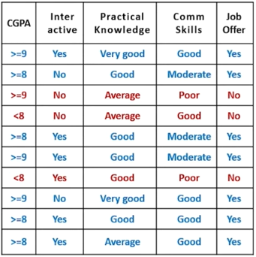 |  |  |  |  | 5 |  | CO1 | 2
2. |  | a) | Identify the differences between Biological Neuron and Artificial Neuron. |  |  |  |  | 2 |  | CO2 | 3
 |  | b) | Solve a given problem using back-propagation algorithm and perform the updated weight of W₃₅.(Use sigmoid activation function =1/1+e^{-x})  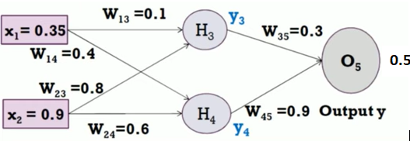 |  |  |  |  | 3 |  | CO2 | 3
3. |  |  | Apply Naïve Bayes Algorithm and predict if an accident will happen or Not?  {Weather Condition -Rain, Road Condition =Good, Traffic Condition = Normal, Engine Problem= No, Accident=?}  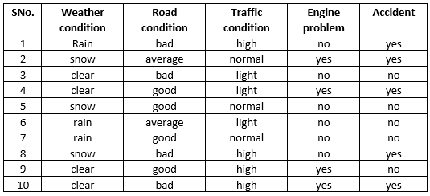 |  |  |  |  | 5 |  | CO2 | 3

