Code No: 23BS1305
PVP23

PVP Siddhartha Institute OF TECHNOLOGY
(Autonomous)

Discrete Mathematics & Graph Theory

Duration: 3 Hours Max. Marks: 70

Note: 1. This question paper contains two Parts A and B.
2. Part-A contains 10 short answer questions. Each Question carries 2 Marks.
3. Part-B contains 5 essay questions with an internal choice from each unit. Each
question carries 10 marks.
4. All parts of Question paper must be answered in one place
___________________________________________________________________________
Part - A
10 x 2 = 20 Marks

 |  | Blooms Level | CO
1a) | Show the truth tables for Tautology and Contradiction? | L2 | CO1
1b) | Construct the truth table of (PVQ) → P? | L3 | CO1
1c) | Explain the rule of Modus Tollens and Modus Pones of Proposition? | L2 | CO2
1d) | Define Quantifiers? List the types of Quantifiers. | L1 | CO2
1e) | What is Fibonacci Sequence and Write the Recurrence Relation? | L1 | CO3
1f) | Explain the various Particular Solutions of Non-Homogeneous Recurrence Relation? | L2 | CO3
1g) | Show the Hasse diagram representing the positive divisors of 36. | L2 | CO4
1h) | Define Complete Bipartite Graph with example? | L1 | CO4
1i) | Tell an example of a Graph which is Eulerian but not Hamiltonian? | L1 | CO4
1j) | Define Tree and List the properties of Tree? | L1 | CO4

Part –B
5 x 10 = 50 Marks

 |  |  | Blooms Level | CO | Max. Marks
UNIT-I
2 | (a) | Show that following equivalence without constructing the truth table ¬ (P ∧ Q) → (¬P ∨ (¬ P ∨ Q)) ⇔ (P → Q). | L2 | CO1 | 5M
 | (b) | Construct the Principal Disjunctive Normal Form (PDNF) for the following formula: (∼P → R) ⋀ (Q ⟷ P). | L3 | CO1 | 5M
OR
3 | (a) | Define a compound statement? Illustrate various connectives with an example. | L2 | CO1 | 5M
 | (b) | Obtain the principal disjunctive normal form of | L2 | CO1 | 5M
UNIT-II
4 | (a) | With the use of theory of inference, Show that R (Pis a valid conclusion from the premises | L3 | CO2 | 5M
 | (b) | Apply the rule of specification and generalization, symbolize the following argument and check for its validity:  Premises: Every living thing is a plant or an animal.  John’s goldfish is alive and it is not a plant.  All animals have hearts.  Conclusion: Therefore, John’s goldfish has a heart. | L3 | CO2 | 5M
OR
5 | (a) | Using rules of inference, Verify whether the following argument is valid:  Premises: If Joe is a Mathematician, then he is ambitious.  If Joe is an early riser, then he does not like oatmeal.  If Joe is ambitious, then he is an early riser.  Conclusion: Hence, If Joe is a Mathematician, then he does not like oatmeal. | L3 | CO2 | 5M
 | (b) | Show that  ∀x (P(x) →Q(x))∧ ∀x (Q(x) → R(x))⇒∀x(P(x) → R(x)). | L2 | CO2 | 5M
UNIT-III
6 | (a) | Solve the following recurrence relation  $a_{n} +a_{n-1}- 6a_{n-2} =0 for n≥2,$ given that$a_{0} = -1$ and $a_{1} =8.$ | L3 | CO3 | 5M
 | (b) | Solve $a_{n}-5a_{n-1}+ 6a_{n-2} =2^{n}, n>2$with the initial conditions $a_{0} = 1$ and $a_{1} =1.$ | L3 | CO3 | 5M
OR
7 | (a) | Solve $a_{n}-2a_{n-1}-a_{n-2}+2a_{n-3} =0, n≥3$given that that$a_{0} = 3, a_{1}=6, a_{2}=0$ using the characteristic method. | L3 | CO3 | 5M
 | (b) | Solve the following recurrence relation  $a_{n}-7a_{n-1}+ 10a_{n-2} =4^{n}$. | L3 | CO3 | 5M
UNIT-IV
8 | (a) | Let A= {1,2,3,4,5,6,7 } ,Determine a relation R on A by  $$aRb ⟺ 3 divides ( a – b )$$  Show that R is an equivalence relation. | L2 | CO4 | 7M
 | (b) | Examine whether the following graphs are isomorphic or not. Justify your answer?  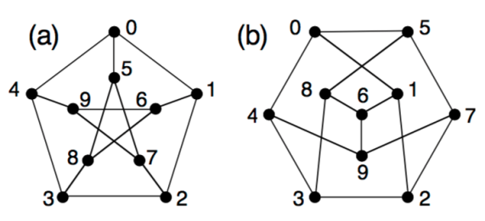 | L4 | CO4 | 5M
OR
9 | (a) | Let D₁₀₀ ≡ {1, 2, 4, 5, 10, 20, 25, 50, 100} be the divisors of 100 and let the relation ≤ be the relation $a ≤ b if a│b$ then  (D₁₀₀, │) is a poset.  Analyze the following bounds from the Hasse diagram?  - greatest lower bound {10, 20}  - least upper bound {10, 20}  - greatest lower bound {5, 10, 20, 25}  - least upper bound {5, 10, 20, 25} | L4 | CO4 | 5M
 | (b) | Consider the relation R = {(a, b), (b, c), (b, d), (d, a), (c, c)} Show the Digraph and Adjacency Matrix for the relation R? | L2 | CO4 | 5M
UNIT-V
10 | (a) | Utilize the Welch Powell Algorithm for finding chromatic number of the following graph.  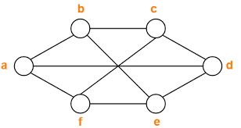 | L3 | CO4 | 5M
 | (b) | Discover a Minimal Spanning Tree for the given weighed graph using Kruskal’s algorithm.  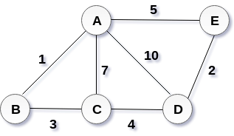 | L4 | CO4 | 5M
OR
11 | (a) | Examine whether the following graph is planar or not. Justify your answer  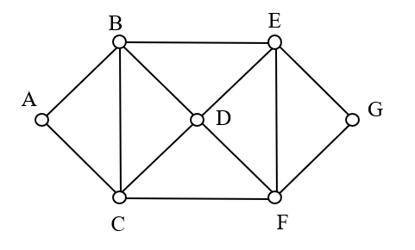 | L4 | CO4 | 5M
 | (b) | Comare and Contrast between Depth First Search and Breadth First Search with an example | L2 | CO4 | 5M

