P.V.P Siddhartha Institute of Technology(Autonomous)
Department of Computer Science and Engineering
Course: B.Tech |  |  | Year: II | Semester: I | Descriptive: II | A.Y:2023-24
Subject Code: 20BS1303 |  |  | Subject Name: Engineering Mathematics-III  (Discrete Mathematical Structures) |  |  | Regulation:PVP20
Duration:  1 hr. 30 min. |  |  | Maximum Marks:15 Marks |  |  | Date:27/11/23 |  |  | Session: F.N
Answer all the Questions.
Each Question carries 5 Marks 3×5 =15M
Q. No | QUESTION |  |  |  |  |  | Marks | CO |  | Level
1. | a) | Solve the recurrence relation using characteristics method with initial conditions a₀=2 and a₁=5. |  |  |  |  | 2.5 | CO3 |  | 3
 | b) | Explain Eulerian and Hamiltonian graphs with examples and draw the graphs of the following.  - Eulerian but not Hamiltonian.  - Hamiltonian but not Eulerian. |  |  |  |  | 2.5 | CO1 |  | 2
2. | a) | Consider the relation R = {(a, b), (b, c), (b, d), (d, a), (c, c)} Show the Digraph and Adjacency Matrix for the relation R? |  |  |  |  | 3 | CO1 |  | 2
 | b) | Let S₁₅₀ be the set of all divisors of 150. Let the relation ≤ be given by a ≤ b if a│b on S₁₅₀.  - Draw the Hasse Diagram for the Poset (S₁₅₀, |).  - Find the least element and greatest element of this POSET if it exists.  - Find the GLB and LUB of {5, 6, 10, 15}. |  |  |  |  | 2 | CO4 |  | 4
3. | a) | Examine whether the following graphs are isomorphic or not. Justify your answer?  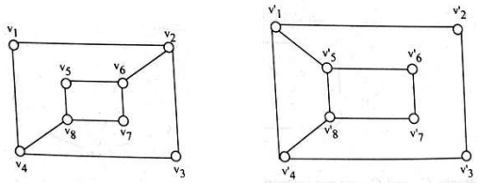 |  |  |  |  | 3 | CO3 |  | 3
 | b) | Discover a Minimal Spanning Tree for the given weighed graph using Kruskal’s algorithm.  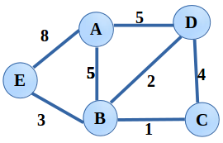 |  |  |  |  | 2 | CO3 |  | 3

