**PRASAD V. POTLURI SIDDHARTHA INSTITUTE OF TECHNOLOGY,**

**KANURU, VIJAYAWADA**

**DEPARTMENT OF COMPUTER SCIENCE & ENGINEERING**

**INNOVATIVE TEACHING METHODOLOGY**

**Academic Year: 2024 - 25**

**Teaching Methodology – Video Activity (Presentation)**

**Class :** II B.TECH

**Semester:** I - Semester

**Section:** S2

**Name of the Course: Advanced** Data Structures **& Algorithm Analysis**

**Name of the Faculty:** Dr. K. Jyothsna Devi

---------------------------------------------------------------------------------------------------------------

**Name of the Topic:** B+ trees ADT operations with example, Threaded binary tress with example, Huffman coding using Greedy approach, Red-black trees ADT operations with example, Optimization in Find and union (Ex: path compression, ranking) with one application, Pattern matching or string matching algorithms (Ex: naive string-matching algorithm, The Rabin-Karp algorithm, The Knuth-Morris-Pratt algorithm ), External sorting algorithms, Binomial queues ADT operations with examples, topological sorting using greedy approach, Skip list, Splay trees, Explain Traveling Salesperson Decision Problem (TSP) using NP Hard graph concept.

**Number of Students Involved : 37**

**Student Name &Regd Number:**

|  |  |  |
| --- | --- | --- |
| **S.No** | **Register No.** | **Name of the Student** |
| 1 | 23501A0569 | KAZA VARUN |
| 2 | 23501A0578 | K. Venkata sai Prakash |
| 3 | 23501A0581 | K. Yeshita Navya |
| 4 | 23501A0582 | KOMMU THILAKAVATHI |
| 5 | 23501A0583 | K. Karthik |
| 6 | 23501A0585 | KORUKONDA MOULIKA |
| 7 | 23501A0590 | K. Pujitha |
| 8 | 23501A0594 | K. Adithya |
| 9 | **23501A0595** | **KURAGANTI NAGA CHARAN** |
| 10 | 23501A0596 | **K. Venkata Lalith Chandan** |
| 11 | 23501A0597 | **L. Rishi SivaKesh** |
| 12 | **23501A0598** | **LANKA HIMAJA** |
| 13 | 23501A05A0 | **L. Sushmitha** |
| 14 | 23501A05A4 | **M. Sri Sai Siri** |
| 15 | 23501A05A6 | **M. Poshanya Guptha** |
| 17 | 23501A05A9 | **M. Sadhika** |
| 18 | 23501A05B0 | **M. Jaya Lakshmi** |
| 19 | 23501A05B1 | **M. Jaya Sai Krishna** |
| 20 | **23501A05B2** | **MANDADHI JANANI** |
| 21 | 23501A05B3 | **M. Rishmitha** |
| 22 | 23501A05B6 | MEKALA KUMAR SAI SIDDHARTHA |
| 23 | 23501A05B7 | M. Pravallika |
| 24 | 23501A05B8 | M. Adithya |
| 25 | 23501A05C1 | M. Aashritha |
| 26 | 23501A05C2 | M. Harshith Ram |
| 27 | 23501A05C4 | M. Bhagya Sai Sri |
| 28 | 23501A05C5 | M. Dakshayani |
| 30 | 23501A05C6 | MULE REVANTH REDDY |
| 31 | 23501A05C8 | M. Poojitha |
| 32 | 23501A05C9 | MYNAM KRISHNA SAHITHI |
| 33 | 23501A05D2 | N. Yavanika |
| 34 | 24505A0508 | Kadaro Manobhi Ram |
| 35 | 24505A0509 | K. Sowmya |
| 36 | 24505A0510 | K. Ajay Krishna |
| 37 | 245050A0511 | Labba Lakshmi Devi |

**Topics:**

1) Discuss the importance of Advanced Data Structures.

2) Explain the Advanced trees and Graph data structures

3) Explain the string matching algorithms

5) Explain the Advantages and Disadvantages of internal and external sorting algorithms

6) Explore the case studies on algorithm design techniques

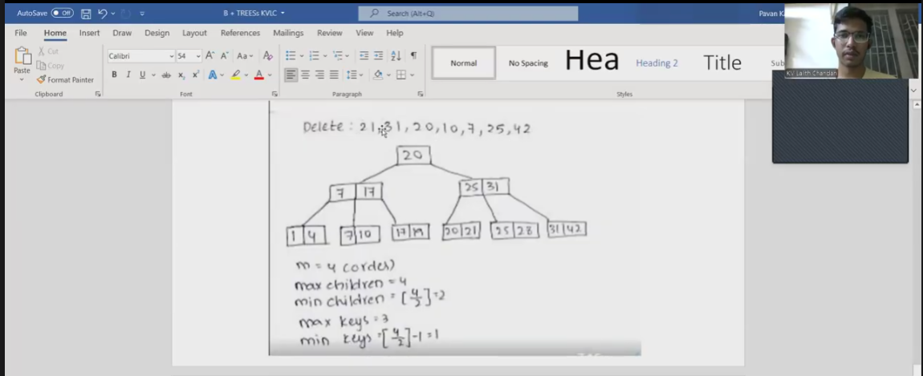

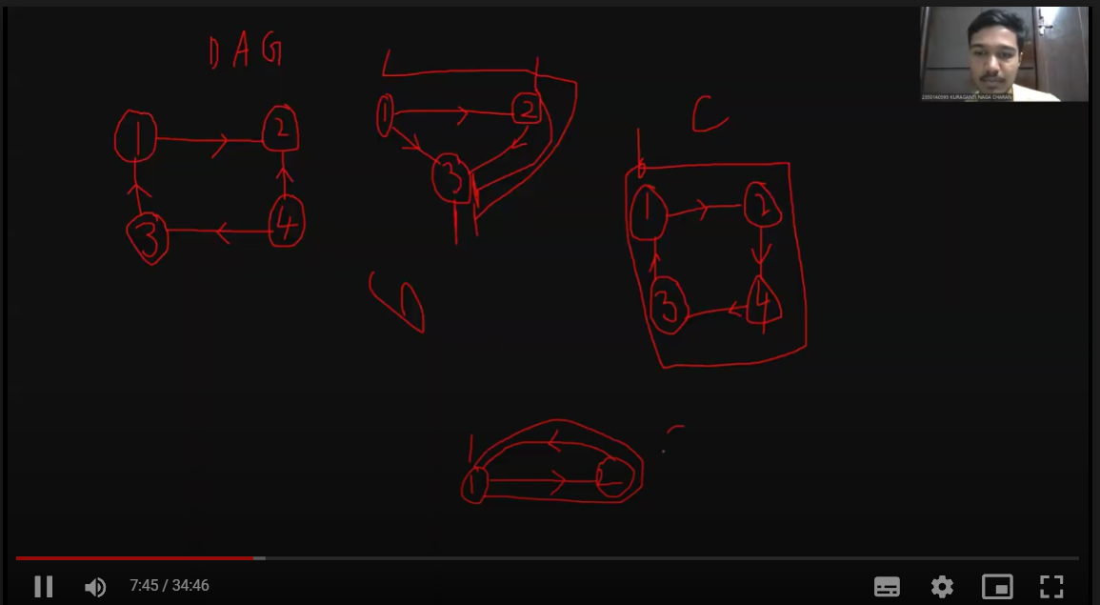

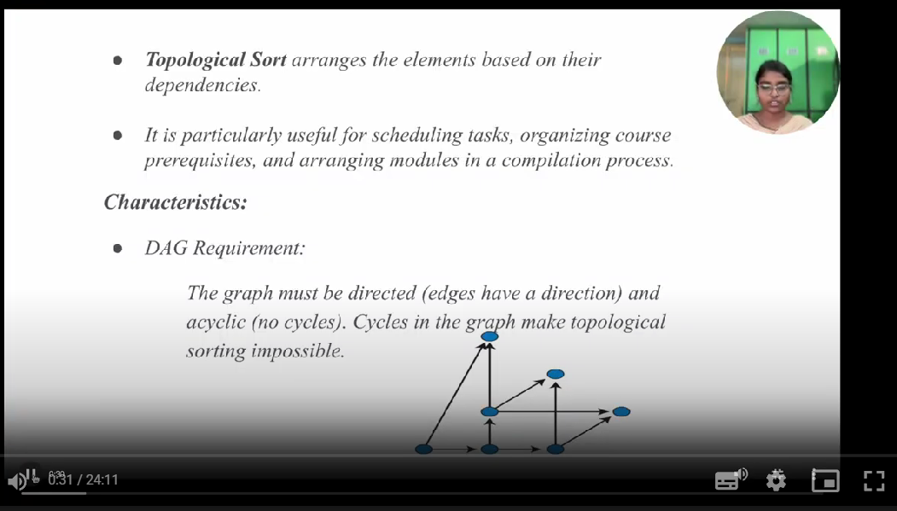

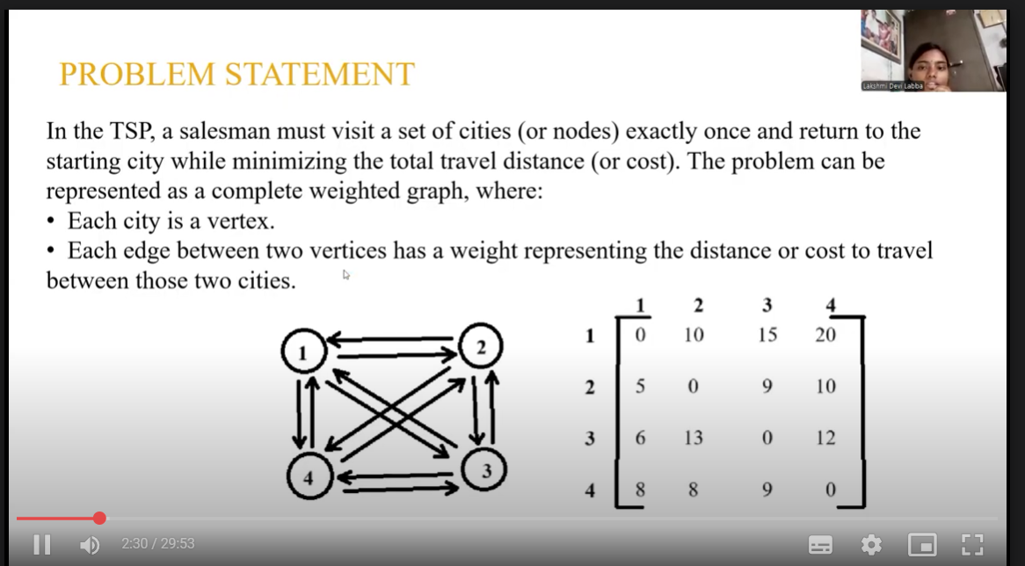

**Signature of the Faculty**