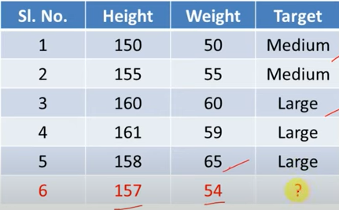

_____________________________________________________________________________________

|  |  |  |
| --- | --- | --- |
| Maths | Computer Science | Result |
| 4 | 3 | Fail |
| 6 | 7 | Pass |
| 5 | 5 | Pass |
| 7 | 7 | Fail |
| 8 | 8 | Pass |

**Query = X= (Maths=6, Computer Science=8), K=3**



