1. Develop and demonstrate JavaScript with POP-UP boxes and functions for the following problems:

a) Input: Click on Display Date button using onclick( ) function Output: Display date in the textbox

b) Input: A number n obtained using prompt Output: Factorial of n number using alert

c) Input: A number n obtained using prompt Output: A multiplication table of numbers from 1 to 10 of n using alert

d) Input: A number n obtained using prompt and add another number using confirm Output: Sum of the entire n numbers using alert

a)date

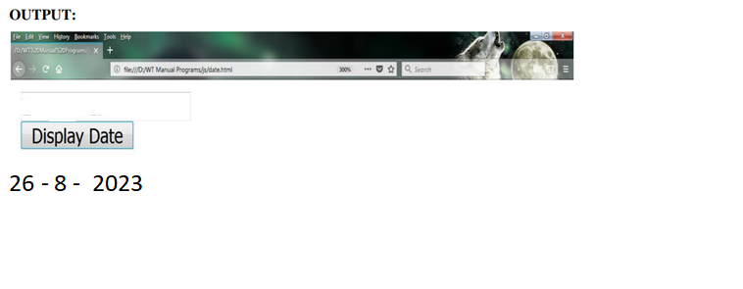

b)Factorial

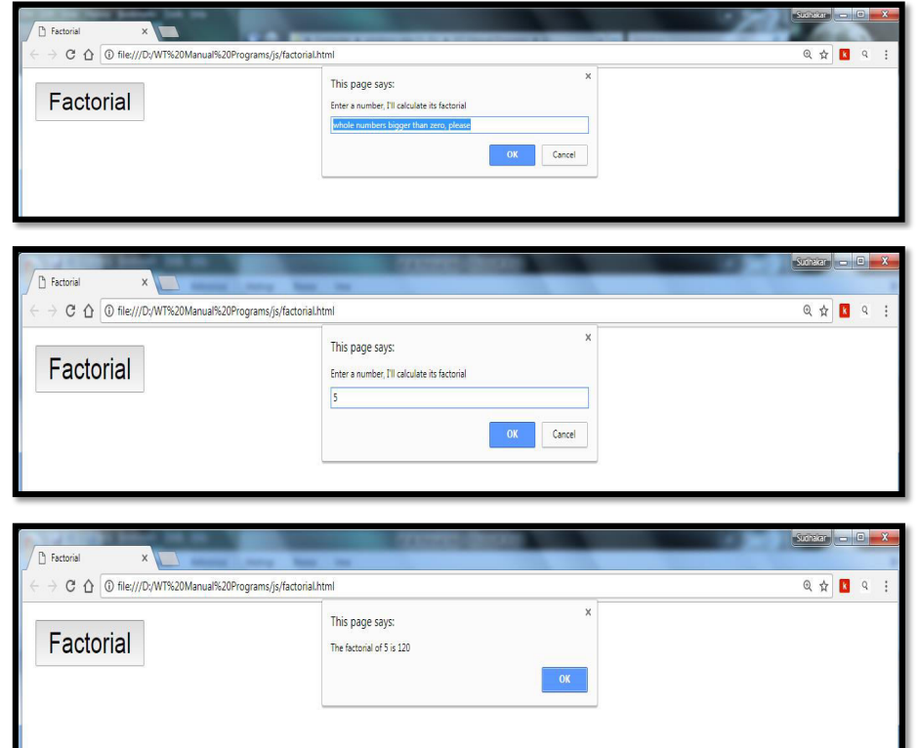

1. Table

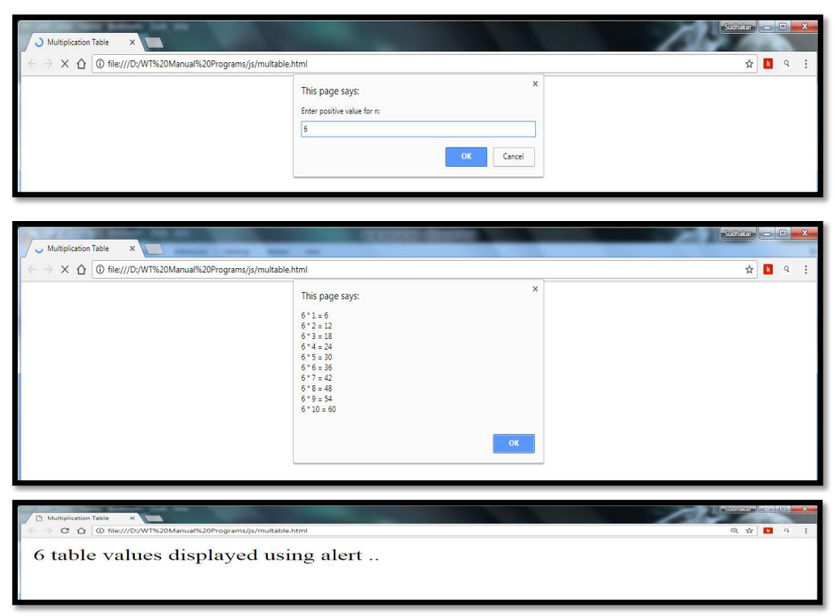

1. Sum of n natural numbers

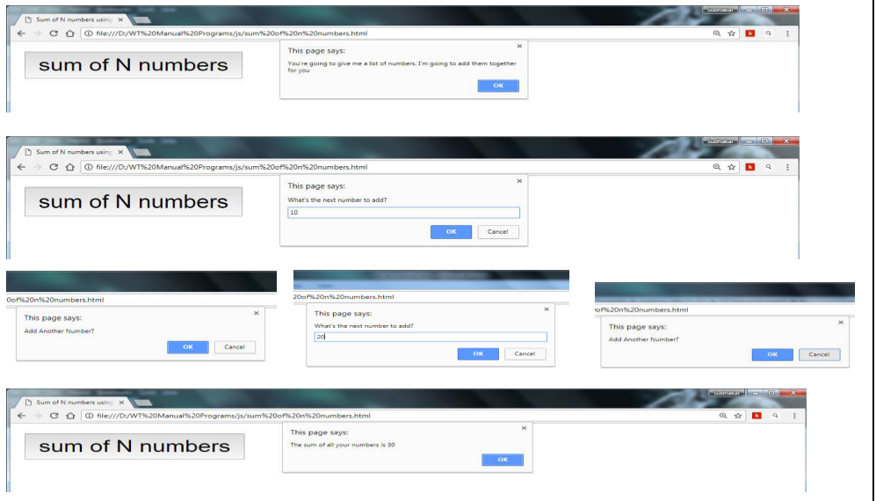

1. Write an HTML page that contains a selection box with a list of 5 countries. When the user selects a country, its capital should be printed next in the list. Add CSS to customize the properties of the font of the capital (color,bold and font size). (Hint: Use css, Java script, and forms)

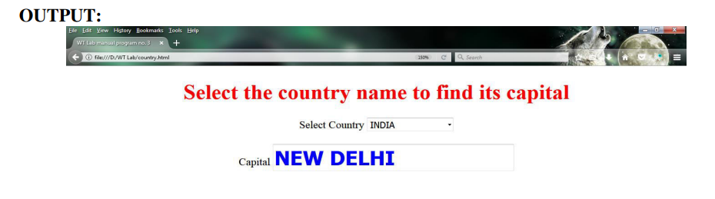

1. Write an HTML page including any required JavaScript that takes a number from text field in the range of 0 to 999 and shows it in words. It should not accept four and above digits, alphabets and special characters.

