**PRASAD V. POTLURI SIDDHARTHA INSTITUTE OF TECHNOLOGY,**

**KANURU, VIJAYAWADA**

**DEPARTMENT OF COMPUTER SCIENCE & ENGINEERING**

**INNOVATIVE TEACHING METHODOLOGY**

**Academic Year: 2024 - 25**

**Teaching Methodology - SEMINAR (Individual Presentation)**

**Class :** II B.TECH

**Semester:** I - Semester

**Section:** S2

**Name of the Course:** Advanced Data Structures & Algorithm Analysis

**Name of the Faculty:** Dr. K. Jyothsna Devi

---------------------------------------------------------------------------------------------------------------

**Name of the Topic: STL Library Maps, B+- Tress, Red- Black Tress and Graph Coloring problem using disjoint sets**

**Number of Students Involved: 04**

**Student Name &Regd Number: 1) L. Himaja (23501A0598)**

**2) Kothuri Pujitha (23501A0590)**

**3) Kaza Varun (23501A0569)**

**4) Muthukuri Aasritha (23501A05C1)**

**Topics:**

1) Discuss the importance of STL Library templates like unordered Maps and ordered Maps templates

2) Explain the importance of B+- trees than B-Tress. Implementation and operations in detail

3) Explain the Red- Black trees pictorial Representation and operations.

4) Discuss the Graph coloring problem implementation using Disjoint sets with an example

5) Explain the Advantages and Disadvantages of B-Trees Vs B+-Trees, AVL tress Vs Red- Black trees

6) Explain the applications of B+-Trees and Red- Black tress.

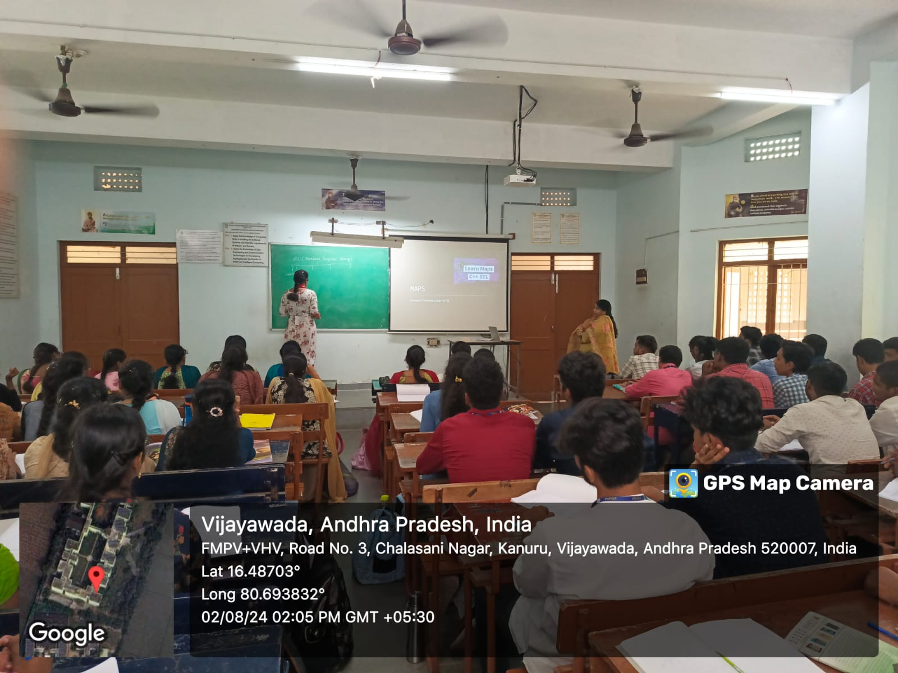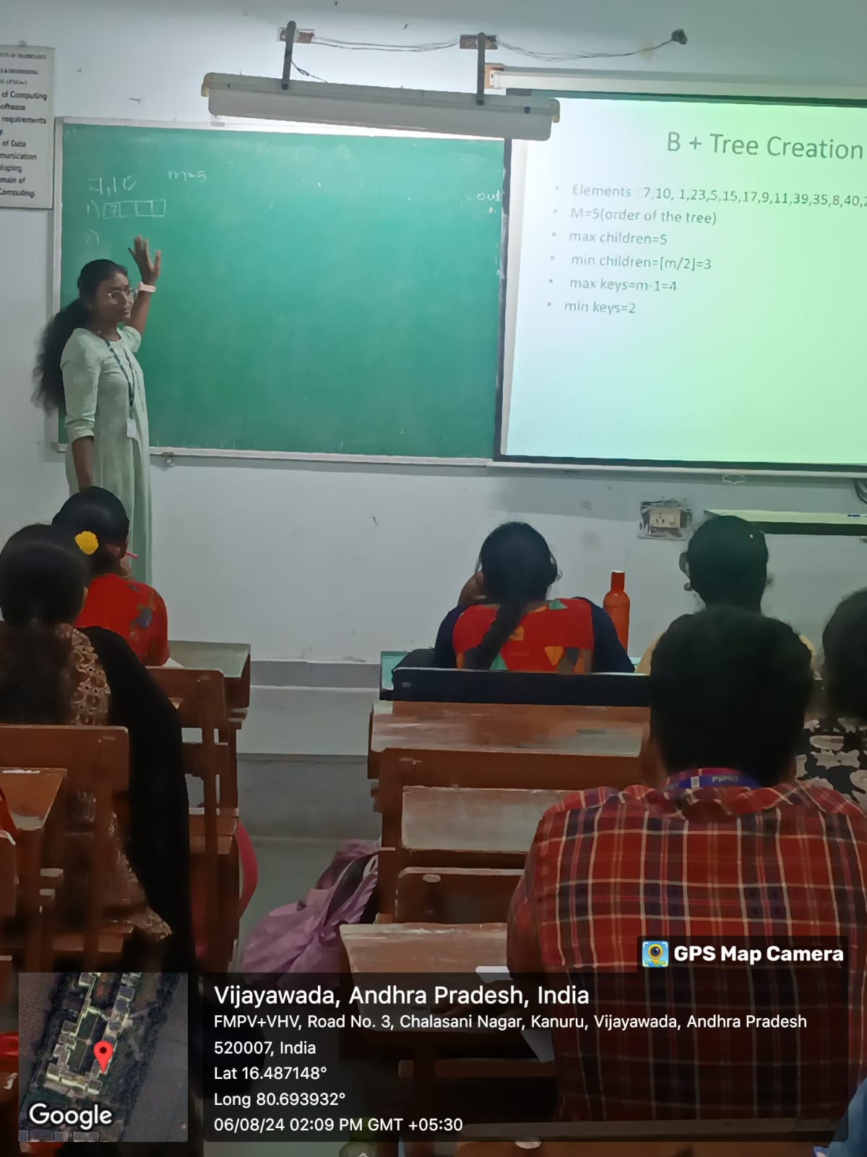

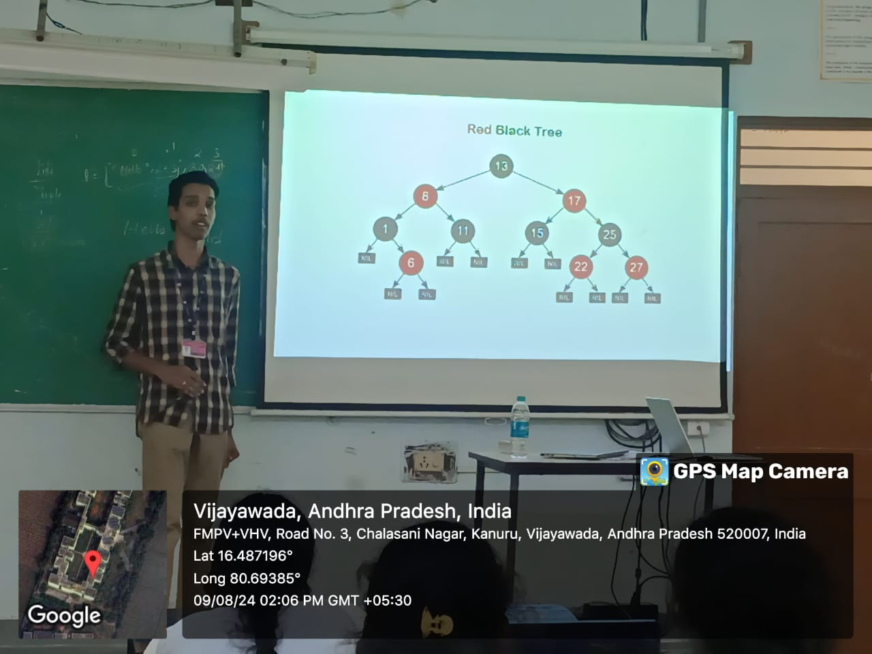

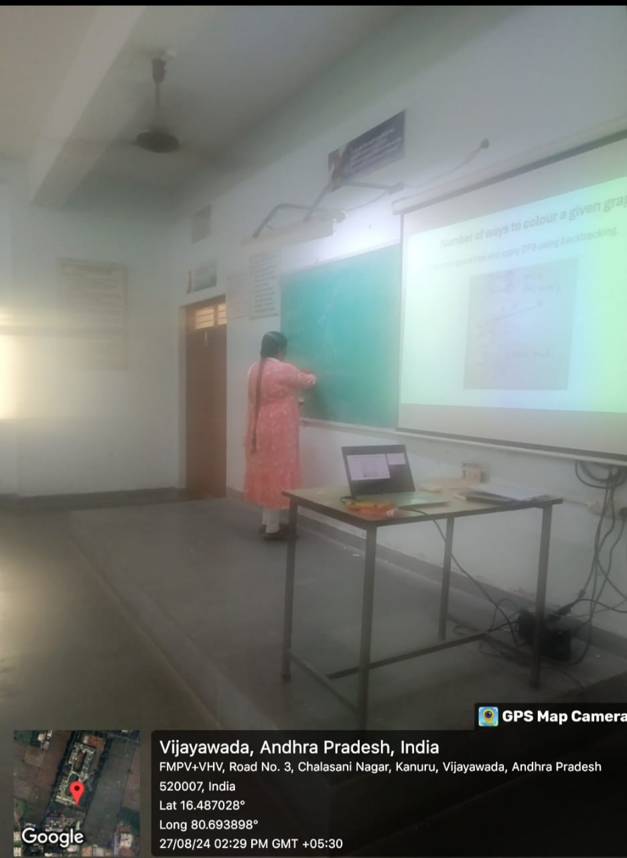

**Signature of the Faculty**