List of questions for Assignment 2:

1. 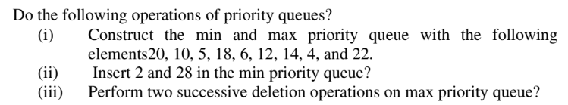

2. 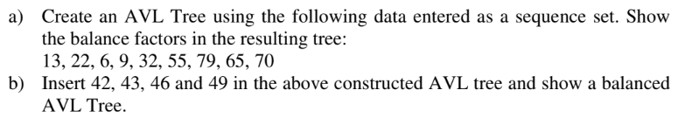

3. 

4. 

5. 

6. 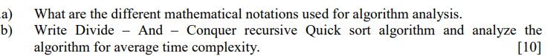

7. 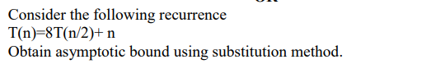

8. 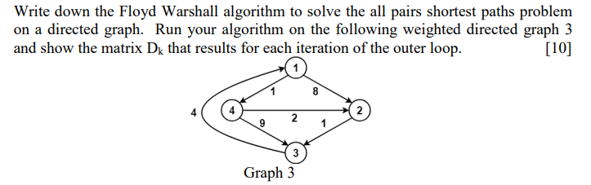

9.

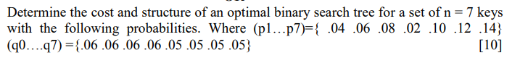

10. 

Solve above problem using fractional knapsack also using greedy approach