Introduction Cascading Style Sheets:

Cascading Style Sheets(css) or simply style sheets are text files that contain one or more rules in the form of property/value pairs to determine how elements in a Web page should be displayed. CSS deals with all the style-related aspects important to create a Web page. W3C has developed some specifications to create and use style sheets. These specifications are called Cascading Style Sheet specifications. The two versions of css specifications have been released till now: the version is known as CSS1 and the second as CSS2. After the introduction of CSS, HTML elements that purely deal with style-related aspects, such as <u>, <centre>, and <strike> have been deprecated and W3C has recommended that in place of these HTML elements, their replacement should be used in CSS.

The syntax of CSS rule is as follow:

Selector {property: property1-value; property2: property2-value; property3: property3-value…………..}

In above syntax, selector is the element that the rule defines, property1, property2, and property3 are the properties defined for that element, and property1-value, property2-value, and property3-value are values assigned to these properties.

Using above CSS syntax, we can create a CSS rule to set three background properties(background-color, background-image, and background-repeat) for <body> element, as follows:

body{background-color:#0000ff;background-image:url(C:\Image.jpg);

background-repeat: repeat-x}

The three properties in one declaration, using the shorthand property named background. This shorthand property is a CSS property which enables you to set two or more properties in one declaration as follows:

body {background: #0000ff url(C:\Image.jpg) repeat-x}

You can create cascading styles in a Web page in four ways:

1. Using inline styles
2. Using external style sheets
3. Using internal style sheets
4. Using style classes.

1.*Inline styles:*

In the Inline Styles method, style for an HTML element is specified using its style attribute. Inline styles are useful when you want to define specific styles for an individual elements present on a Web page.

* Inline Style Example

<html>  
<head>

<title>Inline Styles</title>

</head>

<body>

<table border=”1”>

<caption><h2>Student Details</h2></caption>

<th style=”background-color: #800000”>Name</th>

<th style=”background-color: #800000:”>Date of Birth</th>

<th style=”background-color: #800000:”>Address</th>

<tr>

<td style=”background-color: #0080000”>Sumit Saxena</td>

<td style=”background-color: #0080000”>15-03-1983/td>

<td style=”background-color: #0080000”>Flat No. 303, Shipra Suncity, Ghaziabad</td>

</tr>

<tr>

<td style=”background-color: #0080000”>Amitabh Kumar</td>

<td style=”background-color: #0080000”>22-02-1984</td>

<td style=”background-color: #0080000”>H.No- 125, Kalkaji, Delhi</td>

</tr>

<tr>

<td style=”background-color: #00ff00”>Rohit Jandial</td>

<td style=”background-color: #00ff00”>05-07-1983</td>

<td style=”background-color: #00ff00”>flat no- 324, South ext, Delhi</td>

</tr>

<tr>

<td style=”background-color: #808000”>Avantika</td>

<td style=”background-color: #808080”>10-12-1984</td>

<td style=”background-color: #808080”>H.No- 541,Vikas Puri, Delhi</td>

</tr>

</table>

</body>

</html>

**OUTPUT:**

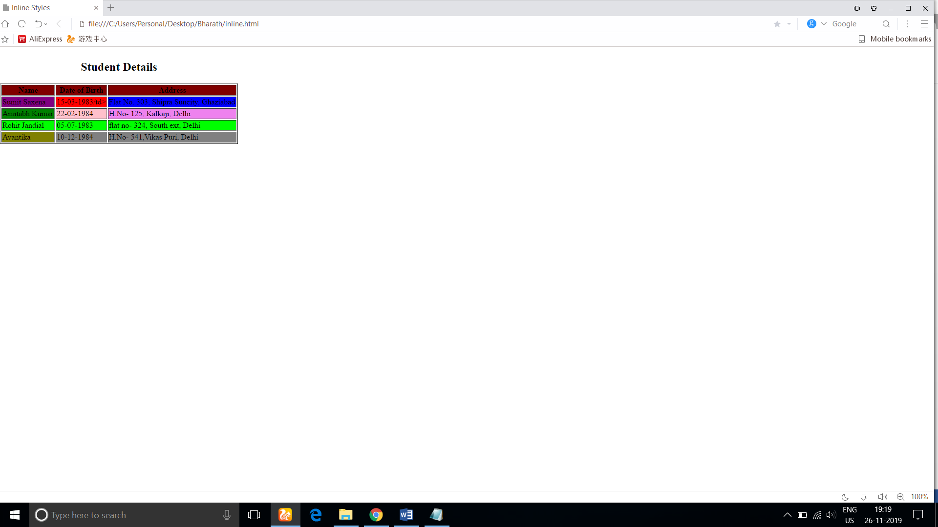

2.*External Style Sheets*

An external style sheet is a separate document that contains only CSS rules and has .css extension. External style sheets are used to apply uniform styles to all the Web pages. For example, let’s assume that you are creating a website that contains more than one Web page and you want same look and feel for same types of HTML elements in all Web pages. In such situation, you can first create all the required CSS rules in an external style sheet then link it to all the Web pages of the website.

* Creating an External Style Sheet

Body{background-color: #f0f8ff; font-family: Arial}

a:link{color: #808080}

a:visited{color: #0000ff}

a:hover{color: #00ff0000}

a:active{color: #ff0000}

Linking a Style to an HTML Document

After creating an external style sheet, you can see the styles added to the style sheet, in an HTML document. To do so, we need to link the style sheet to the HTML document by using the <link> element.

External Style Sheet Example

<html>

<head>

<title>External Style Sheet</title>

</head>

<body>

<h1>External Style Sheet Example</h1>

<a href= page1.html target=”_blank”>

<h2>page1</h2>

<a href=page2.html target=”_blank”>

<h2>page2</h2>

</body>

</html>

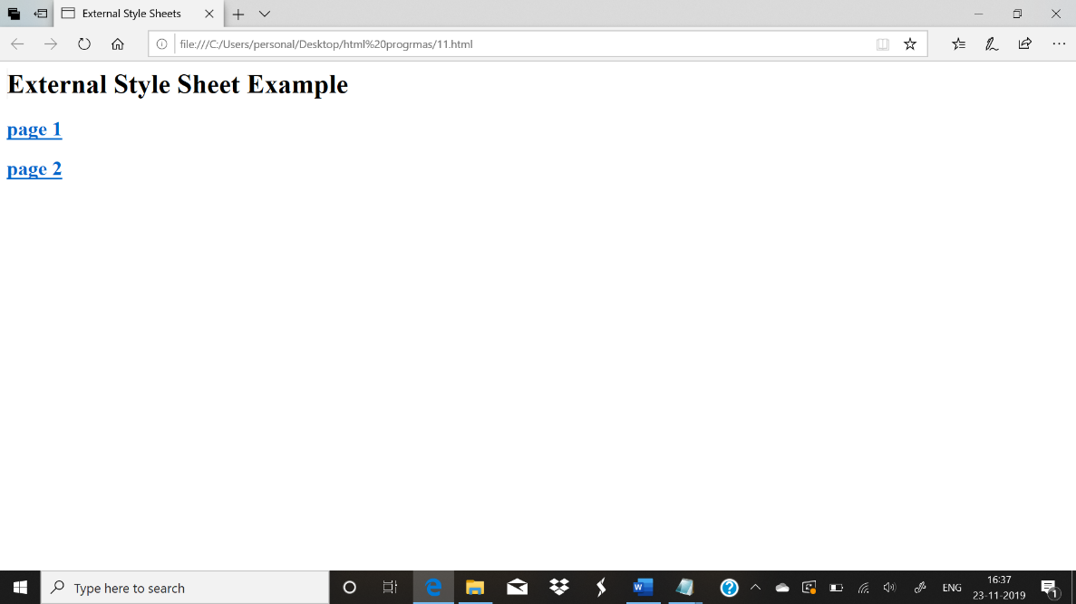

Page without style sheet

Linking an HTML Document to an External Style Sheet

<html>

<head>  
 <title>External Style Sheet</title>

<link rel=”stylesheet” href=”style.css”>

</head>  
 <body>

<h1>External Sheet Example</h1>

<a href=page1.html taget=”_blank”>

<h2>Page1</h2>

<a href=page2.html target=”_blank”>

<h2>Page2</h2>  
 </body>

</html>

*Internal Style Sheets*

Internal style sheets are not separate documents rather they are styles, created inside an HTML document. These style sheets are useful when you want to apply similar styles to all the elements present on a Web page. Internal style sheets are created using the <style> element that is added inside the <head> element of the HTML.

|  |  |
| --- | --- |
| Attribute | Descrption |
| dir | Gives the direction to directionally netural text. You can set this attribute to ltr for left to right text direction or rtl for right to left text direction |
| disabled | Specifies that the styles should not be applied initially. This attribute is a standalone attribute meaning that it is specified without assigning it a value. |
| lang | Sets the media for style sheet definitions. You can set this attribute to screen |
| title | Allow the browser to build a menu of alternative style sheets. You can set the attribute to an alphanumeric value. |
| type | Specifies an essential attribute, which indicates the MIME type of the <style> element content. |

Creating Example for Internal Style Sheet

<html>

<head>

<title>Internal Style Sheets</title>

</head>

<body>

<h1>Internal Style Sheet Example</h1>

<a href= page1.html target=”_blank”>

<h2>page 1</h2>

<a href= Page2.html target=”_blank”>

<h2>page 2</h2>

</body>

</html>

Creating an Internal Style Sheet

<html>

<head>

<title>Internal Style Sheets</title>

<style type=”text/css”>

body {background-color: #fof8ff; font-family: Arial}

a:link {color:#808080}

a:visited {color: #fff000}

a:hover {color: #00ff00}

a:active {color: #ff0000}

</style>

</head>

<body>

<h1>Internal Style Sheet Example</h1>

<a href= page1.html target=”_blank”>

<h2>page1</h2>

<a href=page2.html target=”_blank”>

<h2>page2</h2>

</body>

</html>

OUTPUT:

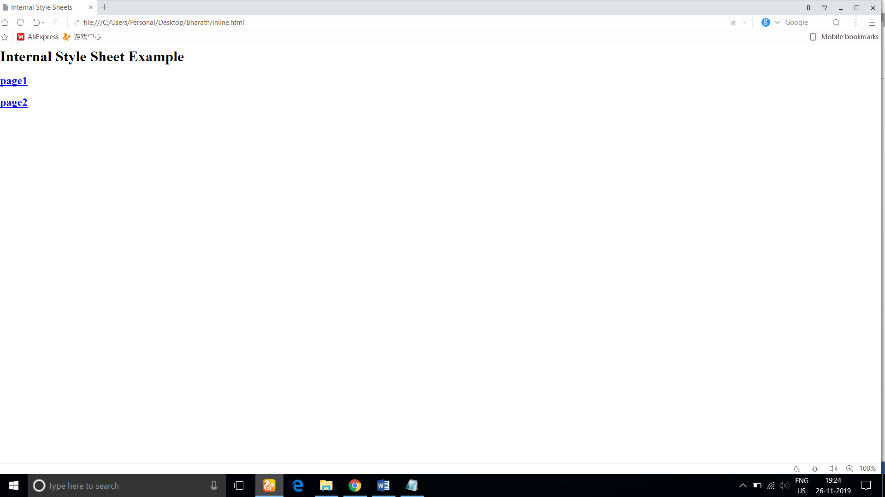

*Style Classes:* To apply a style defined in a style class to an HTML element, you can assign the class attribute of the HTML element to the name of style class. You can create two types of style classes: universal and element specific. A universal style class starts with a dot operator (.) followed by class name. The syntax to define a universal syntax as follows:

<style>

Class name {class definition}

</style>

An element specific style starts with the element name, followed by a dot operator, which is followed by the class name. The syntax to define an element specific is as follows:

<style>

Element name. class name {class definition}

</style>

Applying the style classes:

<html>

<head>

<title>Style</title>

<style>

body {background-color:#f0f8ff}

th.color{background-color:#800000}

.green{background-color:#008000}

</style>

<body>

<table border="1">

<caption><h2>Student Details</h2></caption>

<th class="color">Name</th>

<th class="color">Date of Birth</th>

<th class="color">Address</th>

<tr>

<td class="green">Sumit saxena</td>

<td class="green">15-03-1983</td>

<td class="green">Flat No. 303,Shipra suncity,Ghaziabad</td>

</tr>

<tr>

<td class="green">Amitabh Kumar</td>

<td class="green">22-02-1984</td>

<td class="green">H.No- 125,kalkaji,Delhi</td>

</tr>

<tr>

<td class="green">Rohit Jandial</td>

<td class="green">05-07-1983</td>

<td class="green">Flat No- 324,South Ext,Delhi</td>

</tr>

<tr>

<td class="green">Avantika Srivastava</td>

<td class="green">10-12-1984</td>

<td class="green">H.No- 541,Vikas Puri,Delhi</td>

</tr>

</table>

</body>

</html>

OUTPUT:

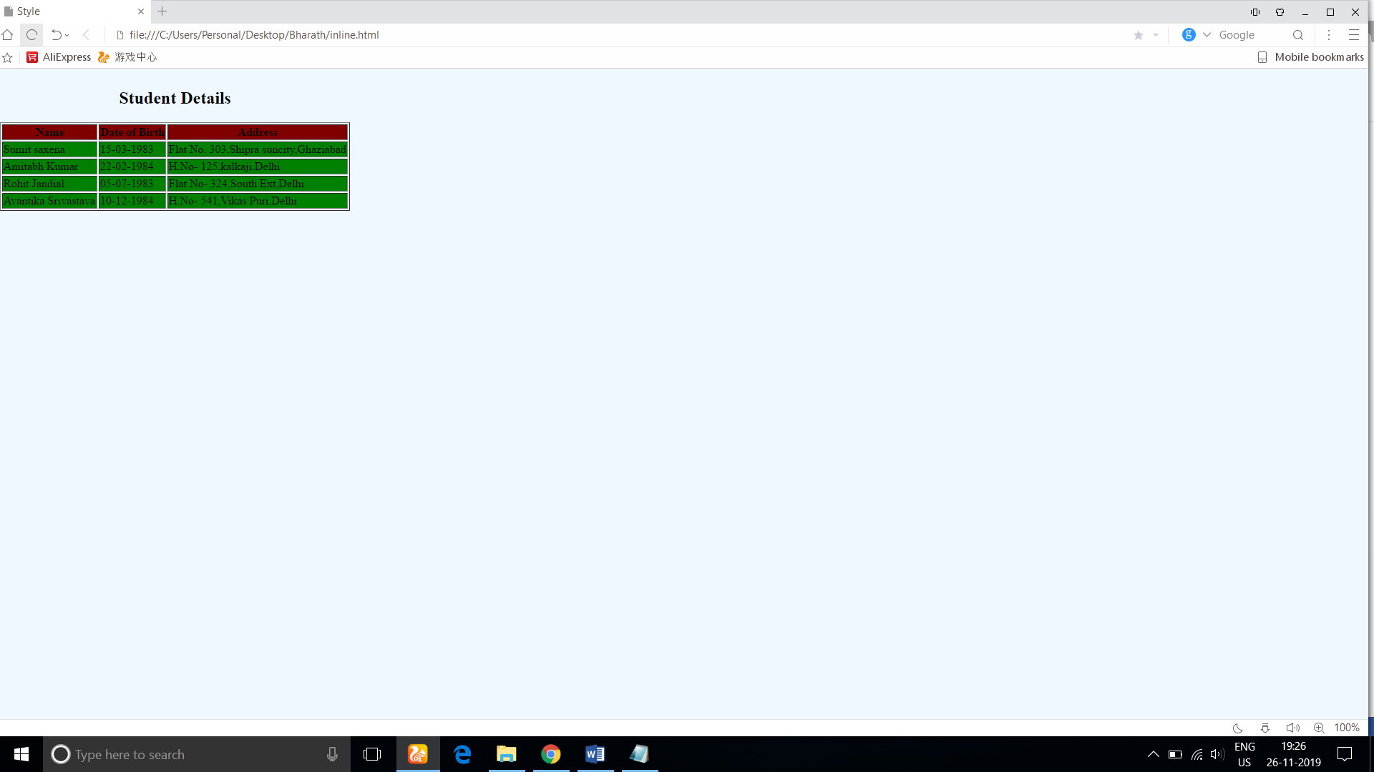

*Multiple Styles:* Multiple styles can be defined by using the different methods to implement CSS. If multiple styles affect the same element, only the last one is used. You can link the external style sheet to the document as follows:

<LINK rel=stylesheet type=”text/css” href=”style1.css”>

<LINK rel=stylesheet type=”text/css” href=”style2.css”>

<LINK rel=stylesheet type=”text/css” href=”style3.css”>

If multiple conflicting styles are found in the external style sheets, the CSS recommendations allow users to select among several alternative style sheets using the rel attribute of the <STYLE> tag, which is combined with the TITLE attribute to select them by name:

<LINK rel=”alternative stylesheet” type=”type./css” href=”style1.css” title=”style1”>

<LINK rel=”alternative stylesheet” type=”type./css” href=”style2.css” title=”style2”>

<LINK rel=”alternative stylesheet” type=”type./css” href=”style3.css” title=”style3”>

Linking Multiple styles

<html>

<head>

<title>External Style Sheets</title>

<link rel=”stylesheet” type=”type./css” href=”style.css”>

<link rel=”stylesheet” type=”type./css” href=”style1.css”>

<link rel=”stylesheet” type=”type./css” href=”style2.css”>

</head>

<body>

<h1>External Style Sheet Example</h1>

<a href= page1.html target="_blank">

<h2>Page 1</h2>

<a href= page2.html target="_blank">

<h2>page 2</h2>

</body>

</html>

OUTPUT:

