P.V.P Siddhartha Institute of Technology
Department of Computer Science and Engineering
Course: B.Tech |  | Year:III | Semester: I | Descriptive: I | A.Y:2025-26
Subject Code: 23CS3503 |  | Subject Name: Formal Languages and Automata Theory |  |  | Regulation:PVP23
Duration:1 hr 30 min |  | Maximum Marks:30 Marks |  |  | Date:28-08-2025 |  |  | Session: F.N
Answer ONE Question from each section. Each Question carries 10 Marks. 3×10M=30M
Q. No | Question |  |  |  |  | Marks | CO |  | Level
1 a) | Design a DFA that accepts a language L over input alphabets ∑ = {a, b} such that L is the set of all strings with  i) odd number of a’s and odd number of b’s  ii) even number of a’s and even number of b’s |  |  |  |  | 5 | CO2 |  | L3
1 b) | Convert the following ε-NFA to NFA .  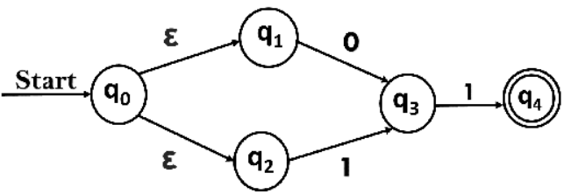 |  |  |  |  | 5 | CO2 |  | L3
 | OR
2 a) | Design a DFA for the language accepting strings that are divisible by 4 over the alphabets ∑ = {0, 1} |  |  |  |  | 5 | CO2 |  | L3
2 b) | Construct DFA from the given NFA transition table.  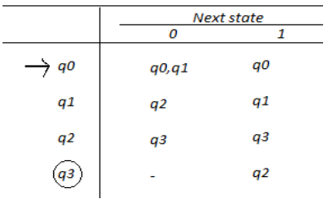 |  |  |  |  | 5 | CO2 |  | L3
3 | Minimize the following DFA  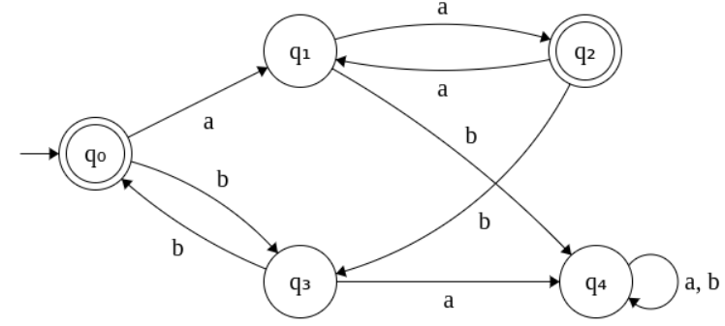 |  |  |  |  | 10 | CO2 |  | L3
 | OR
4 a) | Prove that the language L = { aⁿbⁿ | n ≥ 1 } is not regular using Pumping Lemma. |  |  |  |  | 5 | CO4 |  | L3
4 b) | Convert the given FA into its equivalent regular expression (RE) using state elimination method.  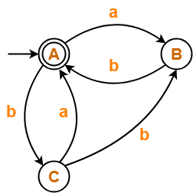 |  |  |  |  | 5 | CO2 |  | L3
5 a) | Given a language L = {w | w starts with 1 and ends with 0}, design a DFA to accept L and demonstrate its tuple notation. |  |  |  |  | 5 | CO2 |  | L3
5 b) | Design a Mealy machine for a binary input sequence such that if it has a substring 110, the machine output A, if the input has substring 101, it outputs B otherwise it outputs C. |  |  |  |  | 5 | CO2 |  | L3
 | OR
6 a) | Examine the given Deterministic Finite Automata (DFAs) and determine whether they are equivalent or not?  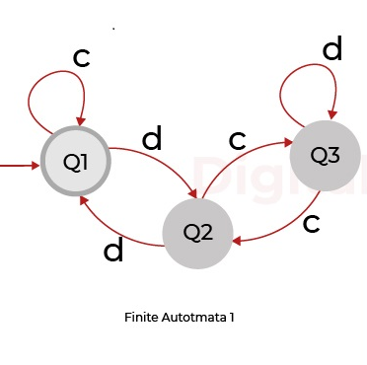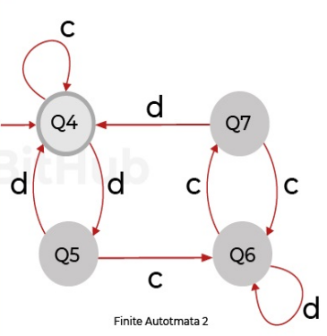 |  |  |  |  | 5 | CO2 |  | L3
6 b) | State Arden’s theorem and construct the regular expression for the following FA using Arden’s theorem  .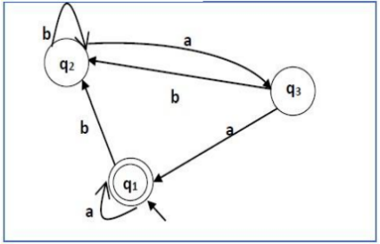 |  |  |  |  | 5 | CO2 |  | L3

