SCHEME
Course: B. Tech |  | Year: II | Semester: II | Descriptive: II
Subject Code: 23CS3401
Subject Name: OPERATING SYSTEMS
Q. No. | Question
1. | A video streaming platform has multiple producer threads that continuously fetch video frames from the network and multiple consumer threads that render these frames on the screen. Sometimes, consumers try to read frames before producers have filled the buffer, leading to race conditions and inconsistent playback.  Consider the following pseudocode for producer and consumer threads (processes)  int n; semaphore s1 = 0; semaphore s2= 0; semaphore s3=n;  Consumer  while (true) {  wait(s1);  wait(s3);  . . .  /* remove an item from  buffer to next consumed */  . . .  signal(s2);  signal(s1);  . . .  /* consume the item in next  consumed */  . . .  }  producer  while (true) {  . . .  /* produce an item in next produced */  . . .  wait(s1);  wait(s2);  . . .  /* add next produced to the buffer */  . . .  signal(s3);  signal(s1);  }  Will the above solution work? If not, give appropriate reason and modify the above solution to work correctly.  The Given Solution Will Not Work  • Semaphore misuse:  - s1 is initialized to 0 but used by both producer and consumer. It seems intended as a mutex, but a mutex should start at 1 (available).  - s2 and s3 are not clearly mapped to “empty” and “full” counts.  • Race conditions:  - Producers may block incorrectly because s1 is 0 at the start.  - Consumers may attempt to consume before producers have produced, leading to inconsistent playback.  • Deadlock risk:  - Both producer and consumer wait on s1 first, which can cause them to block each other indefinitely.  Producer:  while (true) {  produce_item();  wait(empty); // wait if buffer is full  wait(mutex); // enter critical section  add_item_to_buffer();  signal(mutex); // leave critical section  signal(full); // increment count of filled slots  }  Consumer:  while (true) {  wait(full); // wait if buffer is empty  wait(mutex); // enter critical section  remove_item_from_buffer();  signal(mutex); // leave critical section  signal(empty); // increment count of empty slots  consume_item();  }
2. | A cloud data center manages multiple services that require access to shared resources. The system has 4 processes (P1–P4) and 3 resource types (R1, R2, R3). The current allocation and request matrices are shown below:  Available Resources: R1 = 1, R2 = 0, R3 = 1  Using the Deadlock Detection algorithm, determine:  - Whether the system is in deadlock.  - If deadlock exists, list the processes involved.  If no deadlock, provide a possible safe sequence.  Deadlock Detection Algorithm  We check if each process’s Request ≤ Available. If yes, it can finish, release its Allocation, and update Available.  - Available initially: (1,0,1)  Check P1:  - Request = (0,1,0)  - Compare with Available (1,0,1): Needs R2=1 but Available R2=0 → cannot proceed.  Check P2:  - Request = (1,0,1)  - Compare with Available (1,0,1): Request ≤ Available → can proceed.  - After completion, release Allocation (0,1,0).  - New Available = (1+0, 0+1, 1+0) = (1,1,1).  Check P3:  - Request = (0,0,1)  - Compare with Available (1,1,1): Request ≤ Available → can proceed.  - Release Allocation (1,1,0).  - New Available = (1+1, 1+1, 1+0) = (2,2,1).  Check P4:  - Request = (1,1,0)  - Compare with Available (2,2,1): Request ≤ Available → can proceed.  - Release Allocation (0,0,1).  - New Available = (2,2,2).  Finally, Check P1 again:  - Request = (0,1,0)  - Compare with Available (2,2,2): Request ≤ Available → can proceed.  - Release Allocation (1,0,1).  - New Available = (3,2,3).  Step 3: Result  - All processes can finish.  - Safe sequence exists: P2 → P3 → P4 → P1.  - No deadlock.
   | Allocation Matrix |  |  | Request Matrix
  Process | R1 | R2 | R3 | R1 | R2 | R3
  P1 | 1 | 0 | 1 | 0 | 1 | 0
  P2 | 0 | 1 | 0 | 1 | 0 | 1
  P3 | 1 | 1 | 0 | 0 | 0 | 1
  P4 | 0 | 0 | 1 | 1 | 1 | 0
3. | A database server receives multiple disk I/O requests while processing queries. The disk has 200 cylinders (0–199). The disk head is currently positioned at cylinder 50 and moving towards higher-numbered cylinders. The pending request queue is:  95, 180, 34, 119, 11, 123, 62  Using the following disk scheduling algorithms, determine the order of servicing requests and calculate the total head movement in cylinders for each algorithm:  - FCFS (First-Come, First-Served)  - SSTF (Shortest Seek Time First)  - SCAN (Elevator Algorithm)  - C-SCAN (Circular SCAN)  Compare the results and analyze which algorithm is most efficient in this scenario.  FCFS (First Come, First Served)  Order: 95 → 180 → 34 → 119 → 11 → 123 → 62 Head movement:  - |50–95| = 45  - |95–180| = 85  - |180–34| = 146  - |34–119| = 85  - |119–11| = 108  - |11–123| = 112  - |123–62| = 61 Total = 642 cylinders  SSTF (Shortest Seek Time First)  Start at 50. Choose nearest request each time.  - From 50 → 62 (12)  - From 62 → 34 (28)  - From 34 → 11 (23)  - From 11 → 95 (84)  - From 95 → 119 (24)  - From 119 → 123 (4)  - From 123 → 180 (57) Total = 232 cylinders Order: 62 → 34 → 11 → 95 → 119 → 123 → 180  SCAN (Elevator Algorithm)  Head moves upward first (towards higher cylinders).  - Requests ≥ 50: [62, 95, 119, 123, 180] → serviced in ascending order.  - Then reverse direction and service lower requests [34, 11]. Order: 62 → 95 → 119 → 123 → 180 → 34 → 11 Head movement:  - 50→62 = 12  - 62→95 = 33  - 95→119 = 24  - 119→123 = 4  - 123→180 = 57  - 180→34 = 146  - 34→11 = 23 Total = 299 cylinders  C-SCAN (Circular SCAN)  Head moves upward only, then jumps back to start.  - Requests ≥ 50: [62, 95, 119, 123, 180] → serviced in ascending order.  - Then jump to 0 and continue upward to service [11, 34]. Order: 62 → 95 → 119 → 123 → 180 → (jump to 0) → 11 → 34 Head movement:  - 50→62 = 12  - 62→95 = 33  - 95→119 = 24  - 119→123 = 4  - 123→180 = 57  - 180→0 (jump) = 180  - 0→11 = 11  - 11→34 = 23 Total = 344 cylinders  Analysis  - FCFS: Very high head movement (642) → inefficient.  - SSTF: Lowest head movement (232) → most efficient here.  - SCAN: Balanced, avoids starvation, moderate movement (299).  - C-SCAN: Fair distribution, but higher movement (344).
4. | A university’s online learning system uses virtual memory to handle multiple student requests. The system has 3 page frames available in memory. The following page reference string occurs during a session:  7, 0, 1, 2, 0, 3, 0, 4, 2, 3, 0, 3, 2  Using the following page replacement algorithms, determine:  - The sequence of pages loaded into frames.  - The total number of page faults for each algorithm.  Algorithms to apply:  - FIFO (First-In, First-Out)  - Optimal Page Replacement  - LRU (Least Recently Used)  Compare the results and analyze which algorithm performs best in this scenario.  FIFO (First In, First Out)  - Start empty → load 7,0,1 → faults = 3  - Next 2 → replace 7 → [2,0,1] → fault  - Next 0 → already present → no fault  - Next 3 → replace 0 → [2,3,1] → fault  - Next 0 → replace 1 → [2,3,0] → fault  - Next 4 → replace 2 → [4,3,0] → fault  - Next 2 → replace 3 → [4,2,0] → fault  - Next 3 → replace 0 → [4,2,3] → fault  - Next 0 → replace 4 → [0,2,3] → fault  - Next 3 → present → no fault  - Next 2 → present → no fault  Total faults = 9 Sequence: 7,0,1,2,3,0,4,2,3,0  Optimal Page Replacement  - Start empty → load 7,0,1 → faults = 3  - Next 2 → replace 7 (7 not used again soon) → [2,0,1] → fault  - Next 0 → present → no fault  - Next 3 → replace 1 (1 not used again) → [2,0,3] → fault  - Next 0 → present → no fault  - Next 4 → replace 2 (2 used later but far) → [4,0,3] → fault  - Next 2 → replace 4 (4 not used again) → [2,0,3] → fault  - Next 3 → present → no fault  - Next 0 → present → no fault  - Next 3 → present → no fault  - Next 2 → present → no fault  Total faults = 6 Sequence: 7,0,1,2,3,4,2  LRU (Least Recently Used)  - Start empty → load 7,0,1 → faults = 3  - Next 2 → replace 7 (least recently used) → [2,0,1] → fault  - Next 0 → present → no fault  - Next 3 → replace 1 (least recently used) → [2,0,3] → fault  - Next 0 → present → no fault  - Next 4 → replace 2 (least recently used) → [4,0,3] → fault  - Next 2 → replace 3 (least recently used) → [4,0,2] → fault  - Next 3 → replace 0 (least recently used) → [4,3,2] → fault  - Next 0 → replace 4 (least recently used) → [0,3,2] → fault  - Next 3 → present → no fault  - Next 2 → present → no fault  Total faults = 9 Sequence: 7,0,1,2,3,4,2,3,0  Analysis  - Optimal performs best (6 faults) because it looks ahead and replaces the page not needed for the longest time.  - FIFO and LRU both result in 9 faults here.  - In practice, LRU is usually better than FIFO, but in this specific sequence they tie.  - Optimal is theoretical (not implementable in real systems), but it sets the benchmark.
5. | An enterprise file system is being redesigned to support millions of files across multiple departments. The system architects are debating whether to use a tree-structured directory or an acyclic graph directory.  Analyze the strengths and weaknesses of tree-structured directories versus acyclic graph directories in this scenario. Using diagrams, show how each structure organizes files and subdirectories. Conclude which structure better supports file sharing and scalability, and justify your reasoning.  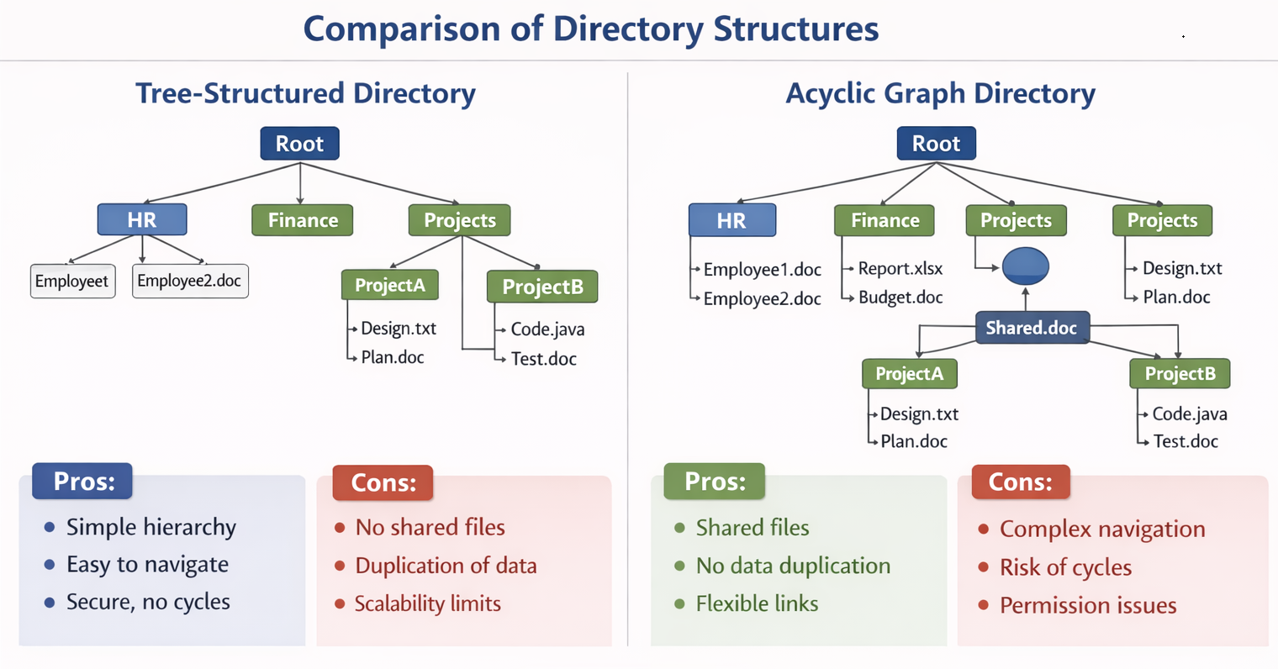  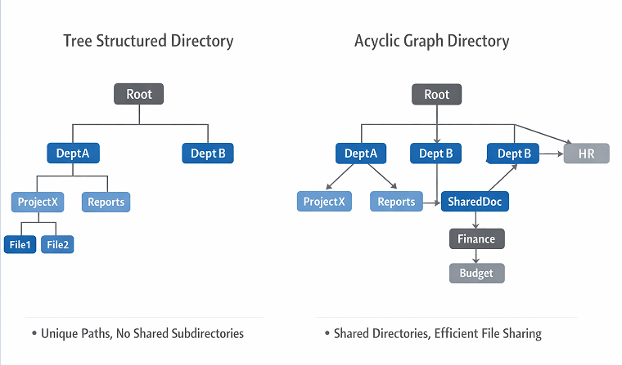  Tree-Structured Directory  Strengths:  - Simple hierarchy (root → departments → subdirectories → files).  - Easy to navigate and understand.  - Secure: no cycles, each file has a unique path.  - Good for small to medium systems with limited sharing needs.  Weaknesses:  - No natural support for file sharing across departments.  - Duplication of files if multiple departments need the same resource.  - Scalability issues when millions of files require cross-department access.  Acyclic Graph Directory  Strengths:  - Supports shared files and directories without duplication.  - Efficient for collaborative environments (e.g., shared project documents).  - Flexible links allow multiple paths to the same file.  - Better scalability for large enterprise systems.  Weaknesses:  - More complex navigation and management.  - Risk of permission conflicts when multiple departments share files.  - Requires careful handling to avoid cycles (though acyclic constraint prevents loops).  For an enterprise file system with millions of files across multiple departments, the Acyclic Graph Directory is the better choice.  - It supports file sharing without duplication.  - It scales more effectively in collaborative environments.  - While slightly more complex to manage, its flexibility outweighs the simplicity of tree structures in large-scale systems.
6. | A financial institution needs strict access control to protect sensitive data such as customer records, transaction logs, and audit files. Different roles (manager, teller, auditor) require different permissions.  Analyze how the access matrix model can be applied to enforce domain-based access control in this system. Construct a sample matrix showing roles and resources, and interpret how it minimizes unauthorized access while supporting least privilege. Compare its effectiveness with other models (e.g., access lists or capability lists).  The institution manages:  - Customer Records (confidential personal data)  - Transaction Logs (daily operations)  - Audit Files (compliance and verification)  Roles:  - Manager – oversees operations and approves updates.  - Teller – handles customer transactions.  - Auditor – verifies compliance and integrity.  The Access Matrix defines permissions by mapping subjects (roles) to objects (resources).  Interpretation  - Manager: Can modify customer and transaction data but only read audit files (cannot tamper).  - Teller: Can update customer records and append new transactions but cannot alter past logs or access audit files.  - Auditor: Can read customer and transaction data and maintain audit files but cannot modify operational data.  This structure enforces:  - Least Privilege: Each role has only the permissions necessary for its duties.  - Separation of Duties: Prevents overlap that could lead to fraud or data corruption.  - Accountability: Clear boundaries for auditing and compliance.  Domain-Based Access Control  Each role operates within its domain:  - Manager Domain: Operational control.  - Teller Domain: Transaction processing.  - Auditor Domain: Verification and compliance.  The access matrix ensures that transitions between domains (e.g., a teller accessing audit files) are restricted unless explicitly authorized.  Comparison with Other Models
  Role / Resource | Customer Records | Transaction Logs | Audit Files
  Manager | Read, Write | Read, Write | Read
  Teller | Read, Write | Append | None
  Auditor | Read | Read | Read, Write
  Model | Characteristics | Strengths | Weaknesses
  Access Matrix | Tabular mapping of subjects to objects | Clear visualization, supports least privilege, easy auditing | Large matrices can be complex to manage
  Access Control Lists (ACLs) | Object-centric (each file lists who can access it) | Simple for file-level control | Harder to audit role privileges globally
  Capability Lists | Subject-centric (each user lists accessible resources) | Efficient for user-centric systems | Risk of capability leakage or misuse

