PRASAD V. POTLURI SIDDHARTHA INSTITUTE OF TECHNOLOGY,
KANURU, VIJAYAWADA
DEPARTMENT OF COMPUTER SCIENCE & ENGINEERING
INNOVATIVE TEACHING METHODOLOGY
Academic Year: 2025 - 26
Teaching Methodology – Video-Based Comparative Analysis (CO4)
Class : III B.TECH (Honors)
Semester: I - Semester
Section: S1,S2,S3
Name of the Course: Data Visusalization (23CS6501)
Name of the Faculty: Dr. K. Jyothsna Devi
---------------------------------------------------------------------------------------------------------------
As part of the innovative teaching methodology, students were assigned a video-based presentation activity. Students selected two visualizations representing the same dataset, where one visualization was static (such as a bar chart, line chart, or 2D plot) and the other was interactive or 3D (such as a Power BI dashboard, animated visualization, or 3D chart).
Students prepared a short video presentation explaining:
- The selected dataset.
- Characteristics of both visualizations.
- Comparative analysis using predefined evaluation metrics.
- Advantages and limitations of each visualization.
- Final recommendation based on evaluation scores.
Number of Students Involved : 21
Student Name &Regd Number:
S.No | Register No. | Name of the Student
1 | 23501A0526 | CHERUKURI RAM CHARAN
2 | 23501A0537 | DUDEKULA CHINNA NASARVALI
3 | 23501A0538 | ERUKUDINNELA AKHIL PREETHAM
4 | 23501A0539 | ADIRAJU SIVA SAI NARAYANA
5 | 23501A0550 | GUNDOLU JAI SAI SRINIVAS
6 | 23501A0559 | KALISETTI KALI PRASAD
7 | 23501A0569 | K. Pujitha
8 | 23501A0594 | KUNCHAM ADITHYA
9 | 23501A0596 | KURAPATI VENKATA LALITH CHANDAN
10 | 23501A05A6 | MADDULA POSHANYA GUPTHA
11 | 23501A05C1 | MOTHUKURI AASRITHA
12 | 23501A05C4 | MUKKAVILLI BHAVYA SAI SREE
13 | 23501A05H1 | TAKKELLA TEJASWI
14 | 23501A05H8 | TUMMEPALLI RESHINI AHLA
15 | 23501A05J5 | YANDURI SIVA SAI SWAROOP
16 | 24505a0501 | ADDEPALLI PAVITHRA LAKSHMI
17 | 24505a0508 | KADARI MANOBHI RAM
18 | 24505a0511 | LABBA LAKSHMI DEVI
19 | 24505a0512 | MIRZA SHANE HYDER
20 | 24505a0515 | PADAVALA SRAVYA
21 | 24505a0519 | SHAIK SUMIYA PARVEEN

Innovative Teaching Strategy Used
- Video-Based Learning
- Comparative Analysis
- Active Learning
- Peer Learning and Presentation
- Outcome-Based Assessment
Student Learning Outcomes
After completing the activity, students were able to:
- Differentiate between static and interactive/3D visualizations.
- Evaluate visualizations using quantitative and qualitative metrics.
- Analyze the effectiveness of different visualization techniques.
- Develop critical thinking and decision-making skills.
- Improve presentation and communication abilities through video submissions.
- Understand the impact of visualization design on user interpretation and engagement.
Outcome of the Activity
Students actively participated in the video presentation activity and demonstrated a clear understanding of visualization evaluation techniques. The activity enhanced analytical thinking, encouraged self-learning, and enabled students to apply theoretical concepts to real-world visualization examples. Students were able to identify the strengths and limitations of different visualization approaches and make informed judgments based on evaluation metrics

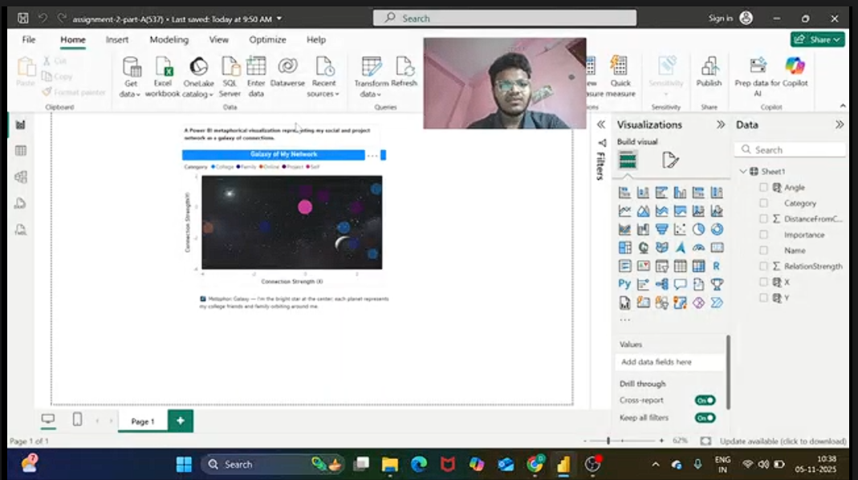

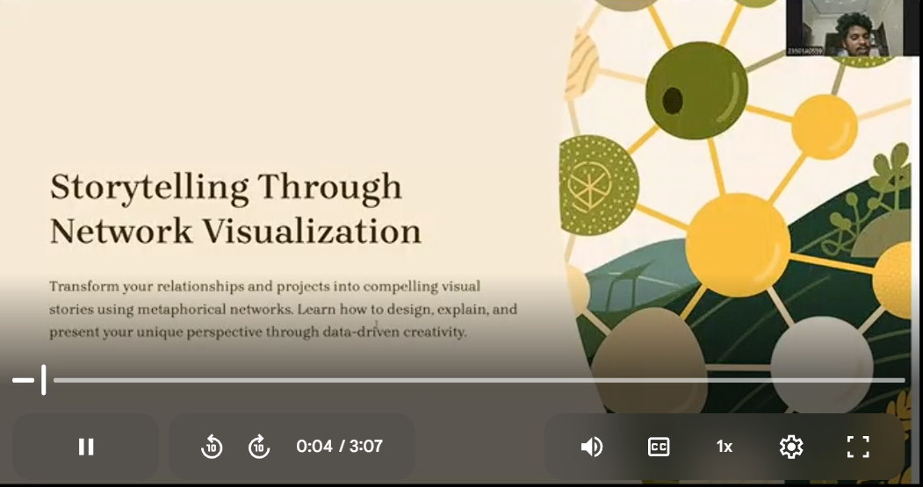

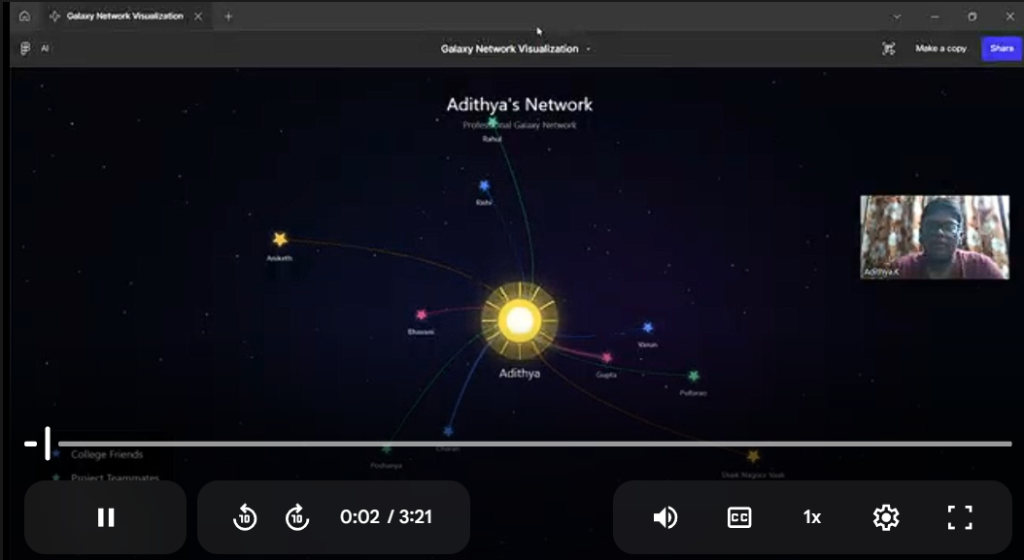
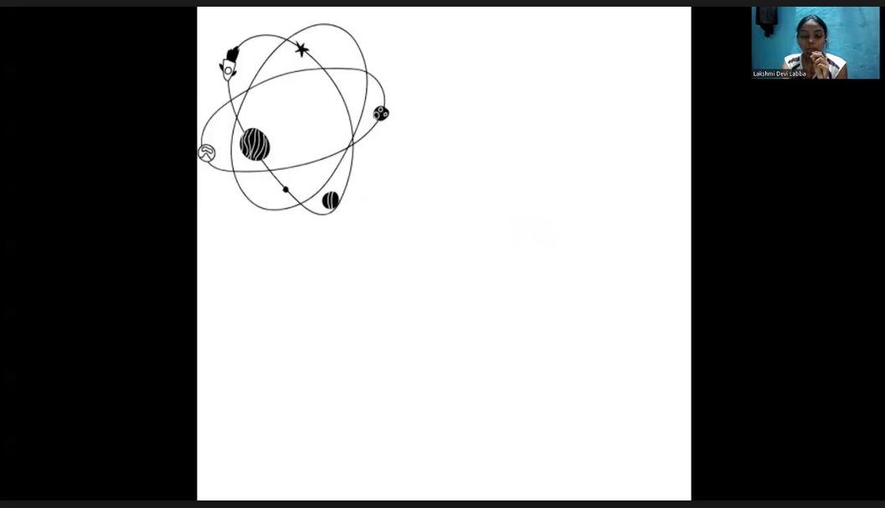

Signature of the Faculty

