UNIT I

Introduction To Operating System

What is an Operating System?
An operating system is system software that acts as an intermediary between a user of a computer and the computer hardware. It is software that manages the computer hardware and allows the user to execute programs in a convenient and efficient manner.
- The operating system controls the hardware and coordinates its use among the various application programs for the various users.
- An operating system is similar to a government. Like a government, it performs no useful function by itself. It simply provides an environment within which other programs can do useful work.
- An operating system is a control program. It manages the execution of user programs to prevent errors and improper use of the computer.
- It is a set of programs previously written and stored in the memory of the computer.

Operating system goals:
- Make the computer system convenient to use. It hides the difficulty in managing the hardware.
- Use the computer hardware in an efficient manner
- Provides an environment in which user can easily interface with computer.
- It acts as a resource allocator

Computer System Structure (Components of Computer System)
Computer system mainly consists of our components-
- Hardware–provides basic computing resources CPU, memory, I/O devices
- Operating system - Controls and coordinates use of hardware among various applications and users
- Application programs – define the ways in which the system resources are used to solve the computing problems of the users, Word processors, compilers, web browsers, database systems, video games
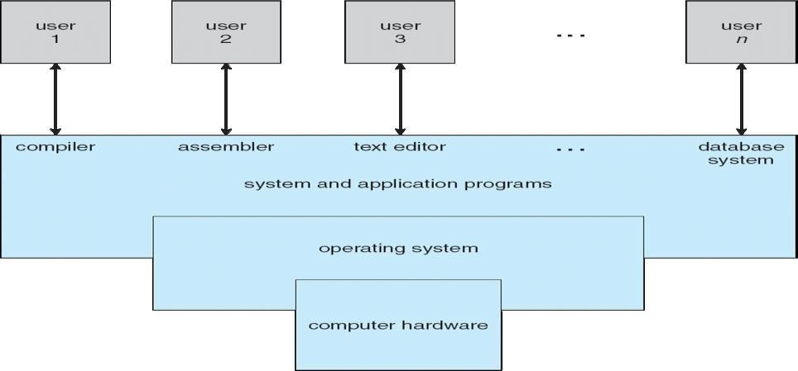
- Users-People, machines, other computers

Components of Computer
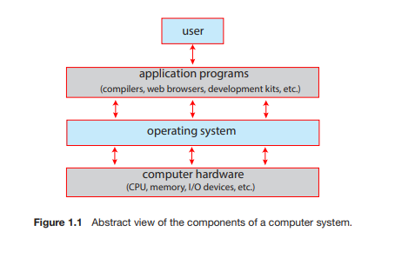

Abstract View of Components of Computer

List of the User Views and System views of OS
Operating System can be viewed from two viewpoints– User views &System views

User Views:- The user’s view of the operating system depends on the type of user.
- If the user is using stand alone system, then OS is designed for ease of use and high performances. Here resource utilization is not given importance.

- If the users are at different terminals connected to a mainframe or minicomputers, by sharing information and resources, then the OS is designed to maximize resource utilization. OS is designed such that the CPU time, memory and i/o are used efficiently, and no single user takes more than the resource allotted to them.

- If the users are in workstations, connected to networks and servers, then the user have a system unit of their own and shares resources and files with other systems. Here the OSis designed for both ease of use and resource availability (files).

- Other systems like embedded systems used in home device (like washing m/c) & automobiles do not have any user interaction. There are some LEDs to show the status of its work
- Users of hand-held systems, expects the OS to be designed for ease of use and performance per amount of battery life

System Views:- Operating system can be viewed as a resource allocator and
control program.

- Resource allocator – The OS acts as a manager of hardware and software resources. CPU time, memory space, file-storage space, I/O devices, shared files etc. are the different resources required during execution of a program. There can be conflicting request for these resources by different programs running in same system. The OS assigns the resources to the requesting program depending on the priority.
- Control Program – The OS is a control program and manage the execution of user program to prevent errors and improper use of the computer.

Operating-System Operations

Modern operating systems are interrupt driven. If there are no processes to execute, no I/O devices to service, and no users to whom to respond, an operating system will sit quietly, waiting for something to happen. Events are signaled by the occurrence of an interrupt or a trap. A trap (or an exception) is a software-generated interrupt. For each type of interrupt, separate segments of code in the operating system determine what action should be taken. An interrupt service routine is provided that is responsible for dealing with the interrupt.

Dual mode operation in operating system with a neat block diagram
Dual-Mode Operation
Since the operating system and the user programs share the hardware and software resources of the computer system, it has to be made sure that an error in a user program cannot cause problems to other programs and the Operating System running in the system.
The approach taken is to use a hardware support that allows us to differentiate among various modes of execution.
The system canbe assumed to work in two separate modes of operation:
1. User mode
2. Kernel mode (supervisor mode, system mode, or privileged mode).
  - A hardware bit of the computer, called the mode bit, is used to indicate the current
mode: kernel (0) or user (1). With the mode bit, we are able to distinguish between a task that is executed by the operating system and one that is executed by the user.
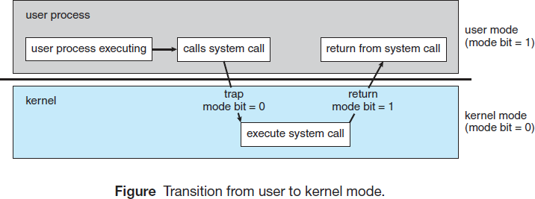
  - When the computer system is executing a user application, the system is in user mode. When a user application requests a service from the operating system (via a system call), the transition from user to kernel mode takes place.

At system boot time, the hardware starts in kernel mode. The operating system is then loaded and starts user applications in user mode. Whenever a trap or interrupt occurs, the hardware switches from user mode to kernel mode (that is, changes the mode bit from 1 to 0). Thus, whenever the operating system gains control of the computer, it is in kernel mode.
The dual mode of operation provides us with the means for protecting the operating system from errant users—and errant users from one another.
  - The hardware allows privileged instructions to be executed only in kernel mode. If an attempt is made to execute a privileged instruction in user mode, the hardware does not execute the instruction but rather treats it as illegal and traps it to the operating system. The instruction to switch to user mode is an example of a privileged instruction.
  - Initial control is within the operating system, where instructions are executed in kernel mode. When control is given to a user application, the mode is set to user mode. Eventually, control is switched back to the operating system via an interrupt, a trap, or a system call.

TIMER :

Timer to prevent infinite loop / process hogging resources

Timer is set to interrupt the computer after some time period

Keep a counter that is decremented by the physical clock.

Operating system set the counter (privileged instruction)

When counter zero generate an interrupt

Set up before scheduling process to regain control or terminate program that exceeds allotted time

Operating-System Functions :

Process Management
  - A program under execution is a process. A process needs resources like CPU time, memory, files, and I/O devices for its execution. These resources are given to the process when it is created or at run time. When the process terminates, the operating system reclaims the resources.
  - The program stored on a disk is a passive entity and the program under execution is an active entity. A single-threaded process has one program counter specifying the next instruction to execute. The CPU executes one instruction of the process after another, until the process completes. A multithreaded process has multiple program counters, each pointing to the next instruction to execute for a given thread.
  - The operating system is responsible for the following activities in connection with Process management:
    - Scheduling process and threads on the CPU
    - Creating and deleting both user and system processes
    - Suspending and resuming processes
    - Providing mechanisms for process synchronization
    - Providing mechanisms for process communication

Memory Management

Main memory is a large array of words or bytes. Each word or byte has its own address.
Main memory is the storage device which can be easily and directly accessed by the CPU. As the program executes, the central processor reads instructions and also reads and writes data from main memory.

To improve both the utilization of the CPU and the speed of the computer's response to its users, general-purpose computers must keep several programs in memory, creating a need for memory management.

The operating system is responsible for the following activities in connection with memory management:
  - Keeping track of which parts of memory are currently being used by user.
  - Deciding which processes and data to move into and out of memory.
  - Allocating and reallocating memory space as needed.

Storage Management
There are three types of storage management
- File system management
- Mass-storage management
- Cache management.

File-System Management

  - File management is one of the most visible component s of an operating system. Computer scan store information on several different types of physical media. Magnetic disk, optical disk, and magnetic tape are the most common. Each of these media has its own characteristics and physical organization. Each medium is controlled by a device, such as a disk drive or tape drive, that also has its own unique characteristics.
  - A file is a collection of related information defined by its creator. Commonly, files represent programs and data. Data files may be numeric, alphabetic, alphanumeric, or binary. Files may be free-form (for example, text files), or they may be formatted rigidly (for example, fixed fields).
  - The operating system implements the abstract concept of a file by managing mass storage media. Files are normally organized into directories to make them easier to use. When multiple users have access to files, it may be desirable to control by whom and in what ways (read, write, execute) files may be accessed.
  - The operating system is responsible for the following activities in connection with file management:
    - Creating and deleting files
    - Creating and deleting directories to organize files
    - Supporting primitives for manipulating files and directories
    - Mapping files onto secondary storage
    - Backing up files on stable(nonvolatile) storage media

Mass-Storage Management
  - As the main memory is too small to accommodate all data and programs, and as the data that it holds are erased when power is lost, the computer system must provide secondary storage to back up main memory. Most modern computer systems use disks as the storage medium for both programs and data.

  - Most programs—including compilers, assemblers, word processors, editors, and formatters— are stored on a disk until loaded into memory and then use the disk as both the source and destination of their processing. Hence, the proper management of disk storage is of central importance to a computer system.

The operating system is responsible for the following activities in connection with disk management:
    - Free-space management
    - Storage allocation
    - Disk scheduling
As the secondary storage is used frequently, it must be used efficiently. The entire speed of operation of a computer may depend on the speeds of the disk. Magnetic tape drives and their tapes, CD, DVD drives and platters are tertiary storage devices. The functions that operating systems provides include mounting and unmounting media in devices, allocating and freeing the devices for exclusive use by processes, and migrating data from secondary to tertiary storage.

Caching
  - Caching is an important principle of computer systems. Information is normally kept in some storage system (such as main memory). As it is used, it is copied into a faster storage system— the cache—as temporary data. When a particular piece of information is required, first we check whether it is in the cache. If it is, we use the information directly from the cache; if it is not in cache, we use the information from the source, putting a copy in the cache under the assumption that we will need it again soon.
  - Because caches have limited size, cache management is an important design problem. Careful selection of the cache size and page replacement policy can result in greatly increased performance.
  - The movement of information between levels of a storage hierarchy may be either explicit or implicit, depending on the hardware design and the controlling operating-system software. For instance, data transfer from cache to CPU and registers is usually a hardware function, with no operating-system intervention. In contrast, transfer of data from disk to memory is usually controlled by the operating system.
  - In a hierarchical storage structure, the same data may appear in different levels of the storage system. For example, suppose to retrieve an integer A from magnetic disk to the processing program. The operation proceeds by first issuing an I/O operation to copy the disk block on which A resides to main memory. This operation is followed by copying A to the cache and to an internal register. Thus, the copy of A appears in several places: on the magnetic disk, in main memory, in the cache, and in an internal register.
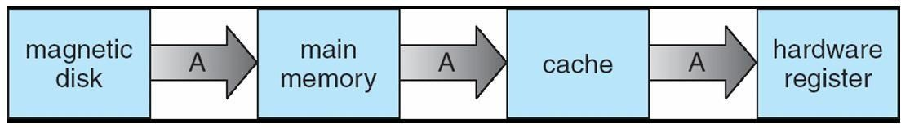
  - In a multiprocessor environment, in addition to maintaining internal registers, each of the CPUs also contains a local cache. In such an environment, a copy of A may exist simultaneously in several caches. Since the various CPUs can all execute concurrently, any updated one to the value of A in one cache is immediately reflected in all other caches where A resides. This situation is called cache coherency, and it is usually a hardware problem (handled below the operating-system level).

I/O Systems
One of the purposes of an operating system is to hide the peculiarities of specific hardware devices from the user. The I/O subsystem consists of several components:
  - A memory-management component that includes buffering, caching, and spooling
  - A general device-driver interface
  - Drivers for specific hardware devices
Only the device driver knows the peculiarities of the specific device to which it is assigned.

Protection and Security
  - If a computer system has multiple users and allows the concurrent execution of multiple processes, then access to data must be regulated. For that purpose, mechanisms ensure that files, memory segments, CPU, and other resources can be operated on by only those processes that have gained proper authorization from the operating system.
  - For example, memory-addressing hardware ensures that a process can execute only within its own address space. The timer ensures that no process can gain control of the CPU for a long time. Device-control registers are not accessible to users, so the integrity of the various peripheral devices is protected.
  - Protection is a mechanism for controlling the access of processes or users to the resources defined by a computer system. This mechanism must provide means for specification of the controls to be imposed and means for enforcement.
  - Protection improves reliability. A protection-oriented system provides a means to distinguish between authorized and unauthorized usage. A system can have adequate protection but still be prone to failure and allow inappropriate access.
  - Consider a user whose authentication information is stolen. Her data could be copied or deleted, even though file and memory protection are working. It is the job of security to defend a system from external and internal attacks. Such attacks spread across a huge range and include viruses and worms, denial-of service attacks etc.
  - Protection and security require the system to be able to distinguish among all its users. Most operating systems maintain a list of user names and associated user identifiers (user IDs). When a user logs in to the system, the authentication stage determines the appropriate user ID for the user.

Computing Environments
The different computing environments are-

Traditional Computing
  - The current trend is toward providing more ways to access these computing environments. Web technologies are stretching the boundaries of traditional computing. Companies establish portals, which provide web accessibility to their internal servers. Network computers are essentially terminals that understand web-based computing. Handheld computers can synchronize with PCs to allow very portable use of company information. Handheld PDAs can also connect to wireless networks to use the company's web portal. The fast data connections are allowing home computers to serve up web pages and to use networks. Some homes even have firewalls to protect their networks.
  - In the latter half of the previous century, computing resources were scarce. Years before, systems were either batch or interactive. Batch system processed jobs in bulk, with predetermined input (from files or other sources of data). Interactive systems waited for input from users. To optimize the use of the computing resources, multiple users shared time on these systems. Time-sharing systems used a timer and scheduling algorithms to rapidly cycle processes through the CPU, giving each user a share of the resources.
  - Today, traditional time-sharing systems are used everywhere. The same scheduling technique is still in use on workstations and servers, but frequently the processes are all owned by the same user (or a single user and the operating system). User processes, and system processes that provide services to the user, are managed so that each frequently gets a slice of computer time.

Mobile Computing :
Mobile Computing is possible through Handheld smartphones, tablets, etc.

The Main functional differences between mobile phones and a “traditional” laptop are :
- Mobiles support Extra feature – more OS features (GPS(Global Positioning System) – for finding locations, gyroscope- for orientation,sliding,tilting etc)
- Allows new types of apps like augmented reality
- Use IEEE 802.11 wireless, or cellular data networks for connectivity
- Leaders are Apple iOS and Google Android

Distributed Systems

- Collection of separate, possibly heterogeneous, systems networked together
  - Network is a communications path, TCP/IP most common
    - Local Area Network (LAN)
    - Wide Area Network (WAN)
    - Metropolitan Area Network (MAN)
    - Personal Area Network (PAN)
- Network Operating System provides features between systems across network
  - Communication scheme allows systems to exchange messages
  - Different computers communicate closely enough to provide the Illusion that only single operating system controls the network.---- Distributed operating system

Client-Server Computing

Designers shifted away from centralized system architecture to - terminals connected to centralized systems. As a result, many of today’s systems act as server systems to satisfy requests generated by client systems. This form of specialized distributed system, called client-server system.
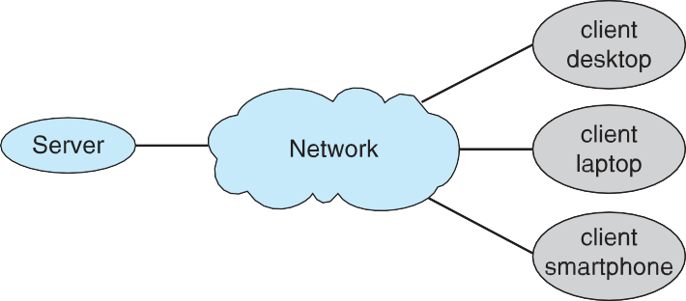

General Structure of Client–Server System

Server systems can be broadly categorized as compute servers and files servers:
- The compute-server system provides an interface to which a client can send a request to perform an action (for example, read data); in response, the server executes the action and sends back results to the client. A server running a database that responds to client requests for data is an example of such a system.
- The file-server system provides a file-system interface where clients can create, update, read, and delete files. An example of such a system is a web server that delivers files to clients running the web browsers.

Peer-to-Peer Computing
  - In this model, clients and servers are not distinguished from one another; here, all nodes within the system are considered peers, and each may act as either a client or a server, depending on whether it is requesting or providing a service.
  - In a client-server system, the server is a bottleneck, because all the services must be served by the server. But in a peer-to-peer system, services can be provided by several nodes distributed throughout the network.
  - To participate in a peer-to-peer system, a node must first join the network of peers. Once a node has joined the network, it can begin providing services to—and requesting services from—other nodes in the network.

Determining what services are available is accomplished in one of two general ways:

    - When a node joins a network, it registers its service with a centralized lookup service on the network. Any node desiring a specific service first contacts this centralized lookup service to determine which node provides the service.
    - The remainder of the communication takes place between the client and the service provider.
    - Example : Napster
(if a node registers its service with central lookup service on network)
    - A peer acting as a client must know, which node provides a desired service by broadcasting a request for the service to all other nodes in the network. The node (or nodes) providing that service responds to the peer making the request. To support this approach, a discovery protocol must be provided that allows peers to discover services provided by other peers in the network.
    - Example : Gnutella
(If a node joins and Broadcast request for service and respond to requests for
service via discovery)

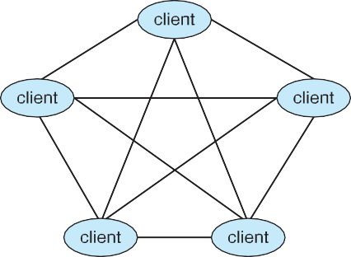

General Structure of P2P System

Ex : Skype is another example of peer-to-peer computing. It allows clients to make voice calls and video calls and to send text messages over the Internet using a technology known as voice over IP (VoIP). Skype uses a hybrid peer to-peer approach. It includes a centralized login server, but it also incorporates decentralized peers and allows two peers to communicate.

Cloud Computing
- Delivers computing, storage, even apps as a service across a network
- Logical extension of virtualization because it uses virtualization as the base for it functionality.
  - Amazon EC2 has thousands of servers, millions of virtual machines, petabytes of storage available across the Internet, pay based on usage
- Many types
  - Public cloud – available via Internet to anyone willing to pay
  - Private cloud – run by a company for the company’s own use
  - Hybrid cloud – includes both public and private cloud components
  - Software as a Service (SaaS) – one or more applications available via the Internet (i.e., word processor)
  - Platform as a Service (PaaS) – software stack ready for application use via the Internet (i.e., a database server)
  - Infrastructure as a Service (IaaS) – servers or storage available over Internet (i.e., storage available for backup use)
- Cloud computing environments composed of traditional OSes, plus VMMs, plus cloud management tools
  - Internet connectivity requires security like firewalls
  - Load balancers spread traffic across multiple applications

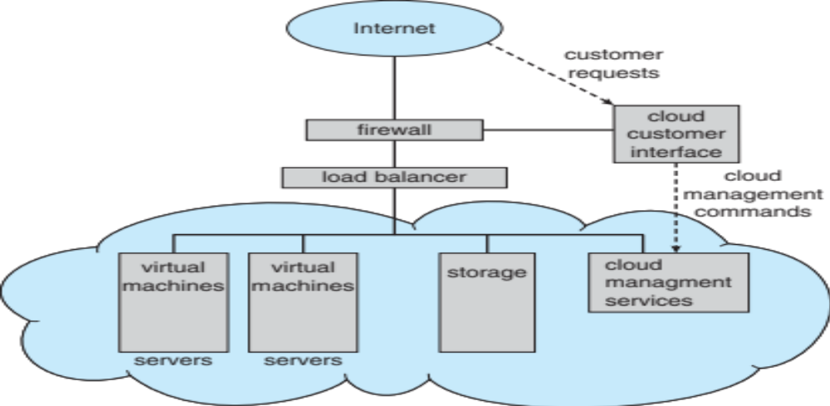

Cloud Computing Environment

1. Traditional Computing
- Traditional computing environments initially consisted of personal computers connected to servers that provided file storage and printing services.
- Remote access in early systems was difficult, and portability was mainly achieved through the use of laptop computers.
- The growth of web technologies and wide-area network bandwidth has expanded traditional computing to include web-based access to internal organizational resources.
- Thin clients are used instead of traditional workstations in environments that require higher security and easier system maintenance.
- Mobile computers and devices can synchronize with office systems and access company resources through wireless and cellular networks.
- Home computing environments now commonly use high-speed Internet connections to support local networks with printers, client systems, and servers.
- Firewalls are used to protect home and office networks by restricting unauthorized communication between devices.
- Earlier systems used batch processing and time-sharing to efficiently utilize limited computing resources.
- Although traditional time-sharing systems are rare today, modern operating systems still apply time-sharing techniques to manage multiple processes for a single user.

2. Mobile Computing
- Mobile computing refers to computing performed on portable and lightweight devices such as smartphones and tablet computers.
- Earlier mobile devices sacrificed processing power and memory capacity in exchange for portability and basic connectivity.
- Modern mobile devices support advanced applications such as multimedia playback, gaming, digital reading, and high-definition video recording.
- Mobile systems include sensors such as GPS, accelerometers, and gyroscopes that enable location-based services and motion detection.
- Augmented reality applications on mobile devices overlay digital information onto real-world environments.
- Mobile devices typically access online services using wireless networks or cellular data networks.
- Due to power and size constraints, mobile devices have lower processing speed and fewer resources compared to desktop computers.
- The two dominant operating systems used in mobile computing are Android and iOS.

3. Client–Server Computing
- Client–server computing is a distributed system model in which client systems send requests to server systems for specific services.
- Server systems process the client requests and return the appropriate results.
- Compute servers perform operations such as data processing and database query execution for client systems.
- File servers provide a file-system interface that allows clients to create, read, update, and delete files.
- Web servers are a common example of file servers that deliver web pages and multimedia content to clients.
- This computing model is widely used in organizational networks and Internet-based applications.

4. Peer-to-Peer Computing
- Peer-to-peer computing is a distributed system model in which all nodes are considered equal and can act as both clients and servers.
- Peer-to-peer systems reduce bottlenecks by distributing services across multiple nodes rather than relying on a single server.
- A node must first join the peer network before it can request or provide services.
- Service discovery in peer-to-peer systems can be achieved using either centralized lookup services or decentralized broadcast mechanisms.
- Early peer-to-peer systems such as Napster used centralized indexing, while systems like Gnutella used decentralized discovery.
- Peer-to-peer computing is commonly used for file sharing and communication services.
- Legal and copyright issues have affected the use and development of peer-to-peer file-sharing systems.
- Skype is an example of a hybrid peer-to-peer system that combines centralized login with decentralized communication.

5. Cloud Computing
- Cloud computing delivers computing resources, storage, and applications as services over the Internet.
- Cloud computing is built on virtualization technology, which allows multiple virtual machines to share physical hardware.
- Users of cloud services are charged based on the amount of resources they consume.
- Public clouds provide services to the general public, while private clouds are used by a single organization.
- Hybrid clouds combine both public and private cloud components.
- Software as a Service provides applications over the Internet, while Platform as a Service offers development platforms.
- Infrastructure as a Service delivers virtualized servers and storage over the Internet.
- Cloud management tools control resource allocation and manage virtual machines within the cloud environment.
- Firewalls are used to secure cloud services and protect user interfaces.

6. Real-Time Embedded Systems
- Embedded systems are specialized computing systems designed to perform specific tasks within larger systems.
- These systems are commonly found in automobiles, household appliances, industrial machines, and medical devices.
- Embedded systems usually provide minimal or no user interface and focus on hardware monitoring and control.
- Some embedded systems run general-purpose operating systems such as Linux with specialized applications.
- Other embedded systems use dedicated embedded operating systems or application-specific integrated circuits.
- Most embedded systems operate as real-time systems with strict timing constraints.
- A real-time system is considered correct only if it produces the correct output within the specified time limit.
- Failure to meet timing constraints in real-time systems can result in system failure.
1.11 Free and Open-Source Operating Systems –
Free and open-source operating systems make source code available for study, modification, and redistribution.
Free software guarantees freedoms of usage and modification, while open-source software focuses on openness of code (not always free of cost). Examples: GNU/Linux, FreeBSD, OpenSolaris, etc.
Free/Open-source OS enable innovation, faster bug fixing, and community-driven development.

1.11.1 History —
- In the 1950s–1970s, software typically included source code.
- Programmers and hobbyist groups (MIT hackers, DECUS, Homebrew Computer Club) shared programs openly.
- By the 1980s, companies shifted to proprietary software, distributing only binary files to protect intellectual property and revenue.
- This shift sparked movements advocating for freedom to study and modify software.

1.11.2 Free Operating Systems —
- Richard Stallman began the GNU Project (1984) to create a free UNIX-compatible OS.
- “Free” refers to freedom, not price.
- Free Software provides four freedoms:
  - Run the program freely
  - Study and modify source code
  - Redistribute copies
  - Redistribute modified versions
- Free Software Foundation (FSF) was formed in 1985 to support development.
- Copyleft licensing (introduced by Stallman) ensures all redistributions remain free.
- GNU General Public License (GPL) requires distributing source code with binaries and keeping derivative works under GPL.

1.11.3 GNU/Linux —
- By 1991, GNU had most OS components except a working kernel.
- Linus Torvalds released a UNIX-like kernel (Linux) in 1991 and invited global contributions.
- Internet collaboration led to rapid development.
- In 1992, Linux was re-released under GPL, making it fully free and open-source.
- Combined GNU tools + Linux kernel = GNU/Linux Operating System.
- Hundreds of distributions exist (e.g., Ubuntu, Debian, Fedora, Red Hat).
- Users can run Linux easily via VirtualBox, QEMU, or pre-built virtual machine images.

1.11.4 BSD UNIX —
- BSD originated in 1978 at UC Berkeley as a modification of AT&T UNIX.
- Early versions required licensing from AT&T → not fully open.
- After legal disputes, 4.4BSD-Lite (1994) was released as a fully open-source system.
- Several BSD distributions exist:
  - FreeBSD – performance and server use
  - OpenBSD – security-focused
  - NetBSD – portability
  - DragonflyBSD – scalability
- Source code is included in distributions and also available online.
- BSD systems use modern version-control systems like Subversion.

1.11.5 Solaris —
- Solaris is Sun Microsystems’ commercial UNIX system.
- Originally based on BSD UNIX, later switched to AT&T System V (1991).
- In 2005, Sun released most of Solaris as OpenSolaris (open-source).
- After Oracle acquired Sun in 2009, the future of OpenSolaris became uncertain.
- Community-driven continuation → Project Illumos, which expanded the codebase and serves as foundation for several open-source Solaris variants.

1.11.6 Open-Source Systems as Learning Tools —

- Open-source OS greatly improve learning by enabling students to:
  - Examine real OS source code
  - Modify and recompile kernels
  - Experiment with new features
  - Understand low-level OS internals directly
- Virtualization tools (VMware, VirtualBox) allow running many OSes without dedicated hardware.
- Historic systems (e.g., Multics, TOPS-20) are now open-sourced, enabling study of older design philosophies.
- Diversity of open-source OS (Linux, BSD, Illumos) allows comparison of architectures, features, and licensing models.
- Cross-pollination between open-source projects accelerates innovation (e.g., OpenSolaris components ported into BSD).

Free Software | Open-Source Software
Focuses on freedom of users to use, study, modify, and share the software. | Focuses on availability of source code and collaborative development.
Emphasizes ethical and social values (software freedom). | Emphasizes practical benefits (better quality, faster development).
Must follow the Four Freedoms defined by the Free Software Foundation (FSF). | Must meet the criteria defined by the Open Source Initiative (OSI).
Uses copyleft licenses (e.g., GPL), which require derivative works to remain free. | Uses permissive licenses (e.g., MIT, BSD) or copyleft licenses.
"Free" refers to freedom, not price. | "Open-source" does not guarantee freedom—only that source code is available.
Example projects: GNU, Emacs, GPL-licensed Linux distributions. | Example projects: Apache, Mozilla Firefox, BSD systems, MIT/BSD-licensed software.

Operating-System Services

- Operating systems provide an environment for execution of programs and services to programs and users
- One set of operating-system services provides functions that are helpful to the user:
  - User interface - Almost all operating systems have a user interface (UI).
    - Varies between Command-Line (CLI), Graphics User Interface (GUI), Batch
  - Program execution - The system must be able to load a program into memory and to run that program, end execution, either normally or abnormally (indicating error)
  - I/O operations - A running program may require I/O, which may involve a file or an I/O device
  - File-system manipulation - The file system is of particular interest. Programs need to read and write files and directories, create and delete them, search them, list file Information, permission management.
  - Communications – Processes may exchange information, on the same computer or between computers over a network
    - Communications may be via shared memory or through message passing (packets moved by the OS)
  - Error detection – OS needs to be constantly aware of possible errors
    - May occur in the CPU and memory hardware, in I/O devices, in user program
    - For each type of error, OS should take the appropriate action to ensure correct and consistent computing
    - Debugging facilities can greatly enhance the user’s and programmer’s abilities to efficiently use the system
- Another set of OS functions exists for ensuring the efficient operation of the system itself via resource sharing
  - Resource allocation - When multiple users or multiple jobs running concurrently, resources must be allocated to each of them
    - Many types of resources - CPU cycles, main memory, file storage, I/O devices.
  - Accounting - To keep track of which users use how much and what kinds of computer resources
  - Protection and security - The owners of information stored in a multiuser or networked computer system may want to control use of that information, concurrent processes should not interfere with each other
    - Protection involves ensuring that all access to system resources is controlled
    - Security of the system from outsiders requires user authentication, extends to defending external I/O devices from invalid access attempts

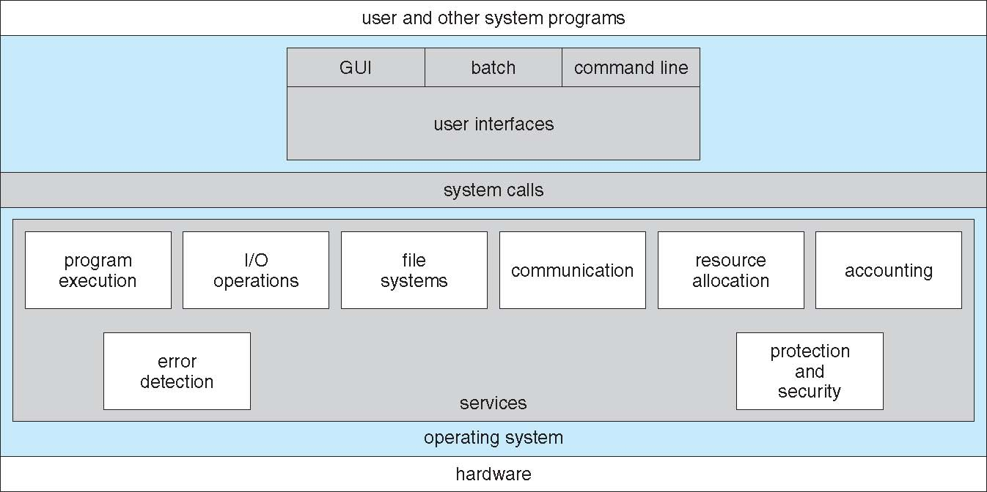

A View of Operating System Services

User Operating-System Interface
There are several ways for users to interface with the operating system.
- Command-line interface, or command interpreter, allows users to directly enter commands to be performed by the operating system.
- Graphical user interface(GUI), allows users to interface with the operating system using pointer device and menu system.

Command Interpreter
  - Command Interpreters are used to give commands to the OS. There are multiple command interpreters known as shells. In UNIX and Linux systems, there are several different shells, like the Bourne shell, C shell, Bourne-Again shell, Korn shell, and others.
  - The main function of the command interpreter is to get and execute the user-specified command. Many of the commands manipulate files: create, delete, list, print, copy, execute, and so on.

The commands can be implemented in two general ways-
- The command interpreter itself contains the code to execute the command. For example, a command to delete a file may cause the command interpreter to jump to a particular section of its code that sets up the parameters and makes the appropriate system call.
- The code to implement the command is in a function in a separate file. The interpreter searches for the file and loads it into the memory and executes it by passing the parameter.
- Thus by adding new functions new commands can be added easily to the interpreter without disturbing it.

Graphical User Interfaces
  - A second strategy for interfacing with the operating system is through a user friendly graphical user interface or GUI. Rather than having users directly enter commands via a command-line interface, a GUI allows provides a mouse-based window-and-menu system as an interface.
  - A GUI provides a desktop metaphor where the mouse is moved to position its pointer on images, or icons, on the screen (the desktop) that represent programs, files, directories, and system functions.
  - Depending on the mouse pointer's location, clicking a button on the mouse can invoke a program, select a file or directory—known as a folder— or pull down a menu that contains commands.

System Calls

  - System calls provides an interface to the services of the operating system. These are generally written in C or C++, although some are written in assembly for optimal performance.
  - Mostly accessed by programs via a high-level Application Programming Interface (API) rather than direct system call use
  - Three most common APIs are Win32 API for Windows, POSIX API for POSIX-based systems (including virtually all versions of UNIX, Linux, and Mac OS X), and Java API for the Java virtual machine (JVM)
  - The below figure illustrates the sequence of system calls required to copy a file content from one file (input file) to another file (output file).
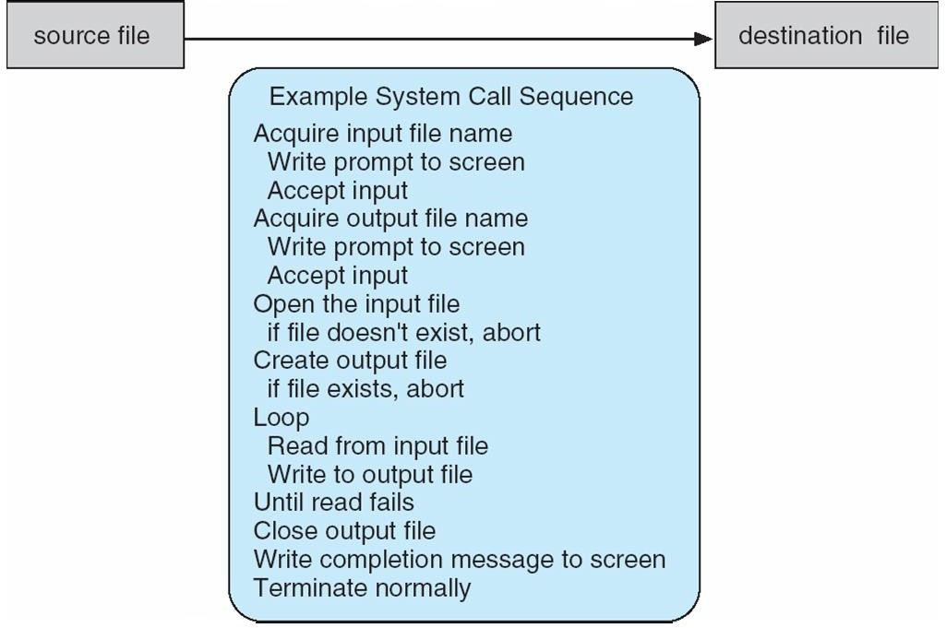
Example of Standard API :

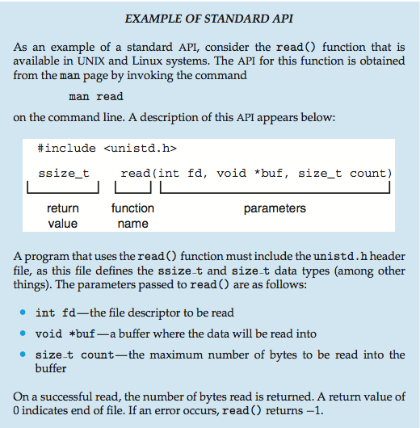

System Call Implementation

    - Most programmers do not use the low-level system calls directly, but instead use an "Application Programming Interface", API.
    - Instead of direct system calls provides for greater program portability between different systems. The API then makes the appropriate system calls through the system call interface, using a system call table to access specific numbered system calls.
    - Each system call has a specific numbered system call. The system call table (consisting of system call number and address of the particular service) invokes a particular service routine for a specific system call.
    - The caller need know nothing about how the system call is implemented or what it does during execution.
    - Just needs to obey API and understand what OS will do as a result call
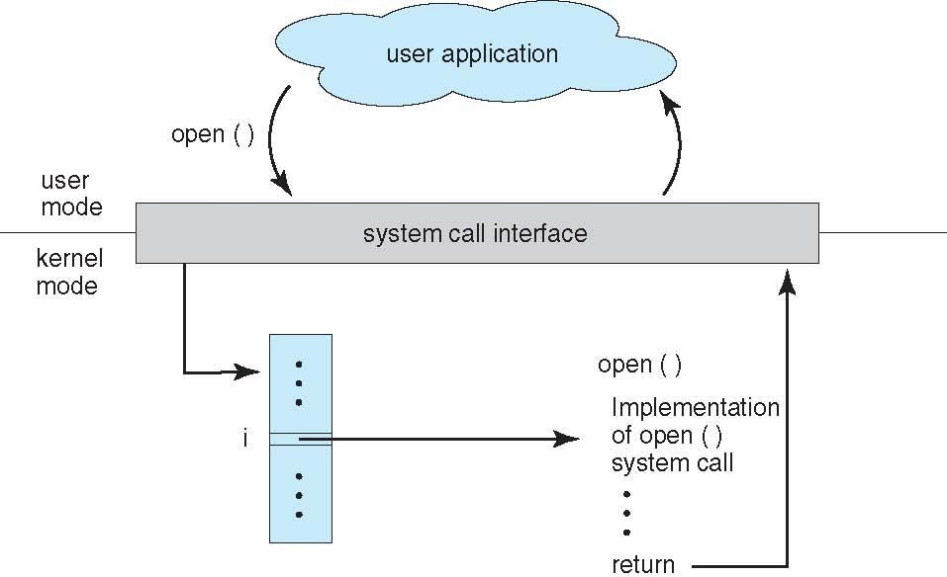
    - Most details of OS interface hidden from programmer by API : Managed by run-time support library (set of functions built into libraries included with compiler)

Figure: The handling of a user application invoking the open()system call.
System Call Parameter Passing

- Often, more information is required than simply identity of desired system call
  - Exact type and amount of information vary according to OS and call
- Three general methods used to pass parameters to the OS
  - Simplest: pass the parameters in registers
    - In some cases, may be more parameters than registers
  - Parameters stored in a block, or table, in memory, and address of block passed as a parameter in a register
    - This approach taken by Linux and Solaris
  - Parameters placed, or pushed, onto the stack by the program and popped off the stack by the operating system
  - Block and stack methods do not limit the number or length of parameters being passed

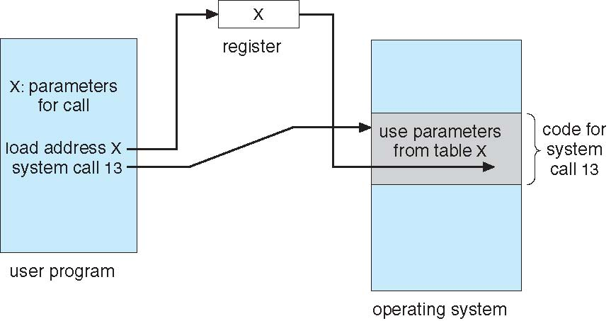

Figure : Passing of parameters as a table.

Types of System Calls

The system calls can be categorized into six major categories:

  - Process Control
  - File management
  - Device management
  - Information management
  - Communications
  - Protection

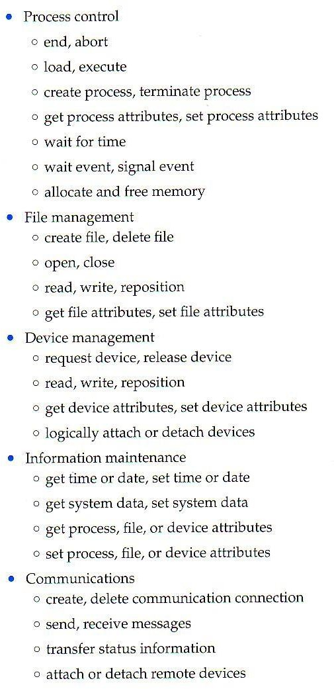
Figure: Types of system calls

- Protection
        - Control access to resources
        - Get and set permissions
        - Allow and deny user access

Process Control

  - Process control system calls include end, abort, load, execute, create process, terminate process, get/set process attributes, wait for time or event, signal event, and allocate and free memory.
  - Processes must be created, launched, monitored, paused, resumed, and eventually stopped.
  - When one process pauses or stops, then another must be launched or resumed
  - Process attributes like process priority, max. allowable execution time etc. are set and retrieved by OS.
  - After creating the new process, the parent process may have to wait (wait time), or wait for an event to occur (wait event).The process sends back a signal when the event has occurred (signal event)

​File Management
The file management functions of OS are –
  - File management system calls include create file, delete file, open, close, read, write, reposition, get file attributes, and set file attributes.
  - After creating a file, the file is opened. Data is read or written to a file.
  - The file pointer may need to be repositioned to a point.
  - The file attributes like filename, filetype,permissions,etc. are reset and retrieved using system calls.
  - These operations may also be supported for directories as well as ordinary files.

​Device Management
  - Device management system calls include request device, release device, read,write, reposition, get/set device attributes, and logically attach or detach devices.
  - When a process needs a resource, a request for resource is done. Then the control is granted to the process. If requested resource is already attached to some other process, the requesting process has to wait.
  - In multiprogramming systems, after a process uses the device, it has to be returned to OS, so that another process can use the device.
  - Devices may be physical (e.g. disk drives ), or virtual / abstract ( e.g. files, partitions, and RAM disks ).

​Information Maintenance
  - Information maintenance system calls include calls to get/set the time, date, system data, and process, file, or device attributes.
  - These system calls are used to transfer the information between user and the OS. Information like current time & date, no. of current users, version no. of OS, amount of free memory, disk space etc. are passed from OS to the user.

​Communication
  - Communication system calls create/delete communication connection, send/receive messages, transfer status information, and attach/detach remote devices.
  - The message passing model must support calls to:
    - Identify a remote process and/or host with which to communicate.
    - Establish a connection between the two processes.
    - Open and close the connection as needed.
    - Transmit messages along the connection.
    - Wait for incoming messages, in either a blocking or non-blocking state.
    - Delete the connection when no longer needed.
  - The shared memory model must support calls to:
    - Create and access memory that is shared amongst processes (and threads.)
    - Freeup shared memory and/or dynamically allocate it as needed.
  - Message passing is simpler and easier, (particularly for inter-computer communications), and is generally appropriate for small amounts of data. Itis easy to implement, but there are system calls for each read and write process.
  - Shared memory is faster, and is generally the better approach where large amounts of data are to be shared. This model is difficult to implement, and it consists of only few system calls.

​Protection
  - Protection provides mechanisms for controlling which users / processes have access to which system resources.
  - System calls allow the access mechanisms to be adjusted as needed, and for non- privileged users to be granted elevated access permissions under carefully controlled temporary circumstances.
Examples of Windows and Unix System Calls :

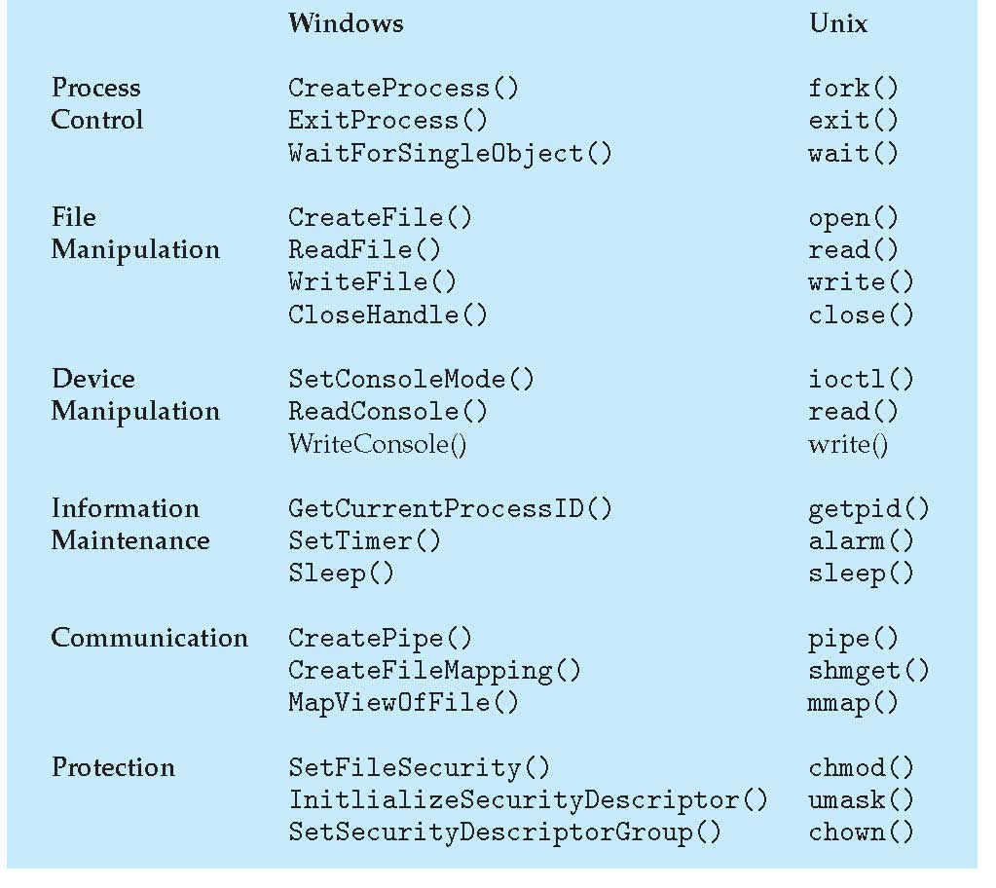

System Programs
A collection of programs that provide a convenient environment for program development and execution (other than OS) are called system programs or system utilities.

System programs may be divided into six categories:

  - File management- programs to create, delete, copy, rename, print, list, and generally manipulate files and directories.
  - Status information- Utilities to check on the date, time, number of users, processes running, data logging, etc. System registries are used to store and recall configuration information for particular applications.
  - File modification-e.g. text editors and other tools which can change file contents.
  - Programming-language support- E.g. Compilers, linkers, debuggers, profilers, assemblers, library archive management, interpreters for common languages, and support for make.
  - Program loading and execution- loaders, dynamic loaders, overlay loaders, etc., as well as interactive debuggers.
  - Communications-Programs for providing connectivity between processes and users, including mail, web browsers, remote logins, file transfers, and remote command execution.

Operating-System Design and Implementation

Design Goals
    - The first problem in designing a system is to define goals and specifications. At the highest level, the design of the system will be affected by the choice of hardware and the type of system: batch, time shared, single user, multiuser, distributed, real time, or general purpose.
    - Beyond this highest design level, the requirements may be much harder to specify. The requirements can, however, be divided into two basic groups
      - User goals(User requirements)
      - System goals(system requirements)

    - User requirements are the features that user care about and understand like system should be convenient to use, easy to learn, reliable, safe and fast.
    - System requirements are written for the developers, ie. People who design the OS. Their requirements are like easy to design, implement and maintain, flexible, reliable, error free and efficient.

Mechanisms and Policies
    - Policies determine what is to be done. Mechanisms determine how it is to be implemented.
    - Example: in timer- counter and decrementing counter is the mechanism and deciding how long the time has to be set is the policies.
    - Policies change overtime. In the worst case, each change in policy would require a change in the underlying mechanism.
    - If properly separated and implemented, policy changes can be easily adjusted without re- writing the code, just by adjusting parameters or possibly loading new data / configuration files.

Implementation
    - Traditionally OS were written in assembly language.
    - In recent years, OS are written in C, or C++. Critical sections of code are still written in assembly language.
    - The first OS that was not written in assembly language , It was the Master Control Program (MCP).
    - The advantages of using a higher-level language for implementing operating systems are: The code can be written faster, more compact, easy to port to other systems and is easier to understand and debug.
    - The only disadvantages of implementing an operating system in a higher-level language are reduced speed and increased storage requirements.

