P.V.P Siddhartha Institute of Technology
Department of Computer Science and Engineering
Course: B.Tech |  | Year: III | Semester: I | Descriptive: I | A.Y:2025-26
Subject Code: 23CS6501 |  | Subject Name: Data Visualization |  |  | Regulation:PVP23
Duration:1 hr 30 min |  | Maximum Marks:30Marks |  |  | Date:08/09/25 |  | Session: F.N
Answer one from each Either-Or type of Questions.
Each Question carries 10 Marks
3×10M=30M
Q.No |  |  |  |  |  | Marks |  | CO | Level
1. | 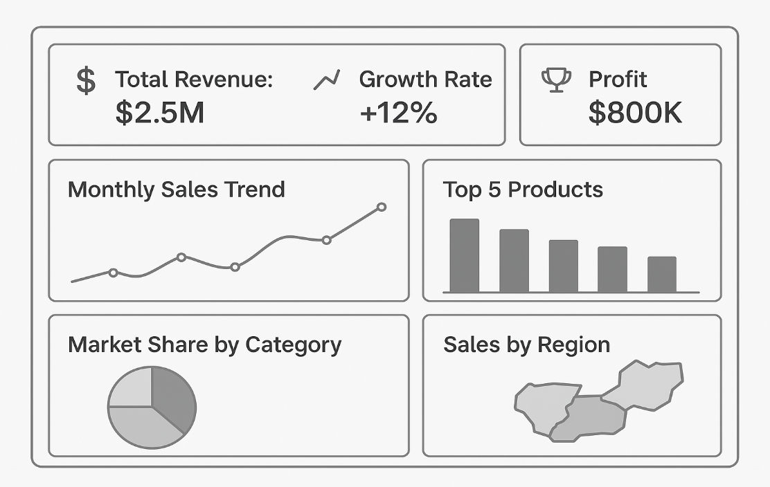  Apply Gestalt principles to design a visualization that reduces information overload. Use the below sales chart into a visualization that reduces information overload and improves clarity of insights. |  |  |  |  | 10 |  | CO1 | L3
(OR)
2. | How can visual perception principles improve a hospital dashboard design? Apply with example. (consider hospital dashboard typically shows patient statistics, bed occupancy, doctor schedules, lab reports, financials, etc) |  |  |  |  | 10 |  | CO1 | L3
3. | Apply the visualization pipeline to create a dashboard for student grades. (The dashboard includes Average scores by subject, Top 5 students, Grade distribution, Attendance vs. GPA trend) |  |  |  |  | 5 |  | CO2 | L3
(OR)
4. | Apply visualization design to avoid clutter in mobile analytics dashboards.  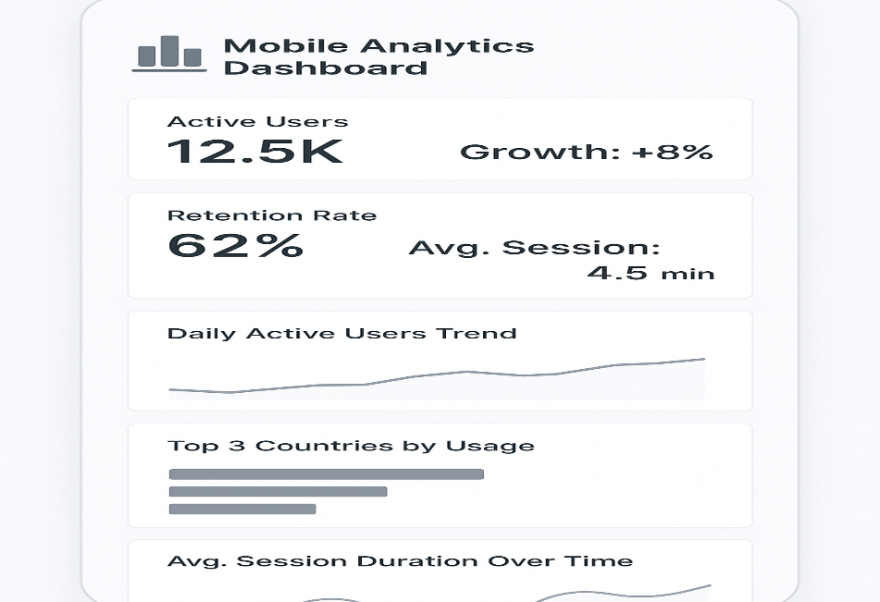 |  |  |  |  | 10 |  | CO2 | L3
5. | Given a dataset of traffic accidents, apply pre-attentive attributes (color, size, shape) to design a visualization that highlights accident hotspots. |  |  |  |  | 10 |  | CO1 | L3
(OR)
6. | Using the visualization, design a dashboard from an e-commerce dataset (Region, Product Category, Sales Amount, Order Date) to highlight regional sales trends, best-selling categories, and seasonal variations, applying principles of effective visualization design. |  |  |  |  | 10 |  | CO2 | L3

