PRASAD V. POTLURI SIDDHARTHA INSTITUTE OF TECHNOLOGY,
KANURU, VIJAYAWADA
DEPARTMENT OF COMPUTER SCIENCE & ENGINEERING
INNOVATIVE TEACHING METHODOLOGY
Academic Year: 2025 - 26
Teaching Methodology – Video-Based Aciviity (AI-Assisted Video-Based Learning for Exploring LLM Behavior and Prompt Engineering)
Class : III B.TECH (Honors)
Semester: II - Semester
Section: S1,S2,S3
Name of the Course: Prompt Engineering for Generative AI (23CS6501)
Name of the Faculty: Dr. K. Jyothsna Devi
---------------------------------------------------------------------------------------------------------------
To provide students with hands-on experience in understanding Large Language Models (LLMs), prompt-response dependency, and prompt engineering techniques through experimentation, comparative analysis, and video-based presentations.
Methodology Adopted
An innovative, activity-based learning approach was implemented using Large Language Model (LLM) tools. Students were assigned a comprehensive activity that combined concept exploration and case-based problem solving. The activity encouraged students to interact directly with AI systems, analyze responses, and apply prompt engineering techniques to improve output quality.
Students selected a Unit-I concept such as Tokenization, Context Window, Hallucination, or LLM Limitations and interacted with an LLM using different prompt designs. They first used a basic prompt and then an improved prompt containing clear instructions and context to observe variations in the generated responses.
Further, students investigated a real-world scenario where zero-shot prompting produced inconsistent outputs. They redesigned the prompts using few-shot prompting or role-based prompting techniques and compared the generated results with the original outputs. Students analyzed how different prompting strategies influenced response accuracy, relevance, consistency, and clarity.
The entire activity was documented and presented through a 5–7 minute video presentation demonstrating the prompts used, responses generated, comparative analysis, and key observations.

Number of Students Involved : 21
Student Name &Regd Number:
S.No | Register No. | Name of the Student
1 | 23501A0526 | CHERUKURI RAM CHARAN
2 | 23501A0537 | DUDEKULA CHINNA NASARVALI
3 | 23501A0538 | ERUKUDINNELA AKHIL PREETHAM
4 | 23501A0539 | ADIRAJU SIVA SAI NARAYANA
5 | 23501A0550 | GUNDOLU JAI SAI SRINIVAS
6 | 23501A0559 | KALISETTI KALI PRASAD
7 | 23501A0569 | K. Pujitha
8 | 23501A0594 | KUNCHAM ADITHYA
9 | 23501A0596 | KURAPATI VENKATA LALITH CHANDAN
10 | 23501A05A6 | MADDULA POSHANYA GUPTHA
11 | 23501A05C1 | MOTHUKURI AASRITHA
12 | 23501A05C4 | MUKKAVILLI BHAVYA SAI SREE
13 | 23501A05H1 | TAKKELLA TEJASWI
14 | 23501A05H8 | TUMMEPALLI RESHINI AHLA
15 | 23501A05J5 | YANDURI SIVA SAI SWAROOP
16 | 24505a0501 | ADDEPALLI PAVITHRA LAKSHMI
17 | 24505a0508 | KADARI MANOBHI RAM
18 | 24505a0511 | LABBA LAKSHMI DEVI
19 | 24505a0512 | MIRZA SHANE HYDER
20 | 24505a0515 | PADAVALA SRAVYA
21 | 24505a0519 | SHAIK SUMIYA PARVEEN

Innovative Elements
- AI-Assisted Learning
- Activity-Based Learning
- Case-Based Learning
- Video-Based Assessment
- Comparative Analysis
- Experiential Learning
- Self-Directed Learning
Student Engagement
Students actively interacted with LLM tools, experimented with multiple prompt designs, evaluated AI-generated responses, and presented their findings through video demonstrations. The activity promoted exploration, collaboration, critical thinking, and practical application of Generative AI concepts.
Learning Outcomes Achieved
Through this activity, students were able to:
- Understand the fundamental concepts and limitations of Large Language Models.
- Analyze the effect of prompt design on AI-generated responses.
- Recognize prompt-response dependency in Generative AI systems.
- Compare zero-shot, few-shot, and role-based prompting techniques.
- Improve response quality through effective prompt engineering.
- Develop analytical, problem-solving, communication, and presentation skills.
- Apply theoretical concepts to practical AI applications.
Outcome of the Activity
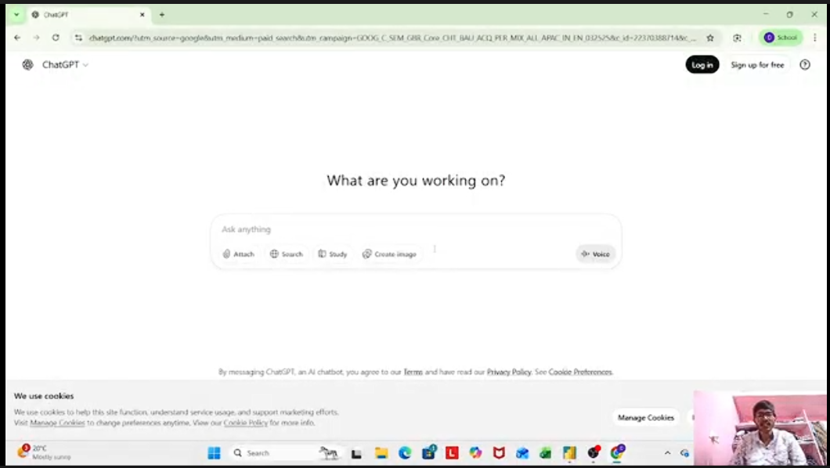
The activity enabled students to gain practical exposure to Generative AI tools and prompt engineering techniques. Students successfully demonstrated how prompt modifications influence response quality and learned to select appropriate prompting strategies for different scenarios. The video-based learning approach enhanced engagement, conceptual understanding, and real-world application of AI concepts.
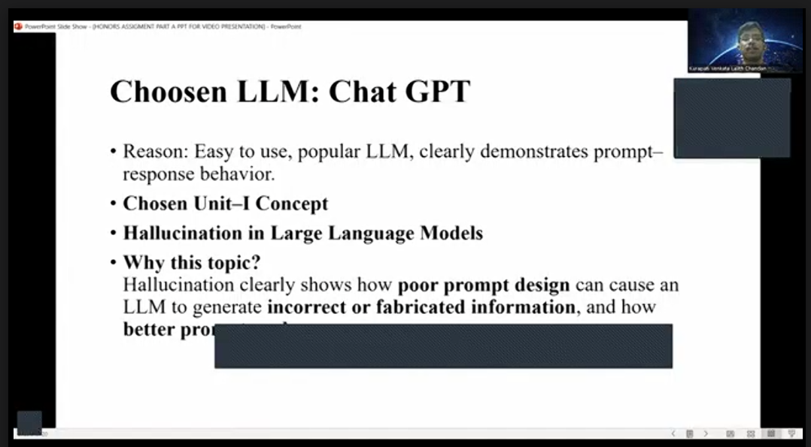

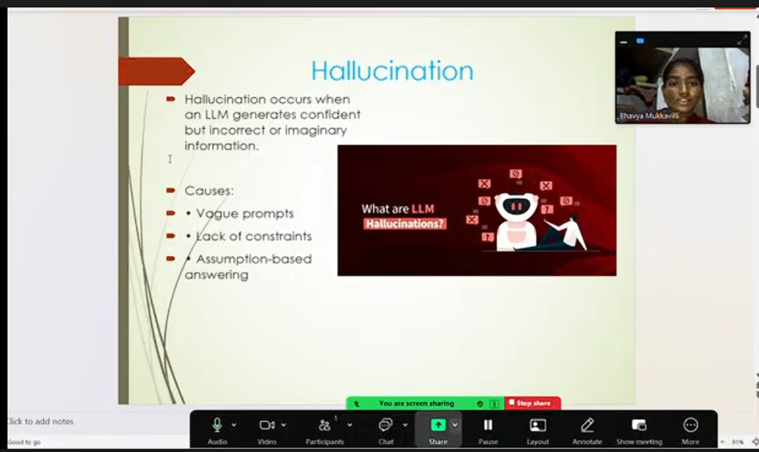

Signature of the Faculty

