UNIT 4
CODING & TESTING
Contents:
Coding and Testing: Coding- Coding Standards and Guidelines, Code Review- Code Walkthrough, Code Inspection, Clean Room Technique, Software documentation- Internal Documentation , External Documentation, Testing- Basic Concepts and Terminologies, Testing Activities, Why Design Test Cases?, Testing in the Large versus Testing in the Small, Unit Testing, Black-box Testing- Equivalence Class Partitioning, Boundary Value Analysis, White-Box Testing- Basic Concepts, Statement Coverage, Branch Coverage, Condition Coverage, Condition and Decision Coverage, Multiple Condition Coverage ,Path Coverage, McCabe’s Cyclomatic Complexity Metric , Debugging- Debugging Approaches, Integration Testing, Phased versus Incremental Integration Testing, Testing Object-Oriented programs- What is a Suitable Unit for Testing Object-Oriented Programs?, System Testing- Smoke Testing, Performance Testing

Software Reliability and Quality Management: Software Reliability- Hardware versus Software Reliability, Reliability Metrics of Software Products, Statistical Testing- Steps in Statistical Testing, Software Quality - Software Quality Models, Software Quality Management System- Evolution of Quality Systems, Product Metrics versus Process Metrics, ISO 9000-What is ISO 9000 Certification? ISO 9000 for Software Industry, SEI Capability maturity model- Comparison between ISO 9000 certification and SEI/CMM.

Introduction:
- Coding is undertaken once the design phase is complete and the design documents have been successfully reviewed.
- In the coding phase, every module specified in the design document is coded and unit tested. During unit testing, each module is tested in isolation from other modules.
- After all the modules of a system have been coded and unit tested, the integration and system testing phase is undertaken
- Integration and testing of modules is carried out according to an integration plan.
- The full product takes shape only after all the modules have been integrated together. System testing is conducted on the full product. During system testing, the product is tested against its requirements as recorded in the SRS document.
- Testing is an important phase in software development, requires the maximum effort and requires the maximum effort.

Coding:
- The input to the coding phase is the design document produced at the end of the design phase.
- The design document contains not only the high-level design of the system in the form of a module structure (e.g., a structure chart), but also the detailed design.
- The detailed design is usually documented in the form of module specifications where the data structures and algorithms for each module are specified.
- The objective of the coding phase is to transform the design of a system into code in a high-level language, and then to unit test this code.
- good software development organisations require their programmers to adhere to some well-defined and standard style of coding which is called their coding standard.
- organisations formulate their own coding standards and require their developers to follow the standards rigorously.
- The main advantages of adhering to a standard:
  - A coding standard gives a uniform appearance to the codes written by different engineers.
  - It facilitates code understanding and code reuse.
  - It promotes good programming practices.
What is the difference between a coding guideline and a coding standard?
- It is mandatory for the programmers to follow the coding standards. Compliance of their code to coding standards is verified during code inspection. Any code that does not conform to the coding standards is rejected during code review and the code is reworked by the concerned programmer.
- In contrast, coding guidelines provide some general suggestions regarding the coding style to be followed but leave the actual implementation of these guidelines to the discretion of the individual developers.
Usually code review is carried out to ensure that the coding standards are followed and also to detect as many errors as possible before testing. Reviews are an efficient way of removing errors from code.
Coding Standards and Guidelines:
Good software development organisations usually develop their own coding standards and guidelines.
Representative coding standards:
- Rules for limiting the use of globals: These rules list what types of data can be declared global and what cannot, with a view to limit the data that needs to be defined with global scope.
- Standard headers for different modules: The header of different modules should have standard format and information for ease of understanding and maintenance.
- Naming conventions for global variables, local variables, and constant identifiers: A popular naming convention is that variables are named using mixed case lettering. Example :GlobalData, localData, CONSTDATA
- Conventions regarding error return values and exception handling mechanisms: The way error conditions are reported by different functions in a program should be standard within an organisation.
Representative coding guidelines:
- Do not use a coding style that is too clever or too difficult to understand: Code should be easy to understand. Many inexperienced engineers actually take pride in writing cryptic and incomprehensible code.
- Avoid obscure side effects: The side effects of a function call include modifications to the parameters passed by reference, modification of global variables, and I/O operations. An obscure side effect is one that is not obvious from a casual examination of the code. Obscure side effects make it difficult to understand a piece of code.
- Do not use an identifier for multiple purposes: Programmers often use the same identifier to denote several temporary entities. There are several things wrong with this approach and hence should be avoided.
- Code should be well-documented: As a rule of thumb, there should be at least one comment line on the average for every three source lines of code.
- Length of any function should not exceed 10 source lines: A lengthy function is usually very difficult to understand as it probably has a large number of variables and carries out many different types of computations.
- Do not use GOTO statements: Use of GOTO statements makes a program unstructured. This makes the program very difficult to understand, debug, and maintain.
Code Review:
- Testing is an effective defect removal mechanism. However, testing is applicable to only executable code.
- Review is a very effective technique to remove defects from source code. In fact, review has been acknowledged to be more cost-effective in removing defects as compared to testing.
- Code review for a module is undertaken after the module successfully compiles. That is, all the syntax errors have been eliminated from the module.
- Code review does not target to design syntax errors in a program, but is designed to detect logical, algorithmic, and programming errors.
- Code review has been recognised as an extremely cost-effective strategy for eliminating coding errors and for producing high quality code.
- Reviews directly detect errors, whereas testing only helps detect failures.
- Eliminating an error from code involves three main activities—testing, debugging, and then correcting the errors. Testing is carried out to detect if the system fails to work satisfactorily for certain types of inputs and under certain circumstances. Once a failure is detected, debugging is carried out to locate the error that is causing the failure and to remove it. Of the three testing activities, debugging is possibly the most laborious and time consuming activity.
- In code inspection, errors are directly detected, thereby saving the significant effort that would have been required to locate the error. Normally, the following two types of reviews are carried out on the code:
  - Code Inspection
  - Code Walkthrough
Code inspection.
- During code inspection, the code is examined for the presence of some common programming errors.
- The principal aim of code inspection is to check for the presence of some common types of errors that usually creep into code due to programmer mistakes and oversights and to check whether coding standards have been adhered to.
- The inspection process has several beneficial side effects, other than finding errors. The programmer usually receives feedback on programming style, choice of algorithm, and programming techniques. The other participants gain by being exposed to another programmer’s errors.
- Good software development companies collect statistics regarding different types of errors that are commonly committed by their engineers and identify the types of errors most frequently committed.
- Such a list of commonly committed errors can be used as a checklist during code inspection to look out for possible errors.
- Following is a list of some classical programming errors which can be checked during code inspection:
  - Use of uninitialised variables.
  - Jumps into loops.
  - Non-terminating loops.
  - Incompatible assignments.
  - Array indices out of bounds.
  - Improper storage allocation and deallocation.
  - Mismatch between actual and formal parameters in procedure calls.
  - Use of incorrect logical operators or incorrect precedence among operators.
  - Improper modification of loop variables.
  - Comparison of equality of floating point values.
  - Dangling reference caused when the referenced memory has not been allocated.
Code walkthrough.
- Code walkthrough is an informal code analysis technique.
- In this technique, a module is taken up for review after the module has been coded, successfully compiled, and all syntax errors have been eliminated.
- A few members of the development team are given the code a couple of days before the walkthrough meeting.
- Each member selects some test cases and simulates execution of the code by hand.
- The main objective of code walkthrough is to discover the algorithmic and logical errors in the code.
- Even though code walkthrough is an informal analysis technique, several guidelines have evolved over the years. Guidelines are based on personal experience, common sense, and several other subjective factors.
  - The team performing code walkthrough should not be either too big or too small. Ideally, it should consist of between three to seven members.
  - Discussions should focus on discovery of errors and avoid deliberations on how to fix the discovered errors.
  - In order to foster cooperation and to avoid the feeling among the engineers that they are being watched and evaluated in the code walkthrough meetings, managers should not attend the walkthrough meetings.
Clean Room Testing:
Cleanroom technique was pioneered at IBM. This technique relies heavily on walkthroughs, inspection, and formal verification for bug removal. The programmers are not allowed to test any of their code by executing the code other than doing some syntax testing using a compiler. It is interesting to note that the term cleanroom was first coined at IBM by drawing analogy to the semiconductor fabrication units where defects are avoided by manufacturing in an ultra-clean atmosphere.
Software Documentation:
When a software is developed, in addition to the executable files and the source code, several kinds of documents such as users’ manual, software requirements specification (SRS) document, design document, test document, installation manual, etc., are developed as part of the software engineering process.
All these documents are considered a vital part of any good software development practice. Good documents are helpful in the following ways:
- Good documents help enhance understandability of code.
- Documents help the users to understand and effectively use the system.
- Good documents help to effectively tackle the manpower turnover problem
- Production of good documents helps the manager to effectively track the progress of the project
Different types of software documents can broadly be classified into the following:
Internal documentation:
- These are provided in the source code itself. Internal documentation can be provided in the code in several forms. The important types of internal documentation are the following:
  - Comments embedded in the source code.
  - Use of meaningful variable names.
  - Module and function headers.
  - Code indentation.
  - Code structuring (i.e., code decomposed into modules and functions).
  - Use of enumerated types.
  - Use of constant identifiers.
  - Use of user-defined data types.
- Even when a piece of code is carefully commented, meaningful variable names have been found to be the most helpful in understanding the code.
External documentation:
- These are the supporting documents such as SRS document, installation document, user manual, design document, and test document.
- A systematic software development style ensures that all these documents are of good quality and are produced in an orderly fashion.
- An important feature that is required of any good external documentation is consistency with the code.
- If the different documents are not consistent, a lot of confusion is created for somebody trying to understand the software.
- Every change made to the code should be reflected in the relevant external documents.
- Another important feature required for external documents is proper understandability by the category of users for whom the document is designed.
- Gunning’s Fog Index:
  - Gunning’s fog index (developed by Robert Gunning in 1952) is a metric that has been designed to measure the readability of a document.
  - The computed metric value (fog index) of a document indicates the number of years of formal education that a person should have, in order to be able to comfortably understand that document.
  - The Gunning’s fog index of a document D can be computed as follows:

Testing
- The aim of program testing is to help realise/identify all defects in a program.
- However, in practice, even after satisfactory completion of the testing phase, it is not possible to guarantee that a program is error free.
- This is because the input data domain of most programs is very large, and it is not practical to test the program exhaustively with respect to each value that the input can assume.
- We must remember that careful testing can expose a large percentage of the defects existing in a program
Testing terminology:
- Mistake: A mistake is essentially any programmer action that later shows up as an incorrect result during program execution. A programmer may commit a mistake in almost any development activity.
- Error: An error is the result of a mistake committed by a developer in any of the development activities. Among the extremely large variety of errors that can exist in a program. The terms error, fault, bug, and defect are considered to be synonyms.
- Failure: A failure of a program essentially denotes an incorrect behaviour exhibited by the program during its execution. An incorrect behaviour is observed either as an incorrect result produced or as an inappropriate activity carried out by the program.
- Test-case: A test case is a triplet [I , S, R], where I is the data input to the program under test, S is the state of the program at which the data is to be input, and R is the result expected to be produced by the program. The state of a program is also called its execution mode.
  - A positive test case is designed to test whether the software correctly performs a required functionality
  - A negative test case is designed to test whether the software carries out something that is not required of the system.
- Test scenario: A test scenario is an abstract test case in the sense that it only identifies the aspects of the program that are to be tested without identifying the input, state, or output. A test case can be said to be an implementation of a test scenario.
- Test script: A test script is an encoding of a test case as a short program. Test scripts are developed for automated execution of the test cases.
- Test suite: A test suite is the set of all tests that have been designed by a tester to test a given program.
- Testability: Testability of a requirement denotes the extent to which it is possible to determine whether an implementation of the requirement conforms to it in both functionality and performance.
- Failure mode: A failure mode of a software denotes an observable way in which it can fail.
- Equivalent faults: Equivalent faults denote two or more bugs that result in the system failing in the same failure mode.
Validation vs Verification:
- The objectives of both verification and validation techniques are very similar since both these techniques are designed to help remove errors in a software.
- The underlying principles of these two bug detection techniques and their applicability are very different.
- Verification:
  - Verification is the process of determining whether the output of one phase of software development conforms to that of its previous phase;
  - Verification is to check if the work products produced after a phase conform to that which was input to the phase.
  - Techniques used for verification include review, simulation, formal verification, and testing.
- Validation:
  - Validation is the process of determining whether a fully developed software conforms to its requirements specification
  - Validation is applied to the fully developed and integrated software to check if it satisfies the customer’s requirements.
  - System testing can be considered as a validation step where it is determined whether the fully developed code is as per its requirements specification.
Error detection techniques = Verification techniques + Validation techniques
How to test a Program:
- Testing a program involves executing the program with a set of test inputs and observing if the program behaves as expected.
- If the program fails to behave as expected, then the input data and the conditions under which it fails are noted for later debugging and error correction.
- Unless the conditions under which a software fails are noted down, it becomes difficult for the developers to reproduce a failure observed by the testers.
Testing Activities:
- Test suite design: The set of test cases using which a program is to be tested is designed possibly using several test case design techniques.
- Running test cases and checking the results to detect failures: Each test case is run and the results are compared with the expected results. A mismatch between the actual result and expected results indicates a failure.
- Locate error: In this activity, the failure symptoms are analysed to locate the errors.
- Error correction: After the error is located during debugging, the code is appropriately changed to correct the error
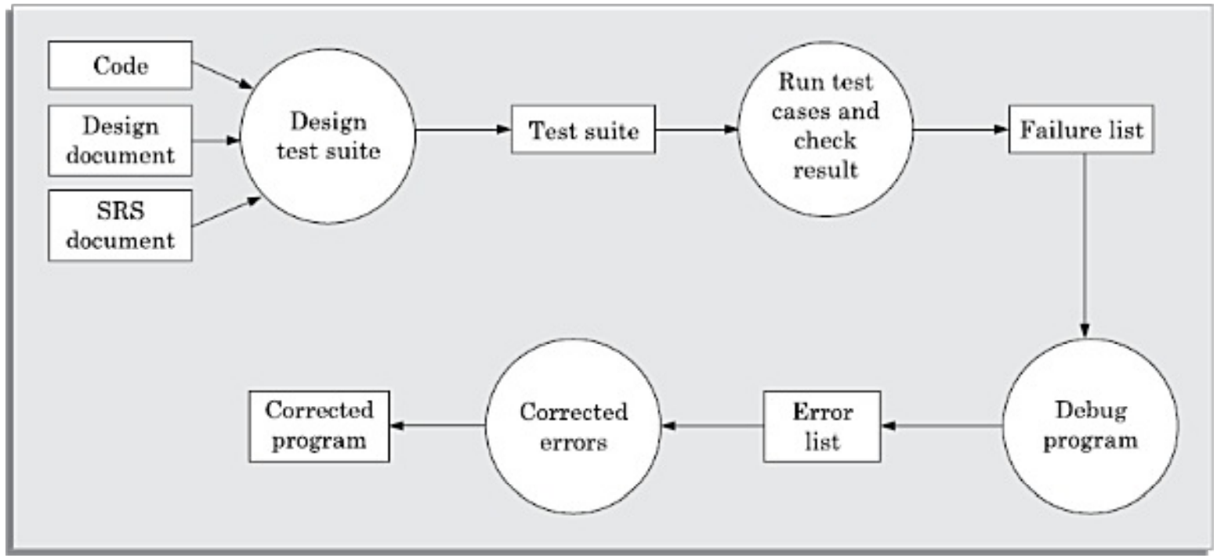
Testing Process

Why design test cases?
- Testing a system using a large number of randomly selected test cases:
  - Does not mean that many errors in the system will be uncovered.
Consider the following example code segment which determines the
greater of two integer values x and y. This code segment has a simple programming error:
if (x>y) max = x;
else max = x; /* should be max = y */
For the given code segment, the test suite {(x=3,y=2);(x=2,y=3)} can detect the error, whereas
a larger test suite {(x=3,y=2);(x=4,y=3);(x=5,y=1)} does not detect the error. All the test
cases in the larger test suite essentially test the same statement, while the other statement
remains undetected. So, it would be incorrect to say that a larger test suite would always
detect more errors than a smaller one, unless of course the larger test suite has also been
carefully designed. This implies that for effective testing, the test suite should be carefully
designed rather than picked randomly

Testing in small vs testing in Large?
A software product is normally tested in three levels or stages:
 Unit testing
 Integration testing
 System testing
Unit Testing
- Unit testing is undertaken after a module has been coded and reviewed.
- This activity is typically undertaken by the coder of the module himself in the coding phase.
- Before carrying out unit testing, the unit test cases have to be designed and the test environment for the unit under test has to be developed.
- In order to test a single module, we need a complete environment to provide all relevant code that is necessary for execution of the module.
- That is, besides the module under test, the following are needed to test the module:
  - The procedures belonging to other modules that the module under test calls.
  - Non-local data structures that the module accesses.
  - A procedure to call the functions of the module under test with appropriate parameters.
- Modules required to provide the necessary environment (which either call or are called by the module under test) are usually not available until they too have been unit tested.
- In this context, stubs and drivers are designed to provide the complete environment for a module so that testing can be carried out.
Stub: A stub procedure is a dummy procedure that has the same I/O parameters as the function called by the unit under test but has a highly simplified behaviour.
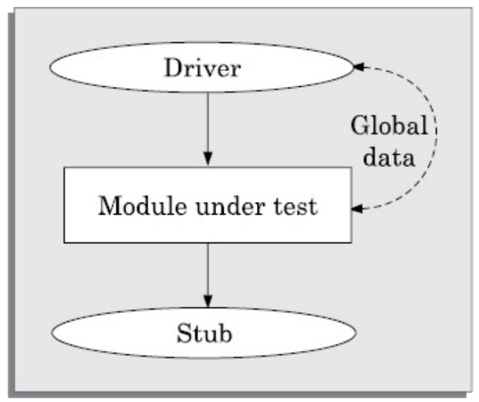
Driver: A driver module should contain the non-local data structures accessed by the module under test. Additionally, it should also have the code to call the different functions of the unit under test with appropriate parameter values for testing.
- Unit testing is referred to as testing in the small, whereas integration and system testing are referred to as testing in the large.
Black-Box testing:
- In black-box testing, test cases are designed from an examination of the input/output values only and no knowledge of design or code is required.
- The following are the two main approaches available to design black box test cases:
  - Equivalence class partitioning
  - Boundary value analysis
Equivalence class partitioning:
- In the equivalence class partitioning approach, the domain of input values to the program under test is partitioned into a set of equivalence classes.
- The partitioning is done such that for every input data belonging to the same equivalence class, the program behaves similarly.
- The main idea behind defining equivalence classes of input data is that testing the code with any one value belonging to an equivalence class is as good as testing the code with any other value belonging to the same equivalence class.
- Equivalence classes for a unit under test can be designed by examining the input data and output data.
- The following are two general guidelines for designing the equivalence classes:
- If the input data values to a system can be specified by a range of values, then one valid and two invalid equivalence classes need to be defined. For example, if the equivalence class is the set of integers in the range 1 to 10 (i.e., [1,10]), then the invalid equivalence classes are [−∞,0], [11,+∞].
- If the input data assumes values from a set of discrete members of some domain, then one equivalence class for the valid input values and another equivalence class for the invalid input values should be defined. For example, if the valid equivalence classes are {A,B,C}, then the invalid equivalence class is U-{A,B,C} where U is the universe of possible input values.
Boundary Value Analysis:
- A type of programming error that is frequently committed by programmers is missing out on the special consideration that should be given to the values at the boundaries of different equivalence classes of inputs.
- Boundary value analysis-based test suite design involves designing test cases using the values at the boundaries of different equivalence classes.
- To design boundary value test cases, it is required to examine the equivalence classes to check if any of the equivalence classes contains a range of values. For those equivalence classes that are not a range of values no boundary value test cases can be defined.
- For an equivalence class that is a range of values, the boundary values need to be included in the test suite. For example, if an equivalence class contains the integers in the range 1 to 10, then the boundary value test suite is {0,1,10,11}.
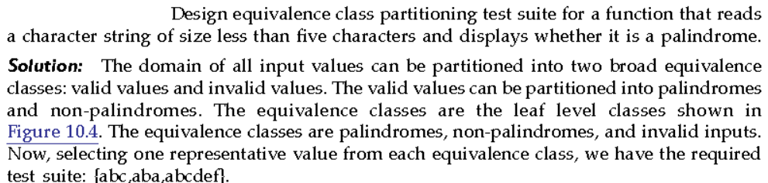
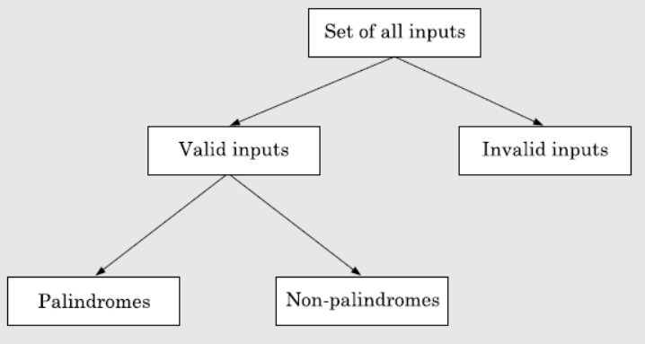
Summary of the Black-box Test Suite Design Approach:
We now summarise the important steps in the black-box test suite design approach:
- Examine the input and output values of the program.
- Identify the equivalence classes.
- Design equivalence class test cases by picking one representative value from each equivalence class.
- Design the boundary value test cases as follows. Examine if any equivalence class is a range of values. Include the values at the boundaries of such equivalence classes in the test suite.
White-Box Testing:
- White-box testing is an important type of unit testing. A large number of white-box testing strategies exist.
- Each testing strategy essentially designs test cases based on analysis of some aspect of source code and is based on some heuristic.
Basic Concepts:
A white-box testing strategy can either be coverage-based or fault based.
Fault-based testing: A fault-based testing strategy targets to detect certain types of faults. These faults that a test strategy focuses on constitutes the fault model of the strategy..
Coverage-based testing: A coverage-based testing strategy attempts to execute (or cover) certain elements of a program.

- Testing criterion
- Stronger versus weaker testing & Complementary testing strategies.

Coverage-Based testing strategies:
- Statement Coverage:
- The statement coverage strategy aims to design test cases so as to execute every statement in a program at least once.
- The principal idea governing the statement coverage strategy is that unless a statement is executed, there is no way to determine whether an error exists in that statement.
- A weakness of the statement- coverage strategy is that executing a statement once and observing that it behaves properly for one input value is no guarantee that it will behave correctly for all input values.
- Nevertheless, statement coverage is a very intuitive and appealing testing technique.
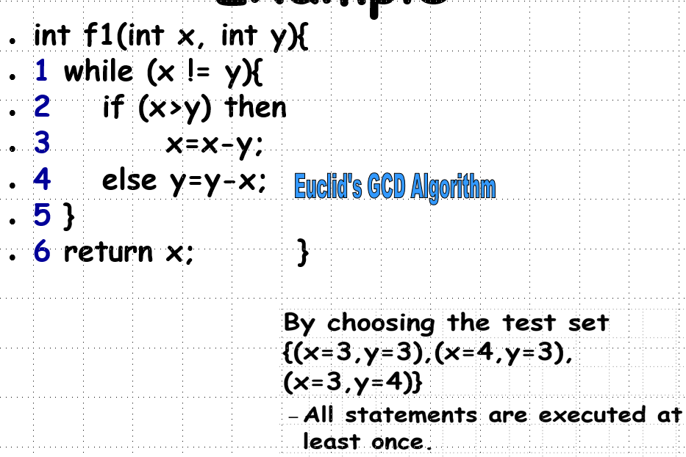
- Branch Coverage:
- A test suite satisfies branch coverage, if it makes each branch condition in the program to assume true and false values in turn.
- For branch coverage each branch in the CFG representation of the program must be taken at least once, when the test suite is executed.
- Branch testing is also known as edge testing, since in this testing scheme, each edge of a program’s control flow graph is traversed at least once.
- Test cases for branch coverage can be:
{(x=3,y=3),(x=3,y=2), (x=4,y=3), (x=3,y=4)}

- Multiple Condition Coverage:
- In the multiple condition (MC) coverage-based testing, test cases are designed to make each component of a composite conditional expression to assume both true and false values.
- For example, consider the composite conditional expression ((c1 .and.c2 ).or.c3). A test suite would achieve MC coverage, if all the component conditions c1, c2 and c3 are each made to assume both true and false values.
- Branch testing can be considered to be a simplistic condition testing strategy where only the compound conditions appearing in the different branch statements are made to assume the true and false values.
- It is easy to prove that condition testing is a stronger testing strategy than branch testing.
- Give an example of a fault that is detected by multiple condition coverage, but not by branch coverage.
Solution: Consider the following C program segment:
if(temperature>150 || temperature>50)
setWarningLightOn();
The program segment has a bug in the second component condition, it should have
been temperature<50. The test suite {temperature=160, temperature=40} achieves branch
coverage. But, it is not able to check that setWarningLightOn(); should not be called
for temperature values within 150 and 50.
- Path Coverage:
- A test suite achieves path coverage if it executes each linearly independent paths (or basis paths) at least once.
- A linearly independent path can be defined in terms of the control flow graph (CFG) of a program.
Control flow graph (CFG):
  - A control flow graph describes how the control flows through the program.
  - A control flow graph describes the sequence in which the different instructions of a program get executed.
  - We need to first number all the statements of a program.
  - A CFG is a directed graph consisting of a set of nodes and edges (N, E), such that each node n ∈ N corresponds to a unique program statement and an edge exists between two nodes if control can transfer from one node to the other.
  - We can easily draw the CFG for any program, if we know how to represent the sequence, selection, and iteration types of statements in the CFG.
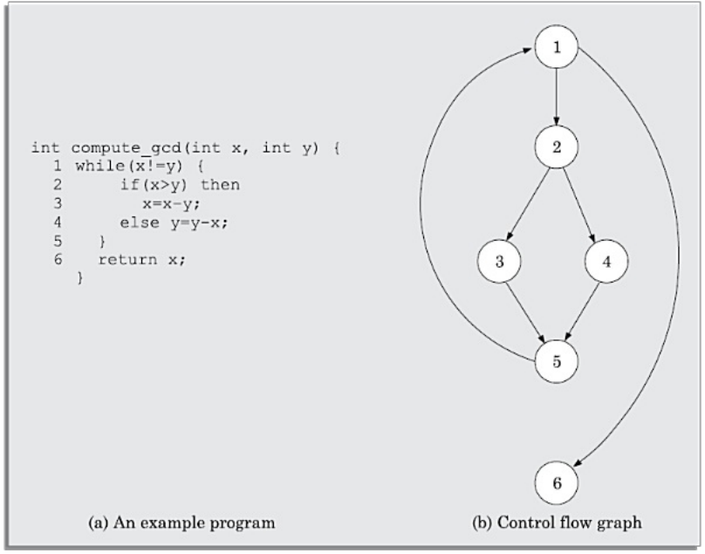
Control Flow Graph for an example program
Path:
  - A path through a program is any node and edge sequence from the start node to a terminal node of the control flow graph of a program.
  - Please note that a program can have more than one terminal node when it contains multiple exit or return types of statements.
  - Writing test cases to cover all paths of a typical program is impractical since there can be an infinite number of paths through a program in presence of loops.
  - Path coverage testing does not try to cover all paths, but only a subset of paths called linearly independent paths (or basis paths).
Linearly independent set of paths (or basis path set):
  - A set of paths for a given program is called a linearly independent set of paths (the basis set), if each path in the set introduces at least one new edge that is not included in any other path in the set.
  - If a set of paths is linearly independent of each other, then no path in the set can be obtained through any linear operations (i.e., additions or subtractions) on the other paths in the set.
McCabe’s Cyclomatic Complexity Metric:
- It is straightforward to identify the linearly independent paths for simple programs, for more complex programs it is not easy to determine the number of independent paths.
- McCabe’s cyclomatic complexity metric is an important result that lets us compute the number of linearly independent paths for any arbitrary program.
- McCabe’s cyclomatic complexity defines an upper bound for the number of linearly independent paths through a program.
  - Method 1:
Given a control flow graph G of a program, the cyclomatic complexity V(G) can be computed as:
V(G) = E – N + 2
where, N is the number of nodes of the control flow graph and E is the number of edges in the control flow graph.
For the CFG of example shown in above figure (GCD function),, E = 7 and N = 6. Therefore, the value of the Cyclomatic complexity = 7 – 6 + 2 = 3.
  - Method 2:
An alternate way of computing the cyclomatic complexity of a program is based on a visual inspection of the control flow graph.
In this method, the cyclomatic complexity V (G) for a graph G is given by the following expression:
V(G) = Total number of non-overlapping bounded areas + 1
Consider the CFG example shown in above figure (GCD function). From a visual examination of the CFG the number of bounded areas is 2. Therefore the cyclomatic complexity, computed with this method is also 2+1=3.
  - Method 3:
The cyclomatic complexity of a program can also be easily computed by computing the number of decision and loop statements of the program. If N is the number of decision and loop statements of a program, then the McCabe’s metric is equal to N + 1.
Steps to carry out path coverage-based testing:
The following is the sequence of steps that need to be undertaken for deriving the path coverage-based test cases for a program:
      - Draw control flow graph for the program.
      - Determine the McCabe’s metric V(G).
      - Determine the cyclomatic complexity. This gives the minimum number of test cases required to achieve path coverage.
      - Repeat
        - Test using a randomly designed set of test cases.
        - Perform dynamic analysis to check the path coverage achieved.
Until at least 90 percent path coverage is achieved.
- Number of independent paths: 3
  - 1,6 test case (x=1, y=1)
  - 1,2,3,5,1,6 test case(x=1, y=2)
  - 1,2,4,5,1,6 test case(x=2, y=1)

Fault-based Testing strategies:
Mutation Testing:
- Mutation testing is a fault-based testing technique in the sense that mutation test cases are designed to help detect specific types of faults in a program.
- In mutation testing, a program is first tested by using an initial test suite designed by using various white box testing strategies.
- After the initial testing is complete, mutation testing can be taken up.
- The idea behind mutation testing is to make a few arbitrary changes to a program at a time.
- Each time the program is changed, it is called a mutated program and the change effected is called a mutant.
- A mutation operator makes specific changes to a program.
- A mutant may or may not cause an error in the program.
- If a mutant does not introduce any error in the program, then the original program and the mutated program are called equivalent programs.
- A mutated program is tested against the original test suite of the program.
  - If there exists at least one test case in the test suite for which a mutated program yields an incorrect result, then the mutant is said to be dead, since the error introduced by the mutation operator has successfully been detected by the test suite.
  - If a mutant remains alive even after all the test cases have been exhausted, the test suite is enhanced to kill the mutant.
- Mutation testing involves generating a large number of mutants.
- Also each mutant needs to be tested with the full test suite.
- Obviously therefore, mutation testing is not suitable for manual testing.
- Several test tools are available that automatically generate mutants for a given program.

Debugging:
After a failure has been detected, it is necessary to first identify the program statement(s) that are in error and are responsible for the failure, the error can then be fixed.
Debugging Approaches:
The following are some of the approaches that are popularly adopted by the programmers for debugging:
- Brute force method:
- This is the most common method of debugging but is the least efficient method.
- In this approach, print statements are inserted throughout the program to print the intermediate values with the hope that some of the printed values will help to identify the statement in error.
- This approach becomes more systematic with the use of a symbolic debugger, because values of different variables can be easily checked and breakpoints and watchpoints can be easily set to test the values of variables effortlessly.
- Backtracking:
- This is also a fairly common approach. In this approach, starting from the statement at which an error symptom has been observed, the source code is traced backwards until the error is discovered.
- Cause elimination method:
- In this approach, once a failure is observed, the symptoms of the failure are noted.
- Based on the failure symptoms, the causes which could possibly have contributed to the symptom is developed and tests are conducted to eliminate each.
- Program slicing:
- This technique is similar to back tracking. In the backtracking approach, one often has to examine a large number of statements.
- However, the search space is reduced by defining slices.
- A slice of a program for a particular variable and at a particular statement is the set of source lines preceding this statement that can influence the value of that variable.

Integration Testing:
- Integration testing is carried out after all (or at least some of) the modules have been unit tested.
- Successful completion of unit testing, to a large extent, ensures that the unit (or module) as a whole works satisfactorily.
- In this context, the objective of integration testing is to detect the errors at the module interfaces (call parameters).
- The objective of integration testing is to check whether the different modules of a program interface with each other properly.
- During integration testing, different modules of a system are integrated in a planned manner using an integration plan.
- The integration plan specifies the steps and the order in which modules are combined to realise the full system.
- After each integration step, the partially integrated system is tested.
- By examining the structure chart, the integration plan can be developed.
- Any one (or a mixture) of the following approaches can be used to develop the test plan:
- Big-bang approach to integration testing:
- Big-bang testing is the most obvious approach to integration testing. In this approach, all the modules making up a system are integrated in a single step.
- In simple words, all the unit tested modules of the system are simply linked together and tested.
- However, this technique can meaningfully be used only for very small systems.
- The main problem with this approach is that once a failure has been detected during integration testing, it is very difficult to localise the error as the error may potentially lie in any of the modules.
- Bottom-up approach to integration testing:
- Large software products are often made up of several subsystems.
- A subsystem might consist of many modules which communicate among each other through well-defined interfaces.
- In bottom-up integration testing, first the modules for each subsystem are integrated.
- Thus, the subsystems can be integrated separately and independently.
- The primary purpose of carrying out the integration testing of a subsystem is to test whether the interfaces among various modules making up the subsystem work satisfactorily.
- In a pure bottom-up testing no stubs are required, and only test-drivers are required.
- Top-down approach to integration testing:
- Top-down integration testing starts with the root module in the structure chart and one or two subordinate modules of the root module.
- After the top-level ‘skeleton’ has been tested, the modules that are at the immediately lower layer of the ‘skeleton’ are combined with it and tested.
- Top-down integration testing approach requires the use of program stubs to simulate the effect of lower-level routines that are called by the routines under test.
- A pure top-down integration does not require any driver routines.
- Mixed approach to integration testing:
- The mixed (also called sandwiched) integration testing follows a combination of top-down and bottom-up testing approaches.
- In a top-down approach, testing can start only after the top-level modules have been coded and unit tested.
- Similarly, bottom-up testing can start only after the bottom level modules are ready.
- The mixed approach overcomes this shortcoming of the top-down and bottom-up approaches.
- In the mixed testing approach, testing can start as and when modules become available after unit testing.
- Therefore, this is one of the most commonly used integration testing approaches.
- In this approach, both stubs and drivers are required to be designed.
Phased vs Incremental Integration Testing

Big-bang integration testing usually implies single step integration. In contrast, in the
other strategies, integration is carried out over a number of steps. In multi-step integration
strategies, modules are integrated either in a phased or incremental manner. A comparison
of these two strategies is as follows:
 In incremental integration testing, only one new module is added to the partially
integrated system in each step of integration.
 In phased integration, a group of related modules are added to the partial system
in each step of integration.

Testing Object Oriented Programs:

- Thus, in an object oriented program, unit testing would mean testing each object in isolation.
- During integration testing (called cluster testing in the object-oriented testing literature) various unit tested objects are integrated and tested.
- Finally, system-level testing is carried out.
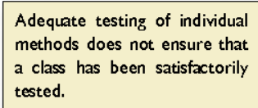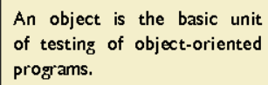

Why are Traditional Techniques Considered Not Satisfactory
for Testing Object-oriented Programs?
- Various object-oriented features (inheritance, polymorphism, dynamic binding, statebased behaviour, etc.) require special test cases to be designed compared to the traditional testing
- The various object-orientation features are explicit in the design models, and it is usually diﬃcult to extract from and analysis of the source code.
- As a result, the design model is a valuable artifact for designing test cases for object oriented programs.
- Therefore, this approach is considered to be intermediate between a fully white-box and a fully black-box approach, and is called a grey-box approach.
Grey Box Testing of Object Oriented Programs:
- The following are some important types of grey-box testing that can be carried on based on UML
State model-based testing
- State coverage: Each method of an object are tested at each state of the object.
- State transition coverage: It is tested whether all transitions depicted in the state model work satisfactorily.
- State transition path coverage: All transition paths in the state model are tested.
- Use case-based testing
- Scenario coverage: Each use case typically consists of a mainline scenario and several alternate scenarios. For each use case, the mainline and all alternate sequences are tested to check if any errors show up.
Class diagram-based testing
- Testing derived classes: All derived classes of a base class have to be instantiated and tested. In addition to testing the new methods defined in the derived class, the inherited methods must be retested.
- Association testing: All association relations are tested.
- Aggregation testing: Various aggregate objects are created and tested.
Sequence diagram-based testing
- Method coverage: All methods depicted in the sequence diagrams are covered.
- Message path coverage: All message paths that can be constructed from the sequence diagrams are covered. Each sequence diagram represents the message passing among objects that occurs for each use case. Each use case consists of a set of scenarios, and a message path represents the message exchanges that occur among concerned objects during execution of a scenario
Integration Testing of Object-oriented Programs
Thread Based approach: In this approach, all classes that need to collaborate to realise
- the behaviour of a single use case are integrated and tested. After all the required classes
- for a use case are integrated and tested, another use case is taken up and other classes (if any) necessary for execution of the second use case to run are integrated and tested. Thisis continued till all use cases have been considered.

Use-based approach: Use-based integration begins by testing classes that either do not
- Need any service from other classes or need services from at most a few other classes.
- already integrated classes are integrated and tested.
- After these classes have been integrated and tested, classes that use the services from theThis is continued till all the classes have been integrated and tested.

System Testing
- After all the units of a program have been integrated together and tested, system testing is taken up.
- System tests are designed to validate a fully developed system to assure that it meets its requirements.
- The test cases are therefore designed solely based on the SRS document.
- There are essentially three main kinds of system testing depending on who carries out testing:
- Alpha Testing: Alpha testing refers to the system testing carried out by the test team within the developing organisation.
- Beta Testing: Beta testing is the system testing performed by a select group of friendly customers.
- Acceptance Testing: Acceptance testing is the system testing performed by the customer to determine whether to accept the delivery of the system.
- In each of the above types of system tests, the test cases can be the same, but the difference is with respect to who designs test cases and carries out testing.
- The system test cases can be classified into functionality and performance test cases.
- Before a fully integrated system is accepted for system testing, smoke testing is performed.
Smoke Testing
- Smoke testing is carried out before initiating system testing to ensure that system testing would be meaningful, or whether many parts of the software would fail.
- The idea behind smoke testing is that if the integrated program cannot pass even the basic tests, it is not ready for vigorous testing.
- For smoke testing, a few test cases are designed to check whether the basic functionalities are working.
- The system test cases can be classified into functionality and performance test cases.
Performance Testing:
- Performance testing is an important type of system testing.
- Performance testing is carried out to check whether the system meets the nonfunctional requirements identified in the SRS document.
- There are several types of performance testing corresponding to various types of non-functional requirements.
- All performance tests can be considered as black-box tests.
- Stress testing:
- Stress testing is also known as endurance testing.
- Stress testing evaluates system performance when it is stressed for short periods of time.
- Stress tests are black-box tests which are designed to impose a range of abnormal and even illegal input conditions so as to stress the capabilities of the software.
- Input data volume, input data rate, processing time, utilisation of memory, etc., are tested beyond the designed capacity.
- Stress testing is especially important for systems that under normal circumstances operate below their maximum capacity but may be severely stressed at some peak demand hours.
- Volume testing:
- Volume testing checks whether the data structures (buffers, arrays, queues, stacks, etc.) have been designed to successfully handle extraordinary situations.
- Configuration testing:
- Configuration testing is used to test system behaviour in various hardware and software configurations specified in the requirements.
- Sometimes systems are built to work in different configurations for different users.
- Compatibility testing ;
- This type of testing is required when the system interfaces with external systems (e.g., databases, servers, etc.).
- Compatibility aims to check whether the interfaces with the external systems are performing as required.
- Regression testing:
- This type of testing is required when a software is maintained to fix some bugs or enhance functionality, performance
- Recovery testing:
- Recovery testing tests the response of the system to the presence of faults, or loss of power, devices, services, data, etc.
- The system is subjected to the loss of the mentioned resources (as discussed in the SRS document) and it is checked if the system recovers satisfactorily.
- Maintenance testing:
- This addresses testing the diagnostic programs, and other procedures that are required to help maintenance of the system.
- It is verified that the artifacts exist and they perform properly.
- Security testing:
- Security testing is essential for software that handle or process confidential data that is to be guarded against pilfering.
- It needs to be tested whether the system is fool-proof from security attacks such as intrusion by hackers.

Software Reliability and Quality Management:

Software Reliability:
- The reliability of a software product essentially denotes its trustworthiness or dependability.
- Alternatively, the reliability of a software product can also be defined as the probability of the product working “correctly” over a given period of time.
- It is obvious that a software product having a large number of defects is unreliable.
- It is also very reasonable to assume that the reliability of a system improves, as the number of defects in it is reduced.
- It is very difficult to characterize the observed reliability of a system in terms of the number of latent defects in the system using a simple mathematical expression.
  - It has been experimentally observed by analyzing the behavior of a large number of programs that 90 per cent of the execution time of a typical program is spent in executing only 10 percent of the instructions in the program.
  - The most used 10 per cent instructions are often called the core 1 of a program.
  - The rest 90 per cent of the program statements are called non-core and are on the average executed only for 10 per cent of the total execution time.
  - It therefore may not be very surprising to note that removing 60 per cent product defects from the least used parts of a system would typically result in only 3 per cent improvement to the product reliability.
- The quantity by which the overall reliability of a program improves due to the correction of a single error depends on how frequently the instruction having the error is executed.
- The quantity by which the overall reliability of a program improves due to the correction of a single error depends on how frequently the instruction having the error is executed.
- Apart from this, reliability also depends upon how the product is used, or on its execution profile.
- If the users execute only those features of a program that are “correctly” implemented, none of the errors will be exposed and the perceived reliability of the product will be high.
- On the other hand, if only those functions of the software which contain errors are invoked, then a large number of failures will be observed and the perceived reliability of the system will be very low.
- Different categories of users of a software product typically execute different functions of a software product.
- We can summarize the main reasons that make software reliability more difficult to measure than hardware reliability:
  - The reliability improvement due to fixing a single bug depends on where the bug is located in the code.
  - The perceived reliability of a software product is observer-dependent.
  - The reliability of a product keeps changing as errors are detected and fixed.
Hardware Reliability vs Software Reliability:
- An important characteristic feature that sets hardware and software reliability issues apart is the difference between their failure patterns.
- Hardware components fail due to very different reasons as compared to software components.
- Hardware components fail mostly due to wear and tear, whereas software components fail due to bugs.
- To fix a hardware fault, one has to either replace or repair the failed part. In contrast, a software product would continue to fail until the error is tracked down and either the design or the code is changed to fix the bug.
- hardware reliability study is concerned with stability
- The aim of software reliability study would be reliability growth.
- A comparison of the changes in failure rate over the product lifetime for a typical hardware product as well as a software product are sketched in the following figure.
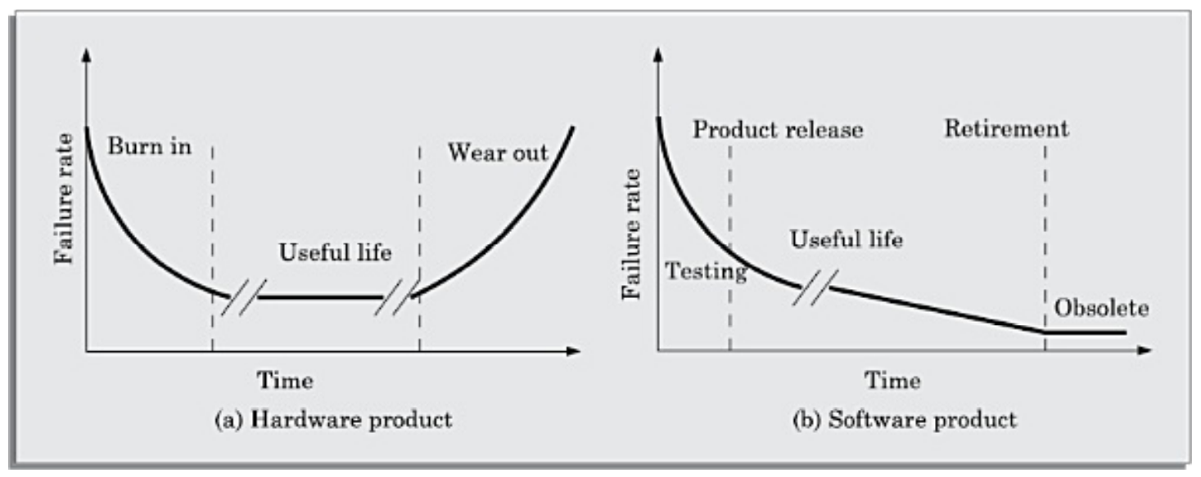
Change in failure rate of a product
Reliability Metrics for Software Products:
- The reliability requirements for different categories of software products may be different
- it is necessary that the level of reliability required for a software product should be specified in the software requirements specification (SRS) document.
- We need some metrics to quantitatively express the reliability of a software product.
- A good reliability measure should be observer-independent. We discuss six metrics that correlate with reliability as follows.
- Rate of occurrence of failure (ROCOF):
- ROCOF measures the frequency of occurrence of failures. ROCOF measure of a software product can be obtained by observing the behavior of a software product in operation over a specified time interval and then calculating the ROCOF value as the ratio of the total number of failures observed and the duration of observation.
- Mean time to failure (MTTF):
- MTTF is the time between two successive failures, averaged over a large number of failures.
- To measure MTTF, we can record the failure data for n failures.
- It is important to note that only run time is considered in the time measurements.
- Mean time to repair (MTTR):
- Once failure occurs, some time is required to fix the error.
- MTTR measures the average time it takes to track the errors causing the failure and to fix them.
- Mean time between failure (MTBF):
- The MTTF and MTTR metrics can be combined to get the MTBF metric: MTBF=MTTF+MTTR.
- Thus, MTBF of 300 hours indicates that once a failure occurs, the next failure is expected after 300 hours.
- Probability of failure on demand (POFOD):
- Unlike the other metrics discussed, this metric does not explicitly involve time measurements.
- POFOD measures the likelihood of the system failing when a service request is made.
- For example, a POFOD of 0.001 would mean that 1 out of every 1000 service requests would result in a failure.
- POFOD metric is very appropriate for software products that are not required to run continuously.
- Availability:
- Availability of a system is a measure of how likely would the system be available for use over a given period of time.
- This metric not only considers the number of failures occurring during a time interval, but also takes into account the repair time (down time) of a system when a failure occurs.
Shortcomings of reliability metrics of software products:
- All the above reliability metrics suffer from several shortcomings.
- One of the reasons is that these metrics are centered around the probability of occurrence of system failures but take no account of the consequences of failures.
- These reliability models do not distinguish the relative severity of different failures.
- In order to estimate the reliability of a software product more accurately, it is necessary to classify various types of failures.
- Please note that the different classes of failures may not be mutually exclusive.
- A scheme of classification of failures is as follows:
  - Transient: Transient failures occur only for certain input values while invoking a function of the system.
  - Permanent: Permanent failures occur for all input values while invoking a function of the system.
  - Recoverable: When a recoverable failure occurs, the system can recover without having to shutdown and restart the system (with or without operator intervention).
  - Unrecoverable: In unrecoverable failures, the system may need to be restarted.
  - Cosmetic: These classes of failures cause only minor irritations, and do not lead to incorrect results. An example of a cosmetic failure is the situation where the mouse button has to be clicked twice instead of once to invoke a given function through the graphical user interface.

Statistical testing:
- Statistical testing is a testing process whose objective is to determine the reliability of the product rather than discovering errors.
- The test cases are designed for statistical testing with an entirely different objective from those of conventional testing.
- To carry out statistical testing, we need to first define the operation profile of the product.
- Operation profile:
  - Different categories of users may use a software product for very different purposes.
  - We can define the operation profile of a software as the probability of a user selecting the different functionalities of the software.
  - If we denote the set of various functionalities offered by the software by {f_{i}}, the operational profile would associate each function {f_{i}} with the probability with which an average user would select {f_{i}} as his next function to use.
  - Thus, we can think of the operation profile as assigning a probability value p_{i} to each functionality f_{i} of the software.
Steps in statistical testing:
- The first step is to determine the operation profile of the software.
- The next step is to generate a set of test data corresponding to the determined operation profile.
- The third step is to apply the test cases to the software and record the time between each failure.
- After a statistically significant number of failures have been observed, the reliability can be computed.
- For accurate results, statistical testing requires some fundamental assumptions to be satisfied.
  - It requires a statistically significant number of test cases to be used.
  - It further requires that a small percentage of test inputs that are likely to cause system failure to be included.
- Now let us discuss the implications of these assumptions.
  - It is straightforward to generate test cases for the common types of inputs, since one can easily write a test case generator program which can automatically generate these test cases.
  - However, it is also required that a statistically significant percentage of the unlikely inputs should also be included in the test suite.
  - Creating these unlikely inputs using a test case generator is very difficult.
Software Quality
- Traditionally, the quality of a product is defined in terms of its fitness of purpose.
- A good quality product does exactly what the users want it to do, since for almost every product, fitness of purpose is interpreted in terms of satisfaction of the requirements laid down in the SRS document.
- “Fitness of purpose” is not a wholly satisfactory definition of quality for software products.
  - Even though it may be functionally correct, we cannot consider it to be a quality product, if it has an almost unusable user interface.
- The modern view of a quality associates with a software product several quality factors (or attributes) such as the following:
  - Portability: A software product is said to be portable, if it can be easily made to work in different hardware and operating system environments, and easily interface with external hardware devices and software products.
  - Usability: A software product has good usability, if different categories of users (i.e., both expert and novice users) can easily invoke the functions of the product.
  - Reusability: A software product has good reusability, if different modules of the product can easily be reused to develop new products.
  - Correctness: A software product is correct, if different requirements as specified in the SRS document have been correctly implemented.
  - Maintainability: A software product is maintainable, if errors can be easily corrected as and when they show up, new functions can be easily added to the product, and the functionalities of the product can be easily modified, etc.
Software Quality Models:
Gravin’s Quality Dimension:
  - David Garvin, a professor of Havard Business School, in his book Total Quality Management, defined the quality of any product in terms eight general attributes of the product, some of these are measurable and some are not.
  - Garvin reasoned that sometimes users have subjective judgment of the quality of a program (perceived quality) that must be taken into account to judge its quality.
  -  Performance: How well it performs the jobs
  -  Features: How well it supports the required features
  -  Reliability: Probability of a product working satisfactorily within a specific period of time
  -  Conformance: Degree to which the product meets the requirements
  -  Durability: Measure of product life
  -  Serviceability: Speed and effectiveness maintenance
  -  Aesthetics: The look and feel of the product
  -  Perceived quality: User’s opinion about the product quality

McCall’s quality factors:
- These are then given in terms of 23 quality criteria that describe the internal view of the software or as seen by the developers.
- The quality factors cannot be measured directly, but can be measured only indirectly through the quality criteria (internal view). The quality criteria can be measured directly. In the following, we briefly describe the eleven quality factors:
- Correctness: The extent to which a software product satisfies its specifications
- Reliability: The probability of the software product working satisfactorily over a given duration
- Efficiency: The amount of computing resources required to perform the required functions
- Integrity: The extent to which the data of the software product remains valid
- Usability: The effort required to operate the software product
- Maintainability: The ease with which it is possible to locate and fix bugs in the software product
- Flexibility: The effort required to adapt the software product to changing requirements
- Testability: The effort required to test a software product to ensure that it performs its intended function
- Portability: The effort required to transfer the software product from one hardware or software system environment to another
- Reusability: The extent to which a software can be reused in other applications
- Interoperability: The effort required to integrate the software with other software
Dromey’s Model:
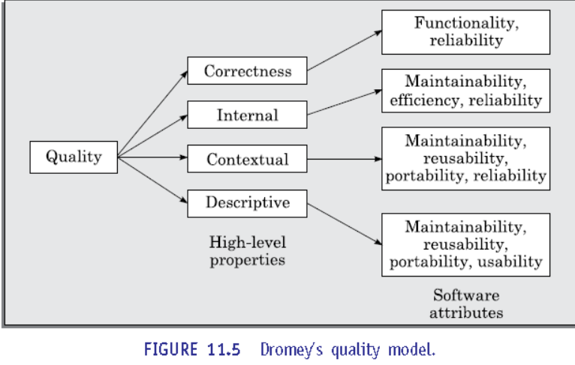
Boehm Model:
Boehm postulated that the quality of a software could be defined based on three highlevel characteristics that are important for the users of the software. These three high-level characteristics are as follows:
As-is utility: How well (easily, reliably, efficiently) can it be used
Maintainability: How easy is it to understand, modify and then retest the software
Portability: How difficult would it be to make the software in a changed environment

Software Quality Management System:
- A quality management system (often referred to as quality system) is the principal methodology used by organizations to ensure that the products they develop have the desired quality.
- A quality system is the responsibility of the organization as a whole.
- However, every organization has a separate quality department to perform several quality system activities.
- The quality system of an organization should have the full support of the top management.
- Without support for the quality system at a high level in a company, few members of staff will take the quality system seriously.
Quality System Activities:
- The quality system activities encompass the following:
  - Auditing of projects to check if the processes are being followed.
  - Collect process and product metrics and analyze them to check if quality goals are being met.
  - Review of the quality system to make it more effective.
  - Development of standards, procedures, and guidelines.
  - Produce reports for the top management summarizing the effectiveness of the quality system in the organization.
- A good quality system must be well documented.
- Without a properly documented quality system, the application of quality controls and procedures become ad hoc, resulting in large variations in the quality of the products delivered.
- ISO 9000 provides guidance on how to organize a quality system.
Evolution of Quality Systems:
- Quality systems have rapidly evolved over the last six decades.
- Prior to World War II, the usual method to produce quality products was to inspect the finished products to eliminate defective products.
  - For example, a company manufacturing nuts and bolts would inspect its finished goods and would reject those nuts and bolts that are outside a certain specified tolerance range.
- Since that time, quality systems of organizations have undergone four stages of evolution as shown in figure.
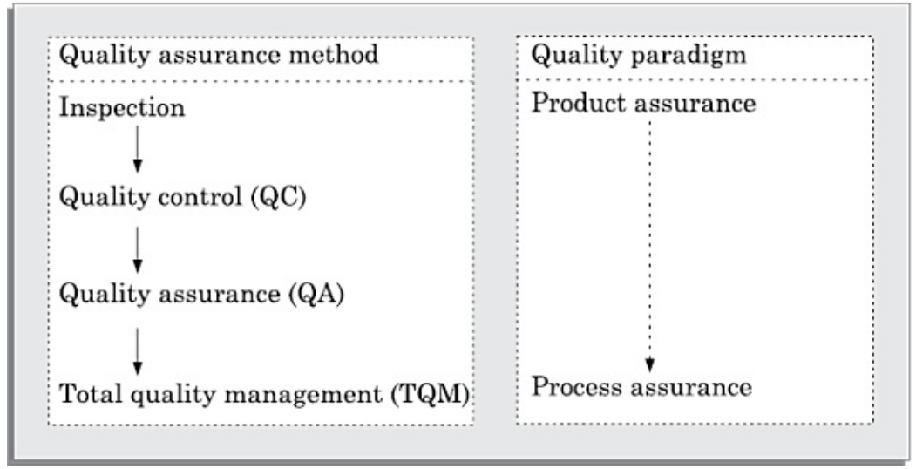
- The initial product inspection method gave way to quality control (QC) principles.
  - Quality control (QC) focuses not only on detecting the defective products and eliminating them, but also on determining the causes behind the defects, so that the product rejection rate can be reduced.
- The next breakthrough in quality systems was the development of the quality assurance (QA) principles.
  - The basic premise of modern quality assurance is that if an organization’s processes are good and are followed rigorously, then the products are bound to be of good quality.
- The modern quality assurance paradigm includes guidance for recognising, defining, analyzing, and improving the production process.
  - Total quality management (TQM) advocates that the process followed by an organization must continuously be improved through process measurements.
  - TQM goes a step further than quality assurance and aims at continuous process improvement.
  - TQM goes beyond documenting processes to optimize them through redesign.
Product metrics vs Process metrics:
- All modern quality systems lay emphasis on collection of certain product and process metrics during product development.
- Product metrics help measure the characteristics of a product being developed, whereas process metrics help measure how a process is performing.
- Examples of product metrics are LOC and function point to measure size, PM (person- month) to measure the effort required to develop it, months to measure the time required to develop the product, time complexity of the algorithms, etc.
- Examples of process metrics are review effectiveness, average number of defects found per hour of inspection, average defect correction time, productivity, average number of failures detected during testing per LOC, number of latent defects per line of code in the developed product.
ISO 9000

- ISO (international Standards Organization):
- a consortium of 63 countries established to formulate and foster standardization.
- ISO published its 9000 series of standards in 1987.
What is ISO 9000 Certification?
- ISO 9000 certification:
- Serves as a reference for contract between independent parties.
- The ISO 9000 standard:
- Specifies guidelines for maintaining a quality system.
ISO 9000 specifies:
- Guidelines for repeatable and high quality product development.
- Also addresses organizational aspects
- Responsibilities, reporting, procedures, processes, and resources for implementing quality management.
Several benefits:
- Confidence of customers in an organization increases.

ISO 9000 for Software Industry,
- A set of guidelines for the production process.
- Not directly concerned about the product it self.
- A series of three standards:
ISO 9001:
Applies to:
- Organizations engaged in design, development, production, and servicing of goods.
- Applicable to most software development organizations.
ISO 9002:
- This standard applies to those organisations which do not design products but are only involved in production.
- Examples of this category of industries include steel and car manufacturing industries who buy the product and plant designs from external sources and are involved in only manufacturing those products.
- Therefore, ISO 9002 is not applicable to software development organisations
ISO 9003:
- This standard applies to organizations involved only in installation and testing of products.

ISO 9000 is a generic standard that is applicable to a large gamut of industries, starting from a steel manufacturing industry to a service rendering company.
- Therefore, many of the clauses of the ISO 9000 documents are written using generic terminologies and it is very diﬃcult to interpret them in the context of software development organisations.
- An important reason behind such a situation is the fact that software development is in many respects radically different from the development of other types of product manufacturing
- Software is intangible, making it difficult to control and manage since it remains invisible until fully developed and running. In contrast, physical product manufacturing, like car production, allows for visible progress tracking, making it easier to estimate work completed and remaining time.
- Software development primarily consumes data as its raw material, unlike other industries that require large quantities of physical materials. Consequently, many ISO 9000 clauses on raw material control are irrelevant to software development organizations.
- Due to such radical differences between software and other types of product development, it was diﬃcult to interpret various clauses of the original ISO standardin the context of software industry. Therefore, ISO released a separate document called ISO 9000 part-3 in 1991 to help interpret the ISO standard for software industry. At present,
- oﬃcial guidance is inadequate regarding the interpretation of various clauses of ISO 9000 standard in the context of software industry and one has to keep on cross referencing the ISO 9000-3 document

SEI Capability maturity model-
- SEI capability maturity model (SEI CMM) was proposed by Software Engineering Institute of the Carnegie Mellon University, USA. CMM is patterned after the pioneering work of Philip Crosby who published his maturity grid of five evolutionary stages in adopting quality practices in his book “Quality is Free”
- The different levels of SEI CMM have been designed so that it is easy for an organization to slowly build its quality system starting from scratch. SEI CMM classifies software development industries into the following five maturity levels:
- Level 1: Initial:
- The initial level, also called the chaotic level, is characterized by ad hoc activities, a lack of defined processes, reliance on individual efforts, poor project management, and rushed development, leading to low-quality software.
- Level 2: Repeatable:
- A repeatable software development organization has basic process discipline, configuration management, and estimation techniques, but success relies on informal understanding rather than documentation, whereas non-repeatable organizations depend heavily on individual effort, making future success uncertain.
- Level 3: Defined:
- At this level, management and development processes are well-defined and documented, with organization-wide understanding, employee training, and review techniques, but process and product quality are not measured.
- Level 4 : Managed:
- At this level, software and process metrics are collected, quantitative quality goals are set and checked, and tools like Pareto charts and fishbone diagrams are used to assess project performance rather than improve processes.
- Level 5: Optimizing:
- At this level, process and product metrics are analyzed for continuous improvement, incorporating feedback and innovations organization-wide, with a focus on refining processes, adopting best practices, and managing changes through configuration management.
Comparison between ISO 9000 certification and SEI/CMM.
- ISO 9000 is awarded by an international standards body. Therefore, ISO 9000 certification can be quoted by an organisation in oﬃcial documents, communicationwith external parties, and in tender quotations. However, SEI CMM assessment is purely for internal use.
- SEI CMM was developed specifically for software industry and therefore addresses many issues which are specific to software industry alone.
- SEI CMM goes beyond quality assurance and prepares an organisation to ultimately achieve TQM. In fact, ISO 9001 aims at level 3 of SEI CMM model.
- SEI CMM model provides a list of key process areas (KPAs) on which an organization at any maturity level needs to concentrate to take it from one maturity level to the next. Thus, it provides a way for achieving gradual quality improvement. In contrast, an organisation adopting ISO 9000 either qualifies for it or does not qualify.

