P.V.P SIDDHARTHA INSTITUTE OF TECHNOLOGY
BRANCH : CSE |  |  | REGULATION : PVP23
Course: B.Tech | SUBJECT: DATA WAREHOUSING AND DATA MINING
Subject Code:23CS3501 |  | Year and Semester: III Year / I Semester
QUESTION BANK

UNIT I

Q.  NO | PART A | CO | LEVEL
1 | Define Data Mining. | 1 | L1
2 | What is a data warehouse? | 1 | L1
3 | List any two differences between OLTP and OLAP. | 1 | L1
4 | What are the types of data that can be mined? | 1 | L1
5 | Define an attribute and give an example. | 1 | L1
6 | What is the purpose of data cleaning? | 1 | L1
7 | What is meant by data discretization? | 1 | L1
8 | Define a data cube. | 1 | L1
9 | List any two real-life applications of data mining. | 1 | L1
10 | What is data reduction? | 1 | L1
 | PART B
11 | Classify and describe different types of data that can be mined in data mining. | 1 | L3
12 | Normalize the following group of data by using the following techniques.  200, 300, 400, 600, 1000  - min-max normalization technique  - z-score normalization  - Decimal scaling.  - Write your observations on the above techniques. | 1 | L3
13 | In what way various data mining functionalities are applied to solve real-world problems | 1 | L3
14 | Identify and discuss the challenges and issues in data mining | 1 | L3
15 | Illustrate the multi-tiered architecture of data warehouse with a neat diagram. | 1 | L3
16 | Illustrate OLAP operations by applying examples for roll-up, drill-down, slice, dice, and pivot. | 1 | L3
17 | How to make use of statistical measures to measure central tendency of data. | 1 | L3
18 | Suppose that the data for analysis includes the attribute age. The age values for the data tuples are (in increasing order):  13, 15, 16, 16, 19, 20, 23, 29, 35, 41, 44, 53, 62, 69, 72  (i) Use min-max normalization to transform the value of 45 for age onto the range [0,1]  (ii) Use Z-Score normalization to transform the value 45 for age where the standard deviation of age is 20.64 years. | 1 | L3
19 | With a neat sketch illustrate KDD (Knowledge Discovery in Databases) process. | 1 | L3
20 | How data reduction techniques are utilized in dimensionality reduction. | 1 | L3

UNIT II

Q.NO | PART A | CO | LEVEL
1 | Define Machine Learning. | 1 | L1
2 | List two real-world applications of Machine Learning. | 1 | L2
3 | What are the main paradigms of machine learning? | 1 | L1
4 | Mention any two stages in a typical Machine Learning process. | 1 | L1
5 | List any 2 datasets used in machine learning? | 1 | L1
6 | Define proximity measure in machine learning. | 1 | L1
7 | What is Euclidean distance? | 1 | L2
8 | Give one difference between KNN and Weighted KNN. | 1 | L2
9 | Define KNN Regression. | 1 | L1
10 | List any two performance evaluation metrics for classification. | 1 | L2
 | PART B
11 | Compare and Contrast Machine Learning from traditional programming to modern approaches. | 2 | L3
12 | Distinguish paradigms of machine learning with examples. | 2 | L3
13 | Illustrate the stages of machine learning process with a neat diagram? | 2 | L3
14 | Describe different types of datasets used for classification and Regression. | 2 | L2
15 | How machine learning is utilized in real-world applications. | 2 | L3
16 | Identify the evaluation measures used for classification and Regression. | 2 | L3
17 | Illustrate K-Nearest Neighbors (KNN) algorithm with an example | 2 | L3
18 | Apply K-nearest neighbor classifier to predict if a patient is diabetic using the features: BMI and Age. Assume K = 3. Test Example:  BMI = 43.6, Age = 40,Sugar = ? Training examples are given in the table above. | 4 | L4
  BMI | Age | Sugar
  33.6 | 50 | 1
  26.6 | 30 | 0
  23.4 | 40 | 0
  43.1 | 67 | 0
  35.3 | 23 | 1
  35.9 | 67 | 1
  36.7 | 45 | 1
  25.7 | 46 | 0
  23.3 | 29 | 0
  31.0 | 56 | 1
19 | Compare and contrast standard KNN with Weighted KNN. | 2 | L3
20 | Apply K-Nearest Neighbors(KNN) algorithm with Euclidean Distance to predict the Fruit Type of Strawberry (Sweetness = 5, Sourness = 5). Analyse the outputs when K=1,3,5. | 4 | L4
  Fruit | Sweetness | Sourness | Fruit Type
  Lemon | 1 | 9 | Sour
  Grapefruit | 2 | 8 | Sour
  Orange | 3 | 7 | Sour
  Cherry | 6 | 4 | Sweet
  Banana | 9 | 1 | Sweet
  Grapes | 8 | 2 | Sweet
  Strawberry | 5 | 5 | ?

UNIT III

Q. NO. | PART A | CO | LEVEL
1 | Define classification in the context of machine learning. | 1 | L1
2 | What is a decision tree? | 1 | L1
3 | Mention any two attribute selection measures used in decision trees. | 1 | L2
4 | What is overfitting in classification? | 1 | L2
5 | Define entropy. | 1 | L2
6 | What is pruning in decision trees? | 1 | L1
7 | State Bayes Theorem. | 1 | L1
8 | What is Naïve Bayes classifier? | 1 | L1
9 | Define information gain | 1 | L2
10 | List any two methods to improve classification accuracy. | 1 | L2
 | PART B
11 | Construct a decision tree using ID3 algorithm for the following example and Classify to predict which patients are high risk for heart disease.  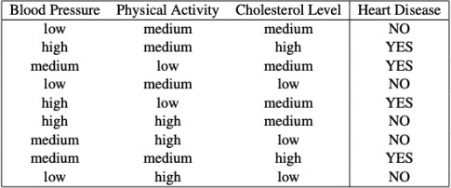 | 3 | L4
12 | Construct a decision tree using ID3 algorithm for the following example and Classify whether the person gets the Job offer or Not.  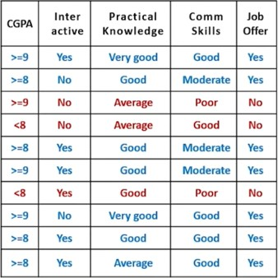 | 3 | L4
13 | Apply Naïve Bayes Algorithm for the below data and analyze whether the person has flu or not for the below sample?  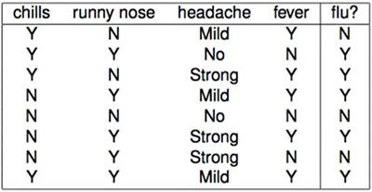  Data Sample: X= (Chills=’Y’, Runny Nose=’N’, Headache=’No’, Fever=’Y’, Flu=?) | 4 | L4
14 | Analyze the given data and apply Naïve Bayes Algorithm for the given sample and predict if an accident will happen or Not?  {Weather Condition -Rain, Road Condition =Good, Traffic Condition = Normal, Engine Problem= No, Accident=?}  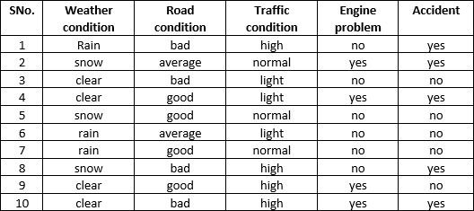 | 4 | L4
15 | Write the Naïve Bayes Algorithm and then solve the below problem. Consider the given dataset and apply Naïve Bayes algorithm to predict that if a fruit has the following properties, then which type of fruit it is? Fruit = {Yellow, Sweet, Long} | 4 | L4
  Fruit | Yellow | Sweet | Long | Total
  Mango | 350 | 450 | 0 | 650
  Banana | 400 | 300 | 350 | 400
  Others | 50 | 100 | 50 | 150
  Total | 800 | 850 | 400 | 1200
16 | Illustrate different attribute selection measures in decision trees with an example? | 2 | L3
17 | Compare and Contrast Bagging and Boosting | 2 | L3
18 | How tree pruning contributes in improving the effectiveness of a decision tree during its construction. | 2 | L3
19 | Compare and contrast Naïve Bayes and Decision Tree classifiers. | 2 | L3
20 | Illustrate the techniques used to improve classification accuracy. | 2 | L3

UNIT IV

Q. NO. | PART A | CO | LEVEL
1 | What is a linear discriminant? | 1 | L1
2 | Define perceptron learning rule. | 1 | L1
3 | What is the role of the activation function in a perceptron? | 1 | L2
4 | Mention one difference between logistic regression and linear regression. | 1 | L2
5 | What is a support vector machine (SVM)? | 1 | L1
6 | Define the margin in the context of SVM. | 1 | L1
7 | What is a linearly non-separable case in classification? | 1 | L2
8 | How kernel is used in non-linear SVMs? | 1 | L2
9 | Define Logistic regression. | 1 | L1
10 | List two applications for linear regression. | 1 | L1
 | PART B
11 | Analyze the given data and Apply Support Vector Machine  to plot hyper plane of the following data point on linearly  separable data: (1,1) (2,1) (1,-1) (2, -1) (4, 0) (5, 1) (5, -1) (6, 0) | 4 | L4
12 | Illustrate the perceptron learning algorithm with an example. | 2 | L3
13 | Analyze the given data and Apply Support Vector Machine  to plot hyper plane of the following data point on linearly  separable data: (2,2), (−2,2), (−2,−2), (2,−2)as positively labelled points (1,1), (1,−1), (−1,−1), (−1,1) as negatively labelled points. | 4 | L4
14 | In what way SVM works in the linearly separable case with an example. | 2 | L3
15 | Illustrate the concept of non-linear SVM and how the kernel trick is used. | 2 | L3
16 | Compare and contrast linear SVM and non-linear SVM with examples. | 2 | L3
17 | Compare and Contrast logistic regression and linear regression with examples. | 2 | L3
18 | Illustrate the concept of logistic regression model with its sigmoid function. | 2 | L3
19 | How linear regression is used for prediction with an example. | 2 | L3
20 | Apply logistic regression to demonstrate binary classification. | 2 | L3

UNIT V

Q. NO. | PART A | CO | LEVEL
1 | What is clustering in data mining? | 1 | L1
2 | Define partitional clustering. | 1 | L1
3 | What is the basic idea of agglomerative clustering? | 1 | L1
4 | List two differences between hierarchical and partitional clustering. | 1 | L2
5 | Define centroid in K-Means clustering. | 1 | L1
6 | What is soft clustering? | 1 | L2
7 | What is the main difference between K-Means and Fuzzy C-Means clustering? | 1 | L2
8 | What is the goal of Expectation Maximization (EM) clustering? | 1 | L2
9 | Define intra-cluster and inter-cluster similarity. | 1 | L2
10 | State one limitation of K-Means clustering. | 1 | L2
 | PART B
11 | Compute the Hierarchical Clustering on the below data and represent the output in a dendrogram | 4 | L3
   | A | B | C | d | e | f
  a | 0
  b | 0.12 | 0
  c | 0.51 | 0.25 | 0
  d | 0.84 | 0.16 | 0.14 | 0
  e | 0.28 | 0.77 | 0.70 | 0.45 | 0
  f | 0.34 | 0.61 | 0.93 | 0.20 | 0.67 | 0
12 | Compute the Hierarchical Clustering on the given data and denote the output in dendogram. | 4 | L3
   | A | B | C | d | e | f
  a | 0
  b | 0.71 | 0
  c | 5.66 | 4.95 | 0
  d | 3.61 | 2.92 | 2.24 | 0
  e | 4.24 | 3.54 | 1.41 | 1.00 | 0
  f | 3.20 | 2.50 | 2.50 | 0.50 | 1.12 | 0
13 | Apply K-Means Clustering on a two- Dimensional dataset containing six data points {(1,1) , (2,1), (1,4), (4,3), (5,4), (6,5)} using K=2, Euclidian Distance , and the initial cluster centroids are c1=(1,1) and c2=(2,1). | 4 | L3
14 | Apply K-Means Clustering with three clusters A1(2,10),A2(2,5),A3(8,4) A4(5,8)A5(7,5) A6(6,4) A7(1,2) A8(4,9) | 4 | L3
15 | Illustrate Fuzzy C-Means clustering with an example. | 3 | L3
16 | Compare K-Means vs Fuzzy C-Means with an example and list the key differences. | 3 | L3
17 | How the Expectation-Maximization (EM) clustering process with an example. | 3 | L3
18 | How Partitioning of Data is done in context of reorganization, Compression and summarization? | 3 | L3
19 | Compare and Contrast Agglomerative and divisive Clustering? | 3 | L3
20 | Illustrate K-means Clustering algorithm with an example? | 3 | L3

Course Coordinators
1. Dr U.Sirisha
2. Ms K.N Divya
3. Ms A Madhuri

HOD,CSE

