UNIT - 2
Cloud Enabling Technologies

1. Ubiquitous Internet

Introduction
Ubiquitous Internet refers to the availability of Internet access anytime, anywhere, and on any device. It forms the backbone of cloud computing and modern digital services.

Meaning
- “Ubiquitous” means present everywhere
- Internet connectivity is embedded into daily life, devices, and systems

Key Features
- Always-on connectivity
- Access through mobile phones, laptops, tablets, IoT devices
- Seamless switching between networks (Wi-Fi, 4G/5G)

Technologies Enabling Ubiquitous Internet
- Broadband networks
- Mobile networks (4G, 5G)
- Wi-Fi hotspots
- Satellite Internet
- IoT connectivity

Role in Cloud Computing
- Enables access to cloud services from anywhere
- Supports SaaS applications like Gmail, Google Drive
- Makes remote work and online education possible

Applications
- Online banking
- Cloud storage
- Smart cities
- E-commerce
- Telemedicine

Advantages
- Convenience
- Global connectivity
- Increased productivity
- Real-time data access

Conclusion
Ubiquitous Internet is a fundamental cloud enabler that allows users to access computing resources without location or time constraints.
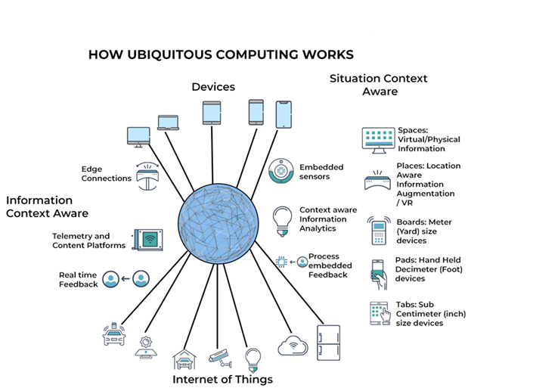

Fig : Ubiquitous Internet

Understanding the Diagram
- Different devices (mobile, laptop, IoT) are connected to the Internet
- Internet connects users to Cloud Services
- Users can access services anytime, anywhere

Use / Purpose
- Enables cloud access from anywhere
- Supports online education, banking, streaming
- Foundation for cloud computing & IoT

2. Eras of Computing

Introduction
Computing has changed step by step over time.
Each era came to solve the problems of the previous one and to make computing easier, faster, and more accessible.

1. Mainframe Era
- One very powerful central computer (mainframe)
- Used only by large organizations like banks and government offices
- Many users worked on it using terminals (keyboard + screen, no processing power)
In simple terms:
One big computer does all the work, many people share it.

2. Personal Computer (PC) Era
- Computers became small and affordable
- People owned individual desktops or laptops
- Each computer worked independently
- Very limited sharing of data and resources
In simple terms:
One computer for one person.

3. Client–Server Era
- Computers connected using a network
- Client computers send requests
- Server computers provide data, storage, or services
- Common in companies and institutions
In simple terms:
Many users (clients) depend on a powerful server.

4. Distributed Computing Era
- Multiple computers work together
- Work is divided among systems
- Improves speed, performance, and reliability
- If one system fails, others continue
In simple terms:
Many computers share the work.

5. Cloud Computing Era
- Computing resources available on demand
- Users pay only for what they use
- Resources are virtualized and available over the Internet
- Examples: AWS, Azure, Google Cloud
In simple terms:
Computing as a service, just like electricity or water.

Comparison of Computing Eras
Era | Key Feature
Mainframe | Centralized computing
PC | Individual computing
Client–Server | Network-based computing
Distributed | Cooperative computing
Cloud | Service-based computing

Conclusion
Each computing era solved the limitations of the previous one.
This continuous evolution finally led to cloud computing, which provides flexible, scalable, and cost-effective computing services today.

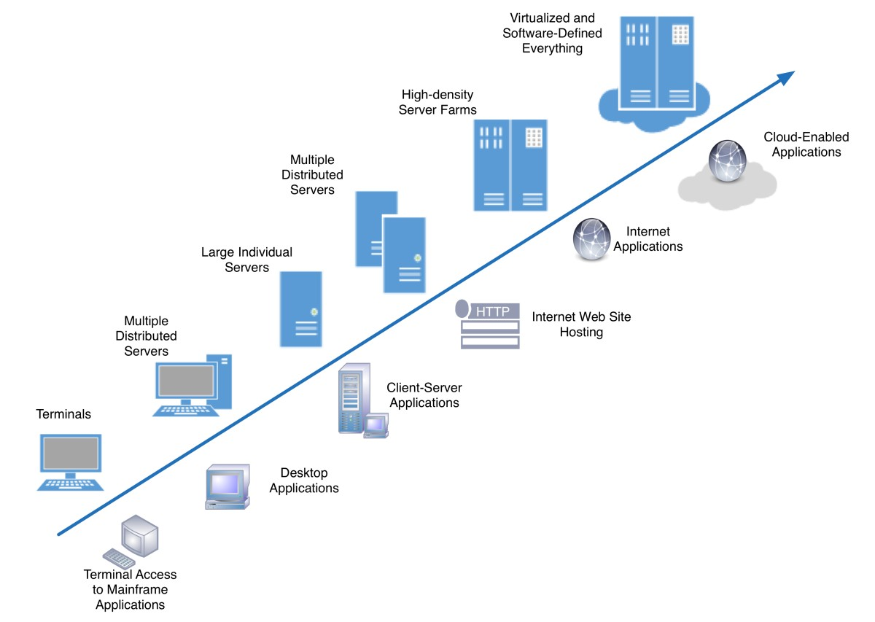

Fig : Eras of Computing

Understanding the Diagram
- Shows evolution from Mainframe → PC → Client–Server → Distributed → Cloud
- Each stage improves performance, accessibility, scalability

3. Parallel Computing vs Distributed Computing

Introduction
Parallel and distributed computing improve performance by using multiple computing units, but differ in architecture and operation.

Parallel Computing
- Multiple processors in a single system
- Shared memory
- Tasks executed simultaneously

Distributed Computing
- Multiple independent computers
- Connected through a network
- Each system has its own memory

Differences
Feature | Parallel | Distributed
Location | Same machine | Different machines
Memory | Shared | Separate
Communication | Fast | Slower
Scalability | Limited | High

Examples
- Parallel: Multicore processors
- Distributed: Cloud data centers

Conclusion
Parallel computing focuses on speed, while distributed computing focuses on scalability and reliability.

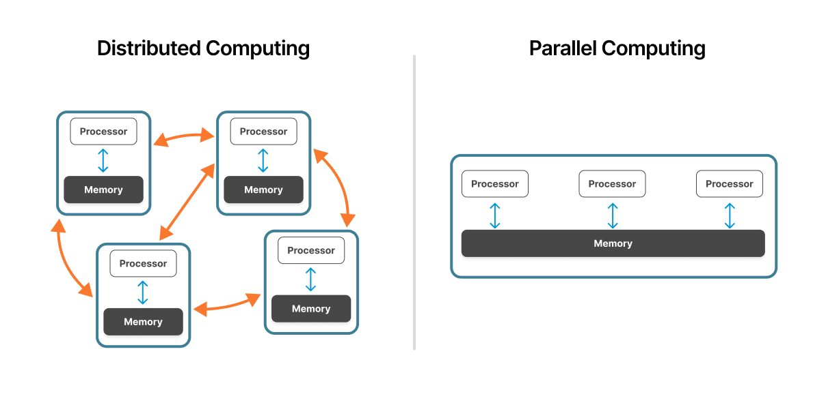

Fig: Parallel Computing vs Distributed Computing

Understanding the Diagram
- Parallel: Multiple CPUs inside one system sharing memory
- Distributed: Independent computers connected via network

Use / Purpose
- Parallel → speed improvement
- Distributed → scalability & reliability

4. What is Parallel Processing?

Introduction
Parallel processing is the execution of multiple tasks simultaneously using multiple processors.

Working Principle
- Problem divided into sub-tasks
- Sub-tasks executed at the same time
- Results combined

Types
- Data parallelism
- Task parallelism

Hardware Support
- Multicore CPUs
- GPUs
- Supercomputers

Advantages
- Faster execution
- Efficient resource utilization
- Reduced processing time

Applications
- Scientific simulations
- Weather forecasting
- Image processing
- Machine learning

Conclusion
Parallel processing improves performance and is essential for high-performance computing systems.
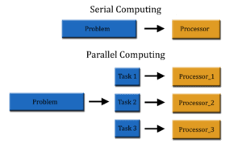

Fig : Parallel Processing

Understanding the Diagram
- One big task is split into smaller tasks
- Each task runs on a separate processor
- Results are combined

Use / Purpose
- Faster execution
- Used in weather prediction, AI, simulations

5. SISD Architecture

Meaning
Single Instruction, Single Data

Characteristics
- One processor
- Executes one instruction at a time
- Processes single data stream

Examples
- Traditional single-core computers

Advantages
- Simple design
- Easy to program

Limitations
- Low performance
- No parallelism

Conclusion
SISD systems are basic and form the foundation of modern architectures.

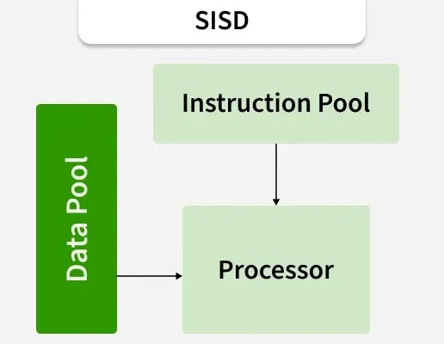

Understanding the Diagram
- One instruction
- One processor
- One data stream

Use / Purpose
- Traditional computing systems
- Easy to design & program
- Base model for understanding other architectures

6. SIMD Architecture

Meaning
Single Instruction, Multiple Data

Working
- Same instruction applied to multiple data items simultaneously

Examples
- GPUs
- Vector processors

Applications
- Image processing
- Scientific calculations

Advantages
- High data processing speed
- Efficient for repetitive tasks

Limitations
- Not suitable for complex logic

Conclusion
SIMD is ideal for data-parallel applications.

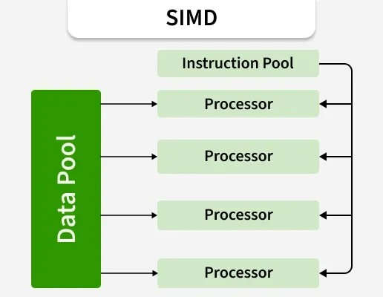

Understanding the Diagram
- Same instruction applied to multiple data items
- One control unit controls many processors

Use / Purpose
- Image processing
- Graphics (GPU)
- Scientific calculations

7. MISD Architecture

Meaning
Multiple Instruction, Single Data

Characteristics
- Multiple instructions operate on same data

Usage
- Rare in practice
- Used in fault-tolerant systems

Advantages
- High reliability

Limitations
- Complex and costly

Conclusion
MISD is mainly theoretical and used in specialized systems.

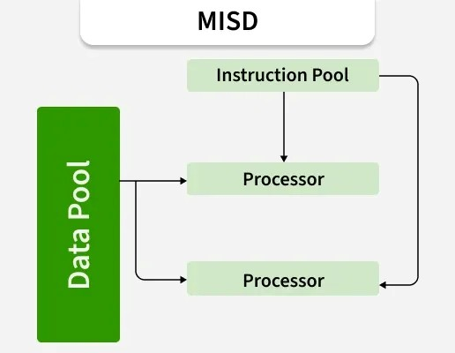

Understanding the Diagram
- Same data processed by multiple instructions
- Multiple processors check same data

Use / Purpose
- Fault-tolerant systems
- Error detection
- Mostly theoretical

8. MIMD Architecture

Meaning
Multiple Instruction, Multiple Data

Characteristics
- Each processor executes different instructions
- Independent data streams

Examples
- Multicore processors
- Distributed systems

Advantages
- Flexible
- Highly scalable

Conclusion
MIMD is the most commonly used architecture in cloud systems.

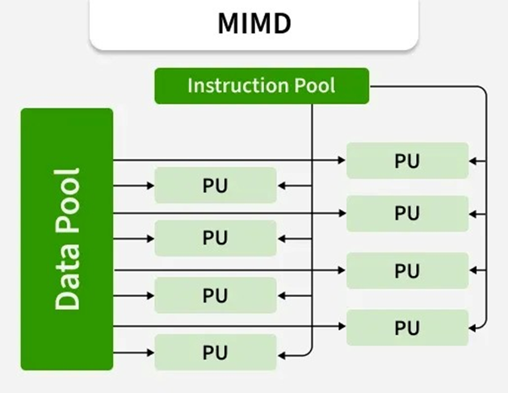

Understanding the Diagram
- Each processor has its own instruction & data
- Processors work independently

Use / Purpose
- Multicore systems
- Distributed & cloud computing
- Most widely used architecture

Elements of distributed computing

9. General Concepts of Distributed Computing

Definition
Distributed computing involves multiple autonomous computers working together as a single system.

Key Concepts
- Resource sharing
- Transparency
- Scalability
- Fault tolerance

Goals
- Improve performance
- Increase availability
- Support large-scale applications

Conclusion
Distributed computing is a core foundation of cloud computing.
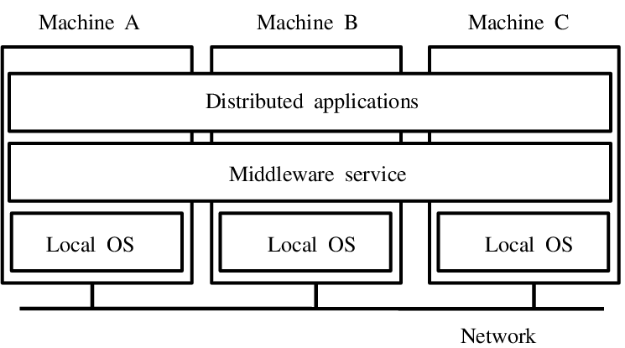

Understanding the Diagram
- Multiple computers (nodes) connected by a network
- Work together as a single system

Use / Purpose
- Resource sharing
- Fault tolerance
- Large-scale cloud applications

10. Components of a Distributed System

Main Components
- Nodes (Computers)
- Network
- Middleware
- Operating systems
- Applications

Function
- Enable communication
- Manage resources
- Provide services

Conclusion
Each component plays a vital role in system coordination.
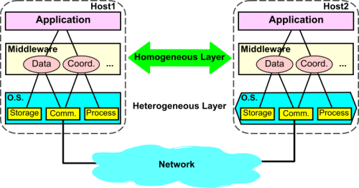

Understanding the Diagram
- Application: User-facing software
- Middleware: Communication & coordination
- OS: Resource management
- Network: Connectivity

Use / Purpose
- Explains internal working
- Middleware is key for cloud systems

11. Architectural Styles for Distributed Computing

Types
- Client–Server
- Peer-to-Peer
- Layered architecture
- Microservices

Importance
- Determines scalability and performance

Conclusion
Architecture defines how distributed systems are designed and managed.

Understanding the Diagram Client Server
- Client sends request
- Server processes and responds

Use / Purpose
- Web applications
- Email systems
- Simplifies centralized management

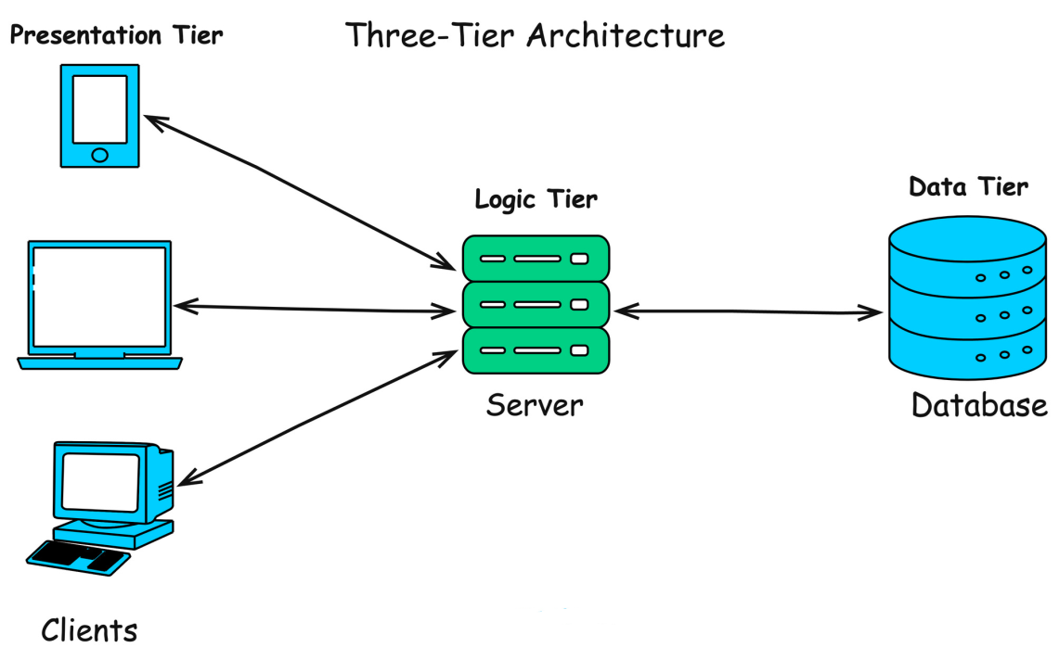

Fig : Architectural Styles – Client Server

12. Models for Interprocess Communication

Definition
IPC allows processes to exchange data and coordinate.

Models
- Message passing
- Shared memory
- Remote invocation

Importance
- Enables coordination
- Supports distributed execution

Conclusion
IPC is essential for process interaction.

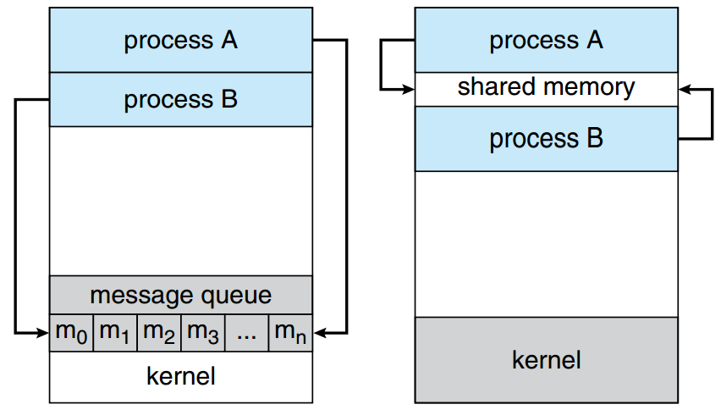

Understanding the Diagram
- Processes exchange data using messages or shared memory
- Ensures coordination

Use / Purpose
- Communication between distributed processes
- Synchronization
- Essential for parallel & distributed systems

13. Remote Procedure Call (RPC)

Meaning
RPC allows a program to execute a procedure on a remote system.

Working
- Client calls procedure
- Server executes
- Result returned

Advantages
- Simple programming
- Location transparency

Conclusion
RPC simplifies distributed application development.

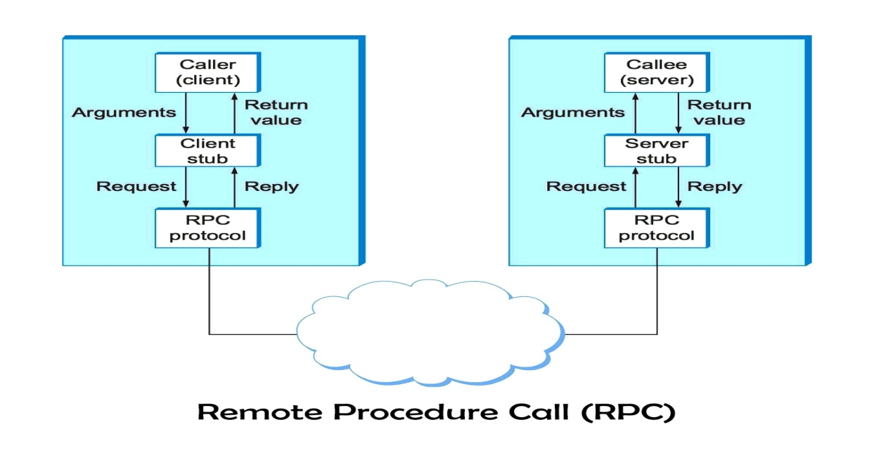

Understanding the Diagram
- Client calls a function
- Server executes it remotely
- Result returned to client

Use / Purpose
- Simplifies distributed programming
- Hides network complexity
- Used in microservices

14. Service-Oriented Architecture (SOA)

Definition
SOA is an architecture where functionality is provided as services.

Features
- Loose coupling
- Reusability
- Interoperability

Applications
- Enterprise systems
- Cloud services

Conclusion
SOA promotes modular and scalable system design.

15. Web Services

Definition
Web services enable communication between applications over the Internet.

Technologies
- SOAP
- REST
- HTTP
- XML/JSON

Advantages
- Platform independent
- Easy integration

Conclusion
Web services are key enablers of cloud interoperability.
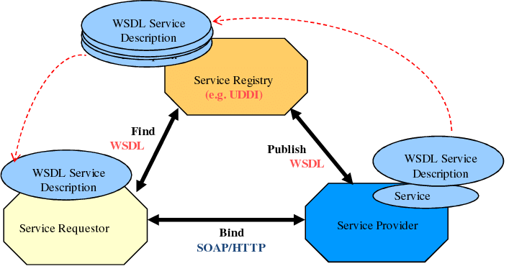

Fig :Web Services

Understanding the Diagram
- Applications communicate over Internet
- Uses HTTP, REST/SOAP

Use / Purpose
- Platform-independent communication
- Enables cloud integration
- Used in APIs

16. Virtualization

Definition
Virtualization is the creation of virtual versions of computing resources.

Types
- Server virtualization
- Storage virtualization
- Network virtualization

Role in Cloud
- Resource pooling
- Cost reduction
- Scalability

Advantages
- Efficient utilization
- Isolation
- Flexibility

Conclusion
Virtualization is the core enabling technology of cloud computing.

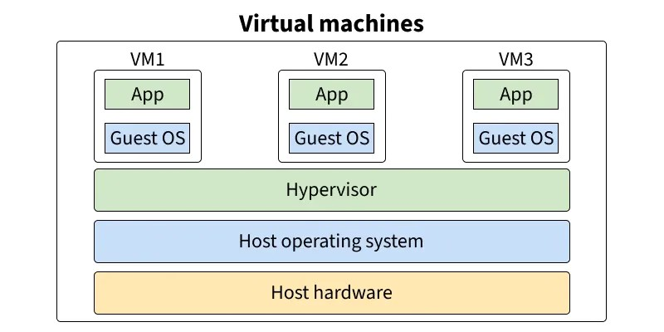
Fig : Virtualization

Understanding the Diagram
- One physical machine
- Hypervisor creates multiple virtual machines
- Each VM acts like a real computer

Use / Purpose
- Efficient resource usage
- Cost reduction
- Backbone of cloud computing

