Experiment – 1
Aim: Build mobile application based on the concept activity life cycle with Custom Toast.
Description:
Android Activity Lifecycle is controlled by 7 methods of android.app.Activity class. The android Activity is the subclass of ContextThemeWrapper class.
Method | Description
onCreate | called when activity is first created.
onStart | called when activity is becoming visible to the user.
onResume | called when activity will start interacting with the user.
onPause | called when activity is not visible to the user.
onStop | called when activity is no longer visible to the user.
onRestart | called after your activity is stopped, prior to start.
onDestroy | called before the activity is destroyed.
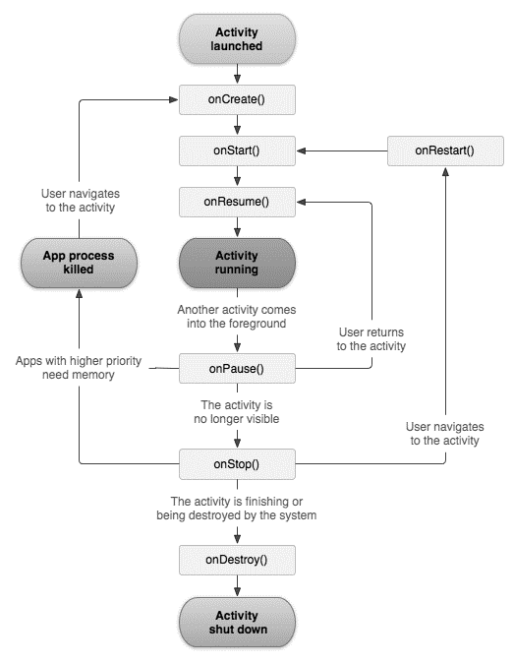

Syntax:
To create a Toast object:
Toast toast = Toast.makeText(getApplicationContext(),"MESSAGE", Duration);

To set gravity for the toast message:
toast.setGravity(gravity, xOffset, yOffset);
To change the duration of a toast message:
toast.setDuration(Toast.LENGTH_LONG);
To display the toast message on android screen:
toast.show();
Program
activity_main.xml
<?xml version="1.0" encoding="utf-8"?>
<LinearLayout
xmlns:android="http://schemas.android.com/apk/res/android"
android:layout_width="match_parent"
android:layout_height="match_parent">
<TextView
android:layout_width="wrap_content"
android:layout_height="wrap_content"
android:text="Hello World"
android:layout_marginLeft="70dp"
android:layout_marginTop="200dp"
android:textSize="40dp"
android:textColor="#C11818"
/>
</LinearLayout>
MainActivity.java
package com.example.exp1;
import androidx.appcompat.app.AppCompatActivity;
import android.os.Bundle;
import android.util.Log;
import android.view.Gravity;
import android.widget.Toast;
public class MainActivity extends AppCompatActivity {
@Override
protected void onCreate(Bundle savedInstanceState) {
super.onCreate(savedInstanceState);
setContentView(R.layout.activity_main);
Toast toast = Toast.makeText(getApplicationContext(), "onCreate called", Toast.LENGTH_LONG);
toast.setGravity(Gravity.TOP,90,90);
toast.show();
}
@Override
protected void onStart(){
super.onStart();
Toast toast = Toast.makeText(getApplicationContext(), "onStart called", Toast.LENGTH_LONG);
toast.setGravity(Gravity.BOTTOM,90,0);
toast.show();
}
@Override
protected void onPause(){
super.onPause();
Toast toast = Toast.makeText(getApplicationContext(), "onPause called", Toast.LENGTH_LONG);
toast.setGravity(Gravity.CENTER_HORIZONTAL,0,0);
toast.show();
}
@Override
protected void onResume(){
super.onResume();
Toast toast = Toast.makeText(getApplicationContext(), "onResume called", Toast.LENGTH_LONG);
toast.setGravity(Gravity.CENTER_VERTICAL,0,0);
toast.show();
}
@Override
protected void onStop(){
super.onStop();
Toast toast = Toast.makeText(getApplicationContext(), "onStop called", Toast.LENGTH_LONG);
toast.setGravity(Gravity.CENTER|Gravity.END,0,0);
toast.show();
}
@Override
protected void onRestart(){
super.onRestart();
Toast toast = Toast.makeText(getApplicationContext(), "onRestart called", Toast.LENGTH_LONG);
toast.setGravity(Gravity.BOTTOM|Gravity.END,0,0);
toast.show();
}
@Override
protected void onDestroy(){
super.onDestroy();
Toast toast = Toast.makeText(getApplicationContext(), "onDestroy called", Toast.LENGTH_LONG);
toast.setGravity(Gravity.TOP|Gravity.END,0,0);
toast.show();
}
}

Output:

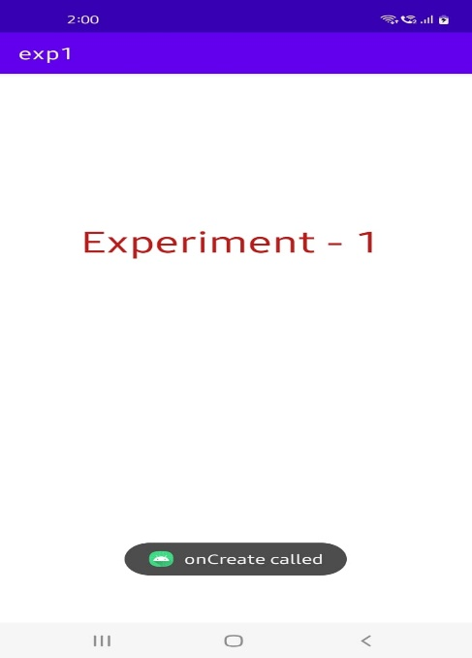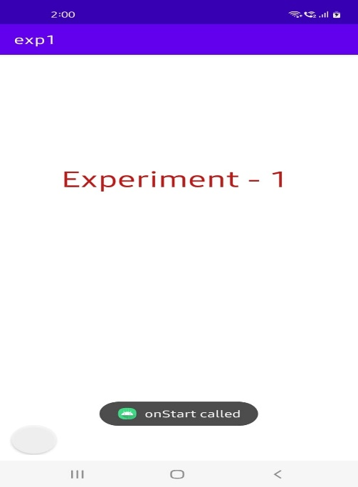

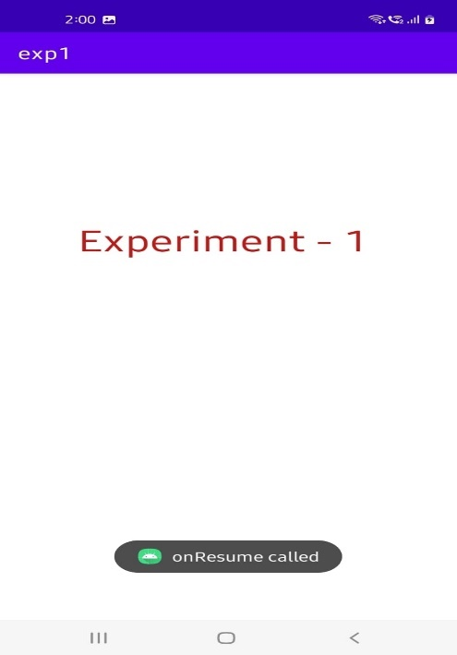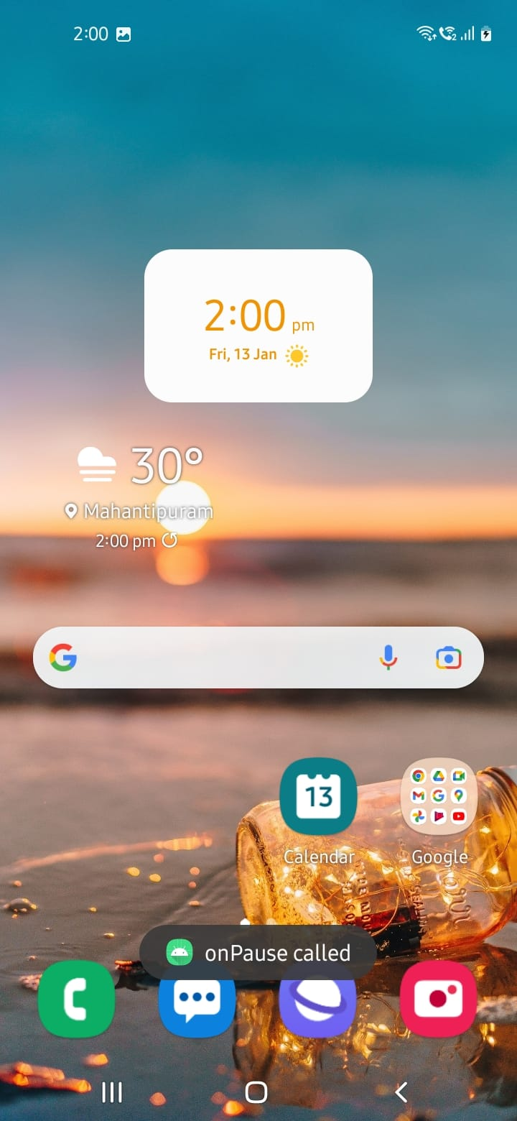

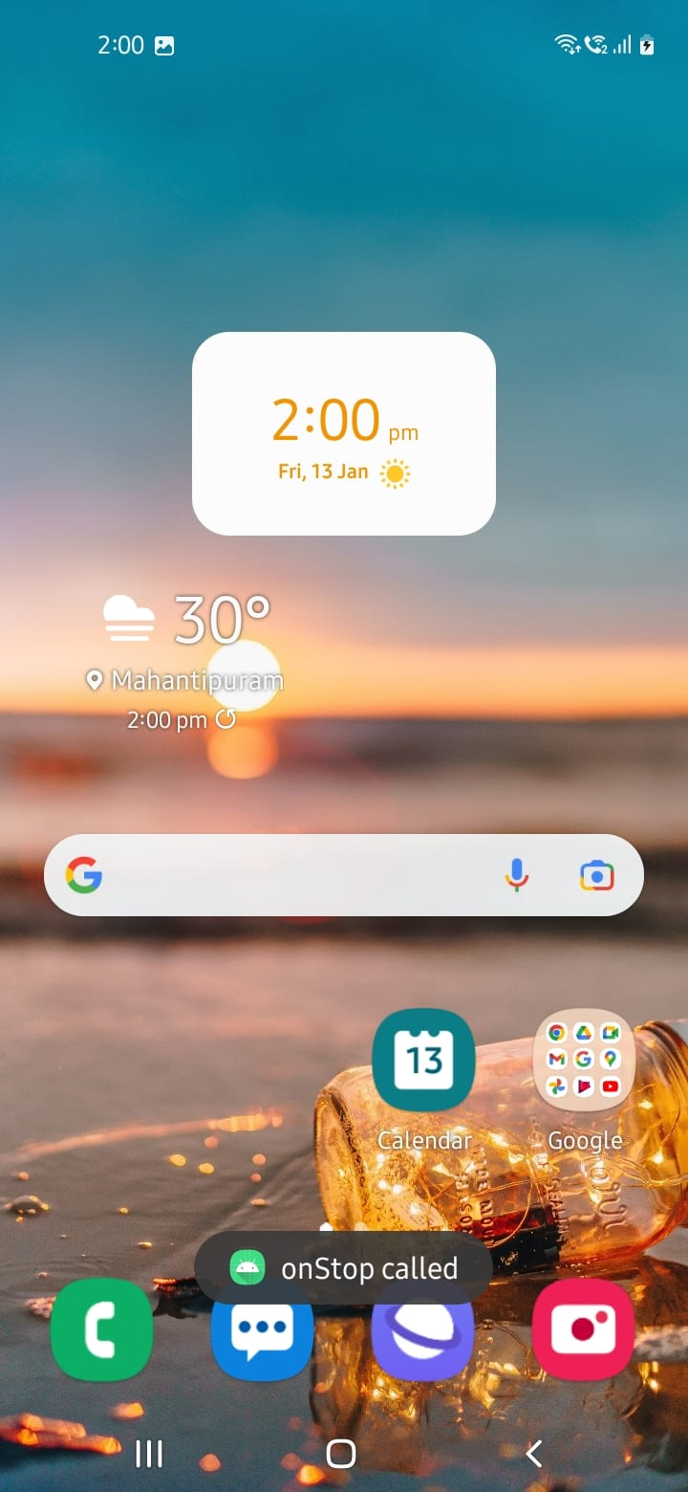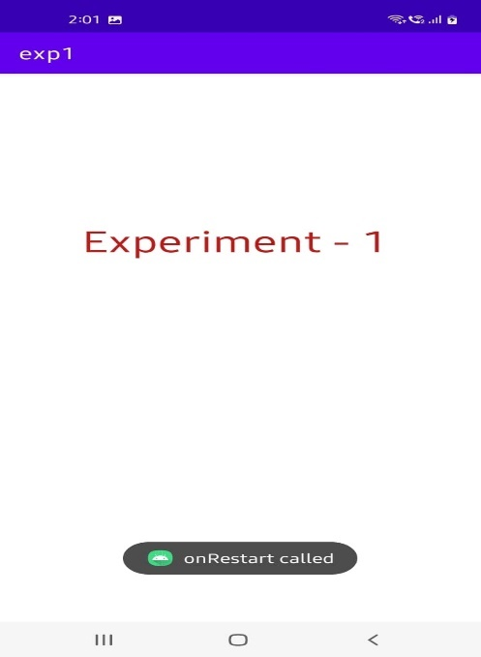

Experiment – 2
Aim: Build mobile application using different layouts (use any 3 layouts)
I. Linear Layout
Description:
Linear layout is a simple layout used in android for layout designing. In the Linear layout all the elements are displayed in linear fashion means all the children/elements of a linear layout are displayed according to its orientation. The value for orientation property can be either horizontal or vertical.
Syntax:
<LinearLayout
xmlns:android="http://schemas.android.com/apk/res/android"
android:layout_width="match_parent"
android:layout_height="match_parent"
android:orientation="vertical" >
…………………….
……………………..
……………………..
</LinearLayout>
Program:
activity_main.xml
<?xml version="1.0" encoding="utf-8"?>
<LinearLayout xmlns:android="http://schemas.android.com/apk/res/android"
android:layout_width="match_parent"
android:layout_height="match_parent"
android:orientation="vertical" >

<TextView
android:layout_width="match_parent"
android:layout_height="wrap_content"
android:layout_marginTop="175dp"
android:layout_marginBottom="30dp"
android:text="Are you"
android:textAlignment="center"
android:textColor="#0000FF"
android:textSize="50sp" />

<TextView
android:layout_width="match_parent"
android:layout_height="wrap_content"
android:text="Sure?"
android:textAlignment="center"
android:textColor="#0000FF"
android:textSize="50sp"
/>
<LinearLayout
android:layout_width="match_parent"
android:layout_height="match_parent"
android:layout_marginTop="50dp"
android:orientation="horizontal">

<Button
android:layout_width="wrap_content"
android:layout_height="75dp"
android:layout_marginLeft="70dp"
android:layout_marginRight="20dp"
android:text="Yes"
android:textSize="30sp" />

<Button
android:layout_width="wrap_content"
android:layout_height="75dp"
android:text="Cancel"
android:textSize="30sp"
android:layout_marginRight="20dp" />

</LinearLayout>
</LinearLayout>
MainActivity.java
package com.example.linearlayout;
import androidx.appcompat.app.AppCompatActivity;
import android.os.Bundle;

public class MainActivity extends AppCompatActivity {

@Override
protected void onCreate(Bundle savedInstanceState) {
super.onCreate(savedInstanceState);
setContentView(R.layout.activity_main);
}
}
Output:
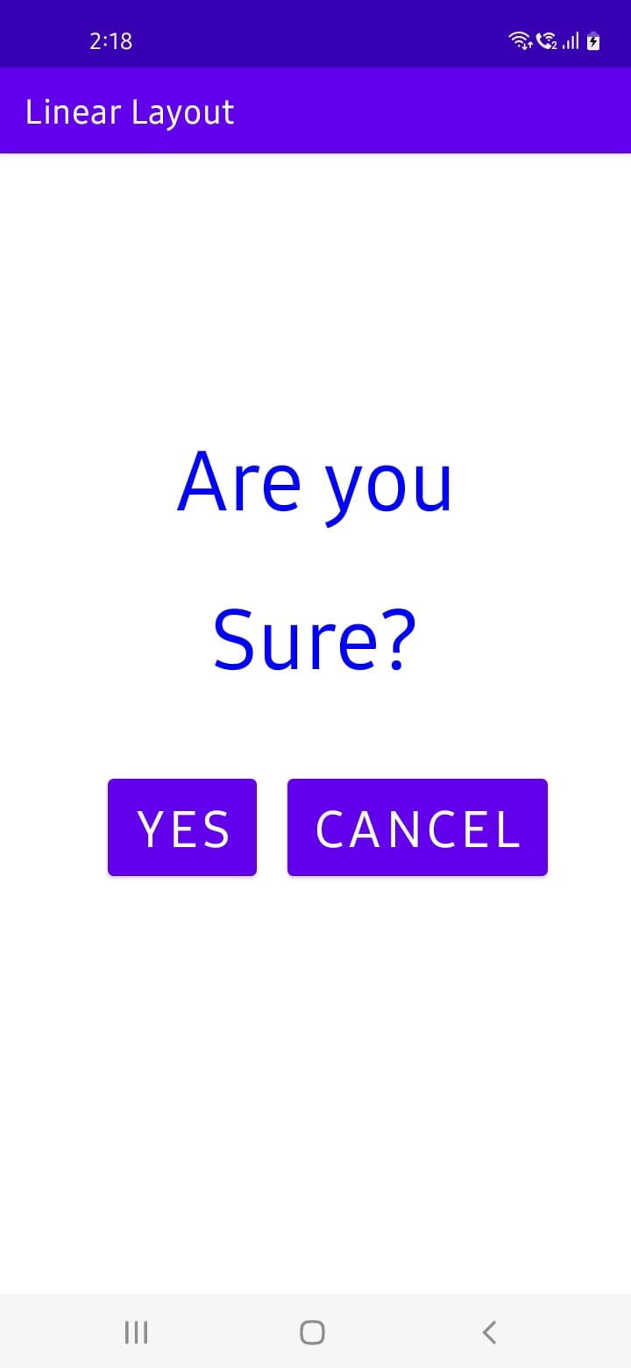

II. Relative Layout
Description:
The Relative Layout is very flexible layout used in android for custom layout designing. It gives us the flexibility to position our component/view based on the relative or sibling component’s position. Just because it allows us to position the component anywhere, we want so it is considered as most flexible layout. For the same reason Relative layout is the most used layout after the Linear Layout in Android. It allows its child view to position relative to each other or relative to the container or another container.
Syntax:
<RelativeLayout
xmlns:android="http://schemas.android.com/apk/res/android"
android:layout_width="match_parent"
android:layout_height="match_parent"
>
…………………….
……………………..
……………………..
</RelativeLayout>
Program:
activity_main.xml
<?xml version="1.0" encoding="utf-8"?>
<RelativeLayout
xmlns:android="http://schemas.android.com/apk/res/android"
android:layout_width="match_parent"
android:layout_height="match_parent"
>

<Button
android:id="@+id/btn1"
android:layout_width="wrap_content"
android:layout_height="wrap_content"
android:layout_alignParentLeft="true"
android:text="Button 1" />
<Button
android:id="@+id/btn2"
android:layout_width="wrap_content"
android:layout_height="wrap_content"
android:layout_alignParentRight="true"
android:layout_centerVertical="true"
android:text="Button 2" />

<Button
android:id="@+id/btn3"
android:layout_width="wrap_content"
android:layout_height="wrap_content"
android:layout_alignParentLeft="true"
android:layout_centerVertical="true"
android:text="Button 3" />

<Button
android:id="@+id/btn4"
android:layout_width="match_parent"
android:layout_height="wrap_content"
android:layout_alignParentBottom="true"
android:text="Button 4" />
<Button
android:id="@+id/btn5"
android:layout_width="wrap_content"
android:layout_height="wrap_content"
android:layout_alignBottom="@+id/btn2"
android:layout_centerHorizontal="true"
android:text="Button 5" />
<Button
android:id="@+id/btn6"
android:layout_width="wrap_content"
android:layout_height="wrap_content"
android:layout_above="@+id/btn4"
android:layout_centerHorizontal="true"
android:text="Button 6" />
<Button
android:id="@+id/btn7"
android:layout_width="wrap_content"
android:layout_height="wrap_content"
android:layout_toEndOf="@+id/btn1"
android:layout_toRightOf="@+id/btn1"
android:layout_alignParentRight="true"
android:text="Button 7" />

</RelativeLayout>
MainActivity.java
package com.example.relativelayout;

import androidx.appcompat.app.AppCompatActivity;

import android.os.Bundle;
public class MainActivity extends AppCompatActivity {
@Override
protected void onCreate(Bundle savedInstanceState) {
super.onCreate(savedInstanceState);
setContentView(R.layout.activity_main);
}
}

Output:
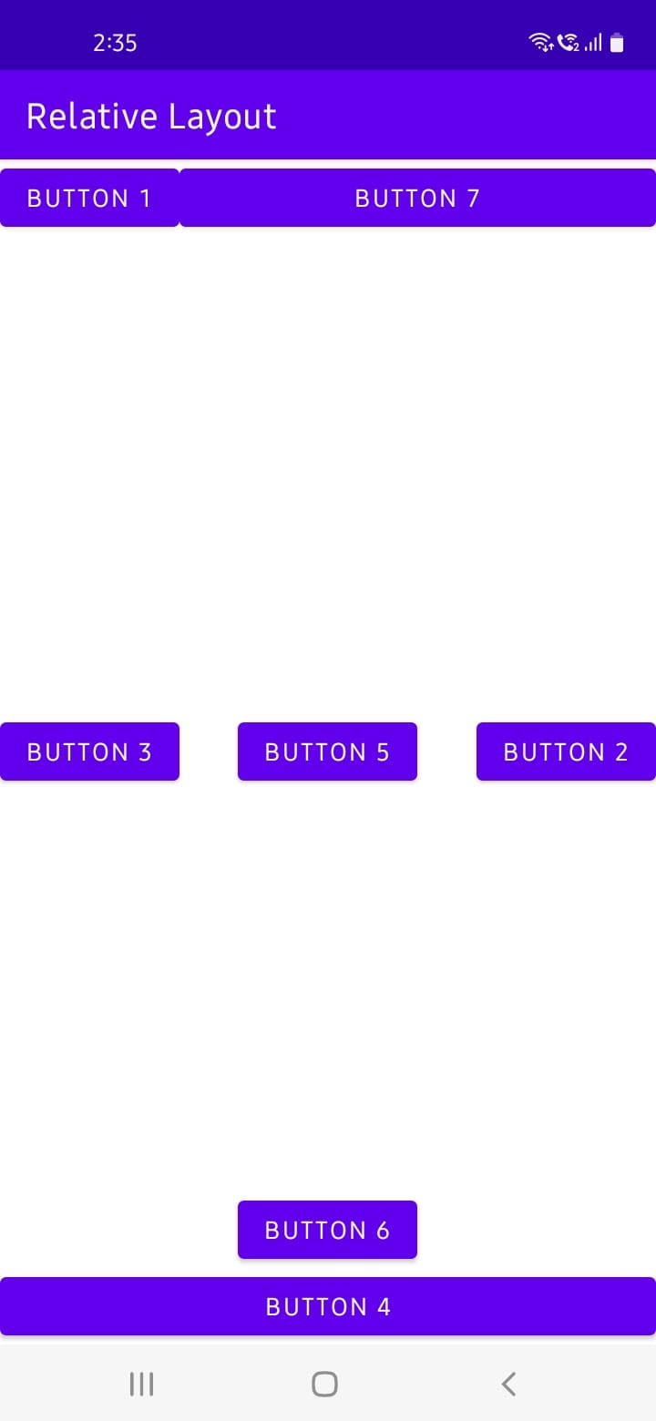
III. Table Layout
Description:
In Android, Table Layout is used to arrange the group of views into rows and columns. Table Layout containers do not display a border line for their columns, rows or cells. A Table will have as many columns as the row with the most cells.
Syntax:
<TableLayout
xmlns:android="http://schemas.android.com/apk/res/android"
android:layout_width="match_parent"
android:layout_height="match_parent"
>
<TableRow>
……………..
……………..
</TableRow>
<TableRow>
……………..
……………..
</TableRow>
…………………….
……………………..
……………………..
</TableLayout>
Program:
main_activity.xml
<?xml version="1.0" encoding="utf-8"?>
<TableLayout xmlns:android="http://schemas.android.com/apk/res/android"
android:layout_width="match_parent"
android:layout_height="match_parent"
android:layout_marginTop="100dp"
android:paddingLeft="10dp"
android:paddingRight="10dp" >
<TableRow android:background="#0079D6" android:padding="5dp">
<TextView
android:layout_width="wrap_content"
android:layout_height="wrap_content"
android:layout_weight="1"
android:text="UserId" />
<TextView
android:layout_width="wrap_content"
android:layout_height="wrap_content"
android:layout_weight="1"
android:text="Name" />
<TextView
android:layout_width="wrap_content"
android:layout_height="wrap_content"
android:layout_weight="1"
android:text="Location" />
</TableRow>
<TableRow android:background="#DAE8FC" android:padding="5dp">
<TextView
android:layout_width="wrap_content"
android:layout_height="wrap_content"
android:layout_weight="1"
android:text="101" />
<TextView
android:layout_width="wrap_content"
android:layout_height="wrap_content"
android:layout_weight="1"
android:text="Ravi" />
<TextView
android:layout_width="wrap_content"
android:layout_height="wrap_content"
android:layout_weight="1"
android:text="Vijayawada" />
</TableRow>
<TableRow android:background="#DAE8FC" android:padding="5dp">
<TextView
android:layout_width="wrap_content"
android:layout_height="wrap_content"
android:layout_weight="1"
android:text="102" />
<TextView
android:layout_width="wrap_content"
android:layout_height="wrap_content"
android:layout_weight="1"
android:text="Ramu" />
<TextView
android:layout_width="wrap_content"
android:layout_height="wrap_content"
android:layout_weight="1"
android:text="Guntur" />
</TableRow>
<TableRow android:background="#DAE8FC" android:padding="5dp">
<TextView
android:layout_width="wrap_content"
android:layout_height="wrap_content"
android:layout_weight="1"
android:text="103" />
<TextView
android:layout_width="wrap_content"
android:layout_height="wrap_content"
android:layout_weight="1"
android:text="Raju" />
<TextView
android:layout_width="wrap_content"
android:layout_height="wrap_content"
android:layout_weight="1"
android:text="Vishakapatnam" />
</TableRow>
</TableLayout>
MainActivity.java
package com.example.tablelayout;
import androidx.appcompat.app.AppCompatActivity;
import android.os.Bundle;
public class MainActivity extends AppCompatActivity {
@Override
protected void onCreate(Bundle savedInstanceState) {
super.onCreate(savedInstanceState);
setContentView(R.layout.activity_main);
}
}
Output:
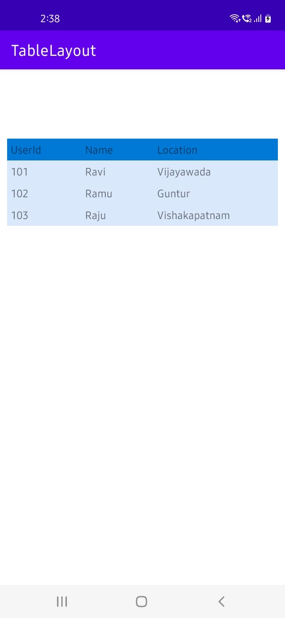

Experiment – 3
Aim: Build mobile application using different dialogs (use any 2 dialogs)
Description:
A dialog is a small window that prompts the user to make a decision or enter additional information. A dialog does not fill the screen and is normally used for events that require users to take an action before they can proceed.
In android, you can create following types of Dialogs:
- Alert Dialog
- DatePicker Dialog
- TimePicker Dialog
- Custom Dialog
I. TimePicker Dialog
Description:
Android Time Picker allows you to select the time of day in either 24 hour or AM/PM mode. The time consists of hours, minutes and clock format. Android provides this functionality through TimePicker class.
Syntax:
To create a view in xml file:
<TimePicker
android:id="@+id/timePicker1"
android:layout_width="wrap_content"
android:layout_height="wrap_content" />
To create a TimePicker object in java file:
import android.widget.TimePicker;
TimePicker timePicker1;
timePicker1 = (TimePicker) findViewById(R.id.timePicker1);
To get the current time:
int hour = timePicker1.getCurrentHour();
int min = timePicker1.getCurrentMinute();
Program:
activity_main.xml
<?xml version="1.0" encoding="utf-8"?>
<RelativeLayout
xmlns:android="http://schemas.android.com/apk/res/android"
android:layout_width="match_parent"
android:layout_height="match_parent">
<TimePicker
android:id="@+id/timePicker1"
android:layout_width="wrap_content"
android:layout_height="wrap_content"
android:layout_centerHorizontal="true"
android:layout_marginTop="20dp" />
<Button
android:id="@+id/button1"
android:layout_width="wrap_content"
android:layout_height="wrap_content"
android:layout_below="@+id/timePicker1"
android:layout_marginTop="10dp"
android:layout_marginLeft="160dp"
android:text="CLICK HERE" />
<TextView
android:id="@+id/textView1"
android:layout_width="wrap_content"
android:layout_height="wrap_content"
android:layout_below="@+id/button1"
android:layout_marginLeft="120dp"
android:layout_marginTop="10dp"
android:textStyle="bold"
android:textSize="18dp"/>
</RelativeLayout>
MainActivity.java
package com.example.timepicker;
import androidx.appcompat.app.AppCompatActivity;
import android.os.Build;
import android.os.Bundle;
import android.view.*;
import android.widget.*;

public class MainActivity extends AppCompatActivity {
TimePicker picker;
Button btnGet;
TextView tvw;
@Override
protected void onCreate(Bundle savedInstanceState) {
super.onCreate(savedInstanceState);
setContentView(R.layout.activity_main);
tvw=(TextView)findViewById(R.id.textView1);
picker=(TimePicker)findViewById(R.id.timePicker1);
picker.setIs24HourView(true);
btnGet=(Button)findViewById(R.id.button1);
btnGet.setOnClickListener(new View.OnClickListener() {
@Override
public void onClick(View v) {
int hour, minute;
String am_pm;
if (Build.VERSION.SDK_INT >= 23 ){
hour = picker.getHour();
minute = picker.getMinute();
}
else{
hour = picker.getCurrentHour();
minute = picker.getCurrentMinute();
}
if(hour > 12) {
am_pm = "PM";
hour = hour - 12;
}
else
{
am_pm="AM";
}
tvw.setText("Selected Time: "+ hour +":"+ minute+" "+am_pm);
}
});
}
}
Output:
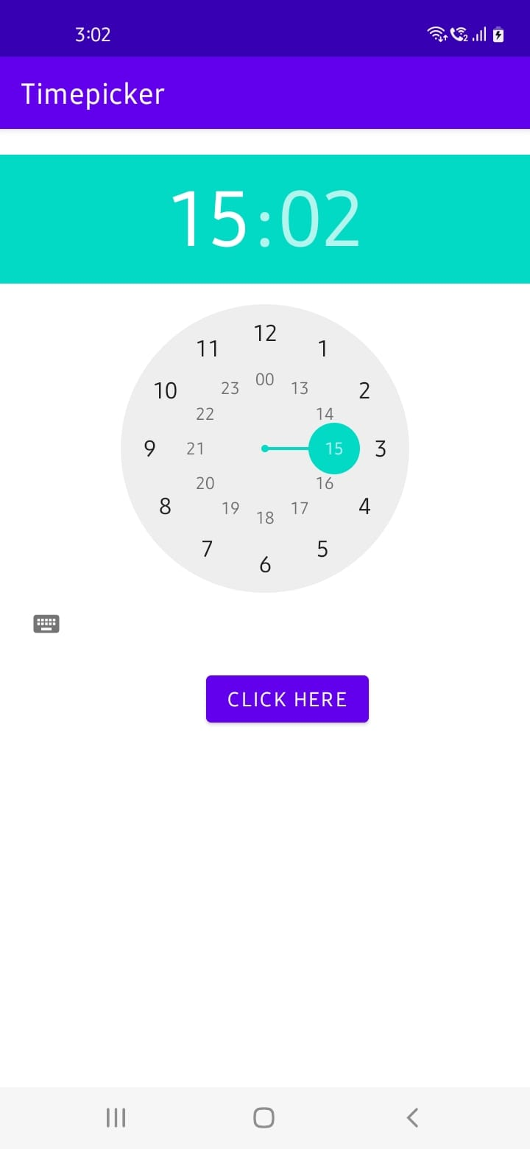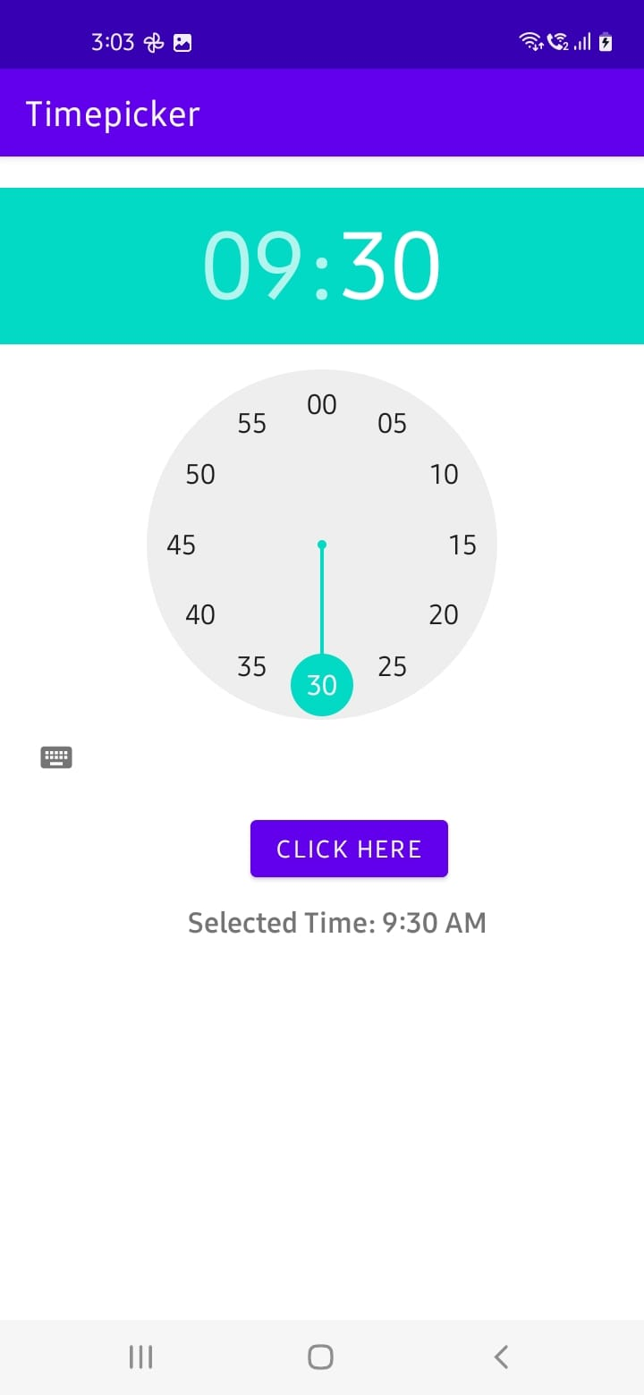

II. DatePicker Dialog
Description:
Android DatePicker is a user interface control that is used to select the date by day, month, and year in the android application. DatePicker is used to ensure that the users will select a valid date.
Android Date Picker allows you to select the date consisting of day, month and year in your custom user interface. For this functionality android provides DatePicker and DatePickerDialog components.
Syntax:
To create a view in xml file:
<DatePicker
android:id="@+id/date"
android:layout_width="wrap_content"
android:layout_height="wrap_content"/>
To create a DatePicker object in java file:
import android.widget.DatePicker;
DatePicker d1 = (DatePicker) findViewById(R.id.date);
To get the selected date:
int hour = timePicker1.getCurrentHour();
int min = timePicker1.getCurrentMinute();
int month = d1.getMonth() + 1;
int year = d1.getYear();
int date = d1.getDayOfMonth();
Program:
activity_main.xml
<?xml version="1.0" encoding="utf-8"?>
<LinearLayout
xmlns:android="http://schemas.android.com/apk/res/android"
android:layout_width="match_parent"
android:layout_height="match_parent"
android:orientation="vertical"
>
<TextView
android:layout_width="wrap_content"
android:layout_height="wrap_content"
android:text="Choose the Date"
android:textStyle="bold"
android:textSize="30dp"
android:textColor="#C53434"
android:layout_marginTop="30dp"
android:layout_marginLeft="80dp"
/>
<DatePicker
android:id="@+id/date"
android:layout_width="wrap_content"
android:layout_height="wrap_content"
android:layout_marginLeft="30dp"
android:layout_marginTop="50dp" />
<Button
android:id="@+id/button1"
android:layout_width="wrap_content"
android:layout_height="wrap_content"
android:text="Enter"
android:layout_marginLeft="140dp"
android:backgroundTint="@color/button_background_color"
/>
<TextView
android:id="@+id/text"
android:layout_width="wrap_content"
android:layout_height="wrap_content"
android:layout_marginLeft="80dp"
android:textSize="25dp"
android:textStyle="bold"
android:textColor="#C83A3A"
/>
</LinearLayout>
MainActivity.java
package com.example.datepicker;
import androidx.appcompat.app.AppCompatActivity;
import android.os.Bundle;
import android.view.*;
import android.widget.*;

public class MainActivity extends AppCompatActivity {
@Override
protected void onCreate(Bundle savedInstanceState) {
super.onCreate(savedInstanceState);
setContentView(R.layout.activity_main);
DatePicker d1 = (DatePicker) findViewById(R.id.date);
Button b1 = (Button) findViewById(R.id.button1);
TextView t1 = (TextView) findViewById(R.id.text);
b1.setOnClickListener(new View.OnClickListener() {
@Override
public void onClick(View view) {
int month = d1.getMonth() + 1;
int year = d1.getYear();
int date = d1.getDayOfMonth();
if(2022 - year >= 18)
t1.setText("You are eligible to Vote");
else
t1.setText("You are not eligible to Vote");
}
});

}
}
Output:
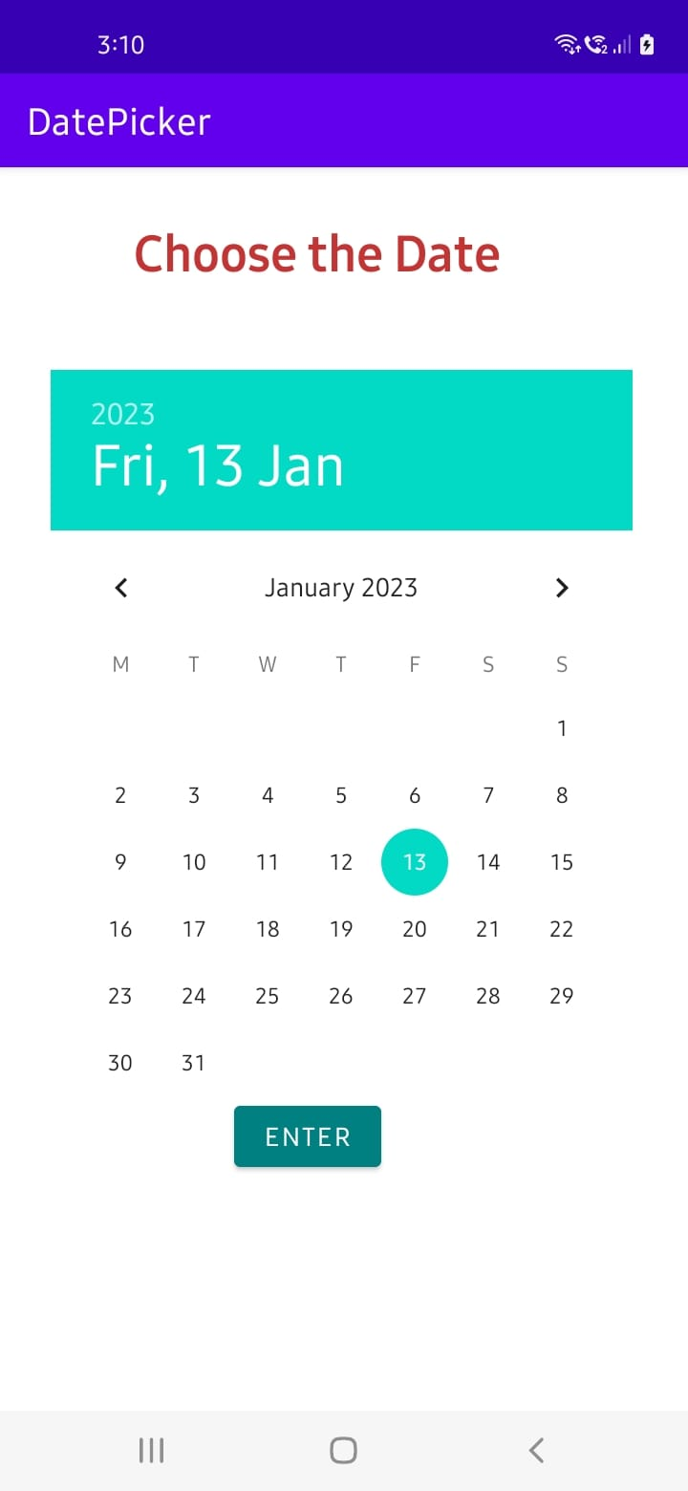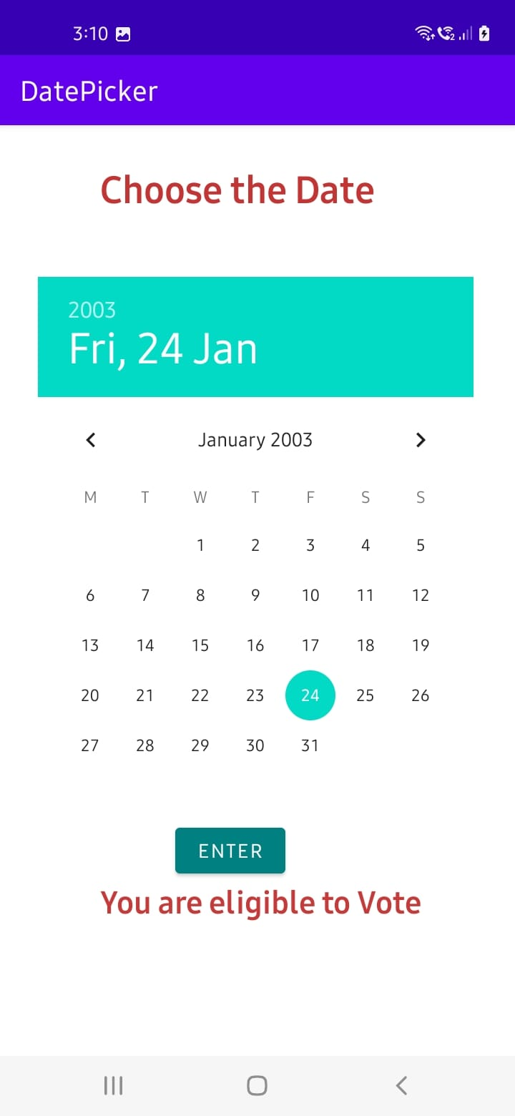

Experiment – 4
Aim: Build mobile application using Recycler View
Description:
RecyclerView is a ViewGroup added to the android studio as a successor of the GridView and ListView. It is an improvement on both of them and can be found in the latest v-7 support packages. It has been created to make possible construction of any lists with XML layouts as an item which can be customized vastly while improving on the efficiency of ListViews and GridViews. This improvement is achieved by recycling the views which are out of the visibility of the user. For example, if a user scrolled down to a position where items 4 and 5 are visible; items 1, 2, and 3 would be cleared from the memory to reduce memory consumption.
Syntax:
recyclerView.setLayoutManager(new LinearLayoutManager(this));
recyclerView.setAdapter(new MyAdapter(getApplicationContext(),items));
Program:
Step – 1: Open Gradle Scripts > build.gradle (Module) and add the following implementation in the dependencies.
implementation 'androidx.recyclerview:recyclerview:1.1.0'
Step – 2:
activity_main.xml
<?xml version="1.0" encoding="utf-8"?>
<RelativeLayout xmlns:android="http://schemas.android.com/apk/res/android"
xmlns:tools="http://schemas.android.com/tools"
android:layout_width="match_parent"
android:layout_height="match_parent"
tools:context=".MainActivity">

<androidx.recyclerview.widget.RecyclerView
android:layout_width="match_parent"
android:layout_height="wrap_content"
android:id="@+id/recyclerview"/>
</RelativeLayout>

item_view.xml
<?xml version="1.0" encoding="utf-8"?>
<RelativeLayout xmlns:android="http://schemas.android.com/apk/res/android"
android:layout_width="match_parent"
android:layout_height="wrap_content"
android:layout_marginTop="10dp"
xmlns:tools="http://schemas.android.com/tools">

<ImageView
android:layout_width="48dp"
android:layout_height="48dp"
android:id="@+id/imageview"
android:layout_marginRight="10dp"
android:layout_centerVertical="true"
/>

<TextView
android:layout_width="match_parent"
android:layout_height="wrap_content"
android:id="@+id/name"
android:layout_toEndOf="@id/imageview"
android:textColor="@color/black"
android:textSize="20dp"
tools:text="Name"/>

<TextView
android:layout_width="match_parent"
android:layout_height="wrap_content"
android:id="@+id/email"
android:layout_toEndOf="@id/imageview"
android:layout_below="@id/name"
android:textColor="@color/black"
tools:text="emial@email.com"/>

<LinearLayout
android:layout_width="match_parent"
android:layout_height="2dp"
android:layout_below="@id/imageview"
android:layout_marginTop="10dp"
android:background="#DAD8D8"/>
</RelativeLayout>

strings.xml (res values strings.xml)
<resources>
<string name="app_name">MyRecyclerViewDemo</string>
</resources>

MainActivity.java
package com.example.myrecyclerviewdemo;

import androidx.appcompat.app.AppCompatActivity;
import androidx.recyclerview.widget.LinearLayoutManager;
import androidx.recyclerview.widget.RecyclerView;

import android.os.Bundle;

import java.util.ArrayList;
import java.util.List;

public class MainActivity extends AppCompatActivity {

@Override
protected void onCreate(Bundle savedInstanceState) {
super.onCreate(savedInstanceState);
setContentView(R.layout.activity_main);

RecyclerView recyclerView = findViewById(R.id.recyclerview);

List<Item> items = new ArrayList<Item>();
items.add(new Item("John wick","john.wick@email.com",R.drawable.a));
items.add(new Item("Robert j","robert.j@email.com",R.drawable.b));
items.add(new Item("James Gunn","james.gunn@email.com",R.drawable.c));
items.add(new Item("Ricky tales","rickey.tales@email.com",R.drawable.d));
items.add(new Item("Micky mose","mickey.mouse@email.com",R.drawable.e));
items.add(new Item("Pick War","pick.war@email.com",R.drawable.f));
items.add(new Item("Leg piece","leg.piece@email.com",R.drawable.g));
items.add(new Item("Apple Mac","apple.mac@email.com",R.drawable.g));
items.add(new Item("John wick","john.wick@email.com",R.drawable.a));
items.add(new Item("Robert j","robert.j@email.com",R.drawable.b));
items.add(new Item("James Gunn","james.gunn@email.com",R.drawable.c));
items.add(new Item("Ricky tales","rickey.tales@email.com",R.drawable.d));
items.add(new Item("Micky mose","mickey.mouse@email.com",R.drawable.e));
items.add(new Item("Pick War","pick.war@email.com",R.drawable.f));
items.add(new Item("Leg piece","leg.piece@email.com",R.drawable.g));
items.add(new Item("Apple Mac","apple.mac@email.com",R.drawable.g));

recyclerView.setLayoutManager(new LinearLayoutManager(this));
recyclerView.setAdapter(new MyAdapter(getApplicationContext(),items));

}
}
Item.java
package com.example.myrecyclerviewdemo;

public class Item {

String name;
String email;
int image;

public Item(String name, String email, int image) {
this.name = name;
this.email = email;
this.image = image;
}

public String getName() {
return name;
}

public void setName(String name) {
this.name = name;
}

public String getEmail() {
return email;
}

public void setEmail(String email) {
this.email = email;
}

public int getImage() {
return image;
}

public void setImage(int image) {
this.image = image;
}
}
MyAdapter.java
package com.example.myrecyclerviewdemo;

import android.content.Context;
import android.view.LayoutInflater;
import android.view.ViewGroup;

import java.util.List;

import androidx.annotation.NonNull;
import androidx.recyclerview.widget.RecyclerView;

public class MyAdapter extends RecyclerView.Adapter<MyViewHolder> {

Context context;
List<Item> items;

public MyAdapter(Context context, List<Item> items) {
this.context = context;
this.items = items;
}

@NonNull
@Override
public MyViewHolder onCreateViewHolder(@NonNull ViewGroup parent, int viewType) {
return new MyViewHolder(LayoutInflater.from(context).inflate(R.layout.item_view,parent,false));
}

@Override
public void onBindViewHolder(@NonNull MyViewHolder holder, int position) {
holder.nameView.setText(items.get(position).getName());
holder.emailView.setText(items.get(position).getEmail());
holder.imageView.setImageResource(items.get(position).getImage());
}

@Override
public int getItemCount() {
return items.size();
}
}

MyViewHolder.java
package com.example.myrecyclerviewdemo;

import android.view.View;
import android.widget.ImageView;
import android.widget.TextView;

import androidx.annotation.NonNull;
import androidx.recyclerview.widget.RecyclerView;

public class MyViewHolder extends RecyclerView.ViewHolder {

ImageView imageView;
TextView nameView,emailView;

public MyViewHolder(@NonNull View itemView) {
super(itemView);
imageView = itemView.findViewById(R.id.imageview);
nameView = itemView.findViewById(R.id.name);
emailView = itemView.findViewById(R.id.email);
}
}

Output:
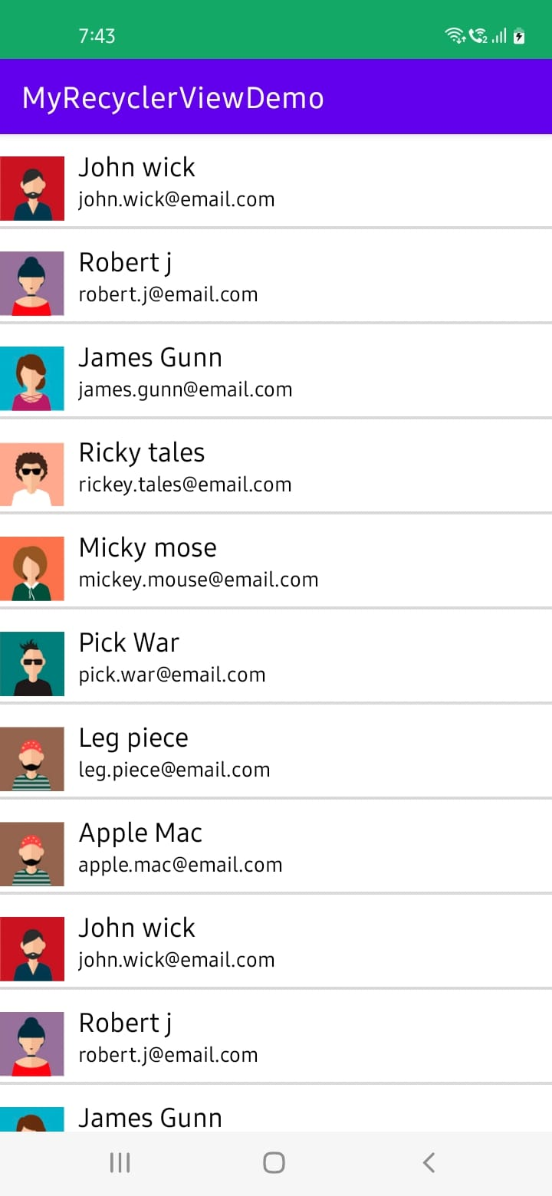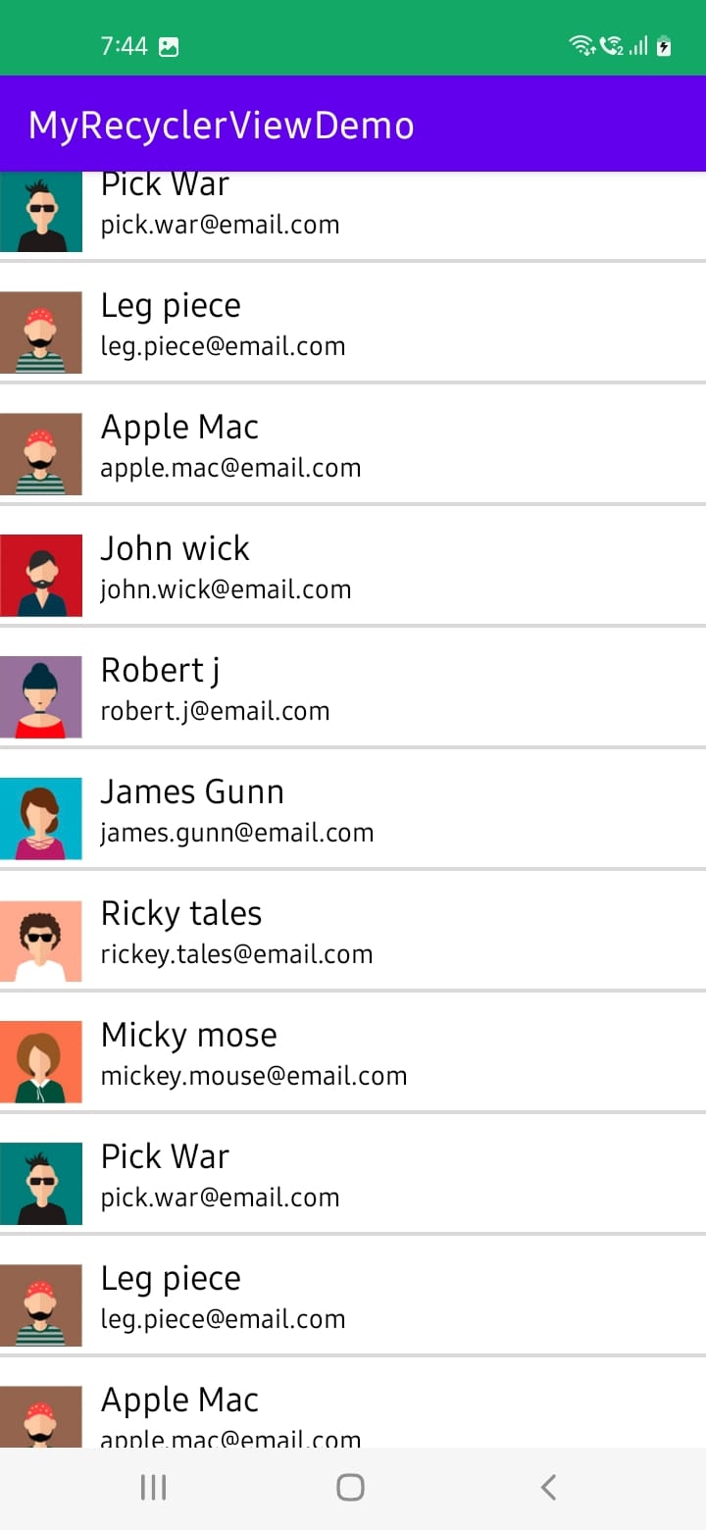

Experiment – 5
Aim: Build mobile application to switch from one activity to another using Intent.
Description:
An intent is to perform an action on the screen. It is mostly used to start activity, send broadcast receiver, start services and send message between two activities. There are two intents available in android as Implicit Intents and Explicit Intents. Here is a sample example to start new activity with old activity.
I. Implicit Intents
An implicit intent allows you to start an activity in another app by describing an action you
intend to perform, such as "share an article", "view a map", or "take a picture".
An implicit intent specifies an action and may provide data with which to perform the action.
Implicit intents do not specify the target activity class, just the intended action.
Android runtime matches the implicit intent request with registered intent handlers.
If there are multiple matches, an App Chooser will open to let the user decide.
In Implicit Intents we do not need to specify the name of the component. We just specify the Action which has to be performed and further this action is handled by the component of another application.
Syntax:
Intent intent = new Intent(Intent.ACTION_VIEW);
intent.setData(Uri.parse("https://www.google.com"));
startActivity(intent);
Program:
activity_main.xml
<LinearLayout
android:layout_height="match_parent"
android:layout_width="match_parent"
android:orientation="vertical"
xmlns:android="http://schemas.android.com/apk/res/android">
<TextView
android:text="Implicit Intents"
android:gravity="center"
android:textSize="30sp"
android:layout_marginTop="100dp"
android:textColor="#FDFBFB"
android:background="#D80E0E"
android:layout_width="match_parent"
android:layout_height="50dp"
android:layout_marginLeft="10sp"
android:layout_marginRight="10sp"/>
<EditText
android:id="@+id/input"
android:layout_marginTop="100dp"
android:hint="Enter the URL"
android:layout_width="match_parent"
android:layout_height="wrap_content"
android:layout_marginLeft="5sp"/>
<Button
android:onClick="submit"
android:layout_gravity="center"
android:text="Submit"
android:layout_marginTop="10dp"
android:id="@+id/btn"
android:layout_width="wrap_content"
android:layout_height="wrap_content"/>
</LinearLayout>
MainActivity.java
package com.example.implicitintents;
import androidx.appcompat.app.AppCompatActivity;
import android.content.Intent;
import android.net.Uri;
import android.os.Bundle;
import android.view.View;
import android.widget.EditText;
public class MainActivity extends AppCompatActivity {
EditText url;
@Override
protected void onCreate(Bundle savedInstanceState) {
super.onCreate(savedInstanceState);
setContentView(R.layout.activity_main);
url = findViewById(R.id.input);
}
public void submit(View view) {
String input = url.getText().toString();
Intent intent = new Intent(Intent.ACTION_VIEW, Uri.parse(input));
startActivity(intent);
}
}
Output:
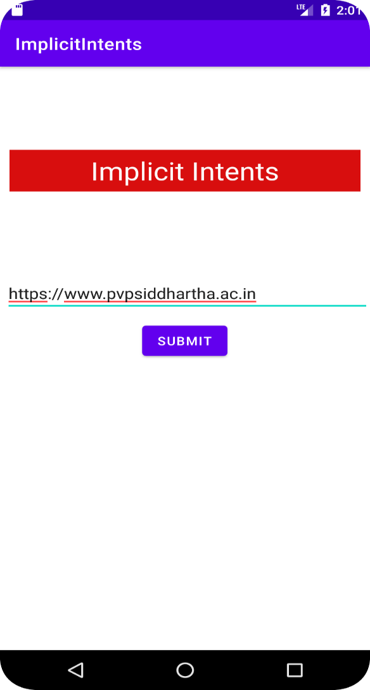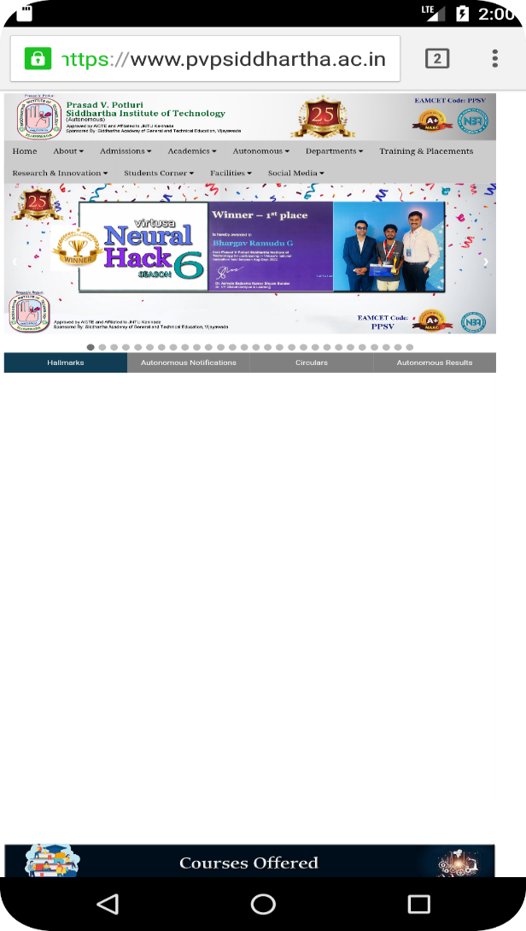

II. Explicit Intents
Explicit Intent specifies the component. In such case, intent provides the external class to be
invoked.
An explicit intent is used to launch a specific app component. Eg. a service in the app or a
particular activity.
To create an explicit intent, we need to define the component name for the intent object (all
other intent properties are optional).
The Intent (Context, Class) constructor supplies the app Context and the component a Class
object. As such, this intent explicitly starts the DownloadService class in the app.
Syntax:
To pass the data to second activity:
Intent intent = new Intent(MainActivity.this, SecondActivity.class);
intent.putExtra("Name", id);
startActivity(intent);
To receive the data from first activity:
Intent intent = getIntent();
String name = intent.getStringExtra("Name");
Program:
activity_main.xml
<LinearLayout
android:layout_height="match_parent"
android:layout_width="match_parent"
android:orientation="vertical"
xmlns:android="http://schemas.android.com/apk/res/android" >
<TextView
android:text="Average Calculator"
android:gravity="center"
android:textSize="30sp"
android:layout_marginTop="50dp"
android:textColor="#FDFBFB"
android:background="#6777D1"
android:layout_width="match_parent"
android:layout_height="50dp"
android:layout_marginLeft="10sp"
android:layout_marginRight="10sp"/>
<LinearLayout
android:layout_marginLeft="10dp"
android:layout_marginRight="10dp"
android:layout_marginTop="50dp"
android:orientation="horizontal"
android:layout_width="match_parent"
android:layout_height="wrap_content">
<TextView
android:textSize="20sp"
android:text="Student Name: "
android:layout_width="wrap_content"
android:layout_height="wrap_content"/>
<EditText
android:id="@+id/sid"
android:layout_width="match_parent"
android:layout_height="wrap_content"/>
</LinearLayout>
<LinearLayout
android:layout_marginLeft="10dp"
android:layout_marginRight="10dp"
android:layout_marginTop="5dp"
android:orientation="horizontal"
android:layout_width="match_parent"
android:layout_height="wrap_content">
<TextView
android:textSize="20sp"
android:text="Subject 1: "
android:layout_width="wrap_content"
android:layout_height="wrap_content"/>
<EditText
android:id="@+id/sub1"
android:layout_width="match_parent"
android:layout_height="wrap_content"/>
</LinearLayout>
<LinearLayout
android:layout_marginLeft="10dp"
android:layout_marginRight="10dp"
android:layout_marginTop="5dp"
android:orientation="horizontal"
android:layout_width="match_parent"
android:layout_height="wrap_content">
<TextView
android:textSize="20sp"
android:text="Subject 2: "
android:layout_width="wrap_content"
android:layout_height="wrap_content"/>
<EditText
android:id="@+id/sub2"
android:layout_width="match_parent"
android:layout_height="wrap_content"/>
</LinearLayout>
<LinearLayout
android:layout_marginLeft="10dp"
android:layout_marginRight="10dp"
android:layout_marginTop="5dp"
android:orientation="horizontal"
android:layout_width="match_parent"
android:layout_height="wrap_content">
<TextView
android:textSize="20sp"
android:text="Subject 3: "
android:layout_width="wrap_content"
android:layout_height="wrap_content"/>
<EditText
android:id="@+id/sub3"
android:layout_width="match_parent"
android:layout_height="wrap_content"/>
</LinearLayout>
<Button
android:onClick="percent"
android:layout_gravity="center"
android:text="Calculate Average"
android:layout_marginTop="10dp"
android:id="@+id/btn"
android:layout_width="wrap_content"
android:layout_height="wrap_content"/>
</LinearLayout>
MainActivity.java
package com.example.explicitintents;

import androidx.appcompat.app.AppCompatActivity;

import android.content.Intent;
import android.os.Bundle;
import android.util.Log;
import android.view.View;
import android.widget.EditText;

public class MainActivity extends AppCompatActivity {
EditText et1, et2, et3, et4, et5, et6;
@Override
protected void onCreate(Bundle savedInstanceState) {
super.onCreate(savedInstanceState);
setContentView(R.layout.activity_main);
et1 = findViewById(R.id.sid);
et2 = findViewById(R.id.sub1);
et3 = findViewById(R.id.sub2);
et4 = findViewById(R.id.sub3);

}
public void percent(View view) {
String id = et1.getText().toString();
int sub1 = Integer.parseInt(et2.getText().toString());
int sub2 = Integer.parseInt(et3.getText().toString());
int sub3 = Integer.parseInt(et4.getText().toString());
int total = sub1+sub2+sub3;
double per = (double)total/3;
Log.d("act",total+" "+per);
String res = String.valueOf(per);
Intent intent = new Intent(this, SecondActivity.class);
intent.putExtra("Percent",res);
intent.putExtra("sid",id);
startActivity(intent);
}
}
activity_second.xml
<LinearLayout
android:layout_height="match_parent"
android:layout_width="match_parent"
android:orientation="vertical"
xmlns:android="http://schemas.android.com/apk/res/android" >
<TextView
android:layout_marginLeft="10dp"
android:layout_marginTop="50dp"
android:textSize="30sp"
android:textColor="#4CAF50"
android:text="Student Average"
android:layout_width="match_parent"
android:layout_height="wrap_content"/>
<TextView
android:layout_marginRight="10dp"
android:layout_marginLeft="10dp"
android:layout_marginTop="30dp"
android:id="@+id/result"
android:layout_width="match_parent"
android:layout_height="50dp"/>
</LinearLayout>
SecondActivity.java
package com.example.explicitintents;

import androidx.appcompat.app.AppCompatActivity;

import android.content.Intent;
import android.os.Bundle;
import android.widget.TextView;
import android.widget.Toast;

public class SecondActivity extends AppCompatActivity {
TextView tv;
@Override
protected void onCreate(Bundle savedInstanceState) {
super.onCreate(savedInstanceState);
setContentView(R.layout.activity_second);
tv = findViewById(R.id.result);
Intent intent = getIntent();
String sid = intent.getStringExtra("sid");
String per = intent.getStringExtra("Percent");
tv.setText("Student "+sid+" : "+per);
}
@Override
public void onBackPressed() {
Toast.makeText(this,"You are not allowed to go back",Toast.LENGTH_LONG); }
}
Output:
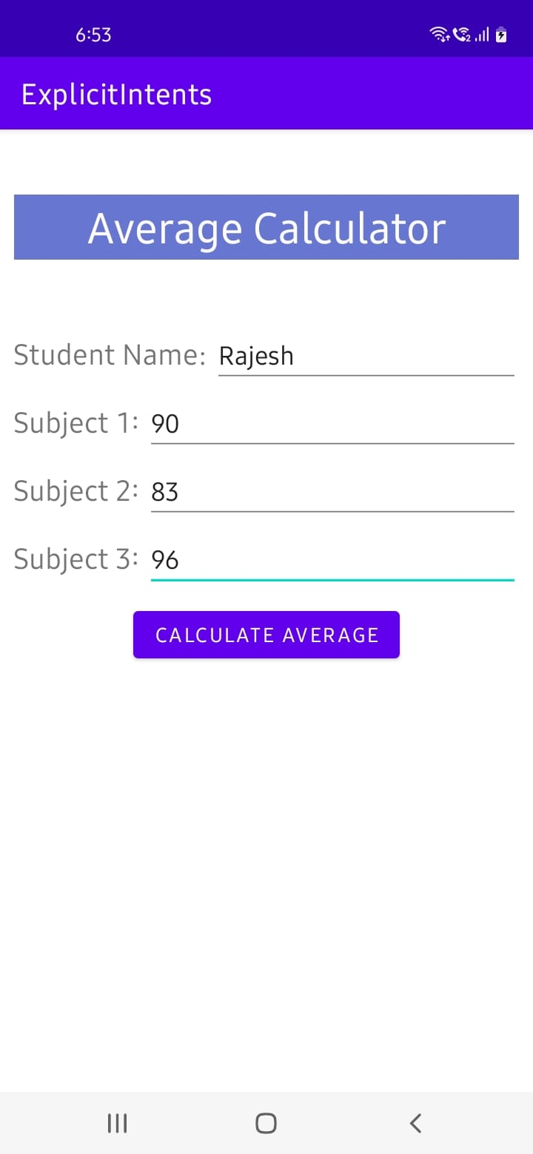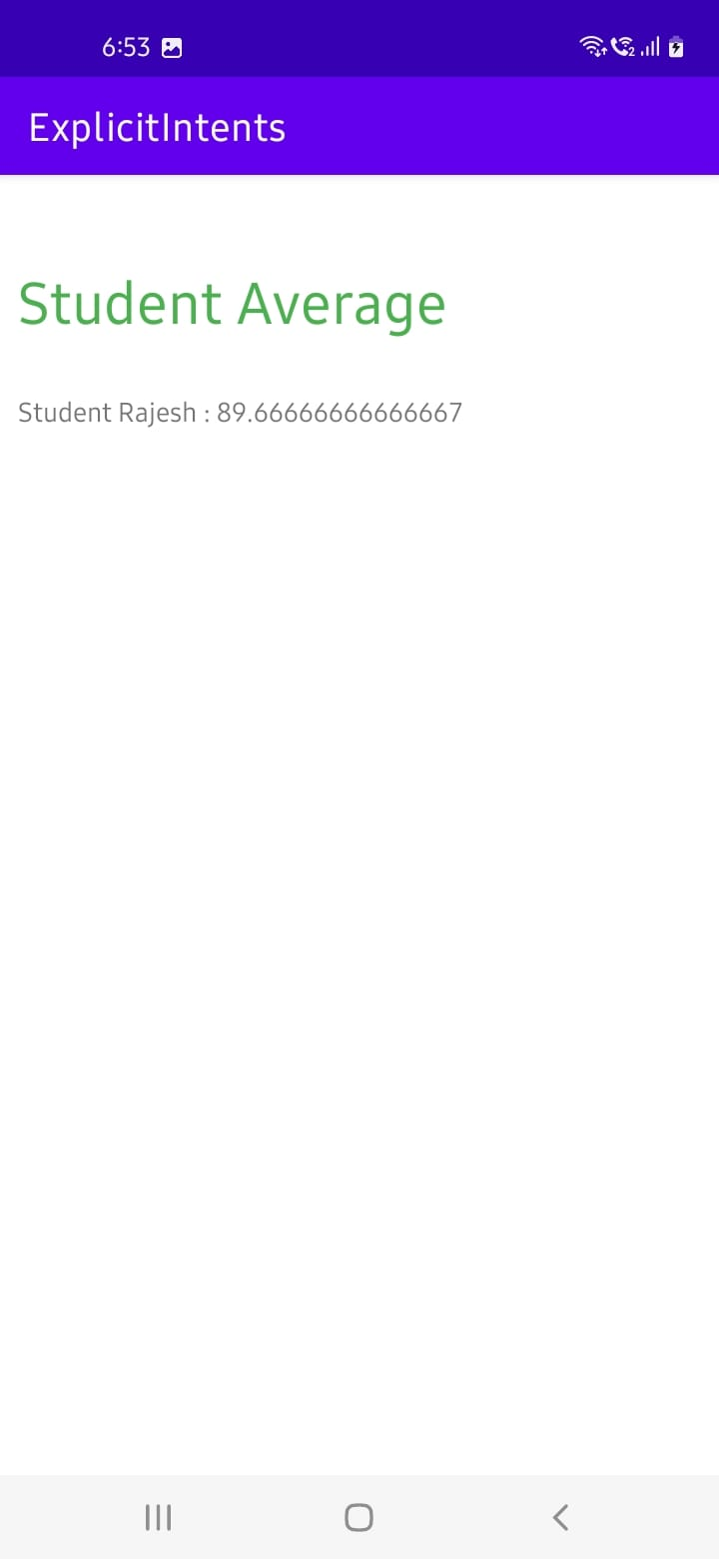
Experiment – 6
Aim: Build mobile application to demonstrate Dynamic Fragments.
Description:
Fragments are more often used for user interface purposes. Fragments are used when the user wants to see two different views of two different classes on the same screen. Fragments were added with Android Honeycomb. So, if you are developing an application only for Android 3.0 (HoneyComb) or higher, then Android provides you access to the Fragments class. You can also access the FragmentManager by calling the getFragmnetManager() method in your Activities.
Syntax:
To add the fragment:
FragmentManager fm=getSupportFragmentManager();
FragmentTransaction ft=fm.beginTransaction();
ft.add(R.id.f1,new frag1());
ft.addToBackStack(null);
ft.commit();
To remove the fragment:
FragmentManager fm=getSupportFragmentManager();
FragmentTransaction ft=fm.beginTransaction();
if(fm.getBackStackEntryCount()>0) {
fm.popBackStack();
Toast.makeText(this, "Fragment is deleted!!", Toast.LENGTH_SHORT).show();
}
ft.commit();
To replace the fragment:
FragmentManager fm=getSupportFragmentManager();
FragmentTransaction ft=fm.beginTransaction();
ft.replace(R.id.f1,new frag2());
Toast.makeText(this, "Fragment is replaced!!", Toast.LENGTH_SHORT).show();
ft.addToBackStack(null);
ft.commit();

Program:
activity_main.xml
<?xml version="1.0" encoding="utf-8"?>

<LinearLayout xmlns:android="http://schemas.android.com/apk/res/android"
xmlns:app="http://schemas.android.com/apk/res-auto"
xmlns:tools="http://schemas.android.com/tools"
android:layout_width="match_parent"
android:layout_height="match_parent"
tools:context=".MainActivity"
android:orientation="vertical">

<fragment
android:id="@+id/f1"
android:layout_width="match_parent"
android:layout_height="300dp"
class="com.example.dynamicfragment.frag2"
android:layout_margin="30dp"/>

<Button
android:id="@+id/add"
android:layout_width="match_parent"
android:layout_height="wrap_content"
android:text="Add the fragment"
android:onClick="add"/>
<Button
android:id="@+id/delete"
android:layout_width="match_parent"
android:layout_height="wrap_content"
android:text="Remove the fragment"
android:onClick="delete"/>
<Button
android:id="@+id/replace"
android:layout_width="match_parent"
android:layout_height="wrap_content"
android:text="Replace the fragment"
android:onClick="replace"/>

</LinearLayout>
MainActivity.java
package com.example.dynamicfragment;
import androidx.appcompat.app.AppCompatActivity;
import androidx.fragment.app.FragmentManager;
import androidx.fragment.app.FragmentTransaction;
import android.os.Bundle;
import android.view.View;
import android.widget.Toast;

public class MainActivity extends AppCompatActivity {

@Override
protected void onCreate(Bundle savedInstanceState) {
super.onCreate(savedInstanceState);
setContentView(R.layout.activity_main);
}

public void add(View v)
{

FragmentManager fm=getSupportFragmentManager();
FragmentTransaction ft=fm.beginTransaction();
ft.add(R.id.f1,new frag1());
Toast.makeText(this, "Fragment is added!!", Toast.LENGTH_SHORT).show();
ft.addToBackStack(null);
ft.commit();
}

public void delete(View v)
{

FragmentManager fm=getSupportFragmentManager();
FragmentTransaction ft=fm.beginTransaction();
if(fm.getBackStackEntryCount()>0) {
fm.popBackStack();
Toast.makeText(this, "Fragment is deleted!!", Toast.LENGTH_SHORT).show();
}

ft.commit();
}

public void replace(View v)
{

FragmentManager fm=getSupportFragmentManager();
FragmentTransaction ft=fm.beginTransaction();
ft.replace(R.id.f1,new frag2());
Toast.makeText(this, "Fragment is replaced!!", Toast.LENGTH_SHORT).show();
ft.addToBackStack(null);
ft.commit();
}
}
fragment_frag1.xml
<?xml version="1.0" encoding="utf-8"?>
<FrameLayout xmlns:android="http://schemas.android.com/apk/res/android"
xmlns:tools="http://schemas.android.com/tools"
android:layout_width="match_parent"
android:layout_height="match_parent"
tools:context=".frag1"
android:background="#C18383">

<TextView
android:layout_width="match_parent"
android:layout_height="match_parent"
android:text="Hello"
android:textSize="50dp"
android:textColor="#3F51B5"
android:gravity="center"/>

</FrameLayout>
frag1.java
package com.example.dynamicfragment;
import android.os.Bundle;
import androidx.fragment.app.Fragment;
import android.view.LayoutInflater;
import android.view.View;
import android.view.ViewGroup;
public class frag1 extends Fragment {

public frag1() {

}

@Override
public View onCreateView(LayoutInflater l, ViewGroup container,
Bundle savedInstanceState) {
// Inflate the layout for this fragment
View v= l.inflate(R.layout.fragment_frag1, container, false);
return v;
}

}
fragment_frag2.xml
<?xml version="1.0" encoding="utf-8"?>
<FrameLayout
xmlns:android="http://schemas.android.com/apk/res/android"
xmlns:tools="http://schemas.android.com/tools"
android:layout_width="match_parent"
android:layout_height="match_parent"
tools:context=".frag2"
android:background="@color/teal_200">

<TextView
android:layout_width="match_parent"
android:layout_height="match_parent"
android:text="World"
android:textColor="#3F51B5"
android:textSize="50dp"
android:gravity="center"
/>

</FrameLayout>
frag2.java
package com.example.dynamicfragment;
import android.os.Bundle;

import androidx.fragment.app.Fragment;

import android.view.LayoutInflater;
import android.view.View;
import android.view.ViewGroup;

public class frag2 extends Fragment {

public frag2() {
}

@Override
public View onCreateView(LayoutInflater inflater, ViewGroup container, Bundle savedInstanceState) {
View v=inflater.inflate(R.layout.fragment_frag2, container, false);
return v;
}

}

Output:
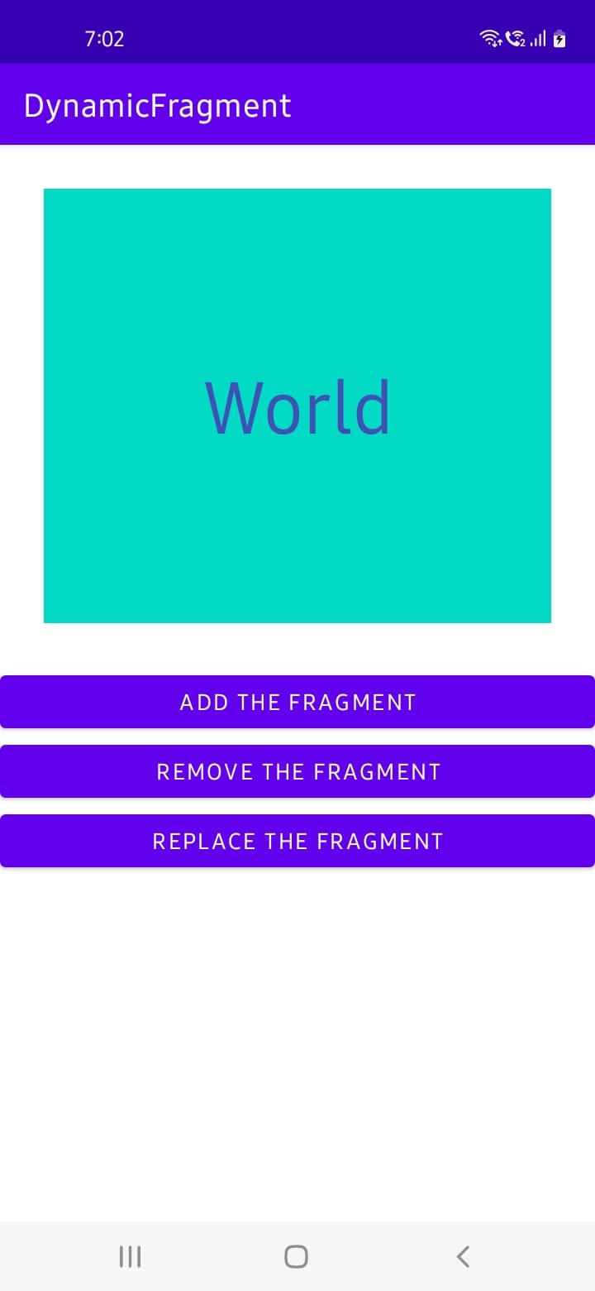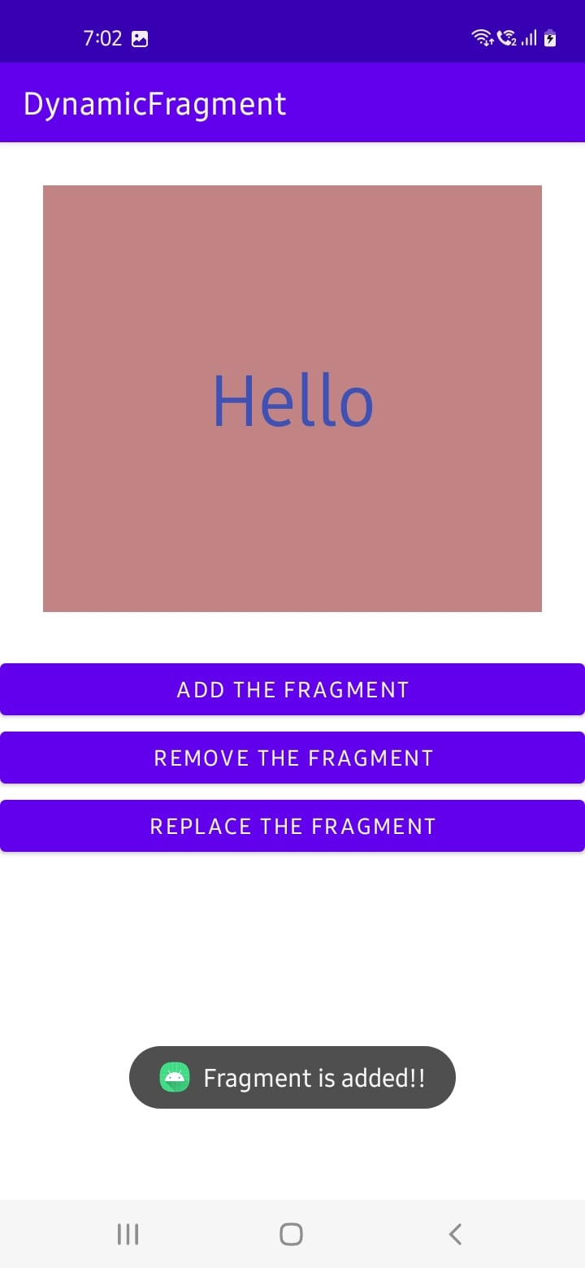

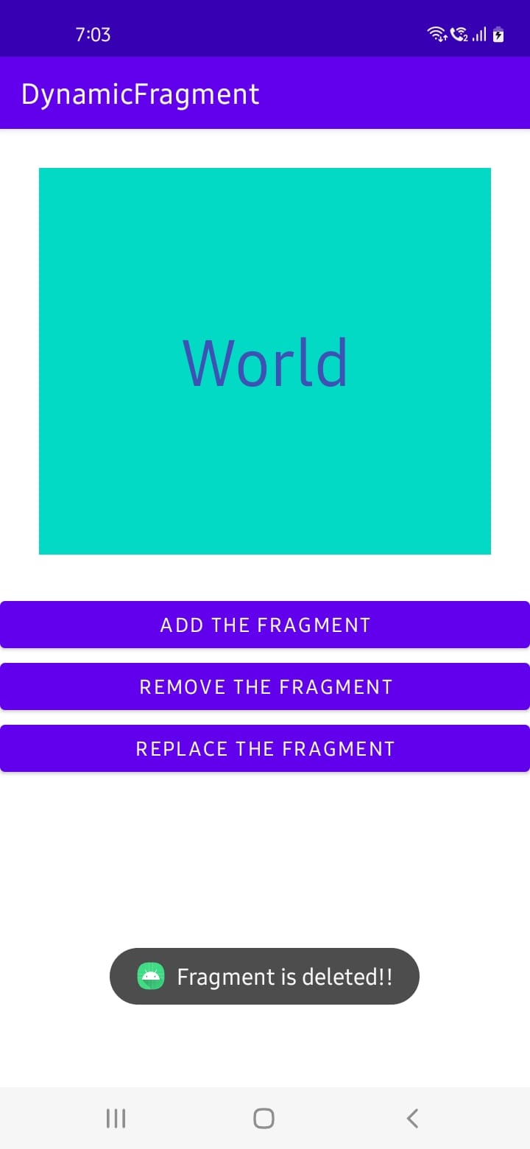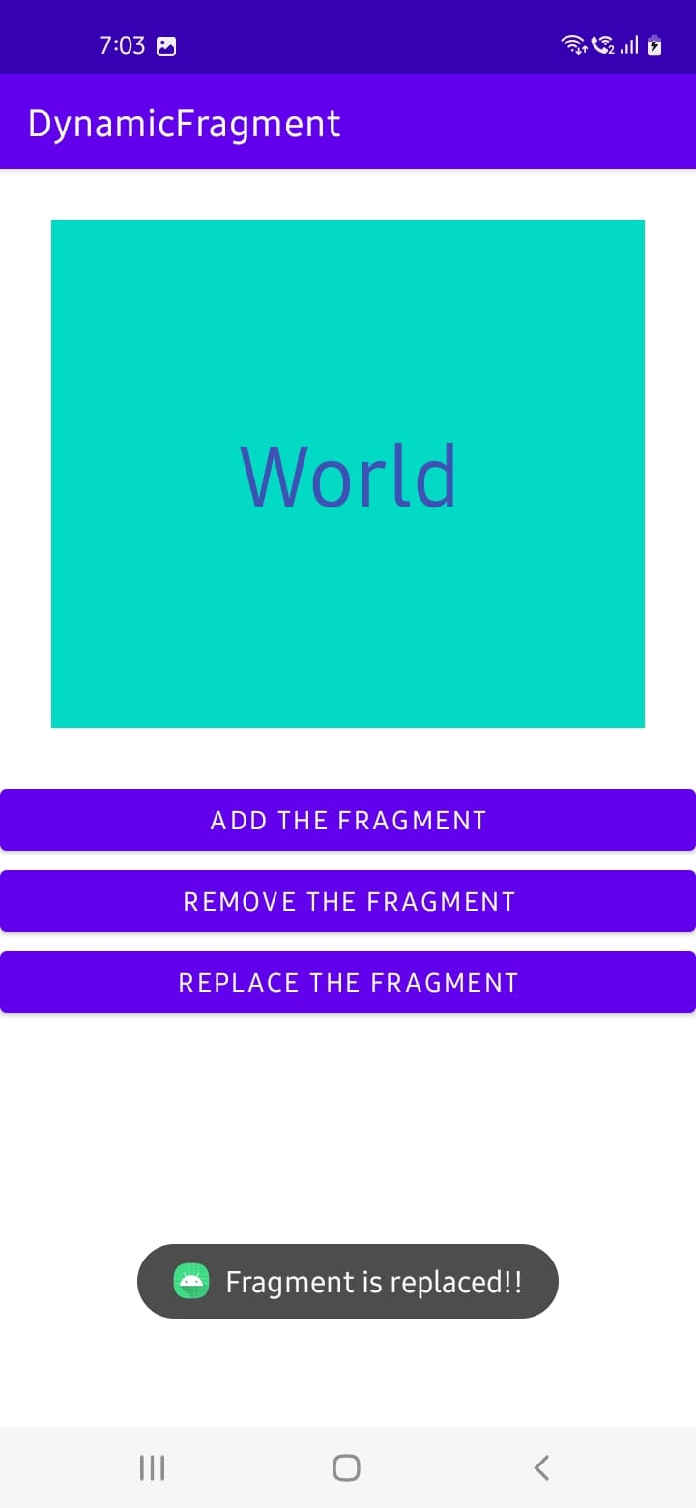

Experiment – 7
Aim: Build mobile application serverless database SQLite Database, Firebase (cloud-hosted database).
I. SQLite
Description:
SQLite is an open-source relational database that is used to perform database operations on android devices such as storing, manipulating or retrieving persistent data from the database. It is embedded in android by default. So, there is no need to perform any database setup or administration task.
SQLite is a software library that implements SQL database engine that is:
• Self-contained (requires no other components)
• Serverless (requires no server backend)
• Zero-configuration (does not need to be configured for your application)
• Transactional (changes within a single transaction in SQLite either occurs completely or not at all)
Program (CRUD Operations)
activity_main.xml
<?xml version="1.0" encoding="utf-8"?>
<androidx.constraintlayout.widget.ConstraintLayout xmlns:android="http://schemas.android.com/apk/res/android"
xmlns:app="http://schemas.android.com/apk/res-auto"
xmlns:tools="http://schemas.android.com/tools"
android:layout_width="match_parent"
android:layout_height="match_parent"
tools:context=".MainActivity">
<EditText
android:id="@+id/editTextTextPersonName"
android:layout_width="312dp"
android:layout_height="68dp"
android:layout_marginTop="24dp"
android:ems="10"
android:hint="Course"
android:inputType="textPersonName"
app:layout_constraintEnd_toEndOf="parent"
app:layout_constraintHorizontal_bias="0.494"
app:layout_constraintStart_toStartOf="parent"
app:layout_constraintTop_toBottomOf="@+id/editTextTextPersonName4" />

<EditText
android:id="@+id/editTextTextPersonName3"
android:layout_width="312dp"
android:layout_height="68dp"
android:layout_marginTop="24dp"
android:ems="10"
android:hint="Name"
android:inputType="textPersonName"
app:layout_constraintEnd_toEndOf="parent"
app:layout_constraintHorizontal_bias="0.494"
app:layout_constraintStart_toStartOf="parent"
app:layout_constraintTop_toTopOf="parent" />

<EditText
android:id="@+id/editTextTextPersonName4"
android:layout_width="312dp"
android:layout_height="68dp"
android:layout_marginTop="24dp"
android:ems="10"
android:hint="Section"
android:inputType="textPersonName"
app:layout_constraintEnd_toEndOf="parent"
app:layout_constraintHorizontal_bias="0.494"
app:layout_constraintStart_toStartOf="parent"
app:layout_constraintTop_toBottomOf="@+id/editTextTextPersonName3" />

<EditText
android:id="@+id/editTextTextPersonName5"
android:layout_width="312dp"
android:layout_height="68dp"
android:layout_marginTop="24dp"
android:ems="10"
android:hint="Year"
android:inputType="textPersonName"
app:layout_constraintEnd_toEndOf="parent"
app:layout_constraintHorizontal_bias="0.494"
app:layout_constraintStart_toStartOf="parent"
app:layout_constraintTop_toBottomOf="@+id/editTextTextPersonName" />

<Button
android:id="@+id/button"
android:layout_width="209dp"
android:layout_height="58dp"
android:layout_marginTop="20dp"
android:onClick="insert_Data"
android:text="CREATE"
android:textSize="20sp"
app:layout_constraintEnd_toEndOf="parent"
app:layout_constraintStart_toStartOf="parent"
app:layout_constraintTop_toBottomOf="@+id/editTextTextPersonName5" />

<Button
android:id="@+id/button2"
android:layout_width="209dp"
android:layout_height="58dp"
android:layout_marginTop="8dp"
android:onClick="update_Data"
android:text="UPDATE"
android:textSize="20sp"
app:layout_constraintEnd_toEndOf="parent"
app:layout_constraintStart_toStartOf="parent"
app:layout_constraintTop_toBottomOf="@+id/button3" />

<Button
android:id="@+id/button3"
android:layout_width="209dp"
android:layout_height="58dp"
android:layout_marginTop="8dp"
android:onClick="delete_Data"
android:text="DELETE"
android:textSize="20sp"
app:layout_constraintEnd_toEndOf="parent"
app:layout_constraintStart_toStartOf="parent"
app:layout_constraintTop_toBottomOf="@+id/button4" />

<Button
android:id="@+id/button4"
android:layout_width="209dp"
android:layout_height="58dp"
android:layout_marginTop="8dp"
android:onClick="view_Data"
android:text="READ"
android:textSize="20sp"
app:layout_constraintEnd_toEndOf="parent"
app:layout_constraintStart_toStartOf="parent"
app:layout_constraintTop_toBottomOf="@+id/button" />

</androidx.constraintlayout.widget.ConstraintLayout>

MainActivity.java
package com.example.myapplication;
import androidx.appcompat.app.*;
import android.database.*;
import android.os.Bundle;
import android.view.View;
import android.widget.*;

public class MainActivity extends AppCompatActivity {

//initialize variables
EditText name, age, address, course;
Button insert, update, delete, view;
DBHelper DB;

@Override
protected void onCreate(Bundle savedInstanceState) {
super.onCreate(savedInstanceState);
setContentView(R.layout.activity_main);

//EditTexts UI
name = findViewById(R.id.editTextTextPersonName3);
age = findViewById(R.id.editTextTextPersonName4);
address = findViewById(R.id.editTextTextPersonName5);
course = findViewById(R.id.editTextTextPersonName);

//Buttons UI
insert = findViewById(R.id.button);
update = findViewById(R.id.button2);
delete = findViewById(R.id.button3);
view = findViewById(R.id.button4);

//initialize Database
DB = new DBHelper(this);

}

public void insert_Data(View v) {
String nameTXT = name.getText().toString();
String ageTXT = age.getText().toString();
String courseTXT = course.getText().toString();
String addressTXT = address.getText().toString();

Boolean checkInsertData = DB.insertuserdata(nameTXT, ageTXT, addressTXT, courseTXT);
if (checkInsertData)
Toast.makeText(MainActivity.this, "Data Inserted", Toast.LENGTH_SHORT).show();
else
Toast.makeText(MainActivity.this, "Data Not Inserted", Toast.LENGTH_SHORT).show();

DB.close();
}

public void update_Data(View v){
String nameTXT = name.getText().toString();
String ageTXT = age.getText().toString();
String addressTXT = address.getText().toString();
String courseTXT = course.getText().toString();

Boolean checkUpdateData = DB.updateuserdata(nameTXT, ageTXT, addressTXT, courseTXT);
if(checkUpdateData)
Toast.makeText(MainActivity.this, "Entry Updated", Toast.LENGTH_SHORT).show();
else
Toast.makeText(MainActivity.this, "New Entry Not Updated", Toast.LENGTH_SHORT).show();

DB.close();
}

public void delete_Data(View v){
String nameTXT = name.getText().toString();
Boolean checkDeleteData = DB.deletedata(nameTXT);
if(checkDeleteData)
Toast.makeText(MainActivity.this, "Entry Deleted", Toast.LENGTH_SHORT).show();
else
Toast.makeText(MainActivity.this, "Entry Not Deleted", Toast.LENGTH_SHORT).show();

DB.close();
}

public void view_Data(View v){
Cursor res = DB.getdata();
if(res.getCount()==0){
Toast.makeText(MainActivity.this, "No Entry Exists", Toast.LENGTH_SHORT).show();
return;
}

StringBuffer buffer = new StringBuffer();
while(res.moveToNext()){
buffer.append("Name: "+res.getString(0)+"\n");
buffer.append("Section: "+res.getString(1)+"\n");
buffer.append("Course: "+res.getString(3)+"\n");
buffer.append("Year: "+res.getString(2)+"\n\n");
}

//alert pop-up for viewing all data
AlertDialog.Builder builder = new AlertDialog.Builder(MainActivity.this);
builder.setCancelable(true);
builder.setTitle("User Entries");
builder.setMessage(buffer.toString());
builder.show();

DB.close();
}
}

DBHelper.java
package com.example.myapplication;
import android.content.*;
import android.database.Cursor;
import android.database.sqlite.*;
public class DBHelper extends SQLiteOpenHelper {

public DBHelper(Context context) {
super(context, "Userdata.db", null, 1);
}
@Override
public void onCreate(SQLiteDatabase DB) {
DB.execSQL("create Table Userdetails(name TEXT primary key, age TEXT, address TEXT, course TEXT)");
}
@Override
public void onUpgrade(SQLiteDatabase DB, int i, int ii) {
DB.execSQL("drop Table if exists Userdetails");
}
public Boolean insertuserdata(String name, String age, String address, String course)
{
SQLiteDatabase DB = this.getWritableDatabase();
ContentValues contentValues = new ContentValues();
contentValues.put("name", name);
contentValues.put("age", age);
contentValues.put("address", address);
contentValues.put("course", course);
long result=DB.insert("Userdetails", null, contentValues);
if(result==-1){
return false;
}else{
return true;
}
}
public Boolean updateuserdata(String name, String age, String address, String course)
{
SQLiteDatabase DB = this.getWritableDatabase();
ContentValues contentValues = new ContentValues();
contentValues.put("age", age);
contentValues.put("address", address);
contentValues.put("course", course);
Cursor cursor = DB.rawQuery("Select * from Userdetails where name = ?", new String[]{name});
if (cursor.getCount() > 0) {
long result = DB.update("Userdetails", contentValues, "name=?", new String[]{name});
if (result == -1) {
return false;
} else {
return true;
}
} else {
return false;
}
}
public Boolean deletedata (String name)
{
SQLiteDatabase DB = this.getWritableDatabase();
Cursor cursor = DB.rawQuery("Select * from Userdetails where name = ?", new String[]{name});
if (cursor.getCount() > 0) {
long result = DB.delete("Userdetails", "name=?", new String[]{name});
if (result == -1) {
return false;
} else {
return true;
}
} else {
return false;
}
}
public Cursor getdata ()
{
SQLiteDatabase DB = this.getWritableDatabase();
Cursor cursor = DB.rawQuery("Select * from Userdetails", null);
return cursor;
}
}

Output:
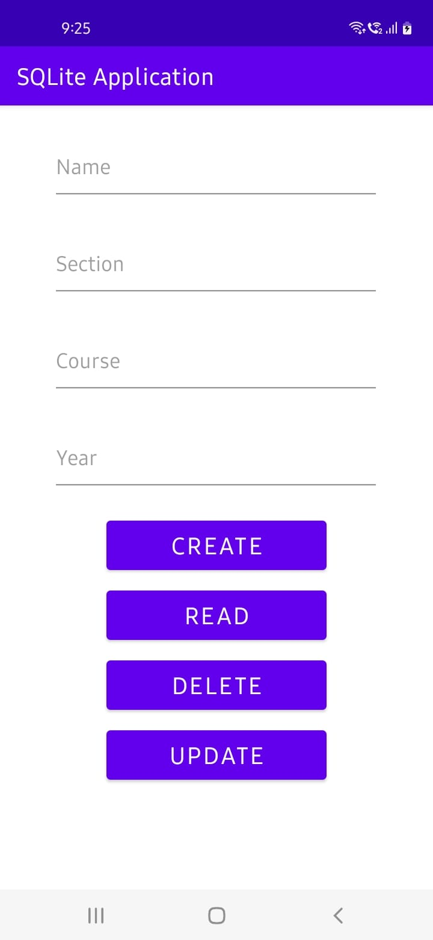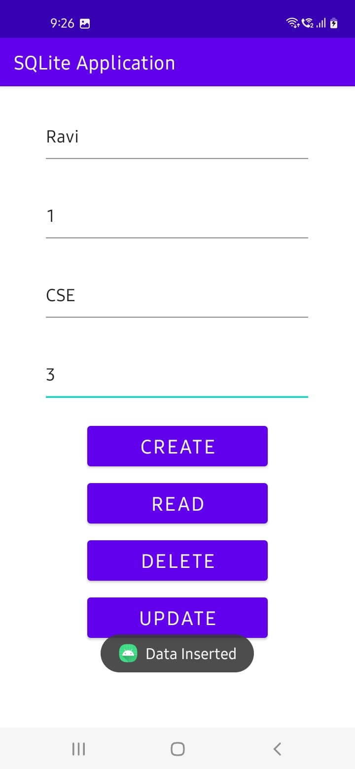
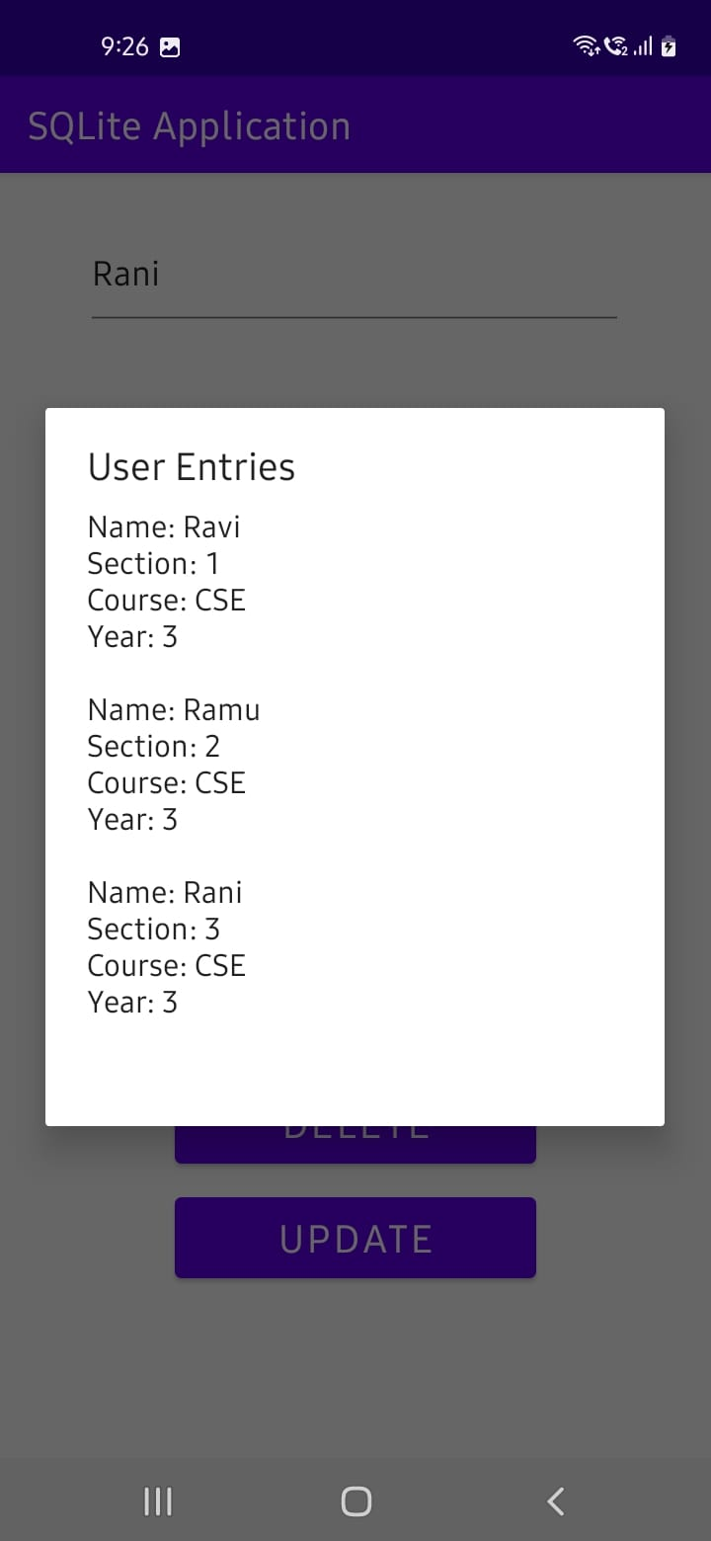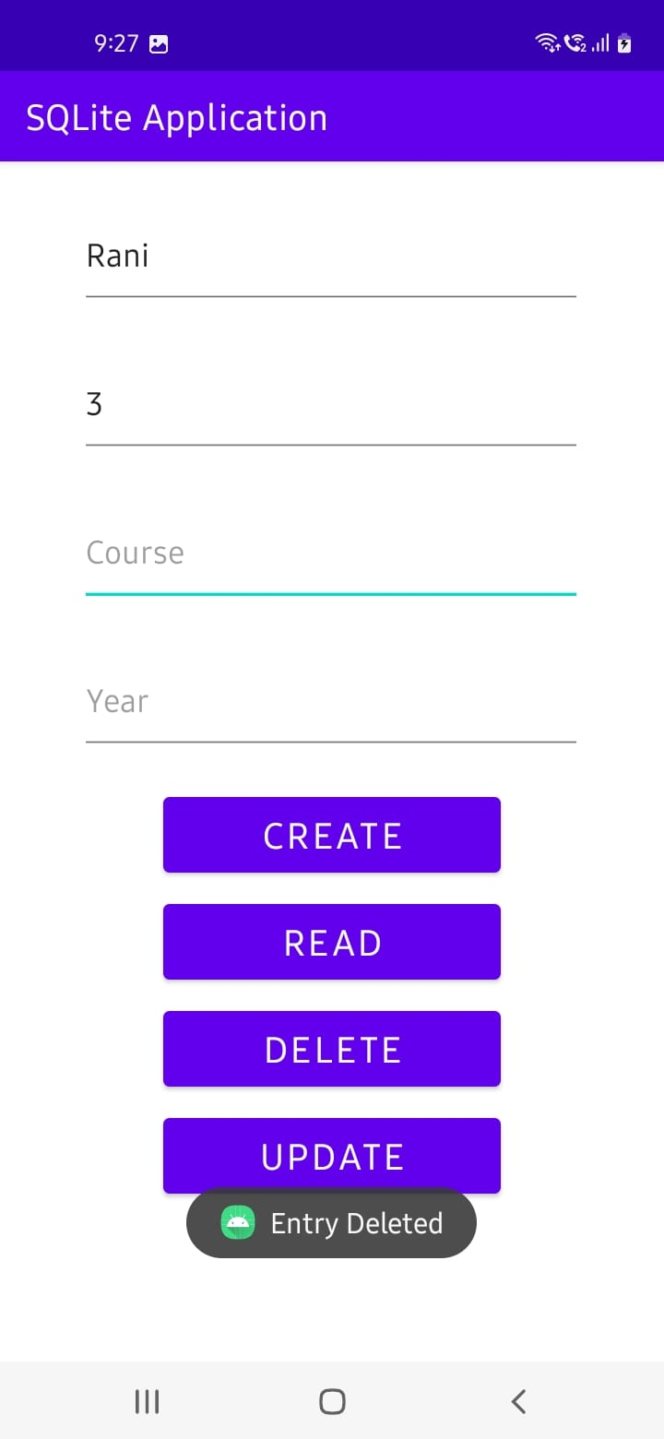
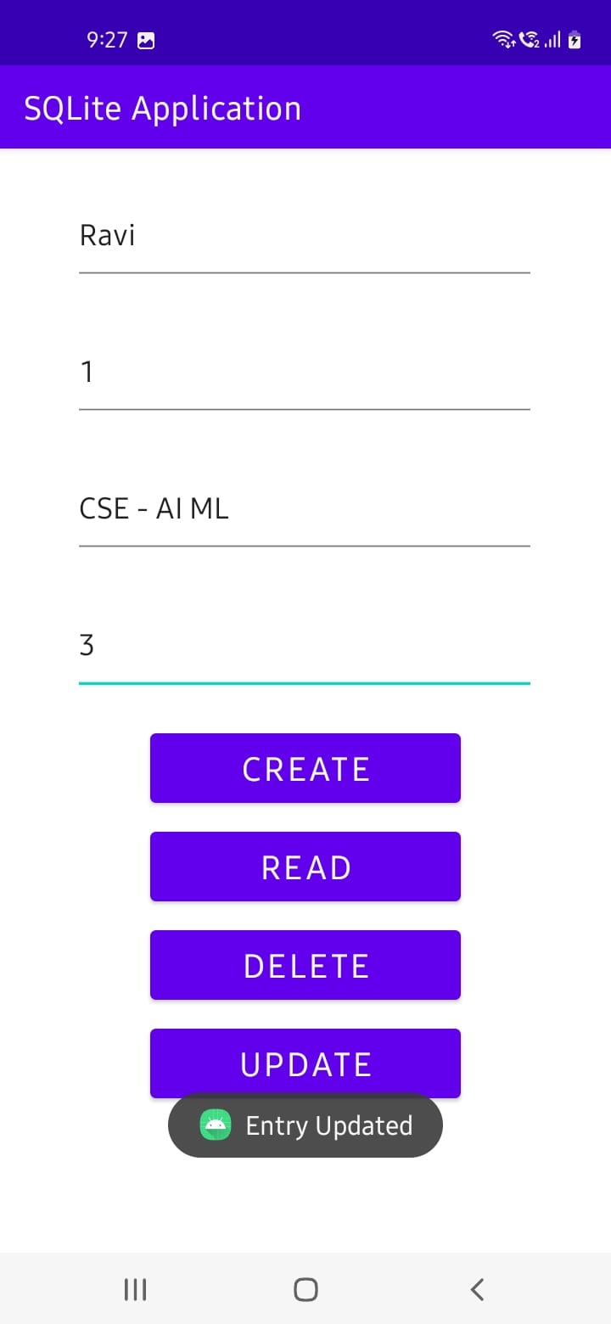

II. Firebase
Description:
The Firebase Realtime Database is a cloud-hosted database in which data is stored as JSON. The data is synchronized in real-time to every connected client. All of our clients share one Realtime Database instances and automatically receive updates with the newest data, when we build cross-platform applications with our iOS, and JavaScript SDKs.
The Firebase Realtime Database is a NoSQL database from which we can store and sync the data between our users in real-time. It is a big JSON object which the developers can manage in real-time. By using a single API, the Firebase database provides the application with the current value of the data and updates to that data. Real-time syncing makes it easy for our users to access their data from any device, be it web or mobile.

Program: (CRUD Operations using Firebase)
activity_main.xml
<?xml version="1.0" encoding="utf-8"?>
<LinearLayout xmlns:android="http://schemas.android.com/apk/res/android"
xmlns:tools="http://schemas.android.com/tools"
android:layout_width="match_parent"
android:layout_height="match_parent"
android:orientation="vertical"
tools:context=".MainActivity">

<androidx.recyclerview.widget.RecyclerView
android:id="@+id/recyclerView"
android:layout_width="match_parent"
android:layout_height="0dp"
android:layout_weight="1" />

<androidx.appcompat.widget.AppCompatButton
android:id="@+id/buttonAdd"
android:layout_width="match_parent"
android:layout_height="50dp"
android:background="@android:color/holo_green_dark"
android:text="ADD NEW USER"
android:textColor="@android:color/white"
android:textStyle="bold"/>

</LinearLayout>
alert_dialog_add_new_user.xml
<?xml version="1.0" encoding="utf-8"?>
<androidx.cardview.widget.CardView xmlns:android="http://schemas.android.com/apk/res/android"
xmlns:app="http://schemas.android.com/apk/res-auto"
android:layout_width="300dp"
android:layout_height="wrap_content"
android:layoutDirection="ltr"
app:cardBackgroundColor="@android:color/white"
app:cardCornerRadius="5dp">

<LinearLayout
android:layout_width="match_parent"
android:layout_height="match_parent"
android:orientation="vertical"
android:padding="10dp">

<EditText
android:id="@+id/textName"
android:layout_width="match_parent"
android:layout_height="40dp"
android:layout_gravity="center"
android:layout_margin="3dp"
android:gravity="center"
android:hint="User name"
android:padding="5dp"
android:textColor="@android:color/black"
android:textColorHint="@android:color/black"
android:textSize="18sp"
android:textStyle="bold" />

<EditText
android:id="@+id/textEmail"
android:layout_width="match_parent"
android:layout_height="40dp"
android:layout_gravity="center"
android:layout_margin="3dp"
android:gravity="center"
android:hint="User email"
android:padding="5dp"
android:textColor="@android:color/black"
android:textColorHint="@android:color/black"
android:textSize="18sp"
android:textStyle="bold" />

<EditText
android:id="@+id/textCountry"
android:layout_width="match_parent"
android:layout_height="40dp"
android:layout_gravity="center"
android:layout_margin="3dp"
android:gravity="center"
android:hint="User Country"
android:padding="5dp"
android:textColor="@android:color/black"
android:textColorHint="@android:color/black"
android:textSize="18sp"
android:textStyle="bold" />

<androidx.appcompat.widget.AppCompatButton
android:id="@+id/buttonAdd"
android:layout_width="match_parent"
android:layout_height="match_parent"
android:layout_marginTop="15sp"
android:background="@android:color/holo_blue_dark"
android:text="Add"
android:textColor="@android:color/black"
android:textSize="20dp"
android:textStyle="bold" />

<androidx.appcompat.widget.AppCompatButton
android:id="@+id/buttonCancel"
android:layout_width="match_parent"
android:layout_height="50sp"
android:layout_marginTop="5dp"
android:background="@android:color/holo_red_light"
android:text="Exit"
android:textColor="@android:color/black"
android:textSize="20dp"
android:textStyle="bold" />
</LinearLayout>
</androidx.cardview.widget.CardView>
user_item.xml
<?xml version="1.0" encoding="utf-8"?>
<LinearLayout xmlns:android="http://schemas.android.com/apk/res/android"
android:layout_width="match_parent"
android:padding="4sp"
android:layout_margin="4sp"
android:orientation="vertical"
android:layout_height="wrap_content">

<TextView
android:id="@+id/textName"
android:layout_width="match_parent"
android:layout_height="wrap_content"
android:textColor="@android:color/black"
android:textStyle="bold"
android:textSize="18sp"
android:text="User name"/>

<TextView
android:id="@+id/textEmail"
android:layout_width="match_parent"
android:layout_height="wrap_content"
android:textColor="@android:color/black"
android:textStyle="italic"
android:textSize="18sp"
android:text="User email"/>

<TextView
android:id="@+id/textCountry"
android:layout_width="match_parent"
android:layout_height="wrap_content"
android:textColor="@android:color/black"
android:textStyle="italic"
android:textSize="18sp"
android:text="User country"/>

<LinearLayout
android:layout_width="match_parent"
android:orientation="horizontal"
android:layout_margin="4sp"
android:padding="4sp"
android:layout_height="wrap_content">

<androidx.appcompat.widget.AppCompatButton
android:id="@+id/buttonDelete"
android:layout_width="0dp"
android:layout_height="40dp"
android:layout_weight="1"
android:layout_margin="3dp"
android:background="@android:color/holo_red_light"
android:text="DELETE"
android:textColor="@android:color/black"/>

<androidx.appcompat.widget.AppCompatButton
android:id="@+id/buttonUpdate"
android:layout_width="0dp"
android:layout_height="40dp"
android:layout_weight="1"
android:layout_margin="3dp"
android:background="@android:color/holo_blue_dark"
android:text="UPDATE"
android:textColor="@android:color/white"/>

</LinearLayout>
</LinearLayout>
view_dialog_confirm_delete.xml
<?xml version="1.0" encoding="utf-8"?>
<androidx.cardview.widget.CardView xmlns:android="http://schemas.android.com/apk/res/android"
xmlns:app="http://schemas.android.com/apk/res-auto"
android:layout_width="300dp"
android:layout_height="wrap_content"
android:layoutDirection="ltr"
app:cardBackgroundColor="@android:color/white"
app:cardCornerRadius="5dp">

<LinearLayout
android:layout_width="match_parent"
android:layout_height="match_parent"
android:orientation="vertical"
android:padding="10dp">

<TextView
android:id="@+id/textTitle"
android:layout_width="match_parent"
android:layout_height="wrap_content"
android:layout_gravity="center"
android:gravity="center"
android:padding="5dp"
android:text="Are you sure ?"
android:textColor="@android:color/black"
android:textSize="18sp"
android:textStyle="bold" />

<androidx.appcompat.widget.AppCompatButton
android:id="@+id/buttonDelete"
android:layout_width="match_parent"
android:layout_height="match_parent"
android:layout_marginTop="15sp"
android:background="@android:color/holo_red_light"
android:text="Yes, Delete"
android:textColor="@android:color/black"
android:textSize="20dp"
android:textStyle="bold" />

<androidx.appcompat.widget.AppCompatButton
android:id="@+id/buttonCancel"
android:layout_width="match_parent"
android:layout_height="50sp"
android:layout_marginTop="5dp"
android:background="@android:color/holo_blue_dark"
android:text="No, Exit"
android:textColor="@android:color/black"
android:textSize="20dp"
android:textStyle="bold" />
</LinearLayout>
</androidx.cardview.widget.CardView>
MainActivity.java
package com.example.realtimedbaddreadupdatedelete;

import androidx.annotation.*;
import androidx.appcompat.app.AppCompatActivity;
import androidx.recyclerview.widget.*;

import android.annotation.SuppressLint;
import android.app.*;
import android.content.*;
import android.graphics.*;
import android.graphics.drawable.ColorDrawable;
import android.os.Bundle;
import android.view.*;
import android.widget.*;
import com.google.firebase.database.*;
import java.util.*;

public class MainActivity extends AppCompatActivity {

DatabaseReference databaseReference;

RecyclerView recyclerView;
ArrayList<UsersItem> usersItemArrayList;
UsersRecyclerAdapter adapter;

Button buttonAdd;

@Override
protected void onCreate(Bundle savedInstanceState) {
super.onCreate(savedInstanceState);
setContentView(R.layout.activity_main);
FirebaseDatabase.getInstance().setPersistenceEnabled(true); // work offline
Objects.requireNonNull(getSupportActionBar()).hide();

databaseReference = FirebaseDatabase.getInstance().getReference();

recyclerView = findViewById(R.id.recyclerView);
recyclerView.setHasFixedSize(true);
recyclerView.setLayoutManager(new LinearLayoutManager(this));

usersItemArrayList = new ArrayList<>();

buttonAdd = findViewById(R.id.buttonAdd);
buttonAdd.setOnClickListener(new View.OnClickListener() {
@Override
public void onClick(View view) {
ViewDialogAdd viewDialogAdd = new ViewDialogAdd();
viewDialogAdd.showDialog(MainActivity.this);
}
});

readData();
}

private void readData() {

databaseReference.child("USERS").orderByChild("userName").addValueEventListener(new ValueEventListener() {
@SuppressLint("NotifyDataSetChanged")
@Override
public void onDataChange(@NonNull DataSnapshot snapshot) {
usersItemArrayList.clear();
for (DataSnapshot dataSnapshot : snapshot.getChildren()) {
UsersItem users = dataSnapshot.getValue(UsersItem.class);
usersItemArrayList.add(users);
}
adapter = new UsersRecyclerAdapter(MainActivity.this, usersItemArrayList);
recyclerView.setAdapter(adapter);
adapter.notifyDataSetChanged();
}

@Override
public void onCancelled(@NonNull DatabaseError error) {

}
});

}

public class ViewDialogAdd {
public void showDialog(Context context) {
final Dialog dialog = new Dialog(context);
dialog.requestWindowFeature(Window.FEATURE_NO_TITLE);
dialog.setCancelable(false);
dialog.setContentView(R.layout.alert_dialog_add_new_user);

EditText textName = dialog.findViewById(R.id.textName);
EditText textEmail = dialog.findViewById(R.id.textEmail);
EditText textCountry = dialog.findViewById(R.id.textCountry);

Button buttonAdd = dialog.findViewById(R.id.buttonAdd);
Button buttonCancel = dialog.findViewById(R.id.buttonCancel);

buttonAdd.setText("ADD");
buttonCancel.setOnClickListener(new View.OnClickListener() {
@Override
public void onClick(View view) {
dialog.dismiss();
}
});

buttonAdd.setOnClickListener(new View.OnClickListener() {
@Override
public void onClick(View view) {
String id = "user" + new Date().getTime();
String name = textName.getText().toString();
String email = textEmail.getText().toString();
String country = textCountry.getText().toString();

if (name.isEmpty() || email.isEmpty() || country.isEmpty()) {
Toast.makeText(context, "Please Enter All data...", Toast.LENGTH_SHORT).show();
} else {
databaseReference.child("USERS").child(id).setValue(new UsersItem(id, name, email, country));
Toast.makeText(context, "DONE!", Toast.LENGTH_SHORT).show();
dialog.dismiss();
}
}
});

dialog.getWindow().setBackgroundDrawable(new ColorDrawable(Color.TRANSPARENT));
dialog.show();

}
}
}
UsersRecyclerAdapter.java
package com.example.realtimedbaddreadupdatedelete;

import android.app.Dialog;
import android.content.Context;
import android.graphics.Color;
import android.graphics.drawable.ColorDrawable;
import android.view.LayoutInflater;
import android.view.View;
import android.view.ViewGroup;
import android.view.Window;
import android.widget.Button;
import android.widget.EditText;
import android.widget.TextView;
import android.widget.Toast;

import androidx.annotation.NonNull;
import androidx.recyclerview.widget.RecyclerView;

import com.google.firebase.database.DatabaseReference;
import com.google.firebase.database.FirebaseDatabase;

import java.util.ArrayList;

public class UsersRecyclerAdapter extends RecyclerView.Adapter<UsersRecyclerAdapter.ViewHolder> {

Context context;
ArrayList<UsersItem> usersItemArrayList;
DatabaseReference databaseReference;

public UsersRecyclerAdapter(Context context, ArrayList<UsersItem> usersItemArrayList) {
this.context = context;
this.usersItemArrayList = usersItemArrayList;
databaseReference = FirebaseDatabase.getInstance().getReference();
}

@NonNull
@Override
public ViewHolder onCreateViewHolder(@NonNull ViewGroup parent, int viewType) {
LayoutInflater layoutInflater = LayoutInflater.from(context);
View view = layoutInflater.inflate(R.layout.user_item, parent, false);
return new ViewHolder(view);
}

@Override
public void onBindViewHolder(@NonNull ViewHolder holder, int position) {

UsersItem users = usersItemArrayList.get(position);

holder.textName.setText("Name : " + users.getUserName());
holder.textEmail.setText("Email : " + users.getUserEmail());
holder.textCountry.setText("Country : " + users.getUserCountry());

holder.buttonUpdate.setOnClickListener(new View.OnClickListener() {
@Override
public void onClick(View view) {
ViewDialogUpdate viewDialogUpdate = new ViewDialogUpdate();
viewDialogUpdate.showDialog(context, users.getUserID(), users.getUserName(), users.getUserEmail(), users.getUserCountry());
}
});

holder.buttonDelete.setOnClickListener(new View.OnClickListener() {
@Override
public void onClick(View view) {
ViewDialogConfirmDelete viewDialogConfirmDelete = new ViewDialogConfirmDelete();
viewDialogConfirmDelete.showDialog(context, users.getUserID());
}
});

}

@Override
public int getItemCount() {
return usersItemArrayList.size();
}

public static class ViewHolder extends RecyclerView.ViewHolder {

TextView textName;
TextView textEmail;
TextView textCountry;

Button buttonDelete;
Button buttonUpdate;

public ViewHolder(@NonNull View itemView) {
super(itemView);

textName = itemView.findViewById(R.id.textName);
textEmail = itemView.findViewById(R.id.textEmail);
textCountry = itemView.findViewById(R.id.textCountry);

buttonDelete = itemView.findViewById(R.id.buttonDelete);
buttonUpdate = itemView.findViewById(R.id.buttonUpdate);
}
}

public class ViewDialogUpdate {
public void showDialog(Context context, String id, String name, String email, String country) {
final Dialog dialog = new Dialog(context);
dialog.requestWindowFeature(Window.FEATURE_NO_TITLE);
dialog.setCancelable(false);
dialog.setContentView(R.layout.alert_dialog_add_new_user);

EditText textName = dialog.findViewById(R.id.textName);
EditText textEmail = dialog.findViewById(R.id.textEmail);
EditText textCountry = dialog.findViewById(R.id.textCountry);

textName.setText(name);
textEmail.setText(email);
textCountry.setText(country);

Button buttonUpdate = dialog.findViewById(R.id.buttonAdd);
Button buttonCancel = dialog.findViewById(R.id.buttonCancel);

buttonUpdate.setText("UPDATE");

buttonCancel.setOnClickListener(new View.OnClickListener() {
@Override
public void onClick(View view) {
dialog.dismiss();
}
});

buttonUpdate.setOnClickListener(new View.OnClickListener() {
@Override
public void onClick(View view) {

String newName = textName.getText().toString();
String newEmail = textEmail.getText().toString();
String newCountry = textCountry.getText().toString();

if (name.isEmpty() || email.isEmpty() || country.isEmpty()) {
Toast.makeText(context, "Please Enter All data...", Toast.LENGTH_SHORT).show();
} else {

if (newName.equals(name) && newEmail.equals(email) && newCountry.equals(country)) {
Toast.makeText(context, "you don't change anything", Toast.LENGTH_SHORT).show();
} else {
databaseReference.child("USERS").child(id).setValue(new UsersItem(id, newName, newEmail, newCountry));
Toast.makeText(context, "User Updated successfully!", Toast.LENGTH_SHORT).show();
dialog.dismiss();
}

}
}
});

dialog.getWindow().setBackgroundDrawable(new ColorDrawable(Color.TRANSPARENT));
dialog.show();

}
}

public class ViewDialogConfirmDelete {
public void showDialog(Context context, String id) {
final Dialog dialog = new Dialog(context);
dialog.requestWindowFeature(Window.FEATURE_NO_TITLE);
dialog.setCancelable(false);
dialog.setContentView(R.layout.view_dialog_confirm_delete);

Button buttonDelete = dialog.findViewById(R.id.buttonDelete);
Button buttonCancel = dialog.findViewById(R.id.buttonCancel);

buttonCancel.setOnClickListener(new View.OnClickListener() {
@Override
public void onClick(View view) {
dialog.dismiss();
}
});

buttonDelete.setOnClickListener(new View.OnClickListener() {
@Override
public void onClick(View view) {

databaseReference.child("USERS").child(id).removeValue();
Toast.makeText(context, "User Deleted successfully!", Toast.LENGTH_SHORT).show();
dialog.dismiss();

}
});

dialog.getWindow().setBackgroundDrawable(new ColorDrawable(Color.TRANSPARENT));
dialog.show();

}
}
}
UsersItem.java
package com.example.realtimedbaddreadupdatedelete;

public class UsersItem {

String userID;
String userName;
String userEmail;
String userCountry;

public UsersItem() {
}

public UsersItem(String userID, String userName, String userEmail, String userCountry) {
this.userID = userID;
this.userName = userName;
this.userEmail = userEmail;
this.userCountry = userCountry;
}

public String getUserID() {
return userID;
}

public void setUserID(String userID) {
this.userID = userID;
}

public String getUserName() {
return userName;
}

public void setUserName(String userName) {
this.userName = userName;
}

public String getUserEmail() {
return userEmail;
}

public void setUserEmail(String userEmail) {
this.userEmail = userEmail;
}

public String getUserCountry() {
return userCountry;
}

public void setUserCountry(String userCountry) {
this.userCountry = userCountry;
}
}

Output:
