Inductive Proximity Sensors
Inductive proximity sensors operate under the electrical principle of inductance. Inductance is the phenomenon where a fluctuating current, which by definition has a magnetic component, induces an electromotive force (emf) in a target object.
To amplify a device’s inductance effect, a sensor manufacturer twists wire into a tight coil and runs a current through it.
An inductive proximity sensor has four components; The coil, oscillator, detection circuit and output circuit. The oscillator generates a fluctuating magnetic field the shape of a doughnut around the winding of the coil that locates in the device’s sensing face.
When a metal object moves into the inductive proximity sensor’s field of detection, Eddy circuits build up in the metallic object, magnetically push back, and finally reduce the Inductive sensor’s own oscillation field. The sensor’s detection circuit monitors the oscillator’s strength and triggers an output from the output circuitry when the oscillator becomes reduced to a sufficient level.
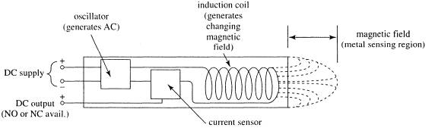
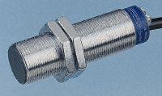

Capacitive Proximity Sensors:

Capacitive Proximity Sensors Theory of Operation Capacitive proximity sensors are similar to inductive proximity sensors. The main difference between the two types is that
capacitive proximity sensors produce an electrostatic field instead of an electromagnetic field. Capacitive proximity switches will sense metal as well as nonmetallic materials such as paper, glass, liquids, and cloth. The sensing surface of a capacitive sensor is formed by two concentrically shaped metal electrodes of an unwound capacitor. When an object nears the sensing surface it enters the electrostatic field of the electrodes and changes the capacitance in an oscillator circuit. As a result, the oscillator begins oscillating. The trigger circuit reads the oscillator’s amplitude and when it reaches a specific level the output state of the sensor changes. As the target moves away from the
sensor the oscillator’s amplitude decreases, switching the sensor output back to its original state.

Sniff sensors. Similar to smoke detectors, these are sensitive to particular gases and send a signal when they de t e c t those gases. Sniff sensors are used for safety as well as search and detection purposes.

Capacitive based sensors
The capacitance between two parallel plates is given by: 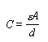
where A is the plate area, d the distance between the plates, and e the permittivity of the dielectric medium. A capacitive touch sensor relies on the applied force either changing the distance between the plates or the effective surface area of the capacitor. In such a sensor the two conductive plates of the sensor are separated by a dielectric medium, which is also used as the elastomer to give the sensor its force-to-capacitance characteristics.
To maximize the change in capacitance as force is applied, it is preferable to use a high permittivity, dielectric in a coaxial capacitor design. . In this type of sensor, as the size is reduced to increase the spatial resolution, the sensor’s absolute capacitance will decrease. With the limitations imposed by the sensitivity of the measurement techniques, and the increasing domination of stray capacitance, there is an effective limit on the resolution of a capacitive array. The figure shows the cross section of the capacitive touch transducer in which the movement of a one set of the capacitors' plates is used to resolve the displacement and hence applied force. The use of a highly dielectric polymer such as polyvinylidene fluoride maximizes the change capacitance. From an application viewpoint, the coaxial design is better as its capacitance will give a greater increase for an applied force than the parallel plate design
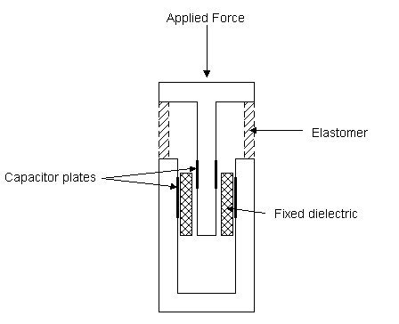

Infrared Sensors
The two types of IR sensors. There are IR sensors with built in circuits which provide a binary output , and there are those which provide an analog output or a multiple bit output.
The sensors with a binary output are only good for detecting the proximity of an obstacle , and not the range. By that I mean that the sensor can only tell you when an obstacle is within a certain distance ( we will call it the threshold distance) . This is fine for most robots which only need to know when an obstacle is right in front of it . This is the cheapest sensor which I will be explaining here.
The other IR sensors, which are ranging sensors , output the actual distance of an obstacle from the sensor. This output can either be analog or a digital byte.
Building an IR sensor , whether ranging or binary , is incredibly simple . Admin talks about how to build your own IR sensor here . Those sensors can be made cheaply but they are not so accurate . If you want accuracy get these Sharp IR sensors. They are the kings of infrared ranging , they are the most accurate IR sensors, and they provide an easy to use analog output. They usually cost between $10-$20 . However, be aware that there are many different types of Sharp IR sensor which have different minimum and maximum ranges , so search around for the one that suits you.
Now that I have explained the different types of IR sensors , I will tell you why IR is NOT the best out there. Infrared sensors , emit infrared light ,and therefore the sensors cannot work accurately outside or even inside , if there is direct or indirect sunlight( but this is not entirely true for Sharp IR sensors , since they will work pretty accurately in ambient light.) So no infrared ranging sensors on your outdoor robot. Also, the way the infrared sensor works is as follows
"The Sharp IR Range Finder works by the process of triangulation. A pulse of light (wavelength range of 850nm +/-70nm) is emitted and then reflected back (or not reflected at all). When the light returns it comes back at an angle that is dependent on the distance of the reflecting object. Triangulation works by detecting this reflected beam angle - by knowing the angle, distance can then be determined. "
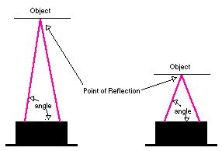 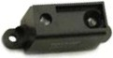

Now since light does not reflect the same way off every surface, the infrared sensor reading will be different for different surfaces , different colors, and different shades EVEN if the range is the same. Most of the time this reading is not too off, so the robot can still function.
CONCLUSION FOR IR SENSORS: Use infrared ranging sensors if:
- You do not care about incredibly accurate ranging
- The sensor will not be used outside in the sun
- You need a narrow beam width
- You want to spend less than $20 per ranging sensor
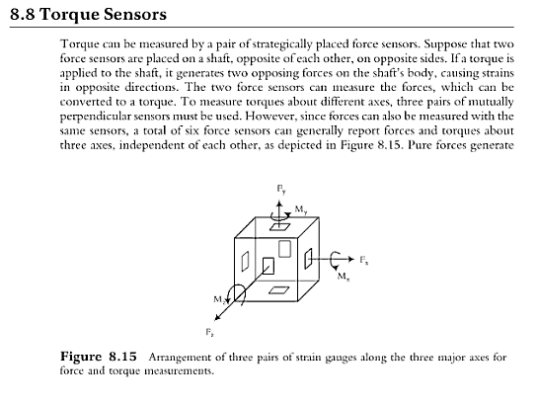

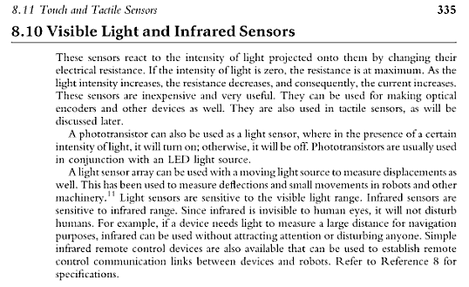

Strain gauges in tactile sensors
A strain gauge when attached to a surface will detect the change in length of the material as it is subjected to external forces. The strain gauge is manufactured from either resistive elements (foil, wire, or resistive ink) or from semiconducting material. A typical resistive gauge consists of the resistive grid being bonded to an epoxy backing film. If the strain gauge is pre-stressed prior to the application of the backing medium, it is possible to measure both tensile and compressive stresses. The semi-conducting strain gauge is fabricated from a suitable doped piece of silicone, in this case the mechanism used for the resistance change is the piezoresistive effect.
When applied to robotic touch applications, the strain gauge is normally used in two configurations: as a load cell, where the stress is measured directly at the point of contact, or with the strain gauge positioned within the structure of the end effector.

Piezoelectric sensors
Polymeric materials that exhibit piezoelectric properties are suitable for use as a touch or tactile sensors, while quartz and some ceramics have piezoelectric properties, polymers such as polyvinylidene fluoride (PVDF) are normally used in sensors.
Polyvinylidene fluoride is not piezoelectric in its raw state, but can be made piezoelectric by heating the PVDF within an electric field. Polyvinylidene fluoride is supplied sheets between as 5 microns and 2 mm thick, and has good mechanical properties. A thin layer of metalization is applied to both sides of the sheet to collect the charge and permit electrical connections being made. In addition it can be moulded, hence PVDF has number of attraction when considering tactile sensor material as an artificial skin.

