Code: 23CS3401/ 23IT3401
PVP23

PVP SIDDHARTHA INSTITUTE OF TECHNOLOGY
(Autonomous)
OPERATING SYSTEMS
(Model Question Paper)

Duration: 3 Hours Max. Marks: 70

Note: 1. This question paper contains two Parts A and B.
2. Part-A contains 10 short answer questions. Each Question carries 2 Marks.
3. Part-B contains 5 essay questions with an internal choice from each unit. Each
question carries 10 marks.
4. All parts of Question paper must be answered in one place.
BL – Bloom’s Level CO – Course Outcome

PART-A
10 x 2 = 20 Marks

Q. NO. | QUESTION | BL | CO | MAX  MARKS
1. a) | Explain the services provided by the operating systems. | CO1 | L2 | 2M
1.b) | Outline the advantages of open-source operating systems. | CO1 | L2 | 2M
1.c) | Outline the different states of the process. | CO1 | L2 | 2M
1.d) | Explain the benefits of multi-threaded programming. | CO1 | L2 | 2M
1.e) | Outline the drawbacks of semaphores. | CO1 | L2 | 2M
1.f) | Describe about deadlock. | CO1 | L2 | 2M
1.g) | Demonstrate address binding. | CO1 | L2 | 2M
1.h) | Explain about paging. | CO1 | L2 | 2M
1.i) | Demonstrate file allocation table. | CO1 | L2 | 2M
1.j) | Explain rotational latency. | CO1 | L2 | 2M

PART –B
5x10=50 Marks

Q. NO. |  | QUESTION | BL | CO | MAX  MARKS
UNIT-I
2 | (a) | Illustrate the abstract view of computer system. | L2 | CO1 | 5 M
2 | (b) | Explain any two computing environments in operating systems. | L2 | CO1 | 5 M
OR
3 | (a) | Describe Operating System Services with a neat sketch. | L2 | CO1 | 10 M
NIT-II
4 |  | Consider the following set of processes, with the length of the CPU burst given in milliseconds:  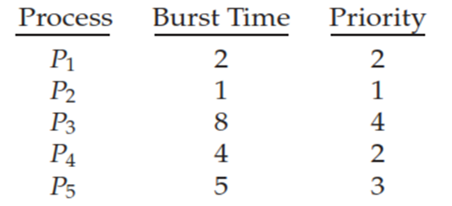  The processes are assumed to have arrived in the order P1, P2, P3, P4, P5 All at time 0.  - Draw four Gantt charts and inspect the execution of these processes by applying the following scheduling algorithms: FCFS, SJF, non preemptive priority (a larger priority number implies a higher priority), and RR (quantum = 2).  - What is the turnaround time of each process for FCFS, SJF, nonpreemptive priority, and RR scheduling algorithms.  - What is the waiting time of each process for each of these scheduling algorithms?  - Which of the algorithms results in the minimum average waiting time (over all processes)? | L4 | CO4 | 10 M
OR
5 |  | The above snapshot is given  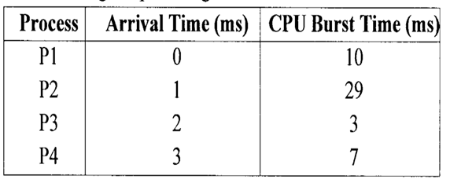  Draw the Gantt chart and apply FCFS, SJF and RR CPU Scheduling algorithms to calculate the turnaround time and waiting time. | L3 | CO2 | 10 M
UNIT-III
6 | Apply semaphores to provide synchronization for Readers-Writers Problem. |  | L3 | CO3 | 10 M
OR
7 | Apply Monitors to provide synchronization for Dining Philosophers problem. |  | L3 | CO3 | 10M
UNIT-IV
8 | Apply FIFO and LRU page replacement algorithms to calculate number of page faults would occur by consider the following page reference string with five page frames: 1, 2, 3, 4, 2, 1, 5, 6, 2, 1, 2, 3, 7, 6, 3, 2, 1, 2, 3, 6. |  | L3 | CO2 | 10M
OR
9 | Consider the order of request is 82, 170, 43, 140, 24, 16, 190. The current position of read/write head is 50. Analyze the total seek time for the following  - FCFS Disk Scheduling  - SSTF Disk Scheduling  - SCAN Disk Scheduling |  | L4 | CO4 | 10M
UNIT-V
10 | Describe the contiguous, linked, and indexed methods of allocating disk space. |  | L2 | CO1 | 10M
OR
11 | Illustrate  - File system mounting  - File sharing |  | L2 | CO1 | 10M

